Department of Veterans Affairs

Solicitation # 36C10B24Q0192

Due: May 13, 2024, 3:00 PM Eastern Time

Submitted via GSA eBuy   
Attention to:   
Contract Specialist, Mina Awad, [Mina.Awad@va.gov](mailto:Mina.Awad@va.gov)  
Contracting Officer, Summer Spalliero, [Summer.Spalliero@va.gov](mailto:Summer.Spalliero@va.gov)

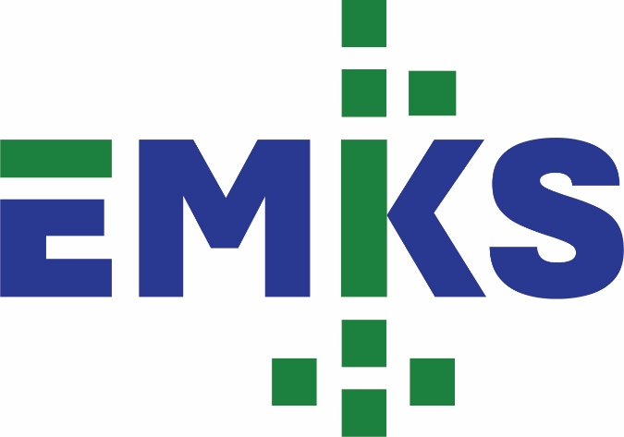

Response to Request for Proposal:   
Volume I Technical

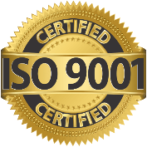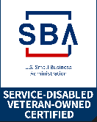

Section 508 Audit, Testing and Training Services

Prepared by:

**EM Key Solutions, Inc. (EMKS)**

*VetCert Certified Service-Disabled Veteran-Owned Small Business*

2000 Park Street North, St. Petersburg, FL 33710  
GSA Contract Number: 47QTCA19D006A

CAGE Code: 7VAC0 | SAM UEI: M733AMAJG9B1

**Mike Snyder, CEO**Phone Number: 1-540-287-7126

Email: [*mike@EMKEYSOLUTIONS.COM*](mailto:mike@EMKEYSOLUTIONS.COM)

*This proposal includes data that shall not be disclosed outside the Government and shall not be duplicated, used, or disclosed – in whole or part – for any purpose other than to evaluate this proposal. If, however, a contract is awarded to the offeror because of – or in connection with – the submission of this data, the Government shall have the right to duplicate, use or disclose the data to the extent provided in the resulting contract. This restriction does not limit the Government's right to use or disclose any data obtained from another source without restriction.*

Table of Contents

Volume I – Technical Factor (20 Page Limit) 1

Technical and Management Approach to PWS Requirements 1

1 Section 508 Compliance Audits (PWS 5.2.1) 1

1.1 508 Compliance and Audit Process 1

1.1.1 Ability to Identify Defects Against U.S. Access Board’s Section 508 ICT Standards 1

1.1.2 Ability for Identify Accessibility Barriers for Assessed ICT Products 1

1.2 ICT Product Audit Timelines and Volume 1

1.2.1 ICT Types for ICT Product Audit 1

1.2.2 Assistive Technology Tools or Products Used 1

1.3 Prevention of 508 Testing Conflicts of Interest 2

1.4 Audit Defect Demonstration Process 2

2 Section 508 Compliance Product Testing (PWS 5.3.1) 2

2.1 508 Compliance and Product Testing Process 2

2.1.1 Ability to Identify Defects Against U.S. Access Board’s Section 508 ICT Standards 2

2.1.2 Ability to Identify Accessibility Barriers for Assessed ICT Products 2

2.2 ICT Product Testing Timelines and Volume 2

2.2.1 ICT Types for ICT Product Testing 2

2.2.2 Assistive Technology Tools or Products Used 2

2.3 Prevention of 508 Compliance Conflicts of Interest 2

2.4 Defect Demonstration Process 2

3 Section 508 Awareness Training (PWS 5.4) 3

3.1 508 Awareness Training Process 3

3.2 Training Methodology 3

3.3 Impact on Section 508 Awareness and ICT Development 3

Tables

**No table of figures entries found.**

Page size shall be no greater than 8 1/2" x 11" with printing on one side, only. The top, bottom, left and right margins shall be a minimum of one inch (1”) each. Font size shall be no smaller than 12-point. Arial or Times New Roman fonts are required. Characters shall be set at no less than normal spacing and 100% scale. Tables and illustrations may use a reduced font size not less than 8-point and may be landscape. Line spacing shall be set at no less than single space. Each paragraph shall be separated by at least one blank line. Page numbers, company logos, and headers and footers may be within the page margins ONLY and are not bound by the 12-point font requirement.

Volume I – Technical Factor (20 Page Limit Overall)

Technical and Management Approach to PWS Requirements

The evaluation process will consider the following:

a. Understanding of the Problem - The proposal will be evaluated to determine the extent to which it demonstrates a clear understanding of all features involved in solving the problems and meeting and/or exceeding the requirements presented in the solicitation and the extent to which uncertainties are identified and resolutions proposed.

b. Feasibility of Approach - The proposal will be evaluated to determine the extent to which the proposed approach is workable and the end results achievable. The proposal will be evaluated to determine the level of confidence provided the Government with respect to the Offeror's methods and approach in successfully meeting and/or exceeding the requirements in a timely manner.

# Section 508 Compliance Audits (PWS 5.2.1)

1. In accordance with PWS Section 5.2.1, Section 508 Compliance Audits, provide a detailed technical and management approach addressing

## 508 Compliance and Audit Process

the 508 Compliance process, specifically how the audit process will identify defects against the United States Access Board’s Section 508 ICT Standards and incorporated guidelines and standards and identify accessibility barriers for each ICT product assessed.

< Provide Team EMKS’s detailed technical and management approach for the audit process.>

### Ability to Identify Defects Against U.S. Access Board’s Section 508 ICT Standards

### Ability for Identify Accessibility Barriers for Assessed ICT Products

## ICT Product Audit Timelines and Volume

Identify the timelines and volume of ICT to include ICT types and any type of assistive technology tools or products used for the audit.

### ICT Types for ICT Product Audit

### Assistive Technology Tools or Products Used

## Prevention of 508 Testing Conflicts of Interest

Identify how the Audit process will prevent conflicts of interest with the 508 testing process referenced in PWS Section 5.3.1, Section 508 Compliance Product Testing.

<Provide measures to prevent conflicts with the 508 testing process.>

## Audit Defect Demonstration Process

Identify the audit defect demonstration process.

# Section 508 Compliance Product Testing (PWS 5.3.1)

2. In accordance with PWS Section 5.3.1, Section 508 Compliance Product Testing, provide a detailed technical and management approach addressing

## 508 Compliance and Product Testing Process

the 508 Compliance product testing process, specifically how the testing process will identify defects against the United States Access Board’s Section 508 ICT Standards and incorporated guidelines and standards and identify accessibility barriers for each ICT product assessed.

<Provide Team EMKS’s detailed technical and management approach for product testing.>

### Ability to Identify Defects Against U.S. Access Board’s Section 508 ICT Standards

### Ability to Identify Accessibility Barriers for Assessed ICT Products

## ICT Product Testing Timelines and Volume

Identify the timelines and volume of ICT to include ICT types and any type of assistive technology tools or products used for the testing.

### ICT Types for ICT Product Testing

### Assistive Technology Tools or Products Used

## Prevention of 508 Compliance Conflicts of Interest

Identify how the 508 compliance testing process will prevent conflicts of interest with the 508 compliance auditing process referenced in PWS Section 5.2.1, Section 508 Compliance Audits.

<Provide measures to prevent conflicts with the 508 compliance auditing process.>

## Defect Demonstration Process

Identify the testing defect demonstration process.

<Describe Team EMKS’s testing defect demonstration process.>

# Section 508 Awareness Training (PWS 5.4)

3. In accordance with PWS Section 5.4, Section 508 Awareness Training, provide a detailed approach addressing the 508 awareness training process, specifically how the 508 awareness training shall be conducted and how it will lead to improvement of section 508 awareness and ICT product development and testing.

## 508 Awareness Training Process

<Detail Team EMKS’s approach for conducting 508 awareness training.>

## Training Methodology

<Describe how Team EMKS will conduct training.>

## Impact on Section 508 Awareness and ICT Development

<Explain how Team EMKS’s training will improve section 508 awareness and ICT product development and testing.>