Body mass, growth and social-communication phenotypes in carriers of 16p11.2 and 22q11.2 copy-number variants
Final analysis report: summary, methods, results, main and supplementary figures (embedded) and tables. Jonathan Sebat (analysis carried out with Claude). Report date 2026-10-26. Status: provisional; the next round adds subjects and manually corrected records (section 7).

Summary of findings
• Head circumference: in 16p11.2 deletion carriers head size rises with BMI more steeply than in unaffected relatives (CNV x BMI versus controls +0.13 SD per SD, p = 0.021; main figure and Table S1); 16p11.2 deletion is the only CNV with a significant excess over controls (heterogeneity across the four CNVs p = 0.21), the effect is confined to head circumference, is present in both sexes and in carriers below and above the median of every polygenic score (Table S4), survives adjustment for sex and for childhood obesity, adult BMI, height and autism PGS (Table S5), and is unchanged by medication adjustment or by excluding medicated carriers (section 3.3).
• Height: carriers differ from controls by a constant shift; the BMI slope on height is the same as in controls in every CNV group (Table S1), and the longitudinal analysis shows no prospective effect of BMI on later height growth (Table S3).
• Social communication: SRS and SCQ rise with BMI in carriers of every CNV (CNV x BMI versus controls nominal or better for all four CNVs on SCQ and for three of four on SRS; Table S2), whereas SSC ASD probands and unaffected relatives show no BMI slope. The slope does not differ across the four CNVs (heterogeneity p = 0.61 for SRS, 0.96 for SCQ), i.e. a shared carrier effect. The effect is not explained by sex, polygenic scores (Table S5) or psychotropic medication (section 3.3). CNB accuracy and speed show no consistent BMI effect after QC.
• Autism diagnosis within CNV group (fig_supp_asd_by_cnv, Tables S7-S8): carriers with autism have larger heads than carriers without in the overgrowth CNVs (+0.45 SD; the excess over the non-carrier ASD effect is significant, p = 0.046) but not in the undergrowth CNVs; BMI does not differ by autism status within any CNV group, so the BMI effects above are not a by-product of ASD carriers being heavier. These contrasts are unchanged by sex or PGS adjustment.
• Interactions with modifiers: of 206 modifier x BMI tests, 47 were adequately powered; 11 were nominal (about two expected by chance, but the tests are correlated) and none survives correction (Table S6). The only directionally consistent signal, adult BMI PGS x BMI on height and head circumference, needs a larger sample.
• Quality control: plausibility screening of height, weight and head circumference changed the SRS, SCQ and head-circumference results by at most 0.03 SD per SD, removed a 16p11.2 duplication CNB accuracy slope that rested on one implausible BMI, and destabilised the CNV x age x BMI three-way terms, which are reported but not emphasised (section 3.6). All numbers are provisional until the corrected records and new subjects are added.

1. Where everything is
All code and outputs live in one folder; frozen copies of the manuscript materials are in a dated subfolder; participant-level tables stay in the controlled data folder. Expanse paths cover the genotype scoring and the summary statistics.
Item | Path
Analysis folder (scripts 00-32, live outputs, logs, reports) | C:\Users\Jonathan Sebat\sebatlab Dropbox\Manuscripts\PGC_joint_submission\Molly\CNV_ASD_growth_analysis\CNV_growth_trajectories
Manuscript materials (frozen copies: main figure, supplementary figures, tables, legends, QC files, handoff) | C:\Users\Jonathan Sebat\sebatlab Dropbox\Manuscripts\PGC_joint_submission\Molly\CNV_ASD_growth_analysis\CNV_growth_trajectories\manuscript_materials_2026-10-24
Controlled participant-level data (analysis_table.rds, hc_visits.rds, PGS scores) | C:\Users\Jonathan Sebat\sebatlab Dropbox\Jon\Claude\CNV_growth_trajectories_data
Growth genomatrix (Molly) | sebatlab Dropbox\G2MH\NetworkPaper\AnalysisByMolly\Clinical\genomatrix\genomatrix.Clinical.02092026.csv
G2MH phenotype and medication releases (Feb 2026) | sebatlab Dropbox\G2MH\DataFreeze\Feb2026\g2mh_project2_data_release_022026.csv; g2mh_project2_medications_data_release_022026.csv
Penn CNB (Anjali, normalised) | sebatlab Dropbox\G2MH\NetworkPaper\AnalysisByAnjali\data\cnb_processing\cnb_normalized.csv
SSC v15 phenotypes (+ README on ages and line endings) | sebatlab Dropbox\Autism\SSC_Version_15_Phenotype_Data_Set_9
SVIP v10 (diagnoses, growth series) | sebatlab Dropbox\G2MH\Simons_Searchlight\SVIP\SVIP\Simons_VIP__16p11.2_Dataset_v10.0
G2MH WGS PGS (Anjali plink2 scores; projected PCs) | sebatlab Dropbox\G2MH\NetworkPaper\AnalysisByAnjali\data\pgs_scores\scores_wgs; ...\data\pca_results\naive\cohort.sscore
Lab GWAS summary-statistics sheet (copy) | C:\Users\Jonathan Sebat\sebatlab Dropbox\Manuscripts\PGC_joint_submission\Molly\CNV_ASD_growth_analysis\CNV_growth_trajectories\resources\GWAS_summary_statistics_sheet_2026-10-26.csv
Expanse: SBayesRC weights (Anjali) | /expanse/projects/sebat1/a1sriniv/pgs_sumstats_organized/processed/txt_weights/ (childhood obesity, childhood BMI, bmi_2018, height_2022, ...); full SBayesRC outputs /expanse/projects/sebat1/a1sriniv/g2mh/4a_pgs/1_wgs/sbayesrc_output/main
Expanse: SBayesRC pipeline copies (not rerun here) | /expanse/projects/sebat1/s3/data/sebat/resources/sbayesrc_scripts/sbayesrc_pipeline.sh; /expanse/projects/sebat1/s3/data/sebat/pgs_pipeline/run_sbayesrc.sh (James, January 2026; template for jsebat/pgs_asd2026_loo/run_sbayesrc.sh). LD reference resources/sbayesrc_resources/ukbEUR_HM3; annotation annot_baseline2.2.txt; container resources/sbayesrc_v0.2.6.sif
Expanse: ASD 2026 GWAS summary statistics and leave-one-out rules | /expanse/projects/sebat1/jsebat/sumstats/ (asd_2026Apr_full/, asd_2026Apr_LOO_by_cohort/, README.md)
Expanse: ASD 2026 weights and scores | /expanse/projects/sebat1/jsebat/pgs_asd2026_loo/ (output/weights/asd2026_full.snpRes, asd2026_loSSC.snpRes; scores/ssc.asd2026_loSSC.sscore)
Expanse: obesity / height / ASD scoring for this report | /expanse/projects/sebat1/jsebat/pgs_obesity_ssc/ (score_ssc_obesity.sh, score_height_asd.sh, scores/, logs/); copies in the controlled data folder (ssc_scores_raw/, g2mh_scores_raw/, ssc_pgs_scores.tsv)
Expanse: genotype sets scored | SSC: /expanse/projects/sebat1/s3/data/sebat/pgs_wf_ssc/05_summary/ssc (9,209 samples, IDs SS...); G2MH WGS: /expanse/projects/sebat1/a1sriniv/g2mh/4a_pgs/1_wgs/05_summary/cohort (1,043 samples); James's PLINK pipeline step 5: /expanse/projects/sebat1/j3guevar/SPARK-WGS-2026_08/plink/pgs/runs/scoring-ancestry-20261012/code/PLINK_PIPELINE_05.scores.py
Expanse: UK Biobank version of the main figure (not used in v3) | /expanse/projects/sebat1/jsebat/growth_tables_20260920/main_with_ukbb (script 17)

2. Methods

2.1 Samples
Carriers of 16p11.2 proximal (BP4-BP5) deletions and duplications and 22q11.2 A-D deletions and duplications were taken from the clinical growth genomatrix (cohorts G2MH, Cardiff, SVIP, Searchlight; G2MH rows masked as Cardiff duplicates removed), ages 2-65, using the latest visit at which the outcome and BMI were both available. ASD status came from the G2MH subject table (Jon/Claude/G2MH_CNV_growth/subjects.csv) and the SVIP diagnosis summary. Unaffected controls were non-carrier SSC designated siblings and parents (sibling height, weight and head circumference from the SSC sibling table; SSC, PMID 20955926) and SVIP non-carrier family members without ASD; no SSC probands and no UK Biobank data are in the current figures. SSC probands with ASD and no CNV served as a separate ASD comparison group. Social-communication and cognitive measures were available for G2MH carriers (SRS-2 total, SCQ lifetime, RBS-R, FSIQ, Penn CNB; PMIDs 10832778, 19900482, 25180981) and for SSC relatives and probands (SRS, SCQ).

2.2 Growth scoring, ages and quality control
Height was scored against the WHO child growth standards and the WHO 2007 reference (PMIDs 16817681, 18026621), head circumference against the UK 1990 reference with adults scored at 18 years (PMID 9496720), child BMI against WHO, and adult BMI as a centile against the pooled non-carrier adults of the clinical cohorts mapped to a Z score (00_scoring.R; childsds R package).
Two data issues were found and corrected during this work. (i) The SSC v15 age columns are ages at a single snapshot date (September 2012), about three years older than the study visit. Sibling and parent visit age was reconstructed as the proband's age at evaluation plus the birth-month difference, which reproduces SSC's own sibling height Z (r = 0.96); implemented in 21_pheno_bmi_gam.R and 01_build.R and documented in README_ages_and_line_endings.md in the SSC folder. (ii) Implausible raw values (heights recorded in metres, heights of 366-640 cm, adult BMI of 60-181, a BMI of 9.2, children with height or BMI Z beyond 5) are screened by 00_qc_growth.R before scoring: metre-coded heights are multiplied by 100; heights outside 60-230 cm (with their BMI), BMI outside 10-70, |height Z| > 5, child |BMI Z| > 5, and head circumference outside 30-70 cm or |Z| > 5 are set to missing. The 106 flagged visit rows (95 individuals) are listed in implausible_height_weight.csv/.md; a correction sheet (implausible_height_weight_corrections.csv) is applied automatically by the QC once filled in. Pre-QC outputs are kept in preQC_20261024/.

2.3 Statistical models (cross-sectional; main figure, Tables S1-S2)
All models are generalised additive models in mgcv (REML; bam with fREML for the carrier-versus-control fits). BMI enters as a continuous Z score; the 70th/30th centile split in the figures is for display only. Within a group: BMI main effect, y ~ BMI + s(age) [+ locus], giving the BMI slope in SD of outcome per SD of BMI; and age x BMI, y ~ s(age) + s(BMI) + ti(age, BMI) [+ locus]. Carriers versus a reference group: CNV x BMI, the age-adjusted difference in BMI slope, y ~ [locus +] CNV + s(age, by = CNV) + s(age, by = BMI) + CNV:BMI; and CNV x age x BMI, y ~ [locus +] CNV + s(age) + s(BMI) + s(age, by = CNV) + ti(age, BMI) + ti(age, BMI, by = CNV), reported as the p-value of the carrier-specific tensor product. Pooled groups (overgrowth = 16p11.2 del + 22q11.2 dup; undergrowth = 16p11.2 dup + 22q11.2 del; all) include locus as a covariate. Heterogeneity of the BMI slope across the four CNV groups was tested within carriers as the Wald test of the locus x BMI interaction in y ~ s(age, by = locus) + locus + BMI + locus:BMI. For SRS and SCQ the trait is plotted against BMI after removing the within-group age smooth, because the BMI effects on these traits do not depend on age.

2.4 Longitudinal (prospective) models (Supplementary figure, Table S3)
In carriers under 18 years, the change in height Z or head-circumference Z from one visit to the next was regressed on BMI Z at the first visit, adjusting for Z at the visit, interval length, sex and (pooled) locus and cohort, with a child random intercept. A mixed GAM with s(age, by = BMI) gives the age-varying effect (age-varying p: BMI effect differs from zero at any age); the same model with a constant BMI term gives the all-ages coefficient; fixed age windows (height: < 8, 8-13, 13-18 y with lmer; head circumference: < 2, 2-5, 5-18 y) give window coefficients. Height used cleaned longitudinal visits of SVIP, Searchlight and Cardiff (intervals >= 0.5 y); head circumference used the full SVIP v10 series plus Cardiff, G2MH and SSC carrier visits (01_build.R, 05_age_varying.R, 07_hc_trajectories.R, 11_supp_prospective.R, 29_supp_table_S3_prospective.R).

2.5 Medication
Current medication from the G2MH medications release was classed by drug name (ATC codes were empty) into antipsychotics, stimulant/ADHD medication, ADHD alpha-agonists, antidepressants, antiepileptics/mood stabilisers and anxiolytics; weight-gain-associated (antipsychotics, valproate, lithium, mirtazapine, gabapentinoids) and weight-loss-associated (stimulants, atomoxetine, topiramate, metformin, GLP-1 agonists) groupings were also formed. Status was known for 85-92% of carriers. For height, head circumference, SRS, SCQ and CNB the within-carrier BMI slopes were refit unadjusted, with class indicators, in carriers on no psychotropic, and with classes plus ASD (27_medication_sensitivity.R; height and head circumference added 2026-10-26 on the main-figure rows of the G2MH carriers; the CNV x BMI contrasts against controls cannot be medication-adjusted because the controls have no medication data).

2.6 Polygenic scores
Weights were SBayesRC posterior effects (PMID 38689000; ukbEUR_HM3 LD reference, baseline 2.2 annotations) computed by Anjali Srinivasan from published summary statistics: adult BMI (Yengo 2018, PMID 30124842), childhood obesity (Bradfield 2019, trans-ancestral, PMID 31504550), childhood BMI (Vogelezang 2020, PMID 33045005), height (Yengo 2022, PMID 36224396), and autism from the April 2026 ASD GWAS (iPSYCH, PGC, SPARK, SSC, MoBa; unpublished, J. Grove; the 2019 release is PMID 30804558). G2MH WGS carriers were scored by Anjali with plink2 (PMID 25722852) and, for autism, scored in this work with the full 2026 weights because G2MH is not a GWAS cohort. SSC controls were scored in this work on the SSC genotype set with the same obesity, childhood BMI, adult BMI and height weights, and for autism with the leave-SSC-out weights, because SSC is in the GWAS (rule in jsebat/sumstats/README.md). Scores were residualised on 10 ancestry principal components within cohort (G2MH: projected PCs; SSC: PCs from the combined ADSI table) and z-scored within cohort. Carriers from SVIP, Searchlight and Cardiff have no scores in this pipeline. The three obesity/BMI scores are moderately correlated (childhood obesity vs childhood BMI r = 0.62; each vs adult BMI r = 0.33); height and autism scores are uncorrelated with them.

2.7 Sex and polygenic-score sensitivity analyses (Tables S4-S6)
Three complementary analyses (30a_build_ssc_pgs.R, 30_sex_pgs_sensitivity.R). Table S5, the confounding check: for each trait and group, the carrier BMI slope and the CNV x BMI shift versus unaffected controls were refit on the same individuals (G2MH carriers and SSC controls with all four scores) unadjusted; adding sex and sex x BMI; adding each PGS with its BMI interaction; adding all four PGS; and all four plus sex. Table S4, strata: the main-figure tests repeated within sex and within below/above-median halves of each PGS, with carriers and controls stratified alike. Table S6, power: for each modifier (sex; each PGS as a continuous z-score) the interaction term BMI x modifier was fitted within carriers (y ~ s(age) + BMI * modifier [+ locus]) and the power to detect an interaction as large as the carriers' own BMI effect was computed from the term's standard error (normal approximation), with the smallest interaction detectable at 80% power (2.8 x SE). Interactions are reported only where that power is at least 80%.

2.8 Autism diagnosis within CNV group (supplementary figure fig_supp_asd_by_cnv)
32_supp_asd_by_cnv.R. Within each CNV group (per locus; pooled overgrowth = 16p11.2 deletion + 22q11.2 duplication; pooled undergrowth = 16p11.2 duplication + 22q11.2 deletion) height Z, head-circumference Z and BMI Z (same scoring and QC as the main figure; latest visit with the outcome and BMI, ages 2-65) were compared between carriers with and without an autism diagnosis (G2MH subject table, SVIP diagnosis summary) with a GAM, y ~ ASD + s(age, k = 8) + sex, plus cohort and, in pooled groups, locus. The non-carrier comparison is SSC probands (ASD) versus SSC designated siblings. Because the ASD carriers are mostly children and non-ASD carriers include adult relatives, the age smooth is essential; 20_asd_age_confound.R shows the head-circumference effect holds within children. Sensitivity: in the individuals with all four polygenic scores (G2MH carriers; SSC non-carriers; scores as in 2.6) each model was refitted with the same covariates, then adding the childhood obesity, adult BMI, height and autism PGS one at a time and all four together, on the same individuals (supp_asd_by_cnv_sensitivity.csv; sheet 'S8 ASD by CNV PGS adj'). Sex is a covariate in every model, so sex confounding is addressed by design rather than by stratification. Interaction with carrier status: each carrier group was pooled with the SSC non-carriers and the model y ~ ASD + locus + ASD x carrier + s(age, by carrier) + sex + cohort fitted; the ASD x carrier coefficient (Table S7 columns int_delta, int_se, int_p; Table S8 with the PGS covariates) is the difference between the ASD effect in the carrier group and in non-carriers.

2.9 Software and run order
R 4.6.1 with data.table, mgcv (Wood 2011, J R Stat Soc B 73:3-36), lme4 and lmerTest, childsds, ggplot2, patchwork, openxlsx, officer; plink2 (PMID 25722852) and Slurm on Expanse. Run order after any data change: 01 -> 05 -> 07 -> 11 -> 29, then 23 -> 25 -> 26 -> 27 -> 28 -> 30 -> 32.

3. Results

3.1 Main figure (fig_main_v3): height, head circumference, SRS and SCQ versus unaffected relatives
• Head circumference. 16p11.2 deletion is the only locus whose head-circumference-BMI coupling exceeds that of unaffected relatives (CNV x BMI +0.13 SD per SD, p = 0.021; CNV x age x BMI p = 0.020; against SSC ASD probands +0.17, p = 0.002). Head circumference rises with BMI in every group including controls (+0.36 SD per SD), so the 16p11.2 deletion effect is an excess over a general relationship; it is present in both sexes and in carriers without ASD.
• Height. No locus shows a constant CNV x BMI shift versus controls after QC (16p11.2 del p = 0.99, 16p11.2 dup 0.24, 22q11.2 del 0.48, 22q11.2 dup 0.99). The CNV x age x BMI terms are nominally significant for 16p11.2 dup and 22q11.2 dup but proved unstable to the removal of a few extreme values and are not emphasised (section 3.6).
• SRS and SCQ. Scores rise with BMI in carriers but not in unaffected relatives: all CNVs versus controls SRS +0.21 SD per SD (p = 1.6e-6), SCQ +0.34 (p = 4.8e-5); 22q11.2 deletion SRS +0.23 (p = 8.4e-6), SCQ +0.27 (p = 0.001); 16p11.2 duplication SRS +0.50 (p = 3.8e-5, n = 34). SSC probands with ASD and no CNV show no BMI slope (SRS +0.03, SCQ +0.03), so the association is specific to CNV carriers rather than to ASD. There is no heterogeneity of the slope across the four CNV groups (SRS p = 0.61, SCQ p = 0.96). Restricting to carriers without an ASD diagnosis attenuates the SRS slope but not the SCQ slope; SCQ (and SRS in some cohorts) contributed to ASD assignment, so that restriction selects on the outcome.
• Penn CNB (supplementary figures). No robust BMI effects on accuracy or speed for any subtest or total. The 16p11.2 duplication accuracy slope (-0.14, p = 0.07) and the across-CNV heterogeneity for the accuracy total (p = 0.11) lost significance when one implausible BMI value was removed by QC; the result is reported as suggestive only.

3.2 Longitudinal analysis (fig_supp_prospective, Table S3)
Higher BMI at a visit precedes faster height growth in 16p11.2 deletion carriers under 8 years (+0.23 SD of height Z per SD of BMI Z to the next visit, t = 3.9, p = 1.6e-4; age-varying p = 0.006; pooled carriers age-varying p = 0.022, < 8 y window +0.13, t = 2.9). For head circumference the effect is positive at all ages (all-ages coefficient, 16p11.2 deletion +0.08, t = 2.1, p = 0.038; pooled +0.10, t = 3.4, p = 7e-4; age-varying p = 7.5e-4). Height results were unchanged by QC; head circumference lost five SVIP intervals and strengthened slightly.

3.3 Medication
Psychotropic use was common (29-33% of carriers; antipsychotics 5-7%) and strongly associated with the traits, but no medication class was associated with BMI, and the BMI slopes on SRS and SCQ were unchanged by adjustment for medication classes or by excluding medicated carriers (SRS all CNVs +0.22, +0.19, +0.23; SCQ +0.35, +0.37, +0.38). ASD diagnosis, not medication, is the only covariate that attenuates the SRS slope. The growth slopes are equally robust: head circumference in 16p11.2 deletion carriers +0.47 unadjusted, +0.48 with medication classes, +0.50 in the 52 carriers on no psychotropic, +0.48 with classes plus ASD (all CNVs +0.37, +0.36, +0.33, +0.33); height in 16p11.2 deletion +0.31, +0.32, +0.27, +0.32. No medication class was associated with head circumference or height, and the only class associated with BMI in the growth rows (weight-loss-associated drugs, +0.37 SD, p = 0.045) would bias the slopes downwards, not upwards. Details and the full table: medication_sensitivity_results.md.

3.4 Sex and polygenic background: confounding is excluded (Table S5)
Adjusting for sex, for any single PGS, for all four PGS (childhood obesity, adult BMI, height, autism), or for all four plus sex leaves the BMI effects essentially unchanged on the same individuals. CNV x BMI versus unaffected controls (estimate, SE, p):
Trait, group | n carriers / controls | Unadjusted | + sex | + all four PGS | + all four PGS + sex
Head circumference, 16p11.2 del | 98 / 4,985 | +0.130 (0.076), p = 0.086 | +0.139, p = 0.065 | +0.142, p = 0.057 | +0.151, p = 0.041
SRS, all CNVs | 349 / 4,988 | +0.192 (0.048), p = 5.8e-5 | +0.194, p = 5.0e-5 | +0.196, p = 4.1e-5 | +0.198, p = 3.6e-5
SRS, 22q11.2 del | 186 / 4,988 | +0.293 (0.055), p = 1.3e-7 | +0.292, p = 1.4e-7 | +0.292, p = 1.4e-7 | +0.292, p = 1.5e-7
SCQ, all CNVs | 268 / 1,030 | +0.318 (0.091), p = 5.0e-4 | +0.311, p = 6.6e-4 | +0.318, p = 5.6e-4 | +0.312, p = 7.1e-4
SCQ, 22q11.2 del | 151 / 1,030 | +0.350 (0.091), p = 1.2e-4 | +0.339, p = 1.9e-4 | +0.347, p = 1.4e-4 | +0.337, p = 2.2e-4
Height, all CNVs | 550 / 5,010 | +0.009 (0.039), p = 0.81 | +0.010, p = 0.80 | +0.013, p = 0.70 | +0.014, p = 0.66

In this subset (G2MH carriers with scores and SSC controls) the 16p11.2 deletion head-circumference contrast is weaker than in the full sample (p = 0.086 versus 0.021) because the SVIP, Searchlight and Cardiff carriers are absent; adjustment moves it towards, not away from, significance. PGS main effects on SRS and SCQ are null. The stratified analysis (Table S4) shows the carrier-versus-control slopes in both sexes and in both halves of every PGS split.

3.5 Interactions: power and findings (Table S6)
Of 206 modifier x BMI interaction tests, 47 had at least 80% power to detect an interaction as large as the carriers' own BMI effect: all PGS and sex for head circumference (pooled and per locus; interaction SE 0.04-0.13), all PGS for height in the pooled, 16p11.2 deletion and overgrowth groups (SE 0.035-0.09), and a few SRS rows (autism PGS pooled, 81%; adult BMI and height PGS in 22q11.2 deletion and undergrowth, 82-86%). Sex x BMI for height (17%), every SCQ row (43-71%), the remaining SRS rows (61-77%) and every CNB row (< 25%) were underpowered, and no interaction is reported for them.
Among the 47 well-powered tests, eleven were nominally significant (p < 0.05; about two would be expected by chance, but the tests are far from independent because the pooled groups contain the per-locus groups and height and head circumference are correlated) and none survives correction for 47 tests (threshold p = 0.0011; smallest p = 0.017): adult BMI PGS x BMI on height (all CNVs +0.088 per SD of PGS, p = 0.017; 16p11.2 del +0.13, p = 0.048; overgrowth +0.12, p = 0.019) and on head circumference (all CNVs +0.089, p = 0.031; overgrowth +0.13, p = 0.027); childhood obesity PGS and height PGS x BMI on head circumference in 22q11.2 deletion (-0.15, p = 0.024; -0.14, p = 0.028) and in the undergrowth pool that contains it (-0.12, p = 0.038; -0.11, p = 0.048); autism PGS x BMI on SRS (all CNVs -0.18, p = 0.019); and autism PGS x BMI on height in 16p11.2 deletion (+0.18, p = 0.040). The adult BMI PGS effect has a consistent direction (stronger BMI-growth coupling with higher polygenic BMI) across groups and traits and is the one candidate worth following up in a larger sample; the others are isolated. There is no credible evidence of sex- or PGS-dependent BMI effects, and the main-figure results are not explained by sex or polygenic background.

3.6 Effect of the plausibility QC
SRS and SCQ results changed by at most 0.03 SD per SD. The 16p11.2 deletion head-circumference effect persisted. The 16p11.2 duplication CNB accuracy slope and the across-CNV heterogeneity lost significance. Several height CNV x age x BMI p-values moved by orders of magnitude in both directions when a handful of extreme heights were removed, so the three-way terms are reported but not emphasised (section 9 of unaffected_controls_report.md).

3.7 Autism diagnosis within CNV group (fig_supp_asd_by_cnv; sheets S7-S8)
Head circumference is larger in carriers with than without autism in the overgrowth CNVs (pooled: Delta +0.45 SD, p = 0.022, n = 188 non-ASD / 96 ASD; 16p11.2 deletion +0.41, p = 0.074; 22q11.2 duplication +0.59, p = 0.16) but not in the undergrowth CNVs (pooled -0.05, p = 0.8); SSC probands also have slightly larger heads than their siblings (+0.14, p = 0.0014). Height does not differ by autism status in any group (all p > 0.07). BMI does not differ by autism status within any CNV group (per locus Delta +0.10 to +0.16, p 0.43-0.78; pooled overgrowth +0.08, p = 0.69; undergrowth +0.15, p = 0.36), whereas SSC probands are marginally heavier than their siblings (+0.11, p = 0.032). So the BMI-related effects in the main figure are not a by-product of the ASD carriers being heavier than non-ASD carriers. Tested against the non-carrier ASD effect (ASD x carrier interaction), the head-circumference excess in the overgrowth CNVs is significant (+0.35 SD, SE 0.17, p = 0.046; 16p11.2 deletion +0.27, p = 0.17; 22q11.2 duplication +0.63, p = 0.063; undergrowth -0.20, p = 0.25), the BMI interactions are null in every group (-0.07 to +0.08, all p > 0.6) and the height interactions are not significant (overgrowth +0.29, p = 0.061; others p > 0.15).
Sensitivity (same individuals, with all four PGS): adding childhood obesity, adult BMI, height and autism PGS, singly or together, to the age- and sex-adjusted model leaves every ASD contrast essentially unchanged. Head circumference, overgrowth: +0.33 (p = 0.20) with age and sex, +0.36 (p = 0.16) with all four PGS (n = 101 / 68; the contrast is attenuated in this subset because SVIP, Searchlight and Cardiff carriers are unscored); 16p11.2 deletion +0.33 to +0.37. BMI: overgrowth +0.07 to +0.13; undergrowth +0.32 (p = 0.092) to +0.35 (p = 0.058); 16p11.2 deletion +0.14 to +0.19; non-carriers +0.13 (p = 0.014) to +0.10 (p = 0.037). Height: carrier contrasts unchanged; among SSC non-carriers the proband-minus-sibling height difference becomes more negative with height PGS in the model (-0.09, p = 0.056, to -0.14, p = 0.00034), i.e. probands are slightly shorter than predicted from their height PGS. The ASD x carrier interactions behave the same way (head circumference, overgrowth: +0.23, p = 0.28, to +0.30, p = 0.16, in the scored subset; BMI interactions all p > 0.3; the height interaction for the overgrowth group reaches p = 0.02 with all four PGS because the SSC proband-sibling difference moves negative, not because the carrier contrast changes). Neither sex nor polygenic background explains the within-CNV ASD effects on head circumference or the absence of ASD effects on BMI.

4. Figures and legends
Full legends are in figure_legends.md in the materials folder and beside each figure as *_legend.txt.
• Main figure (fig_main_v3.png/.pdf; 25_main_figure_v3.R): columns Height, Head circumference, SRS, SCQ; rows unaffected controls, 16p11.2 del, 16p11.2 dup, 22q11.2 del, 22q11.2 dup. A-J: trajectories by BMI tail with CNV x BMI and CNV x age x BMI p-values versus controls. K-T: age-adjusted trait versus BMI Z with the slope and the p-value of its difference from controls; K and P also show SSC ASD probands. The legend includes the across-CNV heterogeneity test.
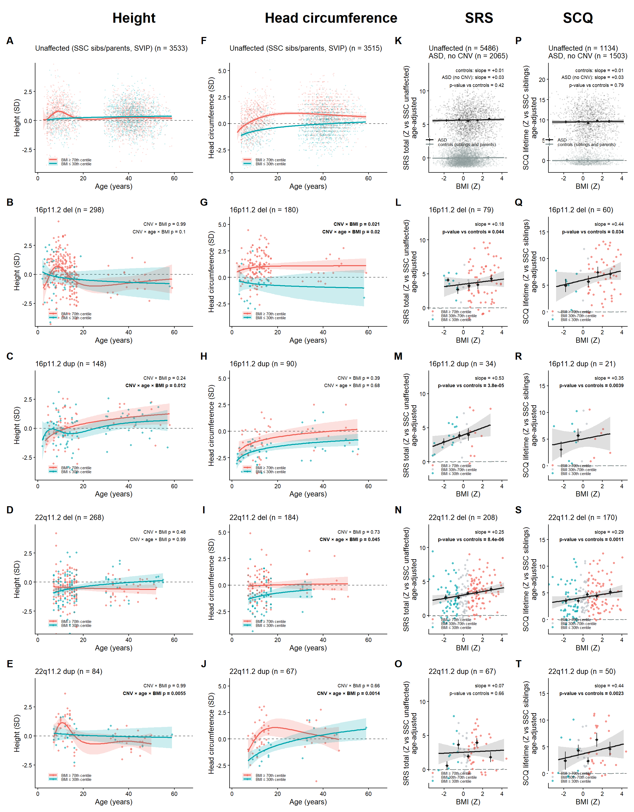

• Supplementary prospective figure (fig_supp_prospective; 11_supp_prospective.R): age-varying prospective effect of BMI on subsequent height and head-circumference growth in carriers < 18 y; Table S3 gives effects, SE, t and p.
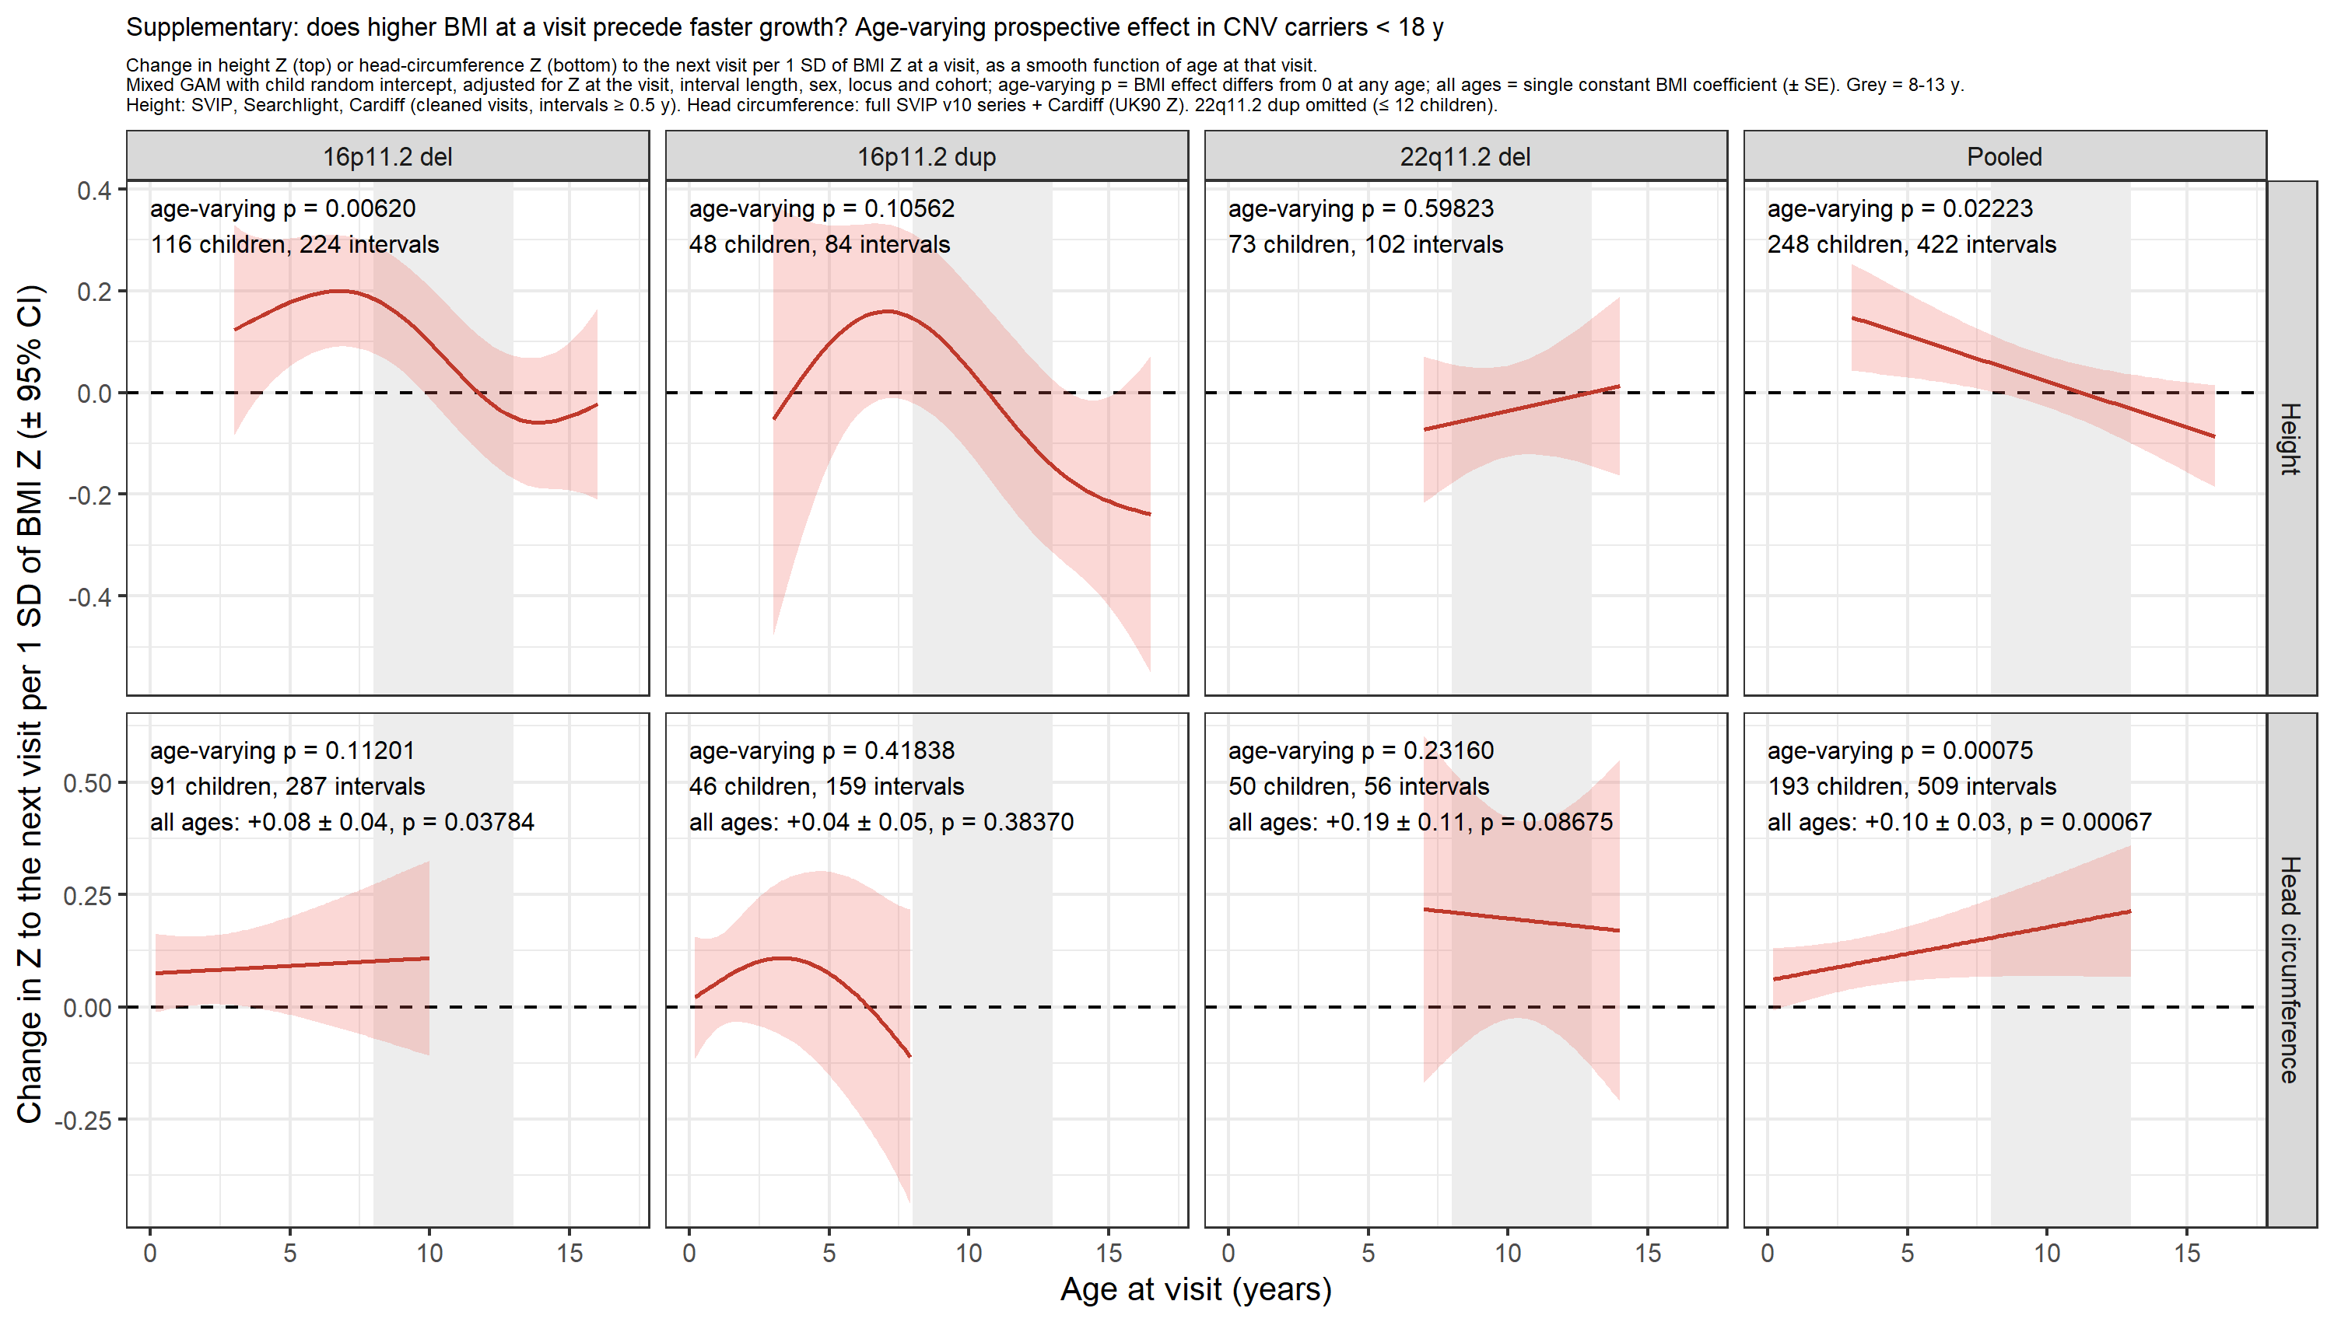

• Supplementary SRS/SCQ figure (fig_cognition_bmi_slopes; 24_cognition_bmi_slopes.R): SRS and SCQ versus BMI with unaffected relatives and SSC ASD probands, plus a forest plot of slopes by group (all carriers, non-ASD carriers, ASD-adjusted).
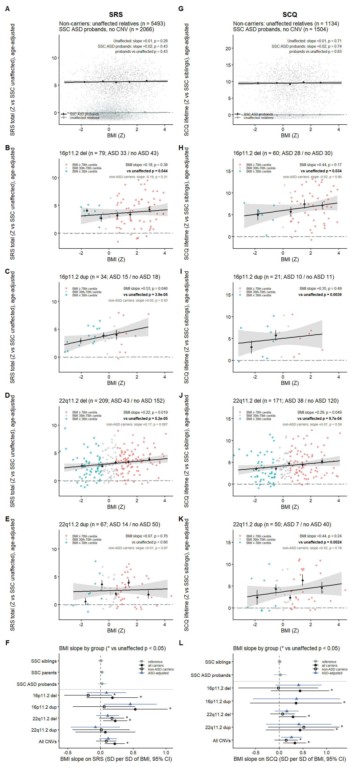

• Supplementary CNB figures (fig_supp_cnb_accuracy_total_bmi; fig_supp_cnb_accuracy_bmi; fig_supp_cnb_speed_bmi; 26_supp_cnb_bmi.R): accuracy total by CNV group with the heterogeneity test in the legend; all accuracy and speed subtests.
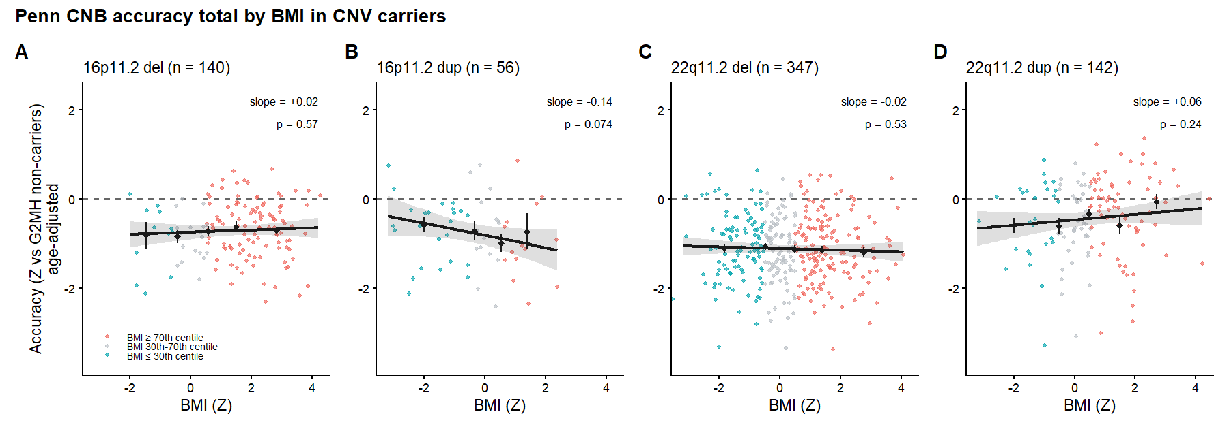

• Supplementary ASD-by-CNV figure (fig_supp_asd_by_cnv; 32_supp_asd_by_cnv.R): mean +/- SE height, head circumference and BMI Z in carriers with versus without an autism diagnosis for each CNV group, the pooled overgrowth and undergrowth groups and SSC probands versus siblings, with the age- and sex-adjusted ASD effect and p-value printed; the legend reports the PGS-adjusted sensitivity analysis.
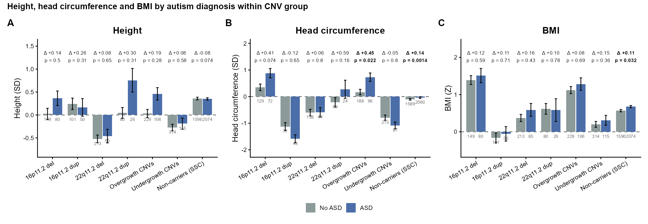

5. Supplementary tables
All tables are sheets of supp_tables_bmi_effects.xlsx (a 'notes' sheet defines every column); each is also a CSV, and supp_tables_bmi_effects.md holds them in text.
Table | Content | Source
S1 | Height and head circumference: within-group BMI slope and age x BMI; CNV x BMI and CNV x age x BMI versus unaffected controls and versus SSC ASD probands; per locus and pooled | 28_supp_tables.R; supp_table_S1_growth.csv
S2 | SRS, SCQ, CNB accuracy and speed: the same quantities (CNB within carriers only) | 28_supp_tables.R; supp_table_S2_cognition.csv
S3 | Prospective effects: age-varying p, all-ages coefficient with SE, t and p; age-window coefficients | 29_supp_table_S3_prospective.R; supp_table_S3_prospective.csv
S4 | Main-figure tests within strata of sex, childhood obesity PGS, adult BMI PGS, height PGS and autism PGS (carriers and controls stratified) | 30_sex_pgs_sensitivity.R; supp_table_S4_sex_pgs_strata.csv
S5 | BMI effects with sex and PGS as covariates (the confounding check), same individuals in every row | 30_sex_pgs_sensitivity.R; supp_table_S5_pgs_adjusted.csv
S6 | Power to detect modifier x BMI interactions (sex, each PGS), with the observed interactions | 30_sex_pgs_sensitivity.R; supp_table_S6_interaction_power.csv
S7 | Height, head circumference and BMI by autism diagnosis within each CNV group, pooled groups and SSC probands vs siblings: means, n, age- and sex-adjusted ASD effect, and the ASD x carrier interaction versus SSC non-carriers | 32_supp_asd_by_cnv.R; supp_table_S7_asd_by_cnv.csv
S8 | Table S7 contrasts and interactions on the subset with all four PGS, unadjusted and adjusted for each PGS and all four (same individuals) | 32_supp_asd_by_cnv.R; supp_table_S8_asd_by_cnv_pgs_adjusted.csv
Medication | Methods, results and table of the medication sensitivity analysis (height, head circumference, SRS, SCQ, CNB) | 27_medication_sensitivity.R, medication_table.R; medication_sensitivity_results.md, medication_sensitivity.csv, medication_prevalence.csv
QC | Flagged implausible records and the correction sheet | 00_qc_growth.R; implausible_height_weight.csv/.md, implausible_height_weight_corrections.csv

6. Sample sizes
Group | Height | Head circ. | SRS | SCQ | CNB acc. / speed | PGS subset: height / HC / SRS / SCQ
Unaffected controls | 5,708 | 5,680 | 5,486 | 1,134 | - | 5,010 / 4,985 / 4,988 / 1,030
SSC ASD probands | 2,074 | 2,060 | 2,065 | 1,503 | - | -
16p11.2 del | 358 | 211 | 79 | 60 | 140 / 142 | 118 / 98 / 74 / 56
16p11.2 dup | 199 | 125 | 34 | 21 | 56 / 56 | 61 / 55 / 30 / 19
22q11.2 del | 357 | 242 | 208 | 170 | 347 / 353 | 268 / 171 / 186 / 151
22q11.2 dup | 118 | 92 | 67 | 50 | 142 / 142 | 103 / 71 / 59 / 42

Counts are individuals with the outcome and BMI after QC (main figure) and, in the last column, G2MH carriers and SSC controls with all four PGS (Tables S5-S6).

7. Caveats and next round
• All numbers are provisional. The next round adds new subjects and the manually corrected records (implausible_height_weight_corrections.csv), then reruns the two chains.
• The CNV x age x BMI (three-way) terms are fragile; treat them as exploratory.
• The PGS analyses cover G2MH carriers only (about half the carriers of the main figure for height and head circumference) and SSC controls; SVIP, Searchlight and Cardiff carriers would need scoring on their own genotype sets.
• Scripts 17 (UK Biobank version), 18, 19, 20, 22 and 10_supplement, and script 21's own supplementary tables, predate the QC and SSC-age fixes.
• SSC parent ages in Molly's genomatrix, analysis_table.rds and the adult BMI reference still carry the snapshot ages in the genomatrix itself; the fix is applied in 01_build.R and 21_pheno_bmi_gam.R and should be propagated to the genomatrix build.
HANDOFF_2026-10-26.md (analysis folder and materials folder) lists the pipeline, run order, data caveats and next steps.

8. References (PubMed IDs)
Fischbach GD, Lord C. The Simons Simplex Collection: a resource for identification of autism genetic risk factors. Neuron 2010. PMID 20955926.
Simons VIP Consortium. Simons Variation in Individuals Project (Simons VIP): a genetics-first approach to studying autism spectrum and related neurodevelopmental disorders. Neuron 2012. PMID 22500628.
WHO Multicentre Growth Reference Study Group. WHO Child Growth Standards based on length/height, weight and age. Acta Paediatr Suppl 2006. PMID 16817681.
de Onis M, Onyango AW, Borghi E, Siyam A, Nishida C, Siekmann J. Development of a WHO growth reference for school-aged children and adolescents. Bull World Health Organ 2007. PMID 18026621.
Freeman JV, Cole TJ, Chinn S, Jones PR, White EM, Preece MA. Cross sectional stature and weight reference curves for the UK, 1990. Arch Dis Child 1995. PMID 7639543.
Cole TJ, Freeman JV, Preece MA. Body mass index reference curves for the UK, 1990. Arch Dis Child 1995. PMID 7639544.
Cole TJ, Freeman JV, Preece MA. British 1990 growth reference centiles for weight, height, body mass index and head circumference fitted by maximum penalized likelihood. Stat Med 1998. PMID 9496720.
Bodfish JW, Symons FJ, Parker DE, Lewis MH. Varieties of repetitive behavior in autism: comparisons to mental retardation. J Autism Dev Disord 2000. PMID 10832778.
Gur RC et al. A cognitive neuroscience-based computerized battery for efficient measurement of individual differences: standardization and initial construct validation. J Neurosci Methods 2010. PMID 19900482.
Moore TM, Reise SP, Gur RE, Hakonarson H, Gur RC. Psychometric properties of the Penn Computerized Neurocognitive Battery. Neuropsychology 2015. PMID 25180981.
Yengo L et al. Meta-analysis of genome-wide association studies for height and body mass index in ~700000 individuals of European ancestry. Hum Mol Genet 2018. PMID 30124842.
Bradfield JP et al. A trans-ancestral meta-analysis of genome-wide association studies reveals loci associated with childhood obesity. Hum Mol Genet 2019. PMID 31504550.
Vogelezang S et al. Novel loci for childhood body mass index and shared heritability with adult cardiometabolic traits. PLoS Genet 2020. PMID 33045005.
Yengo L et al. A saturated map of common genetic variants associated with human height. Nature 2022. PMID 36224396.
Grove J et al. Identification of common genetic risk variants for autism spectrum disorder. Nat Genet 2019. PMID 30804558. The April 2026 ASD GWAS used here is unpublished (summary statistics from J. Grove, iPSYCH).
Zheng Z et al. Leveraging functional genomic annotations and genome coverage to improve polygenic prediction of complex traits within and between ancestries. Nat Genet 2024. PMID 38689000.
Chang CC, Chow CC, Tellier LC, Vattikuti S, Purcell SM, Lee JJ. Second-generation PLINK: rising to the challenge of larger and richer datasets. GigaScience 2015. PMID 25722852.
Wood SN. Fast stable restricted maximum likelihood and marginal likelihood estimation of semiparametric generalized linear models. J R Stat Soc B 2011;73:3-36 (no PMID).
Sacks D, Sebat J et al. (2026). Combined effects of recurrent CNVs, polygenic scores, sex, age and medications on height and BMI; submitted (NatureSubmission_04_13_2026).
PMIDs 22500628, 9496720, 10832778, 19900482 and 25180981 were taken from standard citations and could not be re-verified online during this session; the others were checked against PubMed/PMC records on 2026-10-26.

