Corrected directional models of reciprocal CNV effects on height and BMI
Mirror alone versus continuous generalized dysfunction versus sparse single-hit asymmetry
Exact Sacks et al. reciprocal-CNV effects; burden comparison with Macé et al. and Auwerx et al.

Executive summary
Direction correction: height-biased asymmetry was constrained to move deletion and duplication effects toward the lower-left of the reciprocal-effect plot, whereas BMI-biased asymmetry was constrained to move both effects toward the upper-right.

For height, mirror alone explains the reciprocal trend among mirror loci but fails for the full locus set and predicts a beneficial duplication-burden effect. Both asymmetry models correct the burden direction. The sparse single-hit model is the most parsimonious overall because it has the best conditional AIC and leave-one-locus-out prediction and, uniquely, links the same approximately 2% gene frequency to the discrete asymmetric class, its approximately 30% prevalence, and its enrichment in larger, gene-rich CNVs.
For BMI, the mirror component explains the strong negative deletion-duplication relationship but predicts a more protective duplication effect than observed. Correctly oriented upper-right shifts improve the locus fit and move predicted duplication burden toward zero or obesity. The continuous model has the best conditional AIC and leave-one-locus-out prediction, while the scatter remains a single continuous cloud rather than two curves. BMI is therefore most parsimoniously described by an obesity-shifted mirror model with broadly distributed small upper-right effects, not a distinct sparse asymmetric class.

1. Data and corrected model structure
The single-locus analyses used 33 independent reciprocal height loci (21 mirror and 12 asymmetric) and 32 reciprocal BMI loci from the exact Sacks et al. supplementary statistics. The overlapping 22q11.2 A-D interval was excluded. Each locus contributed its deletion and duplication beta, standard errors, and annotated gene count.
The mirror component treated a CNV effect as the additive sum of latent gene effects. Kosmicki informed the height sign prior (70% of deletion/LoF effects decrease height); Akbari informed the BMI sign prior (posterior mean 78.6% of pLoF effects increase BMI). The ordinary contributor frequency, mean absolute gene effect, and duplication-to-deletion magnitude ratio were estimated from Sacks CNVs rather than imported from the large, ascertainment-selected WES effects.
After calibrating the mirror component, three models were compared on the complete locus set: mirror alone; mirror plus continuous asymmetry, in which many small directional effects add with CNV gene count; and mirror plus a sparse single hit, in which the presence of at least one rare gene creates a fixed directional displacement. In the corrected bivariate parameterization, all asymmetry shifts were restricted to the lower-left for height and the upper-right for BMI. The shift angle was estimated within that quadrant, so both deletion and duplication components remained correctly signed.
Model comparisons below are conditional on the calibrated mirror component. AIC/BIC evaluate fit to the Sacks single-locus data; conditional leave-one-locus-out values test predictive stability. Burden analyses are presented separately: each fitted gene-level model was propagated to expected deletion and duplication burden, calibrated to the Macé deletion coefficient, and checked against the genome-wide direction reported by Auwerx.

2. Height: fit to Sacks et al. single-locus results
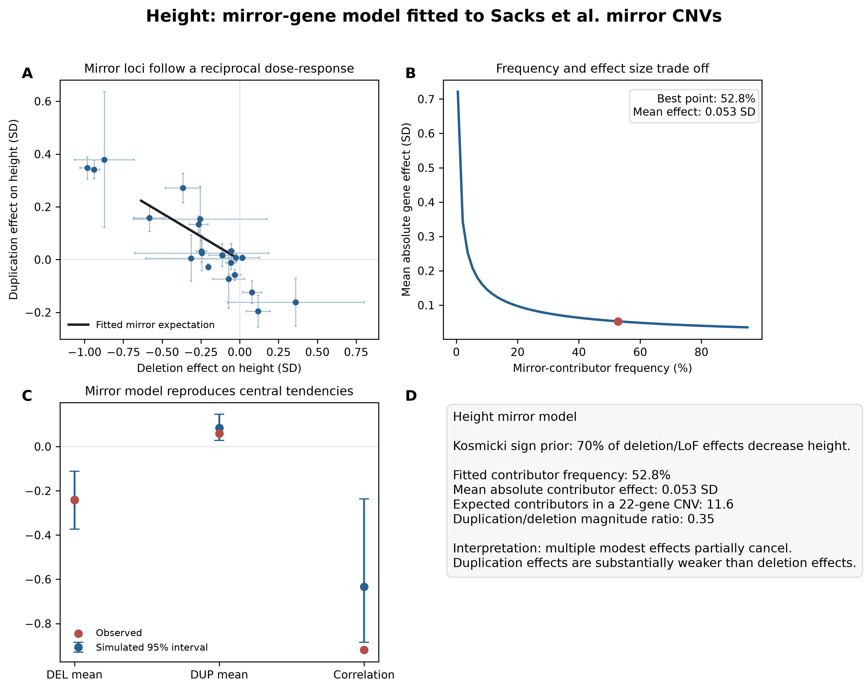
Figure 1. Height mirror model. The observed mirror loci follow a negative reciprocal relationship; the model infers multiple modest contributors and weaker duplication effects.
The fitted height mirror model estimated a contributor frequency of 52.8% and a mean absolute effect of 0.053 SD, corresponding to approximately 11.6 contributors in a 22-gene CNV. The duplication-to-deletion magnitude ratio was 0.35. The exact percentage and per-gene magnitude lie on a broad frequency-effect ridge, but the robust inference is that mirror CNVs aggregate multiple modest effects and that duplication effects are substantially weaker than deletion effects.
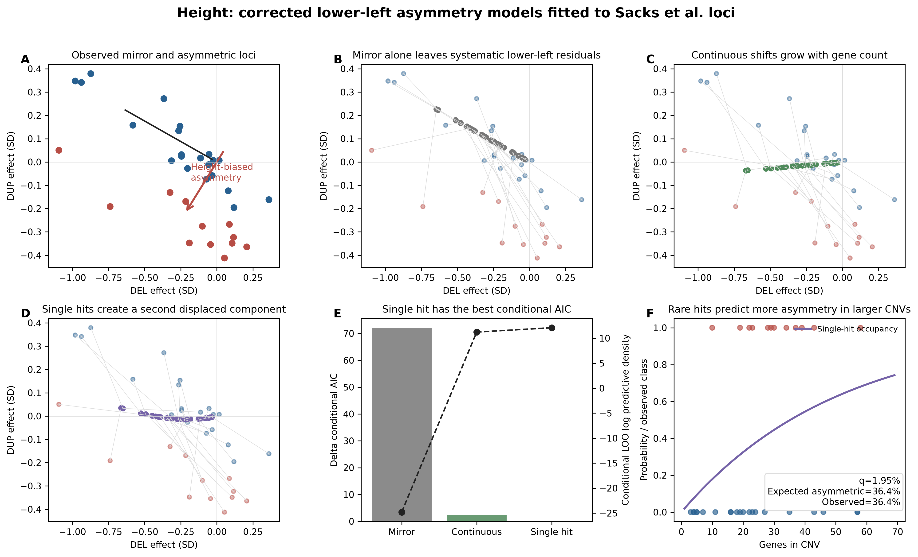
Figure 2. Height single-locus comparison. All asymmetry shifts are lower-left. The single-hit model creates a second displaced component and predicts increasing occupancy in larger CNVs.
model | q | shift_magnitude | shift_DEL | shift_DUP | conditional_AIC | conditional_BIC | conditional_LOO_log_predictive_density | delta_conditional_AIC | delta_conditional_LOO
Mirror alone | 0.000 | 0.000 | 0.000 | 0.000 | 49.609 | 49.609 | -24.804 | 71.964 | 36.900
Mirror + continuous directional shift | 0.082 | 0.056 | 0.005 | 0.056 | -19.913 | -15.424 | 11.224 | 2.442 | 0.871
Mirror + sparse single hit | 0.019 | 0.283 | 0.025 | 0.282 | -22.356 | -17.866 | 12.095 | 0.000 | 0.000

The continuous model estimated q=8.2% and a mean lower-left vector magnitude of 0.056 SD. The sparse model estimated q=1.95% and a much larger vector magnitude of 0.283 SD. The fitted direction was predominantly downward in both models but retained the correct negative deletion component. The single-hit model improved conditional AIC by 2.44 units relative to the continuous model and had a 0.87-unit advantage in conditional leave-one-locus-out prediction.

Specific evidence favoring continuous or single-hit height asymmetry
Evidence compatible with a continuous mechanism: a continuous additive model fits the reciprocal-effect cloud much better than mirror alone, and its small effects can produce negative deletion and duplication burden. Thus, cumulative generalized dysfunction remains biologically and statistically plausible.
Evidence favoring a single hit: the sparse model gives the best conditional information criteria and predictive score; q=1.95% predicts an asymmetric-locus prevalence of 36.4%, close to the observed 36.4%; and the same occupancy mechanism explains why asymmetric CNVs contain more genes and span larger intervals. Within mirror and asymmetric classes, however, the lower-left shift score does not increase with gene count or length, arguing against a simple within-class accumulation gradient.
variable | asymmetric_mean | mirror_mean | asymmetric_median | mirror_median | Welch_p | Mann_Whitney_p
CNV_length_Mb | 1.0626 | 0.6495 | 1.1834 | 0.4494 | 0.0062 | 0.0074
Gene_count | 31.0000 | 22.0000 | 29.5000 | 19.0000 | 0.0191 | 0.0493

subset | variable | Spearman_rho | p_value
all | CNV_length_Mb | 0.1534 | 0.3940
all | Gene_count | 0.1299 | 0.4711
mirror | CNV_length_Mb | -0.0494 | 0.8317
mirror | Gene_count | 0.0546 | 0.8141
asymmetric | CNV_length_Mb | 0.1748 | 0.5868
asymmetric | Gene_count | -0.1049 | 0.7456

3. Height: propagation to Macé/Auwerx burden results
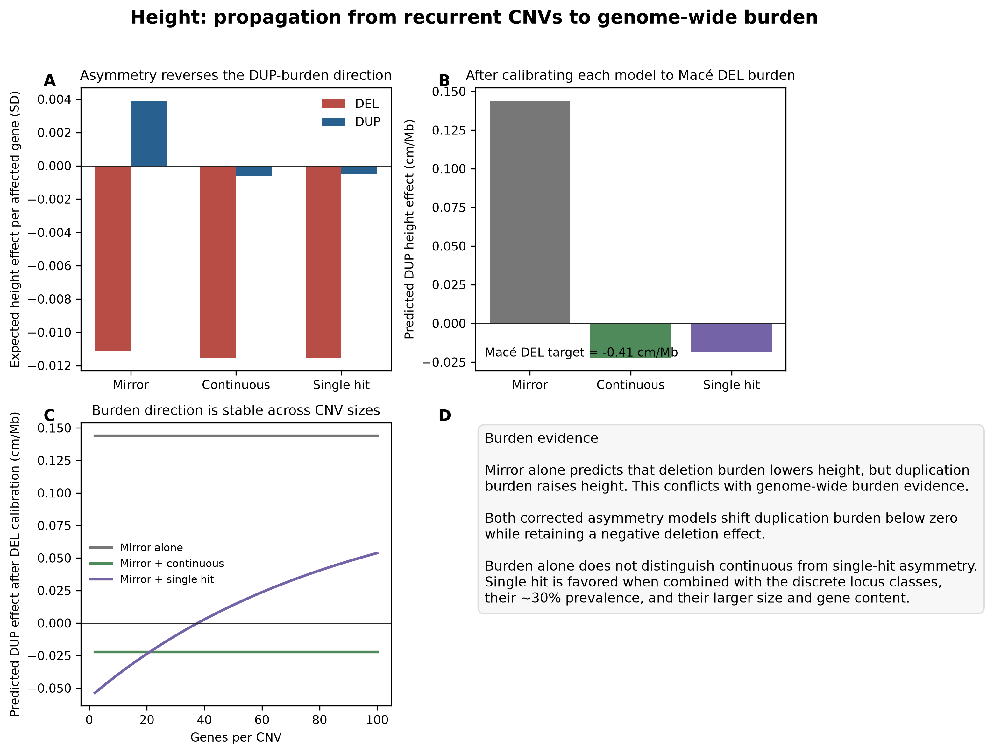
Figure 3. Height burden predictions. Mirror alone predicts positive duplication burden; both lower-left asymmetry models reverse it.
model | DEL_effect_per_affected_gene_SD | DUP_effect_per_affected_gene_SD | DEL_effect_per_affected_gene_native | DUP_effect_per_affected_gene_native | Mace_DEL_target_per_Mb | Mace_units | effective_dosage_genes_per_Mb_to_match_DEL | predicted_DUP_effect_per_Mb_at_matched_density
Mirror alone | -0.0111 | 0.0039 | -0.0890 | 0.0313 | -0.4100 | cm/Mb | 4.6065 | 0.1440
Mirror + continuous | -0.0115 | -0.0006 | -0.0922 | -0.0050 | -0.4100 | cm/Mb | 4.4480 | -0.0223
Mirror + single hit | -0.0115 | -0.0005 | -0.0921 | -0.0041 | -0.4100 | cm/Mb | 4.4518 | -0.0182

The burden analysis is separate from the Sacks single-locus fit. Each model was calibrated to the Macé deletion coefficient of -0.41 cm per deleted Mb by allowing an effective density of dosage-responsive genes per Mb. At that same density, mirror alone predicts that duplication burden increases height, whereas both lower-left asymmetry models predict a negative duplication effect. This directional correction is consistent with the adverse genome-wide CNV-burden pattern reported by Auwerx. Burden therefore rejects mirror alone but does not by itself distinguish continuous from single-hit asymmetry.
Height conclusion: considering burden and single-locus data together, the sparse single-hit model is most parsimonious. Both asymmetry models solve the burden-direction problem, but only the sparse model also naturally accounts for the distinct asymmetric group, its prevalence, and its preferential occurrence in larger and gene-rich CNVs.

4. BMI: fit to Sacks et al. single-locus results
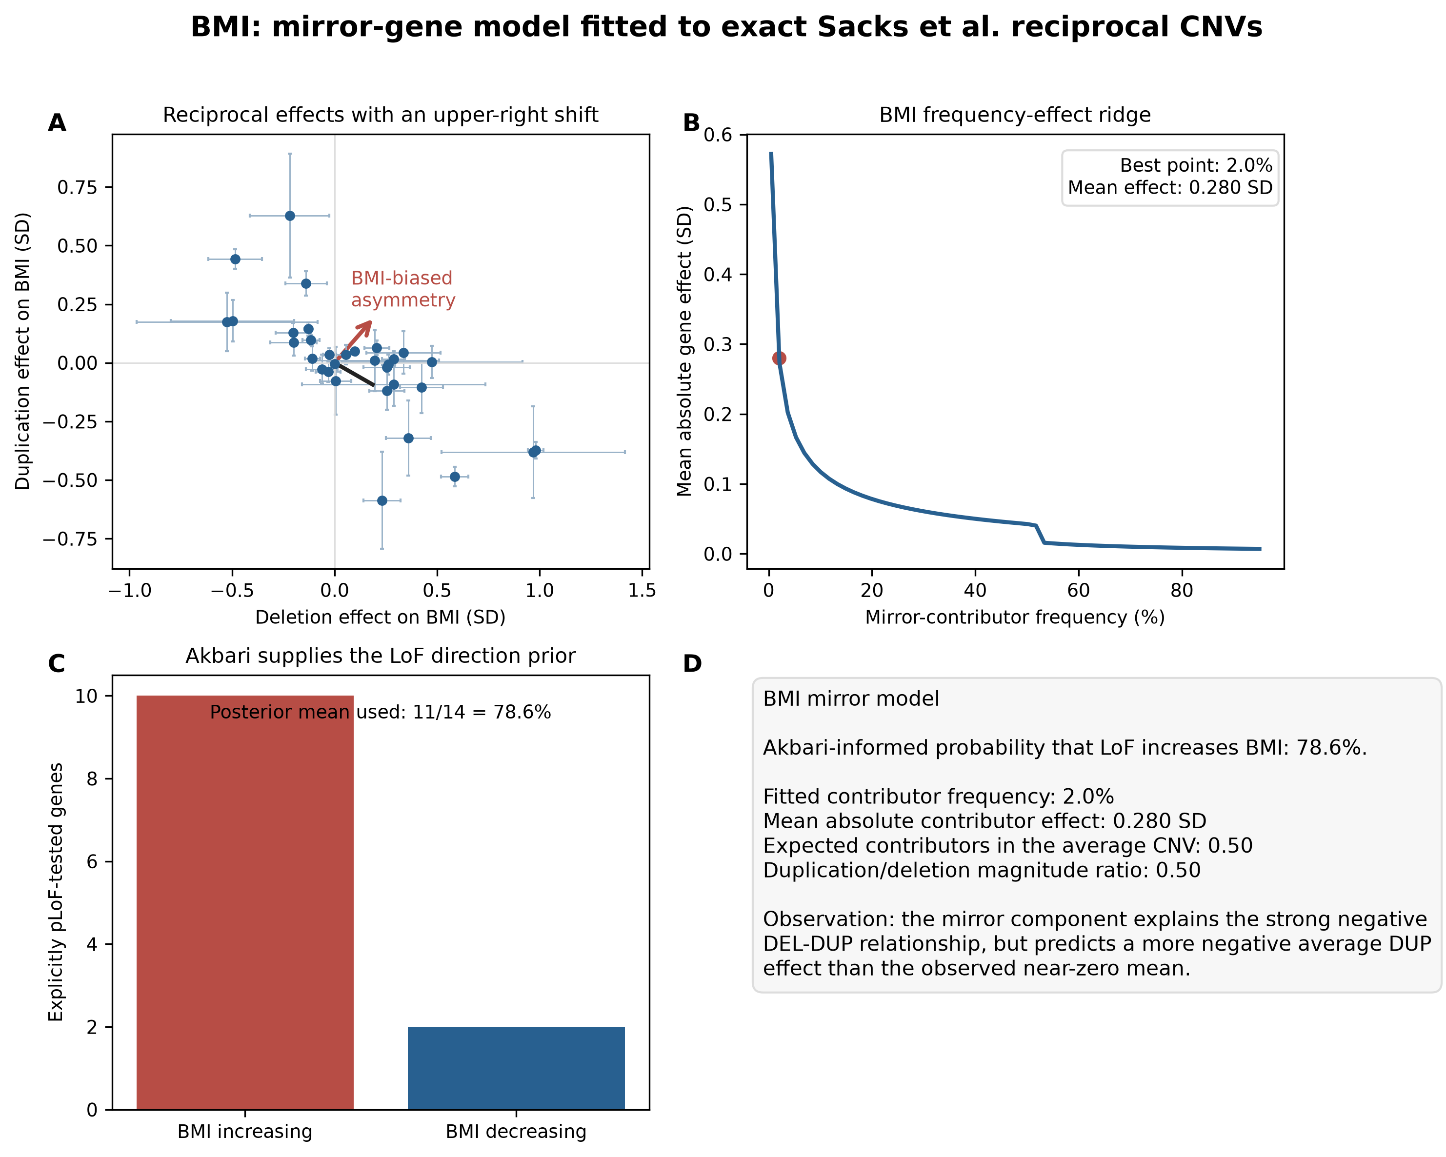
Figure 4. BMI mirror model. The mirror component captures the negative reciprocal trend but leaves an upper-right displacement.
The BMI mirror model estimated a contributor frequency of 2.0%, a mean absolute contributor effect of 0.280 SD, and 0.50 contributors in the average CNV. Duplication effects were 0.50 times the deletion magnitude. The low-frequency/large-effect point estimate is weakly identified and should be interpreted as an effective architecture rather than a literal count. The important observation is that the mirror component explains the strong negative correlation but predicts a more negative average duplication effect than observed.
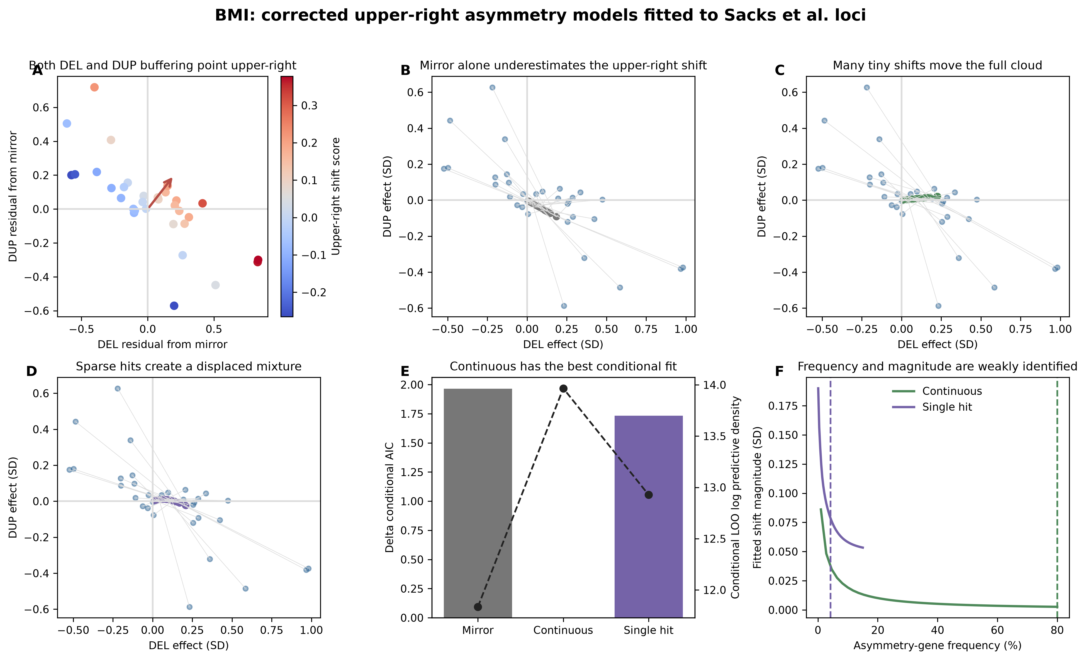
Figure 5. BMI single-locus comparison. Corrected asymmetry moves both deletion and duplication residuals upper-right; continuous and single-hit models are compared on equal directional footing.
model | q | shift_magnitude | shift_DEL | shift_DUP | conditional_AIC | conditional_BIC | conditional_LOO_log_predictive_density | delta_conditional_AIC | delta_conditional_LOO
Mirror alone | 0.000 | 0.000 | 0.000 | 0.000 | -23.670 | -23.670 | 11.835 | 1.964 | 2.130
Mirror + continuous directional shift | 0.800 | 0.003 | 0.001 | 0.002 | -25.634 | -21.237 | 13.965 | 0.000 | 0.000
Mirror + sparse single hit | 0.043 | 0.078 | 0.025 | 0.074 | -23.901 | -19.504 | 12.927 | 1.733 | 1.038

The corrected continuous model estimated a very diffuse process: q reached 80% under the broad 0-80% parameterization, but each upper-right shift was only 0.0026 SD. The more stable quantities are the per-gene shifts, 0.0007 SD for deletion and 0.0020 SD for duplication. The single-hit model estimated q=4.26% and a shift magnitude of 0.078 SD. Continuous asymmetry had the best conditional AIC and exceeded the single-hit conditional leave-one-locus-out score by 1.04 log units.

Specific evidence favoring continuous or single-hit BMI asymmetry
Evidence favoring a continuous mechanism: the loci form one continuous reciprocal cloud rather than two separated curves; residuals from the mirror expectation occur on both the deletion and duplication axes but share an upper-right trait direction; and the continuous model has the best conditional AIC and leave-one-locus-out prediction. The fitted frequency-effect ridge also shows that the data identify a small distributed upper-right load more clearly than a particular event frequency.
Evidence compatible with single hits: a sparse upper-right mixture also improves upon mirror alone and can reproduce individual loci with a near-null deletion or duplication effect. However, there is no independent BMI class label, size enrichment, or occupancy result analogous to height, and the single-hit model does not improve predictive fit over the continuous model.

5. BMI: propagation to Macé/Auwerx burden results
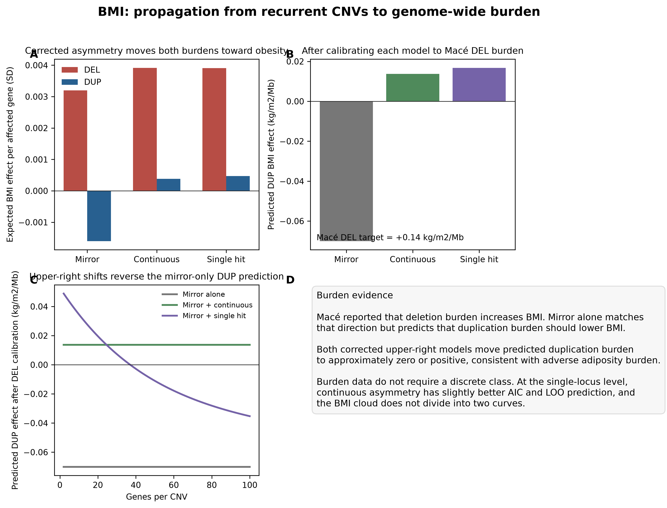
Figure 6. BMI burden predictions. Mirror alone predicts protective duplication burden; both corrected upper-right models move duplication burden to near-zero or positive.
model | DEL_effect_per_affected_gene_SD | DUP_effect_per_affected_gene_SD | DEL_effect_per_affected_gene_native | DUP_effect_per_affected_gene_native | Mace_DEL_target_per_Mb | Mace_units | effective_dosage_genes_per_Mb_to_match_DEL | predicted_DUP_effect_per_Mb_at_matched_density
Mirror alone | 0.0032 | -0.0016 | 0.0150 | -0.0075 | 0.1400 | kg/m2/Mb | 9.3125 | -0.0701
Mirror + continuous | 0.0039 | 0.0004 | 0.0184 | 0.0018 | 0.1400 | kg/m2/Mb | 7.6057 | 0.0137
Mirror + single hit | 0.0039 | 0.0005 | 0.0184 | 0.0022 | 0.1400 | kg/m2/Mb | 7.6241 | 0.0168

The Macé burden result is again analyzed separately from the Sacks locus fit. Macé reported +0.14 kg/m2 of BMI per deleted Mb. Calibrating each model to this deletion coefficient, mirror alone predicts a negative duplication-burden effect. Both corrected upper-right models reverse that prediction to approximately zero or positive, which is directionally consistent with the increased-adiposity burden signal reported by Auwerx. Because both asymmetry models make this correction, the burden result does not favor a sparse BMI class.
BMI conclusion: a shifted mirror model with broadly distributed small upper-right effects is most parsimonious. Sparse hits remain possible for particular loci, but the data do not require a separate asymmetric class and do not identify a stable single-hit frequency.

6. Overall synthesis
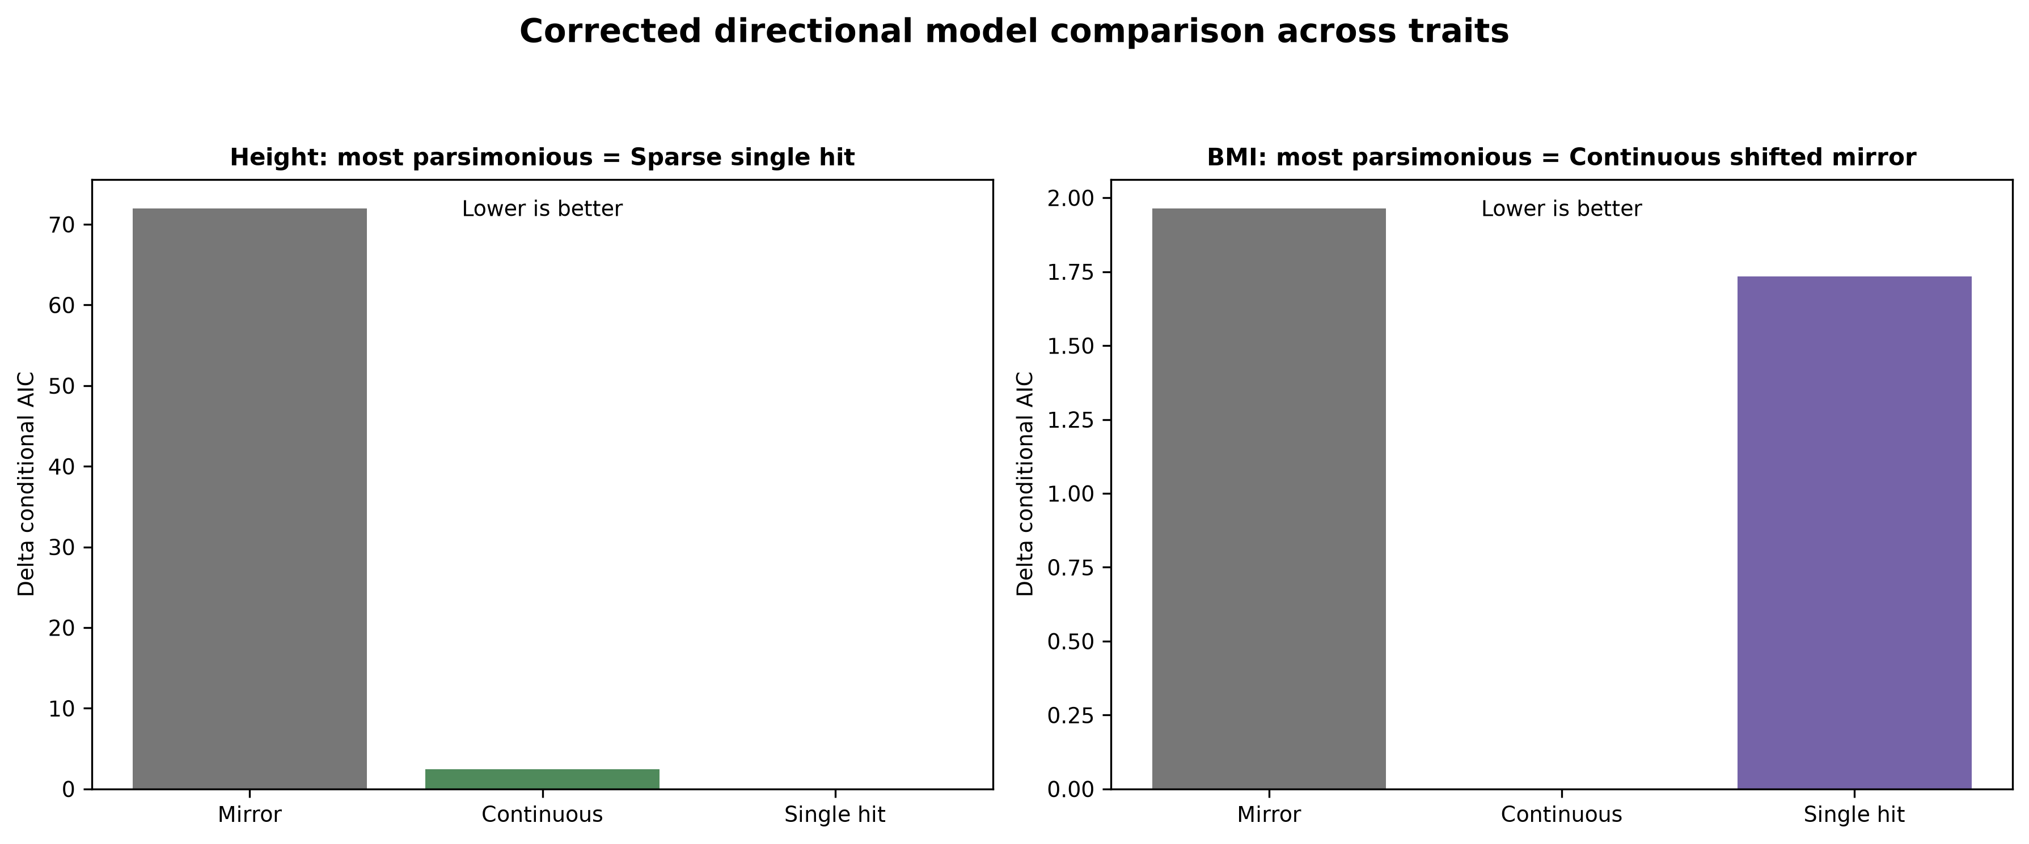
Figure 7. Corrected model comparison. Height favors sparse single-hit asymmetry when all evidence is combined; BMI favors continuous upper-right asymmetry.
Mirror effects are a major component of both traits: deletion and duplication effects are negatively correlated, and duplication effects are weaker than deletion effects. Directional asymmetry is nevertheless required to reconcile recurrent loci with genome-wide burden. The direction differs by trait: lower-left for height and upper-right for BMI.
For height, continuous and sparse mechanisms both fit the lower-left displacement and both produce negative deletion and duplication burden. The decisive evidence is cross-scale: the sparse model also explains the discrete 30% asymmetric group and its size/gene-count enrichment without a within-class gradient. It is therefore the most parsimonious height model.
For BMI, both corrected mechanisms account for DEL- and DUP-side buffering and improve the burden prediction. The absence of two curves, the slightly better conditional AIC and leave-one-locus-out performance of the continuous model, and the non-identifiability of a sparse event frequency favor a continuous obesity-shifted mirror model.

7. Limitations
The mirror contributor frequency and per-gene magnitude are partially confounded. The asymmetry frequency and shift magnitude are likewise weakly identified, especially for BMI. The burden translation uses an effective dosage-responsive gene density rather than a directly observed genome-wide gene count, and the BMI native-unit conversion assumes 1 BMI SD = 4.7 kg/m2. Macé provides a quantitative deletion-burden coefficient but not an equally precise duplication coefficient; Auwerx is therefore used mainly as a directional burden check. These limitations affect exact parameter values more than the qualitative comparison of model directions.

References
Sacks et al. Combinatorial effects of gene dosage, polygenic background and environment on complex traits. medRxiv (2026), doi:10.64898/2026.04.30.26352063.
Kosmicki et al. Rare protein-coding variation and the genetic architecture of height in >1.4 million individuals. medRxiv (2026), doi:10.64898/2026.06.22.26355163.
Akbari P et al. Sequencing of 640,000 exomes identifies GPR75 variants associated with protection from obesity. Science 373:eabf8683 (2021), doi:10.1126/science.abf8683.
Backman JD et al. Exome sequencing and analysis of 454,787 UK Biobank participants. Nature 599:628-634 (2021), doi:10.1038/s41586-021-04103-z.
Macé A et al. CNV-association meta-analysis in 191,161 European adults reveals new loci associated with anthropometric traits. Nature Communications 8:744 (2017), doi:10.1038/s41467-017-00556-x.
Auwerx C et al. The individual and global impact of copy-number variants on complex human traits. American Journal of Human Genetics 109:647-668 (2022), doi:10.1016/j.ajhg.2022.02.010.

