**MATLAB Fitting:**

**There is a utility in MATLAB called “fminsearch” which is documented in the usual several places by MATLAB. A user defined function is to be fit to, as defined by a set of parameters to be found giving the best χ2. Starting values for those parameters are required input since the fminsearch fitter treats non-linear problems in all generality.**

**A series of functions called “fit_package” is used to find the best fit. As examples, a Gaussian and an exponential are implemented, but any function can be defined as desired. The “data” is defined to be a set of individual events which can be histogrammed and the histogram fit to, or a set of data points in (x,y) with errors can be input. The histogram errors are assumed to be the square root of the number of events in the bin.**

**A driver called “test_fit_pak” uses Monte Carlo techniques, already defined, using “Gaus” and “expMC” which are used to check the fitting package and to give some non-linear fitting experience.**

**Results for a Gaussian, with10,000 generated events, mean = 4, σ = 2, are shown below. Only diagonal elements, variances, of the covariance matrix are printed, but the full matrix is computed.**

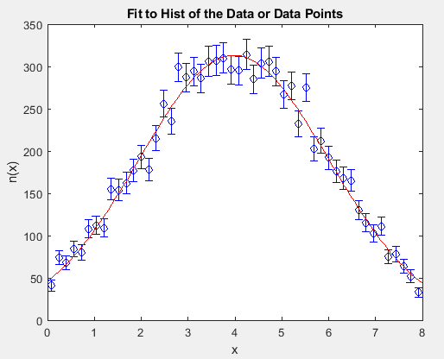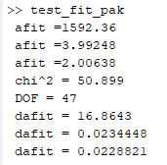

**There are also some MATLAB polynomial fits available for any plot generated. They can be invoking Tools -> Basic Fitting and Data Statistics in the Figure menu. In the example a fourth order polynomial gives an OK fit. However, the polynomial only optimizes w.r.t. the points and the points are not assumed to be weighted by errors. Nevertheless the polynomial fits can be a useful starting point.**

