* 1. **MC Analytic**

**The Monte Carlo technique is widely used in making models of complex systems. In the simplest view it consists in choosing variables from specified distributions, assembling a system from these choices and then studying the resulting performance of the system. In a few cases, the choice of a variable with a specific form of the distribution can be done analytically. Some of these cases are shown in the script “MC_Analytic” which uses the MATLAB random number generator “rand”.**

**One solvable problem is the power law distribution of a variable x, where α is the desired power. The range of the variables is xmin to xmax and r is a random variable giving values from zero to one.**



1.2

**A second example is an exponential distribution with a lifetime τ.**



1.3

**The Brite-Wigner resonance line shape can also be solved analytically and is shown in Eq. 1.4.. The central value is xo and the width, full width at half maximum is Γ. A Gaussian distribution can be achieved by using two random numbers and the fact that the joint probability of two uncorrelated variables is the product of the probabilities. In Eq. 1.5 the standard deviation of the Gaussian is σ as illustrated in Eq. 1.5. The joint probability can have a “radius” chosen from an exponential and an azimuthal angle chosen randomly from zero to 2π. The means of the Gaussian can simply be added to the resulting x and y values.**



1.4



1.5

**The script, “MC_Analytic” gives the user a choice of these distributions and the parameters which specify the distributions, such as the desired power. An example printout for a resonance shape appears in Fig. 1.4 and the output is a histogram of the distribution, displayed in Fig. 1.5.**

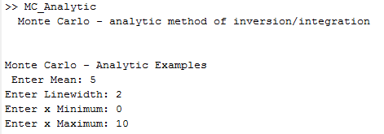

**Figure 1.4: Example of the dialogue for the choice of a resonance distribution.**

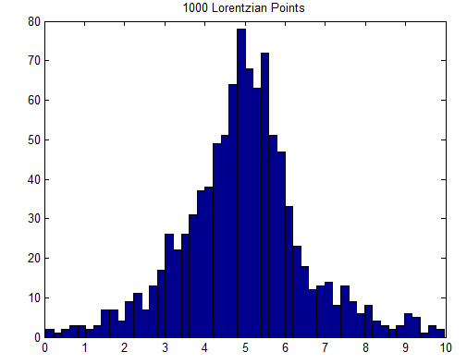

**Figure 1.5: Example of the output plot for the choice of a resonance distribution with 1000 generated entries.**

* 1. **MC Numeric**

**In the vast majority of cases the integral which is needed in the analytic case either cannot be done analytically or the result cannot be inverted. In such cases a variety of numeric techniques are available. The simplest is to choose two random numbers. The first, r1, uniformly populates the x range desired, while the second, r2, weights the chosen x by the probability distribution P(x). The user is encouraged to make a graph of the procedure which will show why it works. It is here assumed that P(x) has a maximum in the x range being used.**



1.6

**An example from the script “MC_Numeric” appears in Fig. 1.6. In this case the angular distribution for Compton scattering with a user defined photon energy is produced. The user can vary the energy and see how the distribution varies, as desired.**

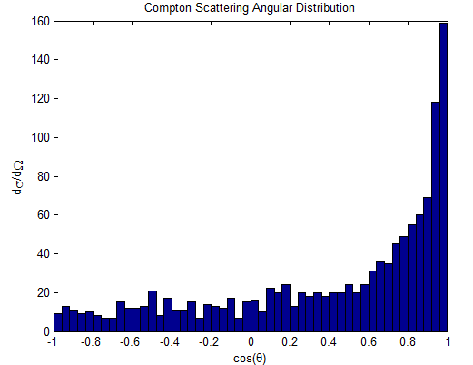

**Figure 1.6: Angular distribution in Compton scattering for a sepecific, user defined, photon energy.**