Blaming Data Centers for Iowa's Nitrate Crisis Lets the Real Polluters Off the Hook
Twelve Iowa counties have weighed data center pauses over water fears. Our 20-year analysis of 70 tech sites and 48 water utilities shows data centers aren't driving nitrate spikes—and scapegoating them stalls action on farm runoff.
By [Author Name / Affiliation Placeholder]
Editor's Note: This essay is adapted from the authors' new statewide empirical study, available as a public preprint at [PREPRINT CITATION FILLER: Insert Preprint Repository Name, Title, and DOI/URL Here, e.g., https://doi.org/10.xxxx/xxxxx]
When Central Iowa Water Works ordered an emergency lawn-watering ban for more than 600,000 central Iowans in June 2025, frustration boiled over fast. Nitrate levels in the Raccoon River had surged to 20.55 milligrams per liter—more than double the federal safe drinking water limit of 10 mg/L—forcing the Fleur Drive plant to run its nitrate removal system for a record 193 days. Within hours of the utility's alerts, local Reddit threads and town hall speakers settled on a convenient villain: Iowa's booming hyperscale data centers.
Today, that suspicion is reshaping local policy across the state. At least 12 Iowa counties—including Linn, Dubuque, and Adair—along with cities like Peosta, have passed or debated moratoriums on new data center construction. While neighbors have fair questions about electric grid strain and tax abatements, water quality has become a central rallying cry. If tech giants like Meta, Microsoft, Google, and Apple are polluting our tap water with nitrates, hitting pause makes total sense.
There is just one problem: the data says they aren't. And by blaming server farms for dirty water, Iowans are taking their eyes off the agricultural runoff that actually threatens our taps. To test whether data centers affect drinking water nitrate, we compiled 20 years of records (2005–2026) from 48 community public water supplies across Iowa and mapped them against all 70 operational, under-construction, and planned data centers statewide. In our working paper ([PREPRINT CITATION FILLER: Author(s), 2026, Preprint URL/DOI]), we tracked nitrate readings before and after facilities broke ground, and before and after they activated cooling systems, comparing communities near data centers to similar utilities without them.
The result was a flat zero. During the construction phase—when bulldozers strip topsoil and grade former farm fields—nearby water utilities saw a statistically meaningless shift of +0.001 mg/L of nitrate. Once data centers went live and began drawing water for cooling, nitrate levels in nearby utilities shifted by -0.012 mg/L—essentially unchanged, and trending slightly downward. Even under statistical equivalence tests designed to rule out small harms, the effect of data centers on tap water nitrate was indistinguishable from zero.
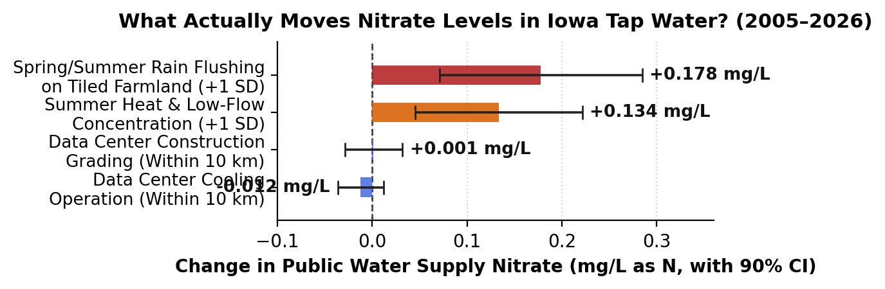
Figure 1: Estimated change in public water supply nitrate (mg/L as N) from data center construction and cooling operations within 10 km, compared to agricultural rainfall flushing and summer heat concentration across 48 Iowa utilities (2005–2026). Source: Authors' calculations [PREPRINT CITATION FILLER].
Why Hot Summers Created a Case of Mistaken Identity
Why did so many Iowans link data centers to nitrate warnings in the first place? It comes down to two things happening at once during hot summer weather. Data centers use the most water for evaporative cooling on sticky afternoons when temperatures top 80 degrees—the exact same window when homeowners turn on lawn sprinklers, driving residential outdoor watering to 40 percent or more of municipal demand. Meanwhile, when river nitrate climbs above 10 mg/L, ion-exchange treatment plants in Des Moines and West Des Moines lose 25 percent or more of their daily pumping capacity because water must move more slowly through removal vessels.
When utilities begged residents to stop watering lawns in June 2025 and June 2026 so treatment plants could keep up, many people assumed data centers were draining the system and causing the nitrate spike. Yet utility billing records show the opposite. Microsoft's six West Des Moines campuses accounted for just 2.4 percent of West Des Moines Water Works' annual water volume and 0.9 percent of Central Iowa Water Works' total water during the July 2025 ban. In Waukee, Apple's data center uses less than 1 percent of the city's water. More importantly, cooling towers do not create nitrogen: they evaporate steam and discharge mineral-heavy water to wastewater plants downstream of drinking water intakes, never adding fertilizer to upstream rivers.
How Paving Cornfields Reduces Nitrogen—and Where Policy Should Focus
Ironically, building a data center on the edge of Altoona, Waukee, or Cedar Rapids actually removes nitrogen from the local watershed. Most large campuses in Iowa are built on 200 to 1,000 acres of former corn and soybean ground. Typical Iowa cropland receives 150 to 200 pounds of commercial nitrogen fertilizer or manure per acre every year, much of which drains through underground farm tiles straight into creeks. Turning a 500-acre cornfield into a server campus and unirrigated prairie grass permanently retires up to 100,000 pounds of annual fertilizer application.
What actually drives the nitrate surges that overwhelmed Central Iowa Water Works? As Figure 1 shows, the real culprit is weather interacting with farm drainage: spring and summer rainstorms flushing nitrogen out of tiled fields (+0.178 mg/L per standard deviation), compounded by summer heat concentrating low river flows (+0.134 mg/L). More than 95 percent of the nitrate in the Des Moines, Raccoon, and Cedar rivers comes from upstream agricultural runoff.
County supervisors and residents have every right to demand smart guardrails on data centers. Communities should require closed-loop cooling or recycled wastewater agreements—and back localized water budgets like the study partnership Linn County signed with Google—while scrutinizing electric rate structures and tax subsidies (Business Record). But pretending that a county moratorium on data centers will keep nitrates out of our drinking water is a costly distraction. Every hearing spent arguing that tech companies are poisoning the Raccoon River is a hearing where state lawmakers avoid talking about agricultural tile drainage, wetland buffers, and fertilizer limits. If Iowans want clean tap water without summer rationing, we need to stop scapegoating server farms and start addressing what washes off our fields.

