Data center development and nitrate in Iowa public water supplies
A forensic audit of a synthetic-data study and a design-based reanalysis of observed compliance data
Working paper draft · November 11, 2026 · Prepared with Claude (Anthropic) for the datacenter-nitrate-iowa replication project (folder 3-claude). All empirical statements are generated from the accompanying code; authors should verify before circulation.

Abstract
Background. A working paper produced by an autonomous AI workflow reported that data center construction and operation had essentially zero effect on nitrate in Iowa public water supplies (PWS) during 2005–2026, with equivalence "confirmed" within ±0.04 mg/L. A second AI-generated package showed that the paper's outcomes were generated rather than observed, but estimated no effect.
Methods. We re-executed the original code in isolation, tested its claimed ingestion of external data, and recovered the treatment effect its simulator planted. We then built an observed-data study from EPA Six-Year Review 4 compliance monitoring for Iowa (2012–2019; 16,603 routine entry-point samples from 845 community systems), documented construction dates and locations of hyperscale campuses from primary and trade sources, and estimated stacked imputation difference-in-differences effects of three new-campus construction starts (Meta Altoona 2013, Microsoft Alluvion 2014, Microsoft Osmium 2018) on the host utility and on monitored municipal systems within 5–20 km, relative to 317 systems more than 30 km from any campus. Inference re-sited each campus at random (Fisher randomization) with confidence sets from test inversion. We added a negative-control exposure and physical mass-balance bounds for river intakes.
Results. Every original nitrate and weather value comes from a seeded random generator, and external data placed where the code claims to read them never change the output. The headline estimate (β = 0.0013, SE 0.0178) reproduces exactly and tracks the simulator's planted term. Run on observed outcomes, the original specification fails its own ±0.25 mg/L equivalence test (β = −0.16, SE 0.19). In the redesigned analysis the host-utility effect was −0.14 mg/L (randomization p = 0.55; 95% confidence set −0.98 to 0.76) and the within-10-km effect was −0.14 (−1.04 to 0.74); minimum detectable effects were about 1.1–1.2 mg/L. A positive 15-km estimate (0.69, p = 0.095) was driven by Des Moines Water Works, which cannot plausibly receive nitrate from the Meta site; treated as a negative control, that utility showed a spurious "effect" of 2.6 mg/L. Conventional cluster-robust tests rejected true placebo nulls in 23%–45% of assignments. Mass balance bounds the river-intake effect of all documented central-Iowa campus land (0.05% of the Raccoon River basin) at ≤0.07 mg/L at mean flow, even with a nitrogen export ceiling about ten times the agricultural yield.
Conclusions. Observed data show no detectable increase in PWS nitrate after data center construction and rule out host-utility effects larger than about 1 mg/L (10% of the 10 mg/L standard) at 90% confidence, which is far wider than the ±0.04 mg/L previously claimed. Physical bounds indicate that land conversion cannot materially change nitrate at large river intakes. The plausible link between data centers and events such as the 2025 Central Iowa watering ban runs through water demand and nitrate-treatment capacity rather than source-water nitrate. Pre-2012 baselines and post-2019 monitoring are needed to address the 2025–2026 period directly.
Keywords: data centers; drinking water; nitrate; Iowa; difference-in-differences; randomization inference; negative controls; research integrity; AI-generated research

1. Introduction
On June 12, 2025, Central Iowa Water Works (CIWW) imposed the first lawn-watering ban in its history after nitrate in the Des Moines and Raccoon rivers (15.6 and 15.3 mg/L as N on June 16, the highest since 2013) pushed its treatment plants to capacity [1]. Because the ban coincided with rapid hyperscale data center growth in the Des Moines metro, residents asked whether data centers were to blame. West Des Moines Water Works (WDMWW) reported that Microsoft's data centers use 2–7% of the city's water and said they did not cause the ban [2,3]. Iowa has hosted hyperscale campuses since Google began building in Council Bluffs in 2007, followed by Microsoft in West Des Moines (2010), Meta in Altoona (2013) and Apple in Waukee (2021–2022) [12–17].
Whether data center development changes nitrate concentrations in public water is an empirical question with distinct physical pathways. Land conversion and construction can change nitrogen export to streams and shallow groundwater; water withdrawals can change a utility's source blend or strain its treatment capacity; and cooling-tower blowdown is discharged downstream of intakes. These pathways imply different exposed water systems and different plausible magnitudes, and they must be distinguished from the agricultural nitrate that dominates Iowa's rivers.
A working paper in the public repository datacenter-nitrate-iowa (folder 1-gemini) reported a statewide panel of 48 systems and 70 facilities and concluded that the effect of data centers was "bounded tightly inside ±0.04 mg/L" [29]. A replication package (2-oai) found that the paper's outcomes were generated and withheld any causal estimate [30]. This paper does three things. First, it independently audits the original analysis and quantifies how its conclusions follow from the simulator's design. Second, it replaces the generated panel with observed EPA compliance data and a documented exposure design, using inference suited to a handful of exposed systems. Third, it bounds the river-intake pathway physically, which turns out to be more informative than any regression the available data support.

2. Pathways and what they imply for study design
- Land conversion and construction runoff. Campuses convert 40–930 acres of mostly row-crop land. Soil disturbance can release nitrogen briefly, and lower long-run fertilization can reduce it. Any effect reaches drinking water only through downstream surface intakes or shallow wells near the site, and is diluted by the receiving river.
- Withdrawals and demand. A data center's water use is a share of its host utility's production (2–7% for WDMWW [2,3]). Additional demand can shift a utility toward a higher-nitrate source (for example purchased river water) or consume nitrate-removal capacity. This pathway acts on the host utility's finished water and on capacity, not on river chemistry.
- Cooling-tower blowdown. Blowdown concentrates the solutes in intake water and is discharged to sewers or streams. It adds little new nitrogen and enters receiving waters downstream of the discharging city.
- Confined aquifers. Systems drawing from the Cambrian-Ordovician (Jordan) aquifer, such as Altoona (wells about 2,500 feet deep), are hydraulically isolated from land-surface nitrogen over decadal time scales [18]. Their nitrate cannot respond to nearby land use, so including them in a pooled design adds apparent precision without information.
These pathways imply that a credible design must define exposure by supply network (host utility) or flow path (downstream intakes), not by proximity alone, and must recognize that the number of truly exposed systems is small.

3. Audit of the original analysis
We retrieved the original files at commit 68148b2 (identical by SHA-256 to the copies frozen by 2-oai), executed the panel builder in an isolated directory with its output and copy destinations redirected and its network helper replaced by an empty response (the original discards the response), and re-estimated the headline specifications with the original estimator (code/02_audit_original.py). Table 1 summarizes the findings. The detailed assessment is in the accompanying peer review.
Table 1. Audit findings for the original (1-gemini) analysis.
Finding | Evidence (reproducible) | Consequence
Outcomes are generated | build_pws_nitrate_panels seeds np.random.default_rng(20261111) and makes 5 rng.normal calls; 5 systems receive hard-coded values | No observed nitrate enters any estimate
External data never read | Download response discarded (_ = try_fetch_url); no read_csv; inserting 987,654.321 mg/L changed nothing (max 10.52 mg/L) | Claimed portal and 'drop-file' ingestion is non-functional
Weather is generated | Hand-entered climate_year_table plus random perturbations | Precipitation and temperature 'mechanism' findings are artifacts
Effect is planted | Generator adds +0.022 mg/L at k = 0 (Q2–Q3) and −0.015 mg/L per 500 acres at k ≥ 2; the planted term alone yields β = −0.0016 | Reported β = 0.0013 (SE 0.0178) is the planted value plus simulation noise
Inference is fabricated or mislabeled | Callaway–Sant'Anna SEs set to stacked SE × 1.04 (overall × 1.03); 2006–2007 cohorts dropped; 'Sun–Abraham' is a stacked regression | Reported group-time uncertainty has no statistical basis
Equivalence misapplied | ±0.25 mg/L margin reused for a binary outcome (a 25-percentage-point margin); 0.05 SD margin uses the simulated SD; parallel trends 'confirmed' when p > 0.10 | TOST results cannot establish equivalence
Exposure data unverified | 3 of 9 campus start dates fall outside documented intervals; 6 facilities sit exactly on a water-system coordinate; Meta site placed 3.9 km from its documented location | Treatment timing and distance are misclassified
Units are not independent and many have no data | 11 of 48 systems are described as purchasing CIWW/DMWW water; 10 have no nitrate samples of their own in EPA SYR4; observed data give 303 system-years for 2012–2019, not 4,176 balanced quarters | Pseudo-replication; the 'balanced panel' cannot exist
Reported counts differ from code | Ever-treated systems (code vs. text): municipality 19 vs 15, 10 km 31 vs 21, HUC-10 34 vs 24 | Tables were not generated from the code
The regenerated quarterly panel matched the hash reported by 2-oai exactly (b3b504529d6d…), confirming that the two audits examined the same computation. The central problem therefore lies upstream of any econometric choice: the analysis recovers the parameters of its own simulator. A small planted term and low simulated noise guarantee a narrow interval around zero.

4. Observed data

4.1 Nitrate outcomes
We used EPA's Six-Year Review 4 (SYR4) compliance monitoring release for analyte 1040 (nitrate as N) [4,5]. EPA's servers were not reachable from our computing environment, so code/00_extract_public_data.py first attempts the national archive (with its audited SHA-256) and otherwise retrieves the Iowa extract that 2-oai produced from that archive, pinned to a commit and accepted only if its hash matches (it did). The extract contains 28,103 Iowa records from 1,649 systems collected 2012-01-03 to 2019-12-30; 845 are community water systems (814 groundwater, 23 surface water, 8 groundwater under the direct influence of surface water).
Results in µg/L were converted to mg/L, and detection limits were converted independently. Non-detects (30% of eligible samples) keep the interval from zero to their own reporting limit. The primary series uses limit/√2, and the bounds are carried through as sensitivity analyses [32]. Reporting limits vary widely (median 1.0 mg/L; 57% of non-detects have limits of 1 mg/L or more), so changes smaller than about 1 mg/L are invisible for many low-nitrate systems.
We classified water stage using EPA's SYR4 rules [5]: records with source code RW, sampling point RW/SR, or a well, intake, gallery, spring or reservoir facility with no source code are raw water. Remaining routine records are treated as entry-point (finished) samples because inorganic compliance samples are taken at each entry point to the distribution system [7]. This yields 16,603 entry-point and 394 raw-water routine samples. 2-oai labeled 96.9% of these records "unresolved"; most lack an explicit code but come from sampling stations used for entry-point compliance, so the regulatory definition resolves them.
Samples were averaged within sampling point and year, then equally across points to give a system-year mean (6,602 system-years). Monitoring is sparse: 68% of system-years contain a single sample, consistent with annual monitoring for groundwater systems below half the standard. No missing year was filled.

4.2 Locations of water systems
County was decoded from the PWSID (digits 3–4 give Iowa's alphabetical county number). Municipal systems were geocoded by matching the system name to Iowa places in the GeoNames cities500 table (packaged in geonamescache 3.0.2), with same-name places resolved by county and any match more than 60 km from the county's other matches rejected. 348 monitored systems were located. Rural water districts and institutional systems were not geocoded and are excluded from the proximity designs.

4.3 Data center campuses
Rather than reuse the 70-row facility table, which mixes small colocation suites with greenfield campuses and contains dates and coordinates we could not verify, we compiled the hyperscale campuses whose construction start could be documented (Table 2; full source list in data/reference/hyperscale_campuses.csv). The host-utility link is documented for Microsoft and WDMWW [3,14] and presumed for the other campuses (the municipal utility of the host city).
Table 2. Documented hyperscale campuses and their role in the analysis.
Campus | Construction start (documented interval) | Location basis | Host utility (link) | Role
Google Council Bluffs campus 1 (Lake Manawa area) | 2007 (2007–2007) | approx.: former drive-in site near Lake Manawa | IA7820080 (presumed) | Before data window (no baseline)
Google Council Bluffs Southlands campus | 2012 (2011–2012) | Baxtel campus page (10410 Bunge Ave) | IA7820080 (presumed) | Starts in first data year (no baseline)
Microsoft Project Mountain | 2010 (2010–2010) | approx.: S 88th St / 8855 Grand Ave (Dallas County parcel 16-23-351-001) | IA7785007 (documented) | Before data window (no baseline)
Microsoft Project Alluvion | 2014 (2014–2015) | approx.: Iowa Hwy 5 near Veterans Parkway (Business Record) | IA7785007 (documented) | Event (2014)
Microsoft Project Osmium | 2018 (2017–2018) | Baxtel campus page (5855 SW Kerry St) | IA7785007 (documented) | Event (2018)
Meta (Facebook) Altoona campus | 2013 (2013–2013) | Baxtel campus page (100 Share Way NW) | IA7707030 (presumed) | Event (2013)
Apple Waukee campus | 2021 (2021–2022) | approx.: Hickman Rd and S Ave NW Waukee (Business Record) | IA2573080 (presumed) | After data window
Microsoft Project Ginger West | 2022 (2022–2023) | approx.: 11100 Booneville Rd (Business Record) | IA7785007 (documented) | After data window
Microsoft Project Ginger East | 2023 (2022–2023) | approx.: south of Iowa Hwy 5 and east of Veterans Pkwy (Business Record) | IA7785007 (documented) | After data window
Construction-start evidence and URLs for every row are in data/reference/hyperscale_campuses.csv. Approximate coordinates are within about 1–3 km; sensitivity to radius is reported.

4.4 Data that could not be obtained here
EPA SYR3 (2006–2011), Iowa DNR results after 2019, USGS flow-line data and gridded weather were blocked by the network policy of our computing environment. The extraction script includes an SYR3 path (--syr3) with schema checks but it could not be executed here, and the Iowa DNR portal requires interactive queries. The analysis therefore covers 2012–2019 and cannot address 2025–2026 directly.
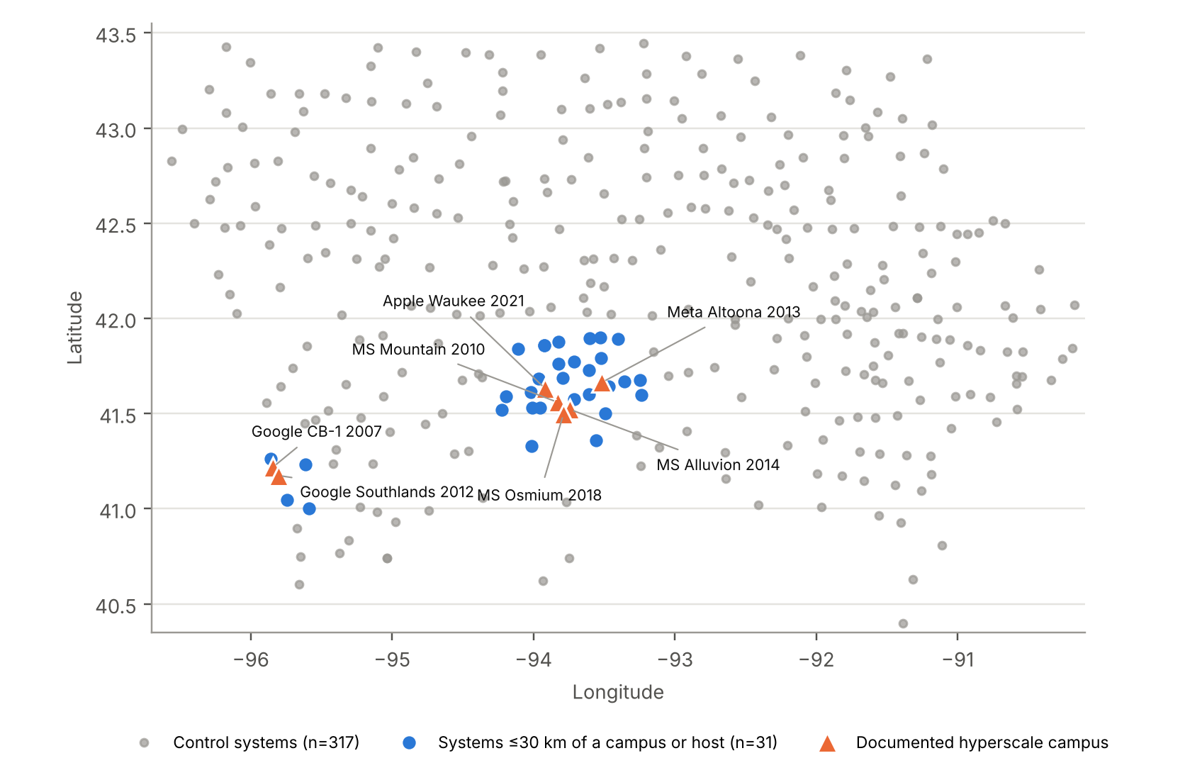
Figure 1. Monitored municipal community water systems and documented hyperscale campuses. Control systems are more than 30 km from every campus.

5. Design and estimation

5.1 Events, exposure and controls
An event is the first construction start of a documented campus in 2013–2019, so that at least one observed baseline year exists: Meta Altoona (2013), Microsoft Alluvion (2014) and Microsoft Osmium (2018). Earlier starts (Google 2007, Microsoft Mountain 2010, Google Southlands 2012) have no observed baseline in SYR4, and later starts fall after the data end. For each event, exposed systems are either the host utility (supply-network pathway) or monitored municipal systems within R = 5, 10, 15 or 20 km (an exploratory proximity screen that does not establish a flow path). Controls are monitored systems more than 30 km from every documented campus that are not hosts (n = 317). A stricter control set also excludes systems within 10 km of any site in the original 70-row table.

5.2 Estimator
We used a stacked imputation estimator [19,20,23]. For each event e, a sub-panel contains its exposed systems and the controls over event time −6 to +6. Event-specific unit effects αᵢₑ and year effects λₜₑ are fitted on untreated observations only, and the effect is the average of Yᵢₜ − α̂ᵢₑ − λ̂ₜₑ over exposed post-event observations (equal weight per exposed system-year). This avoids the forbidden comparisons of two-way fixed effects under staggered timing [21,22] and handles unbalanced annual sampling without filling. Pre-event coefficients for k = −6…−2 (k = −1 omitted) were estimated on untreated observations as a placebo check [19].

5.3 Inference
With one to seven exposed systems, cluster-robust standard errors are unreliable [24,25]. We therefore used Fisher randomization inference [26]. Each draw re-sites every event at a location chosen uniformly from Iowa places with at least 2,000 residents (plus the real sites) that have a monitored system within R, keeps the event year, re-assigns exposure and recomputes the estimator (2,000 draws for main specifications, 1,000 for sensitivity analyses). For host designs, each operator's campuses are re-assigned to a randomly drawn system serving at least 2,000 people. Two-sided p-values count the observed assignment. Confidence sets invert the sharp null of a constant additive effect per event; because the estimator is linear in the outcome, this inversion is exact over a 0.005 mg/L grid. The minimum detectable effect (MDE) is the smallest shift that would be detected at α = 0.05 with 80% probability over the placebo distribution.
Equivalence margins were fixed before estimation at ±0.5 and ±1.0 mg/L (5% and 10% of the 10 mg/L maximum contaminant level). The larger margin is roughly twice the median within-system standard deviation of annual nitrate among nitrate-informative systems (0.45 mg/L) and is comparable to the typical reporting limit. Equivalence is declared only when the 90% randomization confidence set lies inside the margin [31]. The equivalence assessment conditions on the stated randomization model and is not an unconditional proof of no effect.

5.4 Negative control, sensitivity analyses and comparison with the original specification
Des Moines Water Works (DMWW) draws from the Raccoon and Des Moines rivers at and above Des Moines. The Meta Altoona site lies northeast of the city, outside the Raccoon basin and east of the Des Moines River; on our reading of its location, its runoff enters the river below DMWW's intakes (a flow-line check was not possible here). Even if some runoff did reach an intake, Section 6.6 shows the possible effect is below about 0.2 mg/L. Assigning DMWW to the 2013 Meta event is therefore a negative-control exposure [27]: any estimated "effect" measures bias from shocks shared by central-Iowa surface water.
Sensitivity analyses vary the outcome (censoring bounds, log, probability of any sample above 5 mg/L), the sample (systems with detected nitrate of at least 0.5 mg/L in 2012), time effects (region-by-year, source-type-by-year and region-by-source-by-year, using a 3 × 3 grid that mirrors Iowa's climate divisions), controls, start years (documented interval endpoints) and leave-one-event-out. We also re-ran the original two-way fixed-effects specification (10 km cohorts from the original code, PWS and year effects, HUC-10 clustering, ±0.25 mg/L test) on observed outcomes for the 38 of its 48 systems that have data, with randomization inference permuting cohort years across systems.

5.5 Mass-balance bounds for river intakes
For an intake on a river with flow Q, a site of area A that changes nitrogen export from the row-crop yield y₀ to y adds at most ΔC = (y − y₀)·A / Q to the flow-weighted mean concentration. We used the long-run Raccoon River yield y₀ = 26.1 kg N/ha/yr [8]; deliberately extreme construction exports y = 100 and 250 kg N/ha/yr; a low-input developed landscape y = 5; flows for the Raccoon River at Van Meter (mean 1,554 cfs, median 600, Q90 118) [9,10], the Missouri River at Omaha [11] and the Cedar River at Cedar Rapids [9]; and documented campus areas (Table 2), assuming conservatively that all central-Iowa campuses drain to the Raccoon above the Fleur Drive intake.

6. Results

6.1 What the monitoring data can see
Figure 2 shows annual entry-point nitrate for the four utilities most connected to the campuses. DMWW's finished water followed river nitrate, peaking in 2015 (6.48 mg/L annual mean), the year DMWW ran its nitrate-removal facility a record 177 days [28]. WDMWW and Council Bluffs reported non-detects at a 1 mg/L limit in most early years, so changes below 1 mg/L cannot be observed. Altoona's Jordan-aquifer water stayed near or below the reporting limit throughout. None of the series shows a level change aligned with the construction starts.
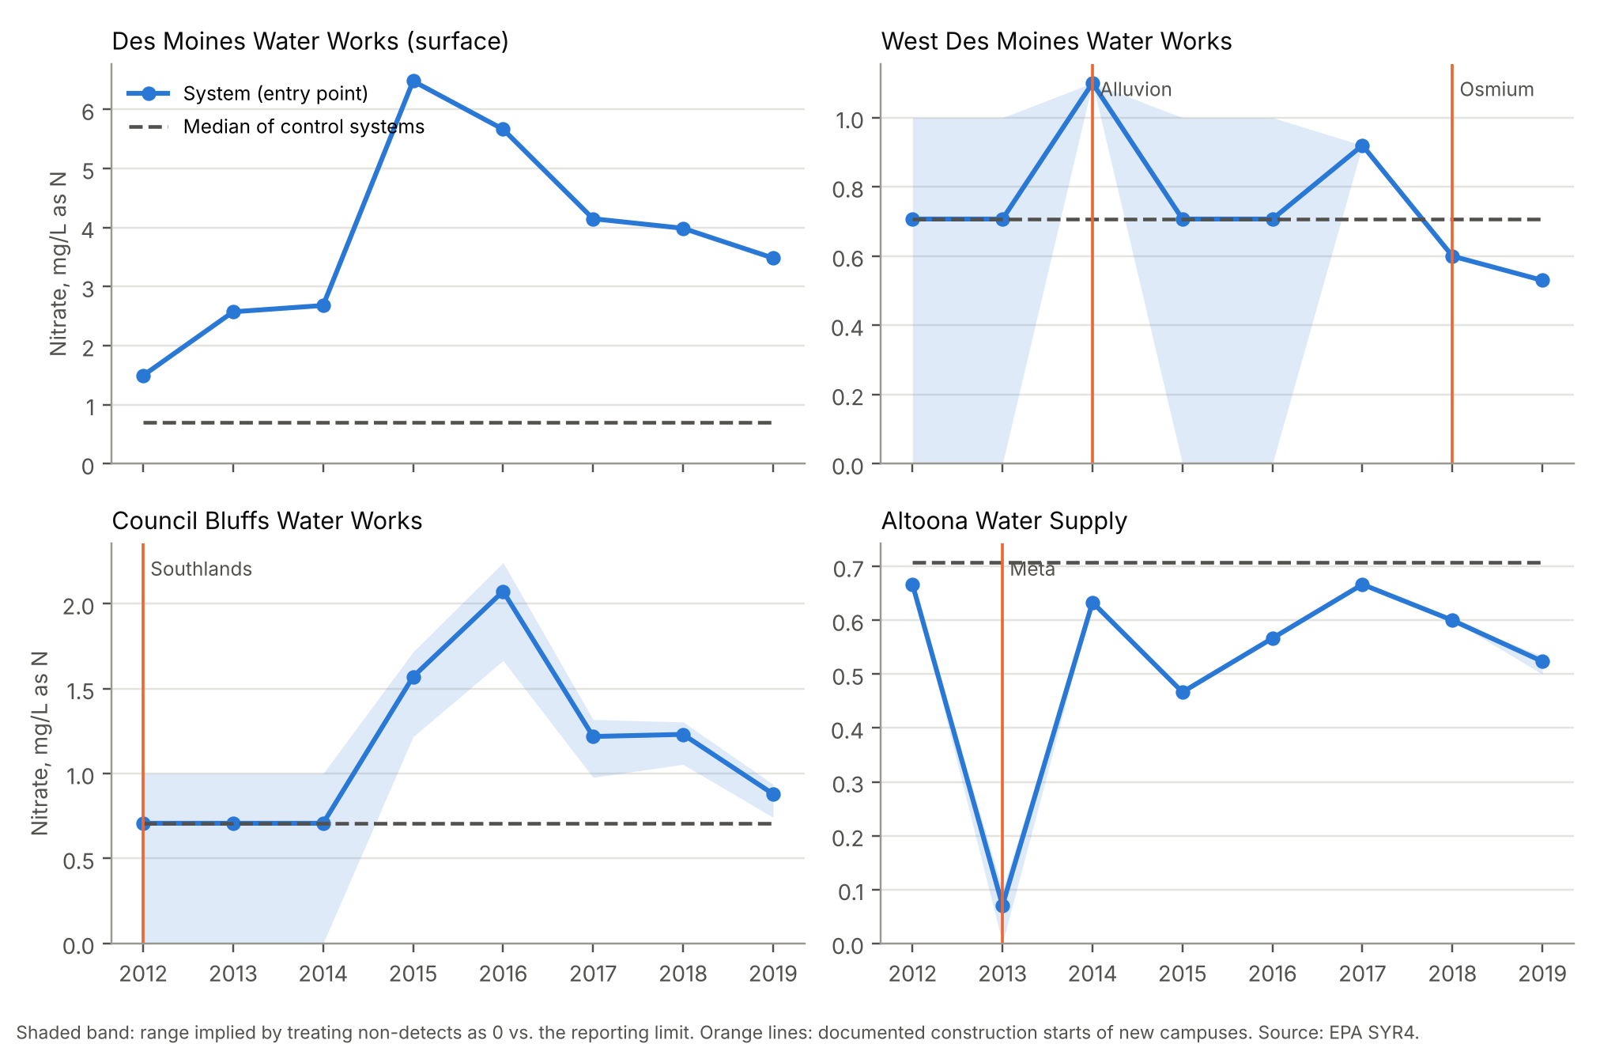
Figure 2. Annual entry-point nitrate for utilities connected to campuses, 2012–2019 (EPA SYR4). Dashed line: median of control systems (dominated by non-detects at 1 mg/L, plotted at 0.71).

6.2 Main estimates
Table 3 reports the effect of a new-campus construction start. For the host-utility design the estimate is −0.14 mg/L (randomization p = 0.55; 90% confidence set −0.72 to 0.47; 95% −0.98 to 0.76). Within 5 and 10 km the estimates are −0.23 and −0.14 with similarly wide sets. The host and 10 km designs rest on two utilities (WDMWW and Altoona) and 13–15 exposed system-years; the 5 km design rests on Altoona alone. Their 90% sets lie within ±1.0 mg/L but not within ±0.5 mg/L, and the MDE is 1.1–1.2 mg/L. The data therefore rule out large effects on host utilities but cannot distinguish zero from effects of several tenths of a mg/L.
Table 3. Effect of a new hyperscale campus construction start on annual mean entry-point nitrate (mg/L as N), stacked imputation estimator.
Exposure | Exposed systems (system-years) | Effect | Randomization p | 90% confidence set | 95% confidence set | MDE (80%) | TWFE, county-cluster SE (p)
Host utility | 2 (15) | −0.14 | 0.55 | −0.72 to 0.47 | −0.98 to 0.76 | 1.2 | −0.11 (0.03; <0.001)
Within 5 km | 1 (7) | −0.23 | 0.42 | −0.98 to 0.52 | −1.28 to 0.80 | 1.2 | −0.23 (0.04; <0.001)
Within 10 km | 2 (13) | −0.14 | 0.59 | −0.79 to 0.49 | −1.04 to 0.74 | 1.1 | −0.10 (0.04; 0.006)
Within 15 km | 7 (51) | 0.69 | 0.095 | 0.03 to 1.01 | −0.19 to 1.14 | 1.0 | 0.59 (0.10; <0.001)
Within 20 km | 10 (80) | 0.35 | 0.20 | −0.09 to 0.54 | −0.21 to 0.62 | 0.7 | 0.25 (0.13; 0.057)
Controls: 317 monitored systems >30 km from every campus. Events: Meta Altoona 2013, Microsoft Alluvion 2014, Microsoft Osmium 2018. Randomization: 2,000 re-sitings. The last column is the conventional static two-way fixed-effects estimate with county-clustered CR1 standard errors, shown only to illustrate overconfidence (Section 6.4).
The 15 km design adds DMWW, Ankeny, Mitchellville, Elkhart and Van Meter and gives 0.69 mg/L (p = 0.095). The event-time profile (Figure 3) peaks two years after the 2013 Meta start, which is calendar 2015, the year of record river nitrate. Pre-event coefficients are small and their randomization intervals include zero, but most baselines are short. The host-utility profile (Figure 4) is flat.
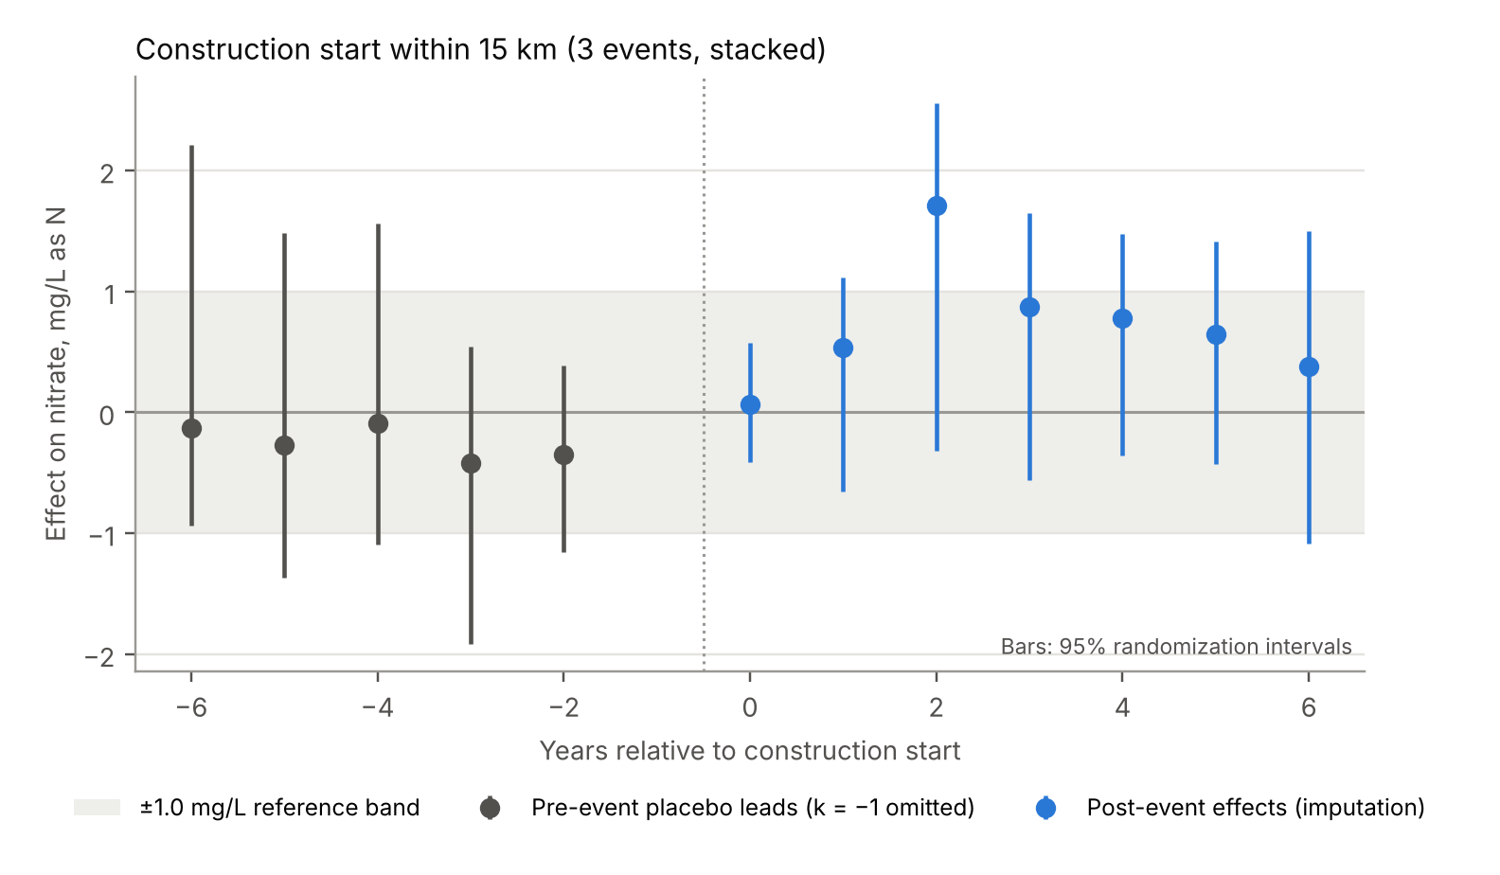
Figure 3. Event-time effects, construction start within 15 km. Pre-event coefficients are placebo leads estimated on untreated observations; bars are 95% randomization intervals.
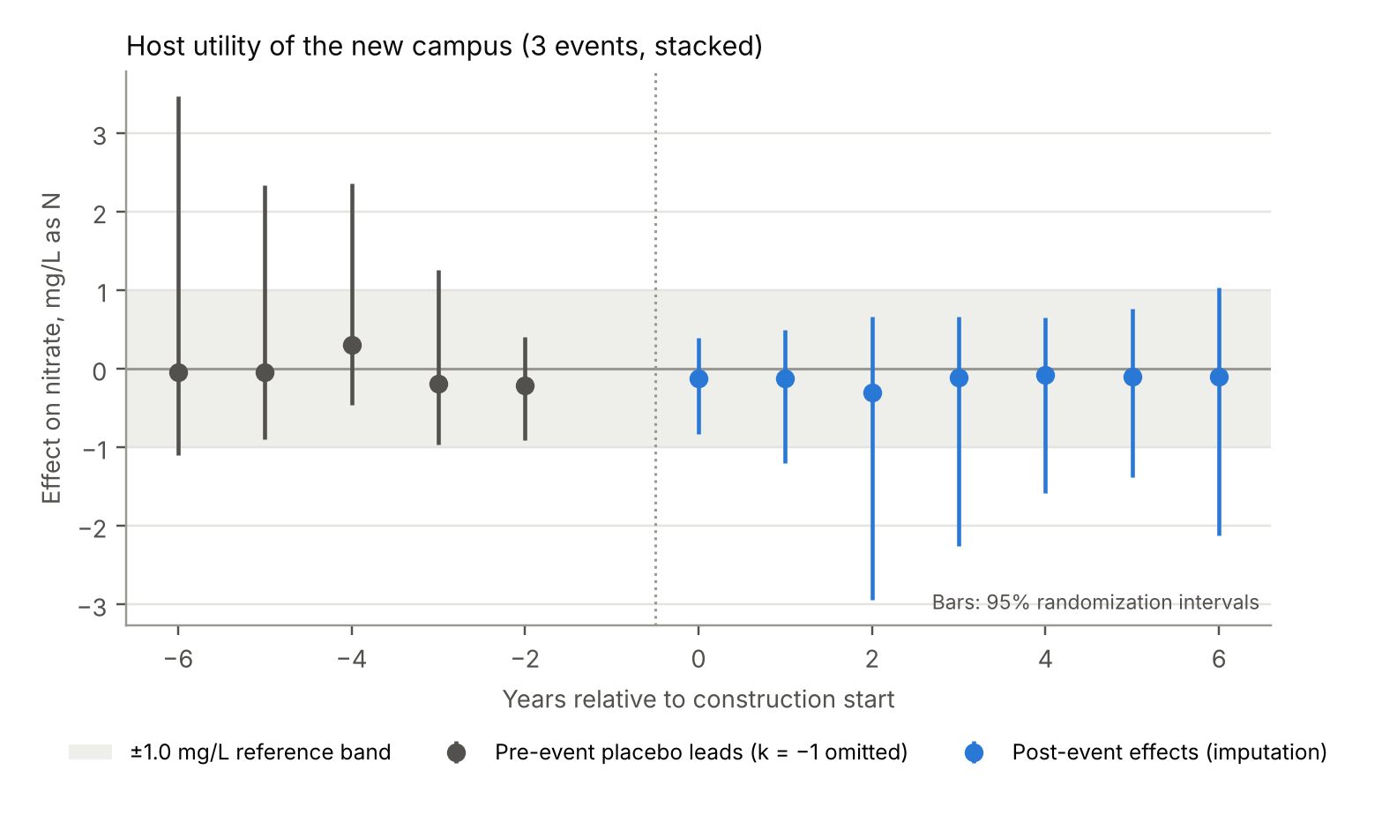
Figure 4. Event-time effects for the host utility of each new campus. Bars are 95% randomization intervals.

6.3 The 15 km estimate is regional surface-water bias
Three checks indicate that the 15 km estimate reflects river nitrate shared by central-Iowa surface-water systems rather than data centers (Table 4). First, the negative control (DMWW assigned to the Meta event, whose site cannot plausibly load DMWW's intakes) produces a spurious "effect" of 2.58 mg/L (p = 0.17), or 1.71 with source-type-by-year effects. Second, excluding DMWW reduces the 15 km estimate to 0.09 (p = 0.72). Third, region-by-source-by-year effects reduce it to 0.16 (p = 0.52). Proximity designs can therefore generate apparent harms as easily as apparent nulls when exposed systems share river sources that controls do not.
Table 4. Sensitivity analyses and negative control (randomization inference, 1,000 re-sitings; negative control 2,000).
Specification | 15 km: effect (p) | 15 km: 95% set | Host: effect (p) | Host: 95% set
Nitrate-informative systems only | 1.01 (0.11) | −0.39 to 1.60 | −0.23 (0.55) | −1.50 to 1.03
Non-detects at 0 (lower bound) | 0.75 (0.086) | −0.16 to 1.22 | 0.09 (0.67) | −0.92 to 1.01
Non-detects at limit (upper bound) | 0.67 (0.094) | −0.17 to 1.14 | −0.23 (0.39) | −1.09 to 0.70
Log nitrate | 0.20 (0.47) | −0.43 to 0.65 | −0.23 (0.44) | −0.88 to 0.47
Any sample > 5 mg/L (probability) | 0.02 (0.54) | −0.14 to 0.16 | −0.00 (1.00) | −0.28 to 0.28
Region-by-year effects | 0.49 (0.17) | −0.31 to 0.98 | −0.33 (0.29) | −1.20 to 0.61
Source-type-by-year effects | 0.54 (0.13) | −0.20 to 1.02 | −0.09 (0.68) | −0.86 to 0.71
Region-by-source-by-year effects | 0.16 (0.52) | −0.40 to 0.65 | −0.16 (0.50) | −0.90 to 0.63
Exclude Des Moines Water Works | 0.09 (0.72) | −0.66 to 0.77 | −0.14 (0.54) | −1.02 to 0.79
Strict controls | 0.71 (0.096) | −0.20 to 1.13 | −0.12 (0.58) | −0.86 to 0.65
Earliest documented start years | 0.67 (0.075) | −0.11 to 1.07 | −0.11 (0.60) | −0.90 to 0.71
Latest documented start years | 0.67 (0.10) | −0.20 to 1.19 | −0.21 (0.41) | −1.08 to 0.71
Negative control: DMWW x Meta 2013 (year effects) | 2.58 (0.17) | −0.93 to above 6
Negative control: DMWW x Meta 2013 (source-by-year effects) | 1.71 (0.21) | −0.93 to 4.59
Log nitrate effects are in log points; the exceedance outcome is a probability. Leave-one-event-out results are in the appendix and in results/tables/table3_sensitivity.csv.
The host-utility estimate is stable across specifications (range −0.33 to 0.09 mg/L in concentration units), and no specification shows a change in the probability that any sample exceeds 5 mg/L (host: −0.001; 95% set −0.28 to 0.28).

6.4 Conventional inference is badly overconfident
Static two-way fixed-effects estimates with county-clustered standard errors (Table 3, last column) report p-values below 0.01 for most designs. Applied to the placebo re-sitings, where the true effect is zero by construction, these tests rejected at the nominal 5% level in 45% of host-utility assignments, 23% of 10 km assignments and 23% of 15 km assignments. With one or two exposed clusters, cluster-robust variance estimates cannot capture the variability of the exposed units [24,25]. Any study of individual campuses that reports conventional clustered p-values should be read with this in mind.

6.5 The original specification on observed outcomes
Applying the original 10 km two-way fixed-effects specification to observed outcomes (38 systems, 303 system-years, 28 HUC-10 clusters) gives β = −0.16 mg/L (SE 0.19; p = 0.39) for construction and −0.15 (SE 0.16) for operation. The 90% interval for construction (−0.48 to 0.16) is not inside ±0.25 mg/L (TOST p = 0.33), so the original equivalence claim fails under the original method. Only 7 systems change construction status within the data window; 13 were already 'treated' before 2012 and contribute no within-system contrast. Permuting cohort years across systems gives p = 0.62.

6.6 Mass-balance bounds
Documented central-Iowa campus land totals 1,071 acres, 0.049% of the 3,441 mi² Raccoon basin, whose mean nitrate-N load is about 23.3 million kg/yr. Table 5 shows that even if every acre exported 100 kg N/ha/yr (about four times the agricultural yield), the flow-weighted increase at the Raccoon intake would be 0.023 mg/L at mean flow and 0.060 mg/L at median flow. A 250 kg/ha/yr ceiling raises these to 0.070 and 0.181 mg/L. After construction, low-input land use lowers export, so the long-run sign is negative (−0.007 mg/L at mean flow). Only when an entire year's extreme load is assumed to arrive at a Q90 low flow, a physically inconsistent combination because construction runoff occurs during storms, does the bound approach 1 mg/L. For the Missouri River at Council Bluffs the bounds are below 0.005 mg/L. Compared with river nitrate of 15–20 mg/L in 2025 [1], land conversion by data centers is not a material source.
Table 5. Upper bounds on the change in flow-weighted nitrate at river intakes from campus land conversion (mg/L as N).
River (flow statistic, cfs) | Campus area | Low-input developed (5 kg/ha) | Extreme construction (100 kg/ha) | Ceiling (250 kg/ha)
Raccoon (Van Meter): mean (1,554) | Documented central-Iowa campuses (1,071 ac) | −0.007 | 0.023 | 0.070
Raccoon (Van Meter): median (600) | Documented central-Iowa campuses (1,071 ac) | −0.017 | 0.060 | 0.181
Raccoon (Van Meter): Q90 1916-2004 (118) | Documented central-Iowa campuses (1,071 ac) | −0.087 | 0.304 | 0.920
Raccoon (Van Meter): median (600) | Including full 2,000-ac Apple site (2,771 ac) | −0.044 | 0.155 | 0.468
Missouri (Omaha): 5th percentile (25,700) | Google Council Bluffs (≈1,068 ac) | −0.000 | 0.001 | 0.004
Cedar (Cedar Rapids): mean (3,780) | Per 1,000 acres | −0.003 | 0.009 | 0.027
Cedar (Cedar Rapids): Q90 WY2004 (690) | Per 1,000 acres | −0.014 | 0.049 | 0.147
Changes are relative to continued row-crop export of 26.1 kg N/ha/yr. The Q90 row applies an annual load at low flow and is shown only as an extreme bound.

7. Discussion
The original paper's conclusion was predetermined by its data-generating code, and its precision (±0.04 mg/L) reflected the low simulated noise rather than any property of Iowa's water. With observed data and the same specification, its own equivalence test fails. This is not a criticism of difference-in-differences or equivalence testing as such; it shows that statistical machinery applied to generated data can reproduce whatever the generator encodes, and that AI-produced analyses need the same provenance checks as any other.
What the observed data support is narrower. Across designs with a plausible pathway (host utility, ≤10 km), estimates are small, negative and imprecise, and the data rule out effects larger than about 1 mg/L on host utilities at 90% confidence. Smaller effects cannot be excluded, because few systems were exposed during 2012–2019, monitoring is mostly annual and many results are censored at 1 mg/L. Positive estimates appeared only when designs included surface-water systems that share regional river shocks with no comparable controls, and a negative control showed that such designs can produce multi-mg/L spurious effects.
For river intakes, the mass balance is more informative than the regressions. Even under export assumptions far beyond agricultural yields, the documented campuses cannot shift nitrate at the Raccoon intake by more than about 0.1–0.2 mg/L. For the Missouri River the bound is negligible. This bound does not depend on the scarce panel data and could be refined with site-specific drainage areas.
The pathway that remains plausible is operational rather than chemical. A utility that meets marginal demand with higher-nitrate water can raise its finished nitrate by at most the demand share times the concentration gap between sources. With a 7% share and a gap approaching the 10 mg/L standard, that is up to about 0.7 mg/L during peaks if the marginal source were nearly at the standard. In practice utilities blend and treat to stay below the standard, so additional demand appears mainly as consumed nitrate-removal capacity and cost. This is consistent with CIWW's description of the 2025 crisis as a capacity problem driven by river nitrate [1,2]. Policy debates about data centers and nitrate would be clearer if they distinguished water quantity and treatment capacity, where data centers are a real but bounded share of demand, from source-water quality, where the evidence points to agricultural nitrogen.

Limitations
- Data end in 2019, so the 2025–2026 events, Apple Waukee, Microsoft Ginger and the Cedar Rapids campuses are outside the window. Early cohorts (Google 2007, Microsoft 2010) lack baselines without SYR3.
- Only three events and two host utilities are informative. Randomization inference treats campus siting as exchangeable across Iowa places with at least 2,000 residents; real siting favors metro areas with specific infrastructure.
- Host links other than Microsoft–WDMWW are presumed. Several coordinates are approximate (1–3 km), and proximity does not establish hydrologic connection.
- Reporting limits of 1 mg/L hide small changes in low-nitrate systems. Annual means from one sample per year mix seasonal timing with level.
- The negative-control flow path and the mass-balance drainage assumptions should be confirmed with NHDPlus flow lines. Measured weather and utility blend records were not available.

What would answer the current question
- Acquire SYR3 (2006–2011) and Iowa DNR compliance results for 2020–2026 for the same systems (the extraction script already supports SYR3).
- Obtain utility operating data: source blend shares, nitrate-removal run days and capacity, and data center demand by month for WDMWW, CIWW, Altoona, Council Bluffs, Waukee and Cedar Rapids.
- Use DNR water-use permits and NPDES records to date first withdrawals and discharges, and NHDPlus to map flow paths from each campus to intakes.
- Pre-register the estimand, margins and randomization scheme before the post-2019 data are analyzed.

8. Conclusion
The claim that data centers have "zero" effect on Iowa drinking-water nitrate, bounded within ±0.04 mg/L, rests on simulated data and cannot be used. Observed compliance data for 2012–2019 show no detectable effect of new campus construction on host or nearby utilities and exclude effects larger than about 1 mg/L, while physical bounds show that land conversion cannot materially affect nitrate at large river intakes. The open question for 2025–2026 concerns demand and treatment capacity, and answering it requires utility operating records and post-2019 monitoring.

Data, code and verification
All code is in 3-claude/code: 00_extract_public_data.py (acquisition with hashes), 01_clean_data.py (cleaning, stage, censoring, geocoding, annual panel), 02_audit_original.py (forensic audit), 03_build_exposure.py, 04_analyze.py (estimation, randomization inference, bounds, figures) and 05_verify_pipeline.py. The verification suite passed 25 of 25 checks, covering provenance hashes, unit conversion, censoring bounds, cell-level recomputation, geocoding spot checks, exact recovery of a known effect on an artificial fixture, the test-inversion identity, near-nominal size of the randomization test (artificial null data), seeded reproducibility and the audit's regeneration hash.
AI-use statement. The audit, data pipeline, analysis and text were produced by Claude (Anthropic) at the request of the project lead and should be reviewed by the authors. Facts about campuses were taken from the cited sources; no observation in this paper was generated or imputed.

References
[1] Iowa Public Radio (2025, June 17). Central Iowa lawn watering ban continues amid high nitrate levels. https://www.iowapublicradio.org/ipr-news/2025-06-17/central-iowa-lawn-watering-ban-high-nitrate-levels-des-moines-river
[2] Axios Des Moines (2025, June 17). Data centers are not to blame for central Iowa water crisis. https://www.axios.com/local/des-moines/2025/06/17/central-iowa-water-ban-data-centers-microsoft
[3] Fortune / Associated Press (2023, September 9). AI ChatGPT usage fuels spike in Microsoft water consumption. https://fortune.com/2023/09/09/ai-chatgpt-usage-fuels-spike-in-microsoft-water-consumption/
[4] U.S. EPA (2024). Six-Year Review 4 Compliance Monitoring Data (2012–2019). https://www.epa.gov/dwsixyearreview/six-year-review-4-compliance-monitoring-data-2012-2019
[5] U.S. EPA (2024). User guide to downloading and using SYR4 data; Data management QA/QC process for the SYR4 ICR dataset (Exhibit E).
[6] U.S. EPA (2016). Six-Year Review 3 Compliance Monitoring Data (2006–2011), SYR3_PhaseChem_3.
[7] 40 CFR 141.23. Inorganic chemical sampling and analytical requirements.
[8] Schilling KE, Zhang Y-K (2004). Baseflow contribution to nitrate-nitrogen export from a large, agricultural watershed, USA. Journal of Hydrology 295:305–316.
[9] U.S. Geological Survey (2005). Water Resources Data, Iowa, Water Year 2004 (WDR-IA-04-1): stations 05484500 and 05464500.
[10] U.S. Geological Survey. StreamStats gage statistics, 05484500 Raccoon River at Van Meter, IA.
[11] Kelly VJ, Hooper RP, Aulenbach BT, Janet M (2001). Concentrations and annual fluxes for selected water-quality constituents from the USGS NASQAN program (WRI 01-4255): Missouri River at Omaha.
[12] Data Center Knowledge (2011, January 10). Microsoft starts building Iowa data center.
[13] Data Center Knowledge (2014, April 18). Microsoft to build new $1.1 billion data center in Iowa; Business Record. Microsoft West Des Moines projects (Mountain, Alluvion, Osmium).
[14] Business Record (2025). Energy, water use under close watch as data centers expand in Iowa.
[15] Data Center Dynamics. Microsoft delays West Des Moines Osmium data center build; Baxtel campus pages (Osmium, Google Southlands, Meta Altoona).
[16] Meta (2021, December 14). Meta announces new expansion to Altoona campus; TechCrunch (2014, November 14). Facebook's newest data center is now online in Altoona, Iowa.
[17] Data Center Dynamics (2021; 2024). Apple begins preparation work in Iowa; Apple launches data center in Waukee, Iowa. Data Center Knowledge (2013, December 2). In Iowa, a field becomes a billion-dollar Google server farm.
[18] City of Altoona. Water Department FAQ (Jordan aquifer wells, ~2,500 ft).
[19] Borusyak K, Jaravel X, Spiess J (2024). Revisiting event-study designs: robust and efficient estimation. Review of Economic Studies 91(6):3253–3285.
[20] Cengiz D, Dube A, Lindner A, Zipperer B (2019). The effect of minimum wages on low-wage jobs. Quarterly Journal of Economics 134(3):1405–1454.
[21] Goodman-Bacon A (2021). Difference-in-differences with variation in treatment timing. Journal of Econometrics 225(2):254–277.
[22] Callaway B, Sant'Anna PHC (2021). Difference-in-differences with multiple time periods. Journal of Econometrics 225(2):200–230.
[23] Wing C, Freedman SM, Hollingsworth A (2024). Stacked difference-in-differences. NBER Working Paper 32054.
[24] Conley TG, Taber CR (2011). Inference with 'difference in differences' with a small number of policy changes. Review of Economics and Statistics 93(1):113–125.
[25] MacKinnon JG, Webb MD (2018). The wild bootstrap for few (treated) clusters. Econometrics Journal 21(2):114–135.
[26] Imbens GW, Rubin DB (2015). Causal Inference for Statistics, Social, and Biomedical Sciences. Cambridge University Press.
[27] Lipsitch M, Tchetgen Tchetgen E, Cohen T (2010). Negative controls: a tool for detecting confounding and bias in observational studies. Epidemiology 21(3):383–388.
[28] Bleeding Heartland (2016, January 5). Des Moines Water Works ran nitrate removal system for nearly half of 2015.
[29] datacenter-nitrate-iowa repository, folder 1-gemini (commit 68148b2). https://github.com/jsemprini/datacenter-nitrate-iowa/tree/main/1-gemini
[30] datacenter-nitrate-iowa repository, folder 2-oai. https://github.com/jsemprini/datacenter-nitrate-iowa/tree/main/2-oai
[31] Lakens D (2017). Equivalence tests: a practical primer. Social Psychological and Personality Science 8(4):355–362.
[32] Helsel DR (2012). Statistics for Censored Environmental Data Using Minitab and R, 2nd ed. Wiley.

Appendix

A1. Specification curve
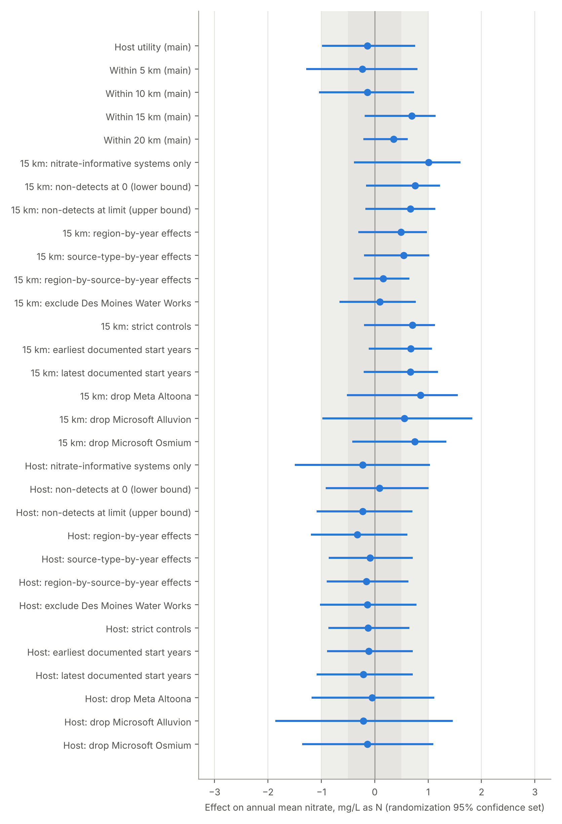
Figure A1. Estimates and 95% randomization confidence sets across specifications (concentration outcomes only). Shading marks ±0.5 and ±1.0 mg/L.

A2. Leave-one-event-out
Specification | Effect | p | 95% set
15 km: drop Meta Altoona | 0.86 | 0.094 | −0.52 to 1.55
15 km: drop Microsoft Alluvion | 0.56 | 0.23 | −0.98 to 1.82
15 km: drop Microsoft Osmium | 0.75 | 0.11 | −0.42 to 1.34
Host: drop Meta Altoona | −0.05 | 0.77 | −1.19 to 1.11
Host: drop Microsoft Alluvion | −0.21 | 0.40 | −1.86 to 1.46
Host: drop Microsoft Osmium | −0.14 | 0.58 | −1.36 to 1.09

A3. Original campus dates compared with documented dates
Campus | Original construction date | Documented start (interval) | Difference (years) | Location difference (km)*
GOOG_CB1 | 2007-07-15 | 2007 (2007-2007) | 0 | 0.0
GOOG_CB2 | 2012-09-01 | 2012 (2011-2012) | 0 | 1.22
MSFT_MTN | 2009-04-15 | 2010 (2010-2010) | -1 | 0.0
MSFT_ALV | 2014-07-10 | 2014 (2014-2015) | 0 | 0.0
MSFT_OSM | 2016-11-01 | 2018 (2017-2018) | -2 | 0.42
META_ALT | 2013-06-18 | 2013 (2013-2013) | 0 | 3.94
APPL_WAU | 2022-06-15 | 2021 (2021-2022) | 1 | 0.0
MSFT_GW | 2021-05-01 | 2022 (2022-2023) | -1 | 0.0
MSFT_GE | 2023-05-10 | 2023 (2022-2023) | 0 | 0.0
*Location differences are informative only where the documented coordinate comes from an independent source (Google Southlands, Microsoft Osmium, Meta Altoona); other documented coordinates reuse the original value after a consistency check.

