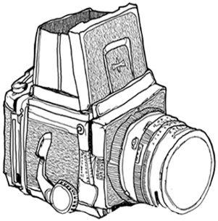

**José Luis Serrano Fotografía**

**JOSE LUIS SERRANO BARRERA**

**NIF: 50430076T**

**C/VITORIA, 11 6ºA**

**28941 FUENLABRADA**

**MADRID**

**DATOS DE LA FACTURA**

|  |
| --- |
|  |

**DATOS DEL CLIENTE**

|  |
| --- |
|  |

**DETALLE**

|  |  |  |  |  |
| --- | --- | --- | --- | --- |
| **SERVICIO** | **BASE IMPONIBLE** | **DESCUENTO** | **CUOTA IVA** | **TOTAL** |

|  |  |  |
| --- | --- | --- |
|  | **TOTAL PEDIDO** |  |
|  | **DESCUENTO** |  |
|  | **BASE IMPONIBLE** |  |
|  | **CUOTA IVA** |  |
|  | **TOTAL** |  |