**Candidate Test**



First of all, thanks for your interest in applying as a **QA** **Test Engineer - Automation**.

Before we continue to the next step, we would like you to complete a test automation exercise, to mimic what you will be working on in Virtru. We believe this will help us understand each other better.

Steps:

1. [Manually] Install virtru browser plugin(currently Virtru support Chrome and Firefox). For example, if you are using Chrome, navigate to below URL: <https://chrome.google.com/webstore/detail/virtru-email-encryption/nemmanchfojaehgkbgcfmdiidbopakpp>

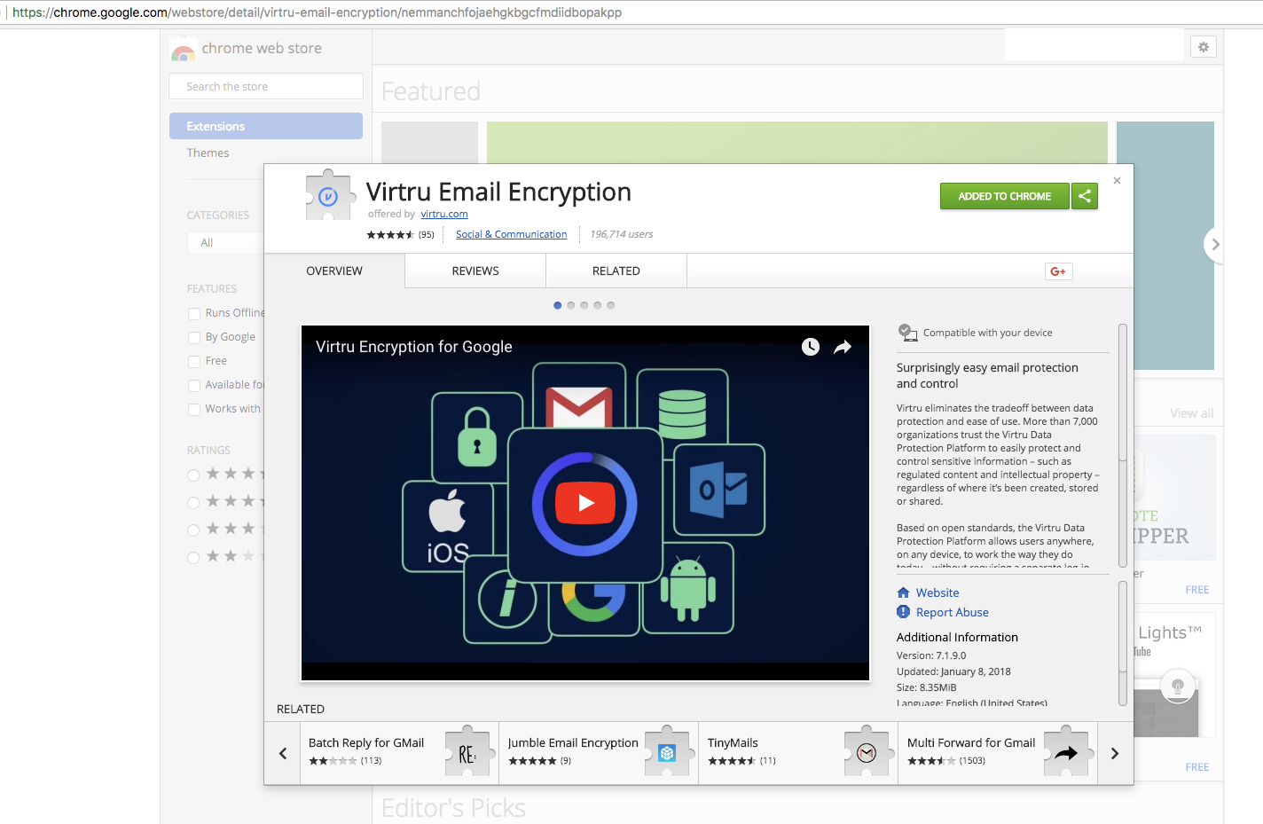

1. [Manually] With Virtru Browser Plugin installed, send out an encrypted email to any email address you have access to, can be just send to yourself.

Video Reference: <https://www.screencast.com/t/AlWQG0H31K>

1. [Automatically] Use WebDriver to start up a clean browser, follow the steps in the below video, and **assert** if the decrypted email body contains the correct contents you have sent in step 2.

Video Reference: <https://www.screencast.com/t/mULUxC52R>

Requirements:

1. To simplify the task, you can do the first 2 steps manually, you need to automate the 3rd step according to the video. <https://www.screencast.com/t/mULUxC52R>
2. You are free to choose the language you like, preferably Python, JavaScript, or Java.
3. Share your code with us using git-based service provider such as **Github/BitBucket** etc
4. We are looking for:
   1. Easy-to-read and maintainable code structure
   2. Robust locators
   3. Assertions
5. Please share the **code** and provide a **video** **recording** of the test run.

Deadline:

3 days from the day you get this task.

How:

Email to notice us you have completed this task and share the completed project with us using the way you prefer: ***dcrowley@virtru.com,*** [***kho@virtru.com***](mailto:kho@virtru.com)***, bstanley@virtru.com***

** Any questions or ideas? Please send email to us directly:***dcrowley@virtru.com, kho@virtru.com, bstanley@virtru.com***