**Web based calender (appointment management) and customer management**

The final target of the software project is a web based calender and customer management (java based?) for different groups like therapeuts, doctors, physiotherapeuts, dentists, etc.

There is a company login and an employee login. And later it should be able to create a test account for a limited time for new customer (like therapeuts) an there should be a web page at the landing page for further information around the system for new customer and the login area.

In general it will look similar like <https://synaptos.at> but a little bit easier to handle. Try a test account I will reference many time to that system.

The system should be multilingual, because we develop it in English (for better communication with you), but finally I need it in german. So we need one table in the database for different languages which can be administrated and I will translate it.

Every employee should be able to access its assigned calendars via web browser and via mobile phone app. So a “simple” employee can only see its calendar, a store manager can see all allocated calendars. That means we need the possibility to allocation calendars to employees.

To step into the web app we need a simple login like:

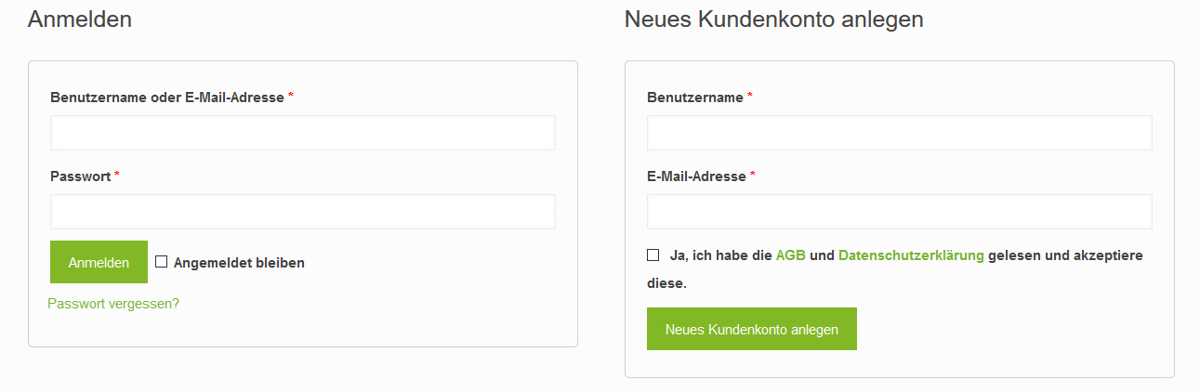

After login there should be always the calendar page shown, but with the difference, that an employee does see only its calendar, a store manager can see its allocated calendars and the super user (admin) can even see more. We will come at a later point to it.

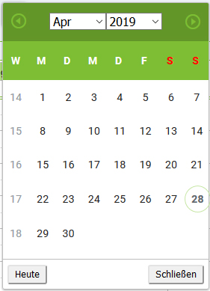

Different views: day, 3 days, 5 days, week, month

Switch the weeks back and forward

Go to actual week

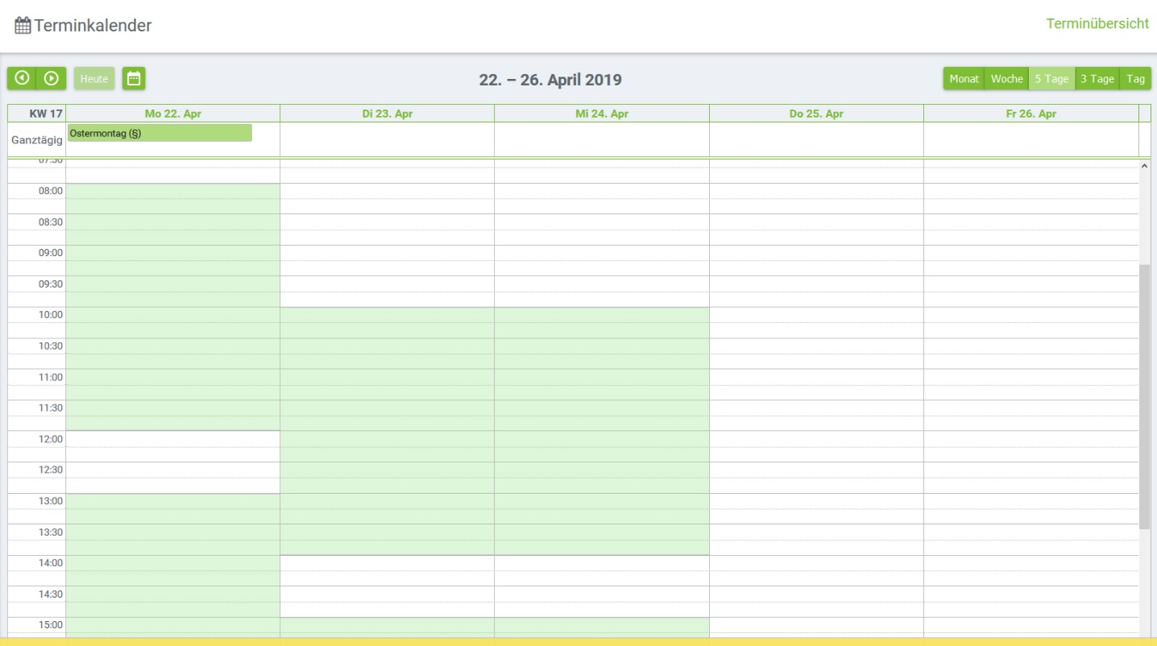

Working time is highlighted and will be set up for each employee in the settings

At the top there are the different calendars listed where we have access with click boxes to select them. The short name from (14) Menu Settings – Users / Benutzer is used. The calendars will be listed side by side

Most of the menu on the left side is visible for all users (employees, store manager, admin). Details, who can access to which menu is set up in settings

**YW**

**x**

**BSAS**

**x**

**AS**

**x**

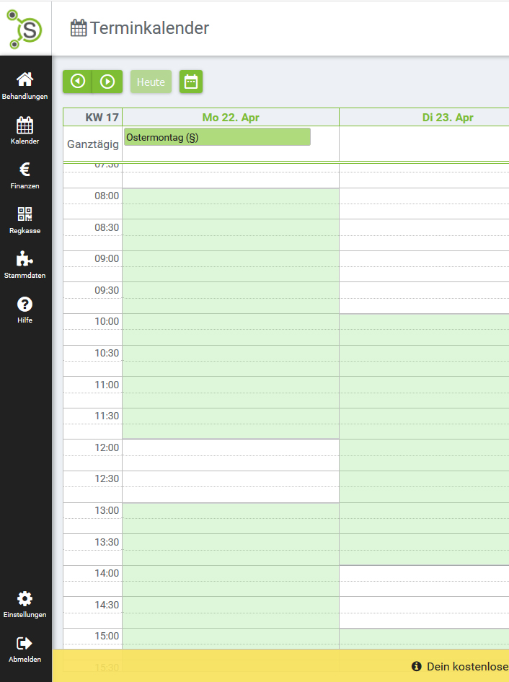

For every user is defined (at Setings / User) which menu is visible and can be accessed.

**(14) Menu Settings – Users / Benutzer**

At this menu the basic information of every user can be set up.

The following data should be contained:

Login name (email) Password

First name / Vorname Surname / Nachname

Shot name (for selection and view in calendar)

Street / Straße Zip-Code / Postleitzahl Place / Ort

Email / Email Telephone Mobile Birthday In company since

Comment (Memofield)

Documents (it should be possible to add documents like cv, contracts, etc.)

Date Comment Document-file

Restricted area: Special click box for this area must be set (AA)

Rights (click boxes to give access to the menu tree, that means the whole menu must be listed with click boxes including (AA))

Access to the following calendars (list with all users and click box to select user)

Working Time (this time will be highlighted at the calendar of the user)

Monday Tuesday Wednesday Thursday Frieday Saturday Sunday

Begin

End

Begin

End

**(15) Menu Settings – Stores / Filialen**

Store Name Street / Straße Zip-Code / Postleitzahl Place / Ort

Email / Email Telephone Mobile

Comment (Memofield)

Documents (it should be possible to add documents like cv, contract)

Date Comment Document-file

List with users which are at this store (clickboxes)

List with users which are the store manager (clickboxes)

**(15) Menu Settings – General setting / Allgemenes**

Calendar view

Begin end

Standard duration of a date (default is 60)

**(1) Menu Calendar**

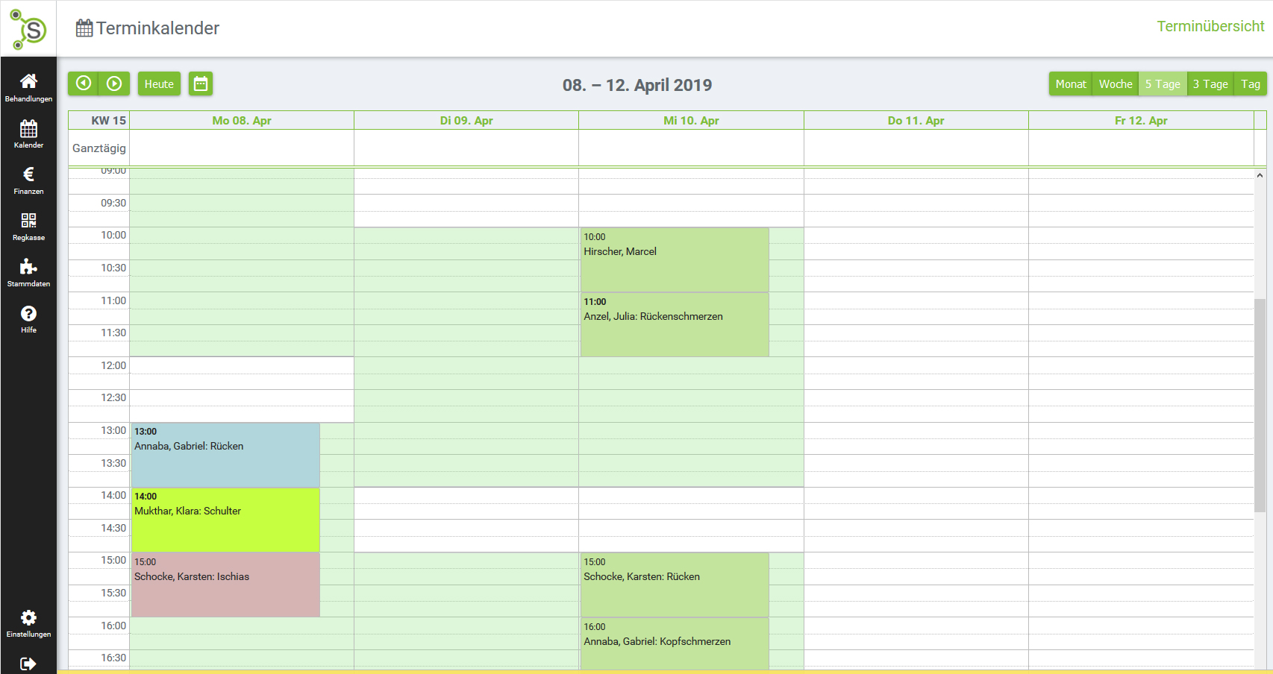

If you click at the calendar a window opens to change an existing date or to make a new date:

Reasons for delete  
cancelled, short-term cancellation, without cancellation, changed

C:\Users\asprung\AppData\Local\Microsoft\Windows\INetCache\Content.Word\scroll bar vertical.jpgC:\Users\asprung\AppData\Local\Microsoft\Windows\INetCache\Content.Word\scroll bar vertical.jpg

Menu   
Date and Base data

Base data

Delete

Therapy

Complaint

Date Complaint Therapy Comment CS better-worse Em

01.03.2017 Headache Tuina; Guasha 7 2 samer AS

01.04.2017 Neck Pain Tuina; Guasha 8 3 worse AS

01.04.2017 Headache Tuina; Guasha 7 1 better AS

Date Complaint Comment Therapies Doctor CS

04.03.2017 Shoulder pain SS ruptur Tuina; Electro Dr. Kleinrath 8

01.03.2018 Neck pain C3/4 Physio; Medi Dr. Hohn 7

01.04.2017 Headache temporal Physio; Electro Dr. Hager 9



Save



Duration: 60 min

Telephone: 06645154242

Reminder via  SMS  EmailSMS

01.03.2018 Clinical Evidence



01.02.2017 Base data scan



Documents

04.04.2017 TCM diagnisis C:\Users\asprung\AppData\Local\Microsoft\Windows\INetCache\Content.Word\pdf-icon.jpg

Copy Date

Physical complaint

ATTENTION [contraindication](https://dict.leo.org/englisch-deutsch/contraindication)

Cancel

Patient: Mayr Walter

Date: 28.04.2019 11:00

Duration: 60 min

Date

Reasons for delete  
cancelled, short-term cancellation, without cancellation, changed

C:\Users\asprung\AppData\Local\Microsoft\Windows\INetCache\Content.Word\scroll bar vertical.jpgC:\Users\asprung\AppData\Local\Microsoft\Windows\INetCache\Content.Word\scroll bar vertical.jpgC:\Users\asprung\AppData\Local\Microsoft\Windows\INetCache\Content.Word\scroll bar vertical.jpg

Doctor: Dr. Hager



Recommendation: personal

Weight: 75

Weight: 75

Size: 176

Gender: man

Zip: 4655

Town: Vorchdorf

Street: Tachlau 7

Last name: Sprung

First name: Albert

Adress: Mr

First date: 25.04.2019

Duration: 60 min

Base data

Delete

Save

Telephone: 06645154242

Reminder via  SMS  EmailSMS

Copy Date

Physical complaint

ATTENTION [contraindication](https://dict.leo.org/englisch-deutsch/contraindication)

Cancel

Patient: Mayr Walter

Date: 28.04.2019 11:00

Duration: 60 min

Date