2025 Spring BIO 2100 Midterm
33 points
Table of contents

1 Instructions! Read this first.
The exam is open note, open course website, open class-related code repositories (mine and those you produced in class). However, you may not get external help ( from other students, directed internet searches, etc.). Please update the statement below to acknowledge these instructions (and that you can use git).
I, INSERT YOUR NAME HERE, promise to not seek external help on the exam. I understand any academic issues will result in a D or F on the exam or in the class and be reported to the Dean of Students. Infractions will also result in me being unable to obtain a letter of recommendation from the department for professional school applications.
The exam should be committed and pushed to github by Friday, 3/28/2025, at 1:15 PM. You can also commit and push along the way, but please mark your final commit (when you are finished) with the comment Finished - ready to grade!.
For all questions, the statement is based on what you might hear from a colleague (e.g., “How do I analyze this?”). This is like when you get a call to review a paper. Please answer questions succinctly but with necessary details on all required steps/concerns you might need to consider.
While the exam is based on a realistic scenario (with citations), some data and scenarios are fictional and contrived for the exam (i.e., don’t quote all this as fact!).
Good luck!

2 Background
Joro spiders (Trichonephila clavata) are coming to New York!
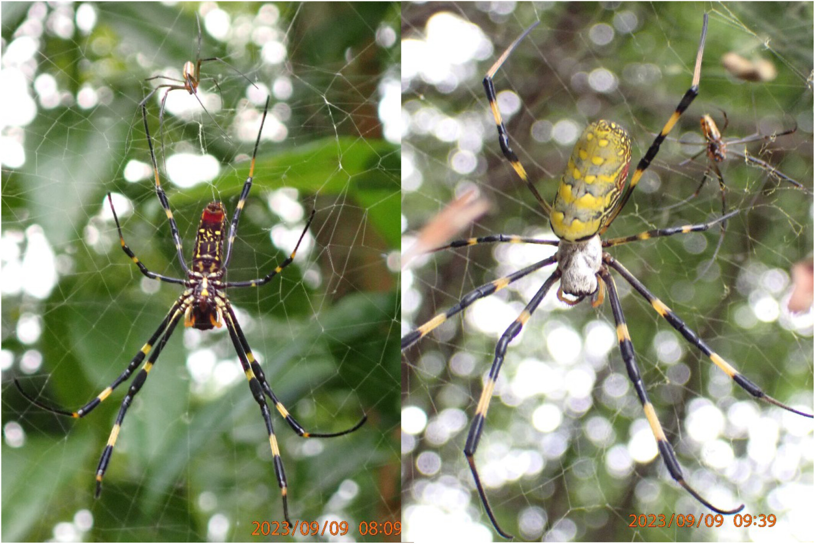
Image from Nelsen et al 2023
Originally from Asia, this spider was first observed in Georgia, USA, circa 2010. Recent modeling studies have suggested the species could thrive in New York (Nelsen et al. 2023).
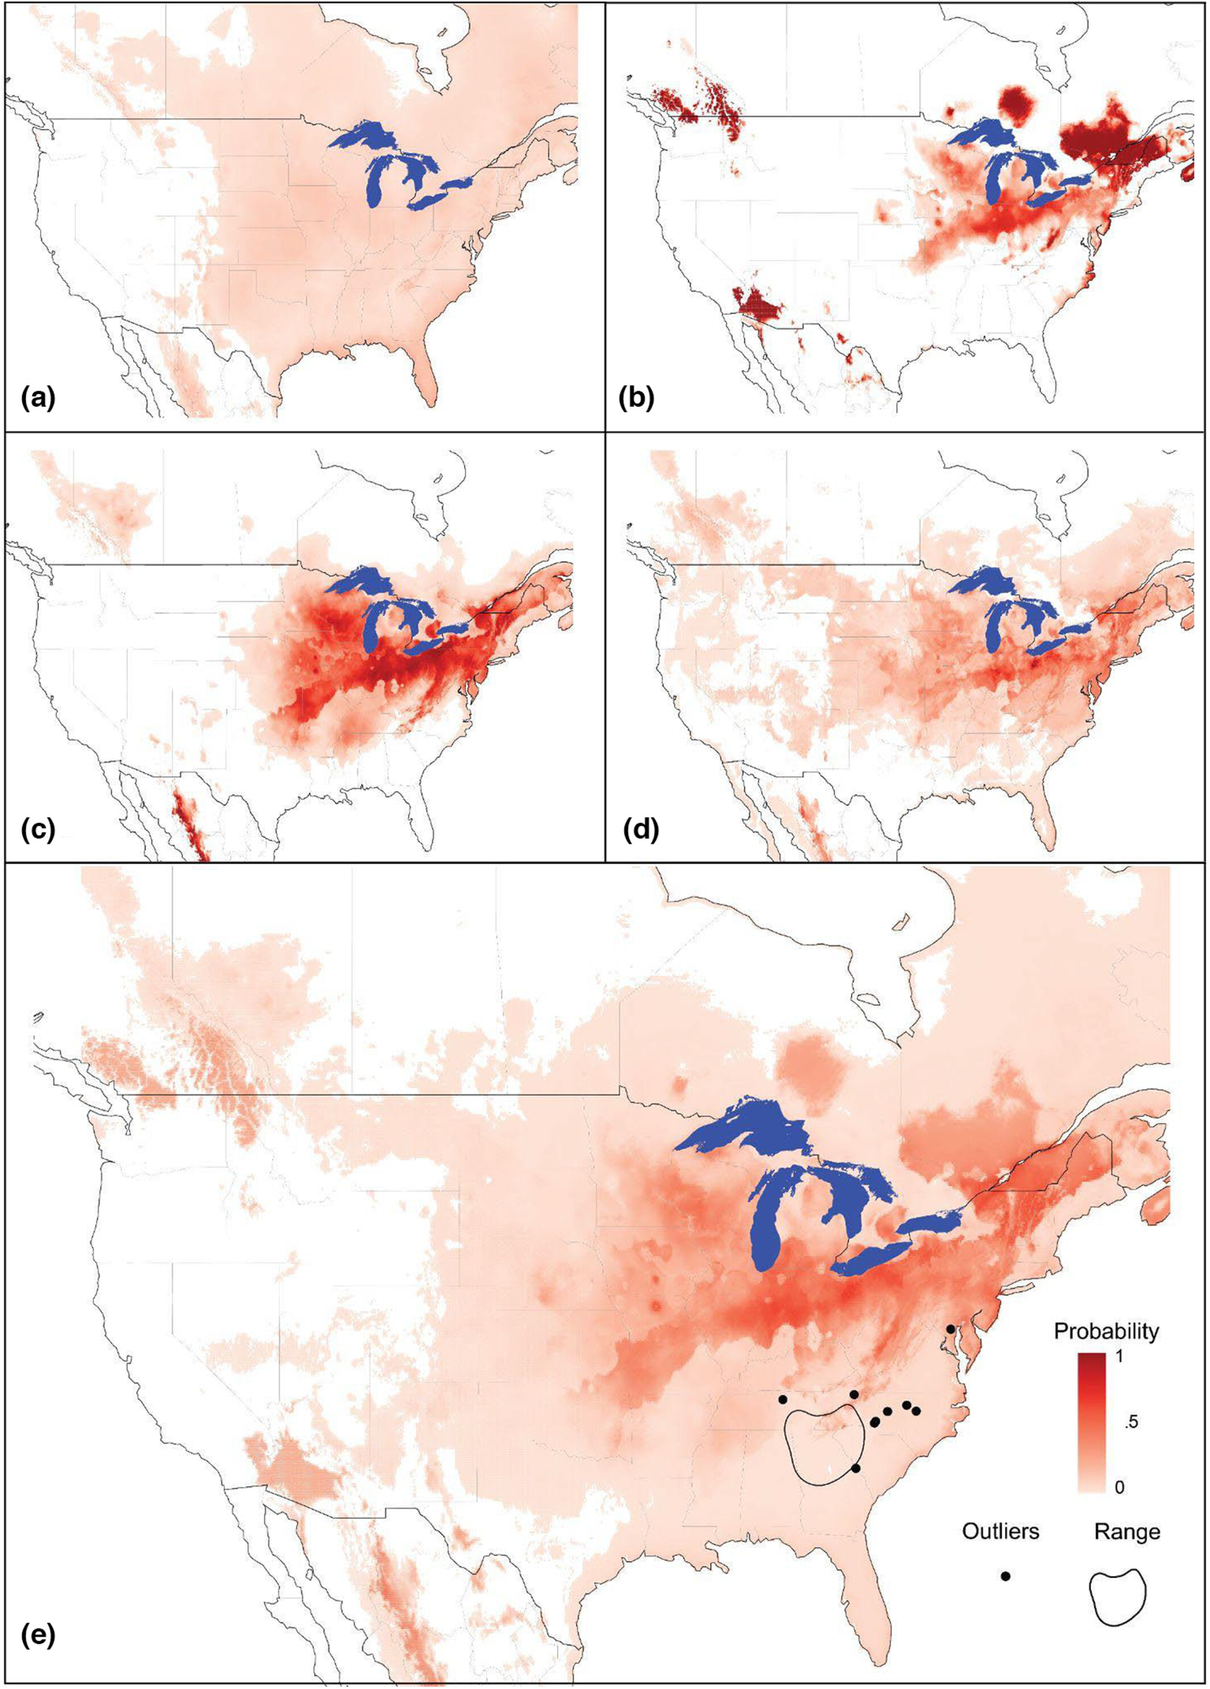
Species distribution model (SDM) predictions of Trichonephila clavata’s suitable range in North America based on its native Asian distribution: (a) General Linear Model, (b) General Additive Model, (c) Maxent, (d) Random Forest, and (e) Averaged prediction of all four models, calculated as an equally weighted average across all four primary models, including T. clavata’s introduced range as of December 2022. From Nelsen et al. 2023.
Given the pending (or already happened?) invasion, ecologists are studying the Joro spider more and more.

3 1
One explanation for the species rapid spread is the specific population that arrived in the United States differs from other populations of Joro spiders. For example, they may differ in their use of ballooning. Ballooning occurs when spiders deploy silk threads to catch air currents and disperse. In Joro spider populations in Japan, 18% of the hatchlings disperse via ballooning. An inital study of Joro spider hatchlings in Georgia indicated 22 out of 85 used ballooning. Does this suggest any difference in the use of ballooning by Joro spiders in Georgia?
Analyze the data. Make sure you include
- null hypothesis (1 point)
- alternative hypothesis (1 point)
- explanation for test you will use (1.5 point)
- results from statistical test (1 point)
- clear explanation of how results relate to your stated hypotheses (1.5 point)

4 2
While presenting their work at a conference, another scientist shared they had done a similar but larger study. They found that 110 out of 425 hatchlings from Georgia used ballooning. What does their data indicate (you can use the same assumption of 18%)?
Analyze the data. Make sure you include
- null hypothesis (1 point)
- alternative hypothesis (1 point)
- explanation for test you will use (1.5 point)
- results from statistical test (1 point)
- clear explanation of how results relate to your stated hypotheses (1.5 point)

5 3
A new student is confused when comparing these studies. Both have the same signal for ballooning.

5.1 a
What is the signal for ballooning rate in both datasets? (2 pts)
PUT YOUR ANSWER HERE

5.2 b
However, they differ in p-value. Why? In answering this make sure you can explain what a p-value is. (2 pts)
PUT YOUR ANSWER HERE

6 4
The larger study also recorded hatchling sex (recorded as male or female). Data is shown below
Spider hatchling gender and ballooning
 | Sex
Use of ballooning | Male | Female
Ballooned | 54 | 56
Did not balloon | 150 | 165
How would you analyze the data to determine if sex impacts ballooning? Make sure you include
- null hypothesis (1 point)
- alternative hypothesis (1 point)
- explanation for test you will use (1.5 point)
- results from statistical test (1 point)
- clear explanation of how results relate to your stated hypotheses (1.5 point)

7 5
Another, related hypothesis is that the invasive spiders have smaller hatchlings. Weight data was collected from a population in Georgia and two populations in Asia (Japan and Korea). It can be loaded using the code below. Weight is in mg.
spider_mass <- read.csv("spider_mass.csv", stringsAsFactors = T)
How would you analyze the data. Make sure you include
- null hypothesis (1 point)
- alternative hypothesis (1 point)
- explanation for test you will use (1.5 point)
- results from statistical test (1 point)
- clear explanation of how results relate to your stated hypotheses (1.5 point)

8 6
Plot the data from question 5. (5 pts)
Nelsen, David R., Aaron G. Corbit, Angela Chuang, John F. Deitsch, Michael I. Sitvarin, and David R. Coyle. 2023. “Veni, Vidi, Vici? Future Spread and Ecological Impacts of a Rapidly Expanding Invasive Predator Population.” Ecology and Evolution 13 (11): e10728. https://doi.org/10.1002/ece3.10728.

