Rate My Course User Guide

Group 3

Title: User Guide

Project: Rate My Course

Document type: Technical Working paper

Version: 1.0

Date: 4/23/17

Author: Jackie Shan, Maya Novarini, Pedro Preciado

Inspected: N/A

Approved: N/A

Confidentiality: Public

Table of Contents

1. List of illustrations - page 3.
2. Introduction - page 5.
3. Concept of Operations - page 6.
4. Procedures -page 7.

List of Illustrations

Rate My Course Homepage

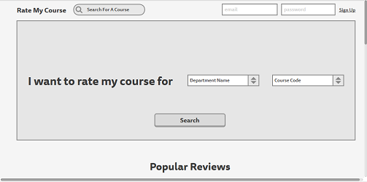

Rate My Course Rate page

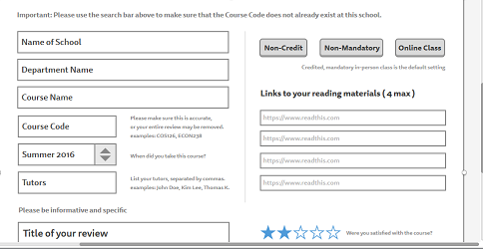

Rate My Course Review page

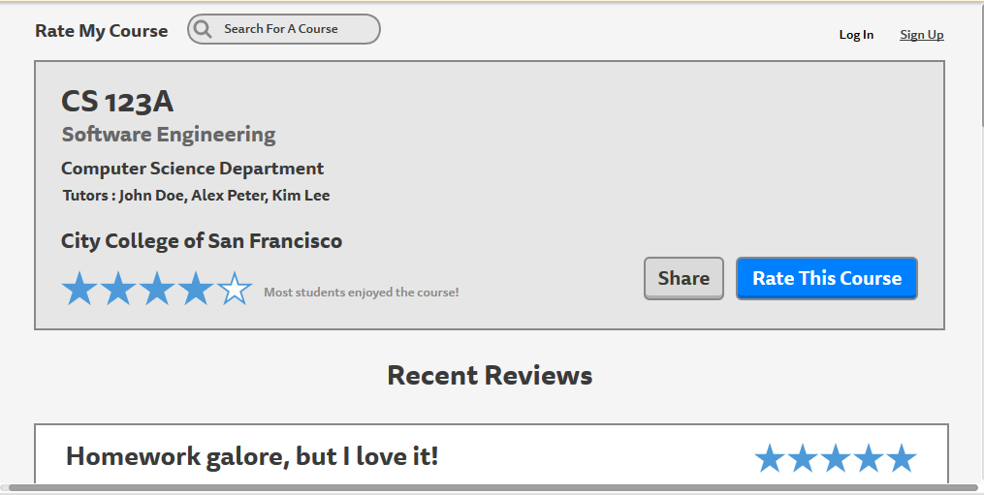

Rate My Course Sign Up page

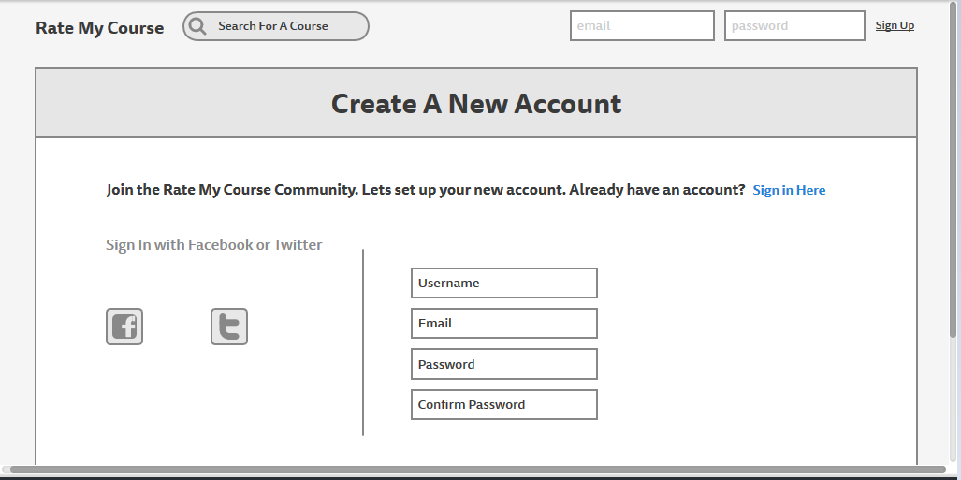

Introduction

Concept of Operations

Procedures