Automatic Music Transcription: The Use of a Fourier Transform to Analyze Waveform Data

Jake Shankman

Computer Systems Research

TJHSST

Dr. Torbert

29 May 2013
Table of Contents
Abstract .................................................................................................................................. 3
Background ........................................................................................................................... 4
Materials Used ...................................................................................................................... 5
My Approach ......................................................................................................................... 6
Phase 1 – Data Extraction …......................................................................................... 6
Phase 2 – Normalization ...…......................................................................................... 6
Phase 3 – FFT …............................................................................................................ 7
Phase 4 – Pitch Mapping ..…......................................................................................... 7
Phase 5 – Rhythm Tracking .......................................................................................... 8
Phase 6 – Transcription ……......................................................................................... 8
Results ................................................................................................................................... 9
Conclusions and Analysis ..................................................................................................... 15
References ............................................................................................................................. 17

Abstract:
The concept of Automatic Music Transcription, or the creation of sheet music by a computer program, is an idea that has been around since at least the mid 70s (Gallard and Piszczalski) . In order for a computer to be able to do such a task, it must take a musical input from a sound file, usually of the .wav variety (from MIDI input) and perform an analysis of frequency and duration. Although this topic has been approached for over 30 years (Gallard and Piszczalski), a general solution has yet to be found and is an active are of research today (Lu).
A very popular, method used to determine the pitches comprising a sound file is to apply a Fast Fourier Transform (FFT). The choice for an FFT is most common due to the speed enhancements present over the similar Discrete Fourier Transform. Both functions are known to take waveform data in the time domain and convert it to a frequency domain that is suitable for music transcription. In essence, the FFT acts like a tuner on an individual time sample; pitch is returned at that specific time input. Being a very well defined function, the commonplace use of the FFT has made it a standard in attempting to perform Automatic Music Transcription.
Running an FFT alone will not necessarily map to pitch. In order to do so, every element returned from the FFT is then linked directly to a known pitch value, in the form of the previously mentioned frequency file. Using python, this frequency file is read into a dictionary. Then, an array of equal size to the FFT result is created whose elements are equated to the closest absolute pitch from frequency to the corresponding coefficient in the FFT output.
The results images show the results of my running .wav files through my program, amt.py. Engraving was done by Lilypond and represents standard sheet music in the treble clef.
Background:
The concept of Automatic Music Transcription, or the creation of sheet music by a computer program, is an idea that has been around since at least the mid 70s (Gallard and Piszczalski). In order for a computer to be able to do such a task, it must take a musical input from a sound file, usually of the .wav variety (from MIDI input) and perform an analysis of frequency and duration. Although this topic has been approached for over 30 years (Gallard and Piszczalski), a general solution has yet to be found and is an active area of research today (Lu).
One possible function to employ in determining the pitch of a note is the Autocorrelation function; this is a summation of portions of a note, taking into account the periodicity of the note and the lag of the system (Bello, Monti and Sandler). Bello, Monti and Sandler used this function in their own experimentation and achieved rather successful results.
Another approach to this problem is through the use of a genetic algorithm. In his 2006 work, Lu attempted to analyze simple musical patterns with a genetic algorithm and was highly accurate in his work. A possible implementation is as follows. Initially, a base population of notes will be bred. Utilizing fitness functions, which determine how accurate the notes are to the actual sound file, portions of the base population will be removed. From here, the population will then breed with itself to produce a fitter offspring. Additionally, each offspring has the potential to undergo a mutation, completely changing note structure. Ultimately, through natural selection, the correct musical notation will be achieved (Lu).
A final, and very popular, method used to determine the pitches in a sound file is to apply a Fast Fourier Transform (FFT). The choice for an FFT is due to the speed enhancements present over the similar Discrete Fourier Transform. Both functions take waveform time-data and convert it to a frequency domain that is suitable for music transcription. In essence, the FFT acts like a tuner on an individual time sample; pitch is returned at that specific time input. Being a very well defined function, the use of the FFT has made it a standard in attempting Automatic Music Transcription.
Materials Used:
Throughout the course of this research project, certain software libraries and computing setups were used. In order to best replicate the results of this research, one should try to create a setup containing the following components. Unless noted, the software should be of the latest release.
- Python (preferably 2.7 or higher)
- Gentoo Linux, or an appropriate OS
- Audacity
- Scipy
- Numpy
- Imri Goldberg's fft_utils.py
- Imri Goldberg's pytuner.py
- Lilypond
- Music21
- frequency.txt; a file containing all pitch values from 0 to D#8
- Various .wav files
The format one chooses to save the result output and the code editor used are irrelevant to the results of this research. That option is left to personal preference along with a suitable image viewer for analyzing results.

My Approach:
To best tackle the problem of Automatic Music Transcription, I have chosen to divide my program into several phases. By sub-setting this program into smaller pieces, or phases, issues of debugging, testing and modification become much simpler. Thus, I addressed the task of music transcription in phases dedicated to data extraction, normalization, mapping pitch to frequency through an FFT, rhythm analysis and transcription, or output, of my results to a sheet music image file. The following sections aim on providing detailed explanations on my process.
Phase 1 – Data Extraction:
In order to perform Automatic Music Transcription, it is necessary to have audio data to transcribe. Due to the widespread popularity, smaller file size, universal access in varying operating systems and ease of availability, the audio files used in this project will be in the .wav file format. Files like these contain the waveform data necessary to perform manipulation for transcription.
After choosing the .wav audio file to transcribe, it is necessary to make sure it is free of metadata. This requirement is due to the nature of my implementation of data extraction. To clear the metadata, one can simply open a program like Audacity, load the .wav file and edit the metadata through the file menu's Open Metadata Editor command. Clicking that option will open a GUI where the user must manually delete all metadata. Once that is done, make sure to save the cleaned file so it's data is ready to be extracted.
Now that the metadata has been cleared away, data can be extracted. The tool used to do this is Scipy's own waveform data extractor; scipy.io.wavfile.read(). An array containing the sampling rate and waveform data is returned in that order.
Phase 2 – Normalization:
Before performing a Fast Fourier Transform on the returned waveform data, it is necessary to normalize said data using a window. This is because the FFT assumes the waveform to be a continuous data set due to the sinusoidal nature of the function. Without any normalization, or process by which the data is made continuous, an anomaly called spectral leakage will occur. Spectral leakage will cause a spill of audio data into other bins, thus creating an excess amount of noise; the FFT will become muddied by this noise and results are very less likely to work. Performing the normalization on my data set is done by utilizing Scipy's Hann function, scipy.signal.hann(). The data set will become windowed and appear continuous to the FFT, making for better accuracy in pitch estimation.
Phase 3 – FFT:
After normalizing the waveform audio data, it is possible to extract pitch by performing a FFT. This function takes input in the time domain and will output coefficients in the frequency domain. The FFT is a summation function performed by manipulating sine and cosine expansions. As previously mentioned, the input data from the .wav file is in the time domain. Running through the fft will return a matrix whose indexes and coefficients correspond to the pitch at a given time. Essentially, this maps waveform audio data to a discernible frequency, otherwise known as pitch. Due to issues with noise, only the peak value of each index will yield the appropriate pitch. Additionally, to ensure greater accuracy, the FFT will be performed on smaller subdivisions of the sound file; these chunks allow the algorithm to pitch out small pieces and determine pitch values that would otherwise be missed. Chunks are necessary for this mapping as otherwise, the FFT would only return one pitch value; the more chunks there are, the more data will be mapped to pitch.
Phase 4 – Pitch Mapping:
Running an FFT alone will not necessarily map to pitch. In order to do so, every element returned from the FFT is then linked directly to a known pitch value, in the form of the previously mentioned frequency file. Using python, this frequency file is read into a dictionary. Then, an array of equal size to the FFT result is created whose elements are equated to the closest absolute pitch from frequency to the corresponding coefficient in the FFT output. Processing the data like this prepares it for the next step in the transcription process. At this time, the pitch detection is done. Each index represents a point in the audio file and contains the corresponding pitch, as given by the FFT. Now all that is left to do is determine rhythm and transcribe.
Phase 5 – Rhythm Tracking:
Rhythm tracking is no easy task. To perform, it is necessary to recursively run through the mapped pitch data, apply Bayesian networks and constantly check back on the result. With that in mind, rhythm tracking will allow us to determine note length, tempo, rests and other facets that we need to appropriately place our sheet music on the staff.
//edit to better explain
Phase 6 – Transcription:
With rhythm and pitch both mapped for each note, it is now time to transcribe the audio file to digital sheet music. Music21, a free online program from MIT, will easily allow us to do this. All that must be done is open a stream object from Music21 in python and then append all our notes; each index in the pitch and rhythm arrays correspond to a note. To append, the array will be looped over at each index, creating a note whose pitch and duration map the values of the corresponding rhythm and pitch indexes. Upon completion of the loop, a virtual staff will exist containing notes derived from the initial waveform audio file. Music21 is unable to display sheet music on its own, so the program will enlist the help of Lilypond to engrave the stream as a digital image. By calling a show(“lily”) method, Music21 is capable of completing the transcription process; data gathered by manipulating audio is finally put done in a standard notation that a musician can read.
Results:
The following images show the results of my running .wav files through my program, amt.py. Engraving was done by Lilypond and represents standard sheet music in the treble clef.
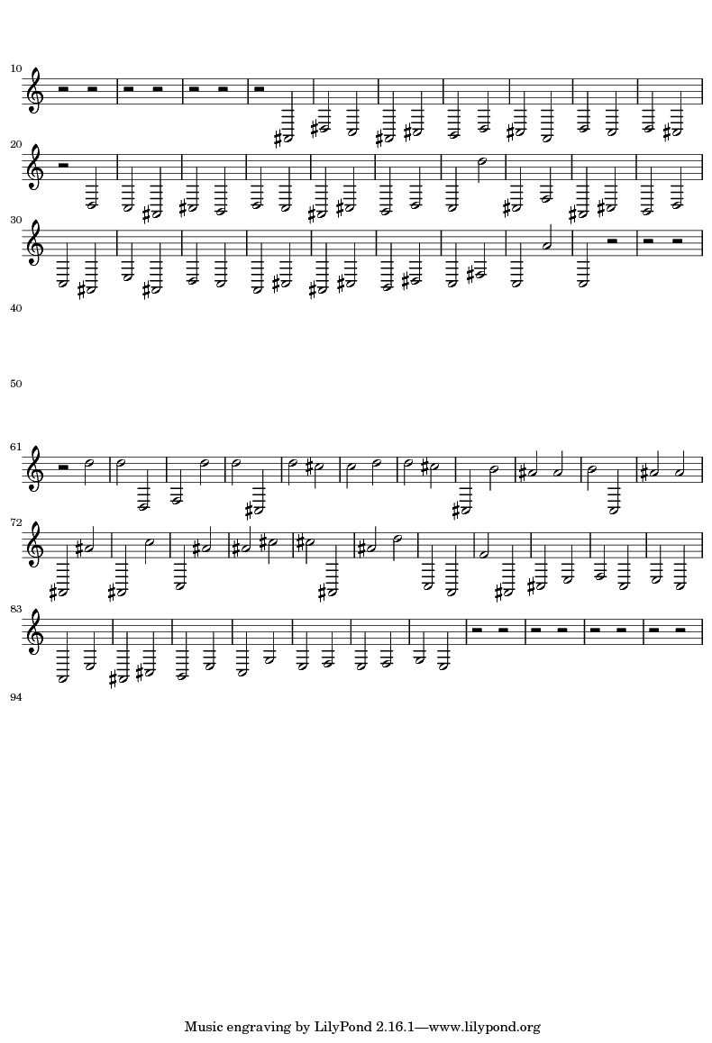Illustration 1: Results from couchplayin2.wav, 19 Feb 2013

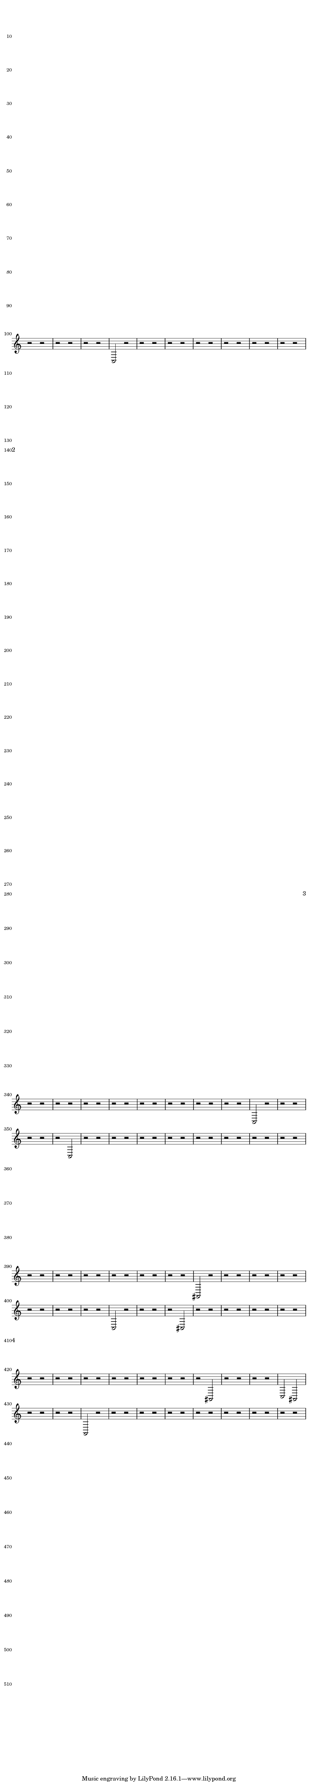Illustration 2: 1st Result from couchplayin2.wav, 28 Feb 2013

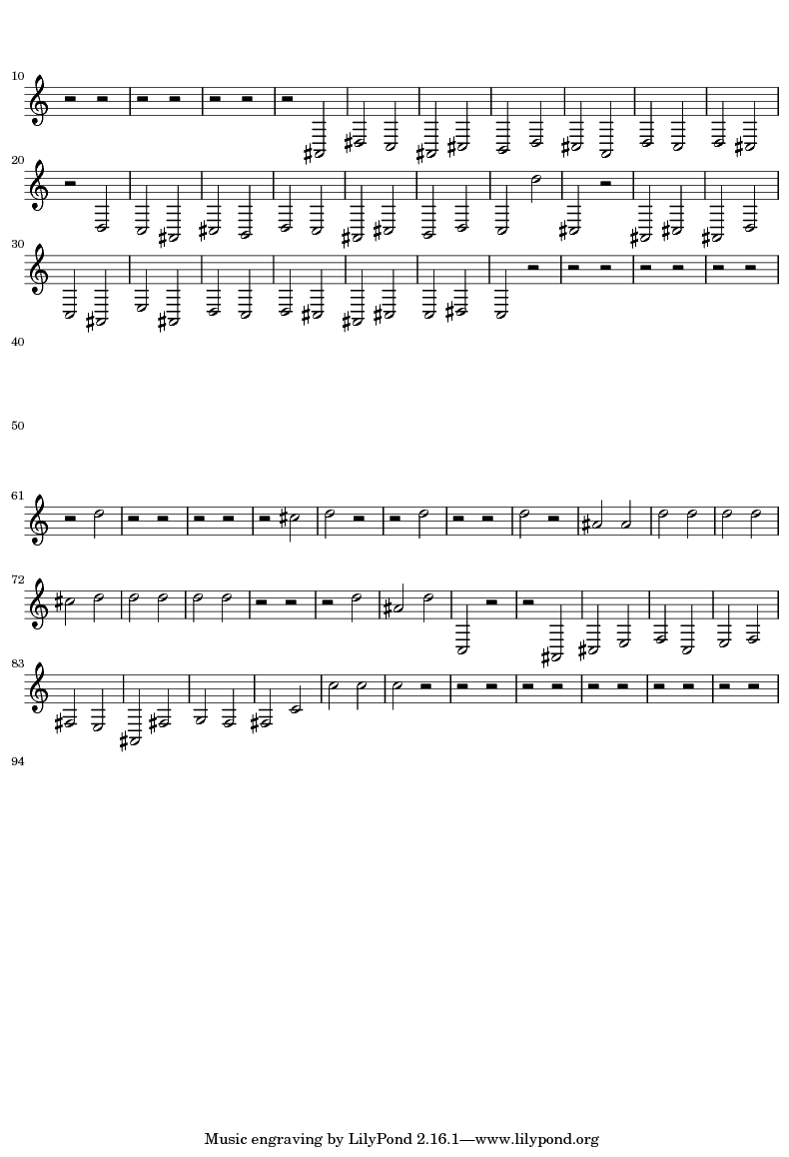Illustration 3: 2nd Result from couchplayin2.wav, 28 Feb 2013

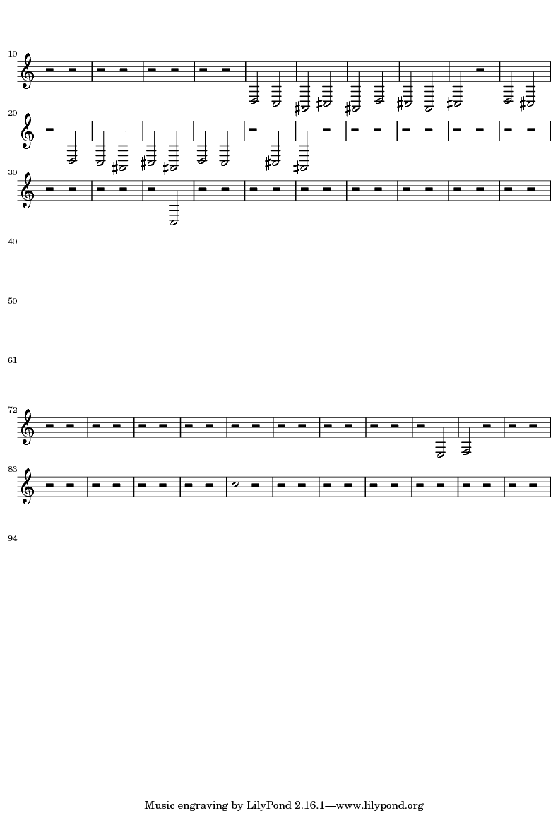Illustration 4: 3rd Result from couchplayin2.wav, 28 Feb 2013

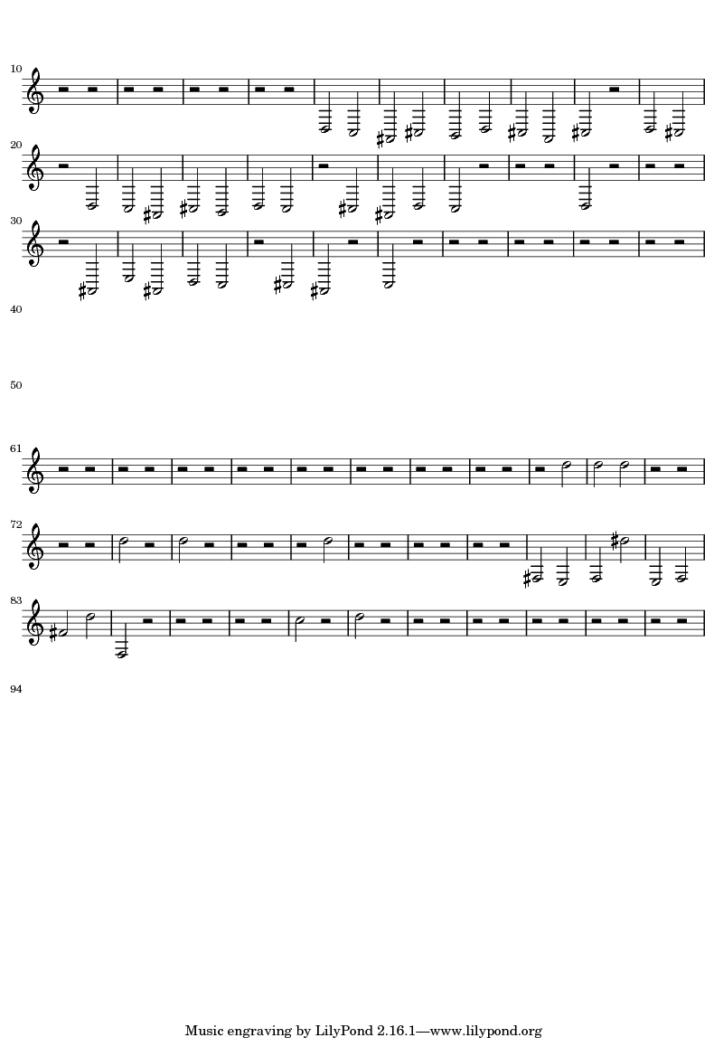Illustration 5: 4th Result from couchplayin2.wav, 28 Feb 2013

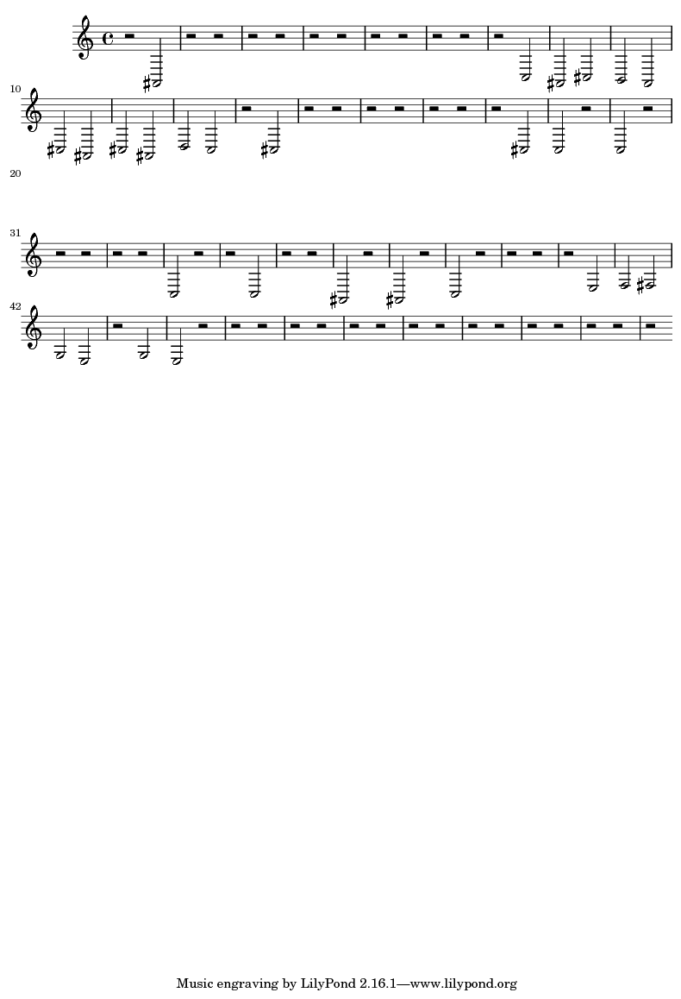Illustration 6: 5th Result from couchplayin2.wav, 28 Feb 2013
Conclusions and Analysis:
An analysis of the output data shown in the preceding section has interesting implications about my automatic music transcription program. Clearly, in it's current state, my program is incapable of accurately producing tempo and rhythm (as it displays all notes as half notes). This was more a design choice than an experimental-programming error; there was not enough time to attempt both pitch detection and rhythm tracking, so the more important of the two tasks was chosen to be undertaken.
In regards to the accuracy of my pitch-detection algorithm, the results obtained are not favorable. With a base knowledge of music, it is very clear that all six trials of couchplayin2.wav do not map accurately to what is being played. Reading the sheet music while listening to the file clearly indicates that the frequencies presented don't match. Unfortunately, without knowing the exact notes played in that audio file, it is impossible for me to determine the degree of error for my code.
When utilizing self-recorded audio files of known note-frequency, I still am not able to ascertain any useful results. While I do know the notes being played in these files, my program returns a blank piece of sheet music for all of these alternative trials. This is most likely due to some sort of noise interference due to a combination of the camera, recording software and recording environment. Although these sound files would be useful in determining the accuracy of my program, they ultimately have little use due to noise-processing issues.
One interesting discovery from this program is through the various couchplayin2.wav results. The different trials each featured a differing manipulation of two parameters in the algorithm, noise and time duration. By manipulating the threshold for noise detection, I am able to determine which frequencies are phased in and out of my sheet music. Meanwhile, playing with the length of the sample given to the FFT will manipulate this same frequency due to sinusoidal windowing. With each increasing trial, duration and the noise-threshold were lowered; ironically, this produced results that are plausibly more in-line with what the actual sheet music for couchplayin2.wav would look like. This leads me to the conclusion that noise and duration do have an impact on music transcription, but to an unknown degree; more experimentation must be done to determine this exact order.
Finally, another unique piece of information was gathered. More trials were run than reported in the results section on couchplayin2.wav. However, all of these non-represented datasets were run using the same parameters of noise and time as the results displayed above. Every time code was run on this file under the same conditions, the exact same result was returned. Consistency like this is important and leads me to better trust the validity of my results.
As previously mentioned, more trials must be run using my code. These trials will consist of manipulations of both time and noise, to determine the optimal level for a given sound file, as well as on various other audio files to determine my program has universal applications. After that, I will be able to take the current state of my program from a pseudo-tuner to transcription software, complete with a more advanced graphics user interface.
References:
⁴Bacon, R. A., Carter, N. P., and Messenger, T. “The Acquisition, Representation and Reconstruction of Printed Music by Computer: A Review.” Computers and the Humanities. Vol.22, No.2 (1988): 117 – 136. JSTOR. Web. 9 March 2012.
³Bello, Juan Pablo, Monti, Guliano and Sandler, Mark. “Techniques for Autmoatic Music Transcription.” King's College London. Web. 9 March 2012.
Cemgil, Ali Taylan. “Bayesian Music Transcription.” PDF File. 14 Sept 2004. Web. 12 Nov 2012.
Cheng, Xiaowen, Hart, Jarod V., and Walker, James S. “Time-frequency Analysis of Musical Rhythm.” PDF File. Web. 2 Jan 2013.
⁵Galler, Bernard A. and Piszczalski, Martin. “Automatic Music Transcription.” Computer Music Journal. Vol. 1, No. 4 (1997): 24 – 31. JSTOR. Web. 9 March 2012.
¹Galler, Bernard A., and Piszczalski, Martin. “Computer Analysis and Transcription of Performed Music: A Project Report.” Computers and the Humanities. Vol. 13, No.3 (1979): 195-206. JSTOR. Web. 9 March 2012.
Glover, John, Lazzarini, Victor, and Timoney, Joseph. “Python for Audio Signal Processing.” The Sound and Digital Music Research Group, National University of Ireland. PDF File. Web. 8 Jan 2013.
Goldberg, Imri. “base_tools.py.” 2007. Python file.
Goldberg, Imri. “fft_utils.py.” 2007. Python file.
Goldberg, Imri. “pytuner.py.” 2007. Python file.
Klapuri, Anssi. “Automatic Music Transcription.” Institute of Signal Processing, Tampere University of Technology. PDF File. Web. 12 Nov 2012.
Lomont, Chris. “The Fast Fourier Transform.” lomont.org. Jan 2010. Web. 11 Sept 2012.
LDS Dactron. “Understanding FFT Windows.” 2003. PDF File. Web. 22 Oct 2012.
²Lu, David. “Automatic Music Transcription Using Genetic Algorithms and Electronic Synthesis.” 25 April, 2006. Web. 9 March 2012.
“Performing FFT Spectrum Analysis.” Avant!. PDF File. Web. 8 Jan 2013.
Raphael, Christopher. “Automated Rhythm Transcription.” Department of Mathematics and Statistics, University of Massachusetts, Amherst. PDF File. 21 May 2001. Web. 12 Nov 2012.
Sek, Michael. “Frequency Analysis – Fast Fourier Transform (FFT).” Victoria University. PDF File. Web. 9 Oct 2012.
Takeda, Haruto, Nishimoto Takuya, and Sagayama, Shigeki. “Rhythm and Tempo Analysis Towards Automatic Music Transcription.” Graduate School of Science and Technology, University of Tokyo. PDF File. Web. 2 Jan 2013.
⁶Wellhausen, Jens. “Towards Automatic Music Transcription: Extraction of MIDI-Data out of Polyphonic Piano Music.” Auschen University Institute of Communications Engineering. Web. 9 March 2012.

