**DNA Sequence Identification – a BLAST Tutorial**

1. Download the “BLAST.fasta” file from canvas
2. Right-click the file, choose “Open With…”, select a text editor program to open the file with (e.g., Notepad, Notepad++, TextEdit, BBEdit, etc.)
3. Inspect the contents of the file, they should look as follows:

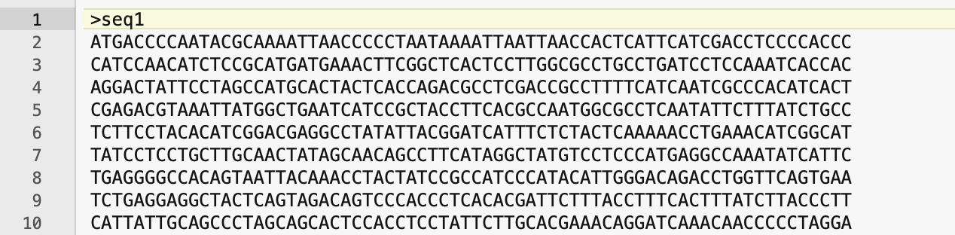

1. Open a browser window and Google: “**Basic Local Alignment Search Tool**”, click the first link
2. Click the button that says **“Nucleotide BLAST”**
3. Copy and paste the entire sequence from the BLAST.fasta file into the Query Sequence box

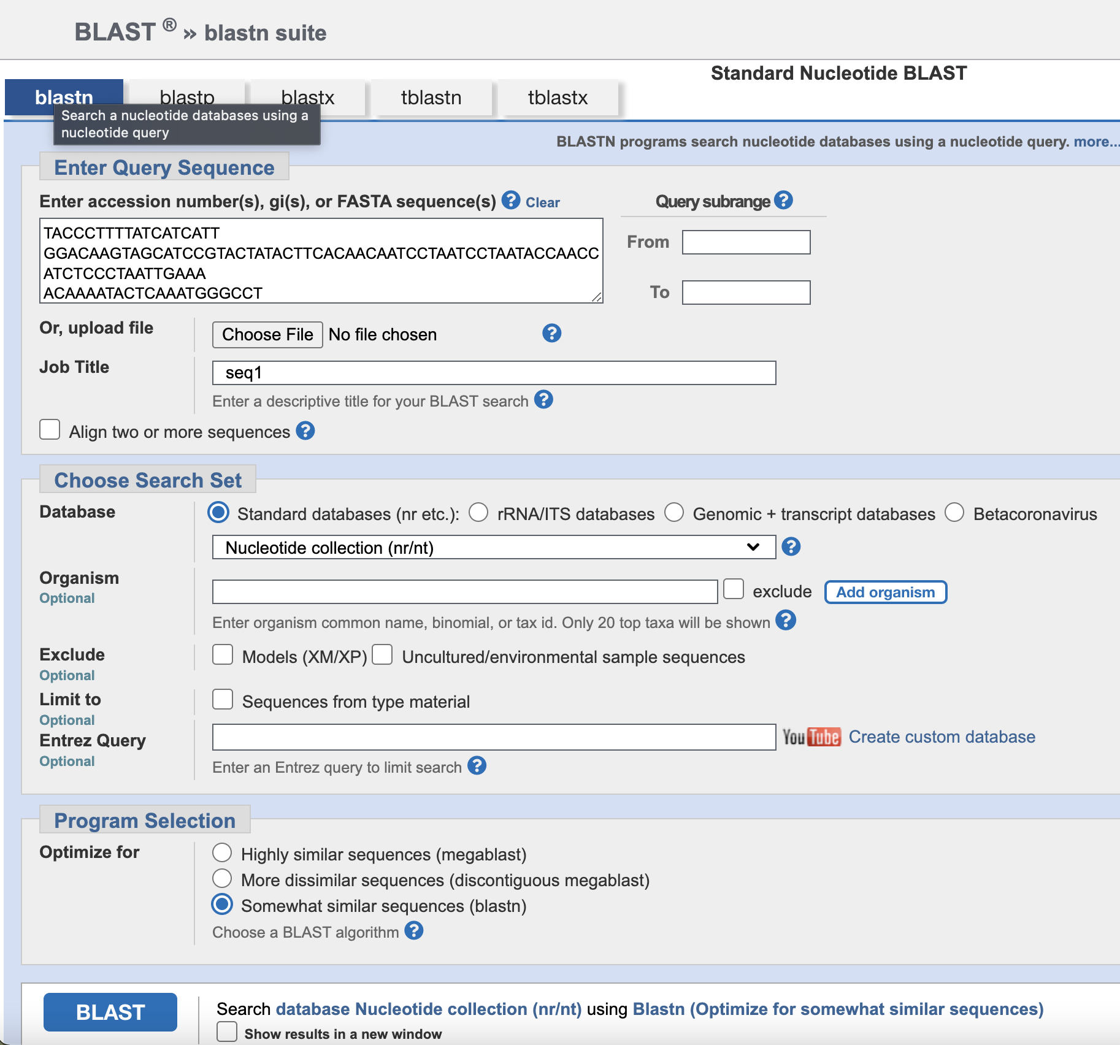

1. Press the “BLAST” button, wait for the process to complete. This may take a minute or so.
2. Which organism does the DNA sequence appear to come from? Clicl on the top hit to look at the alignment.
3. Click the “GenBank” link at the top of the alignment:

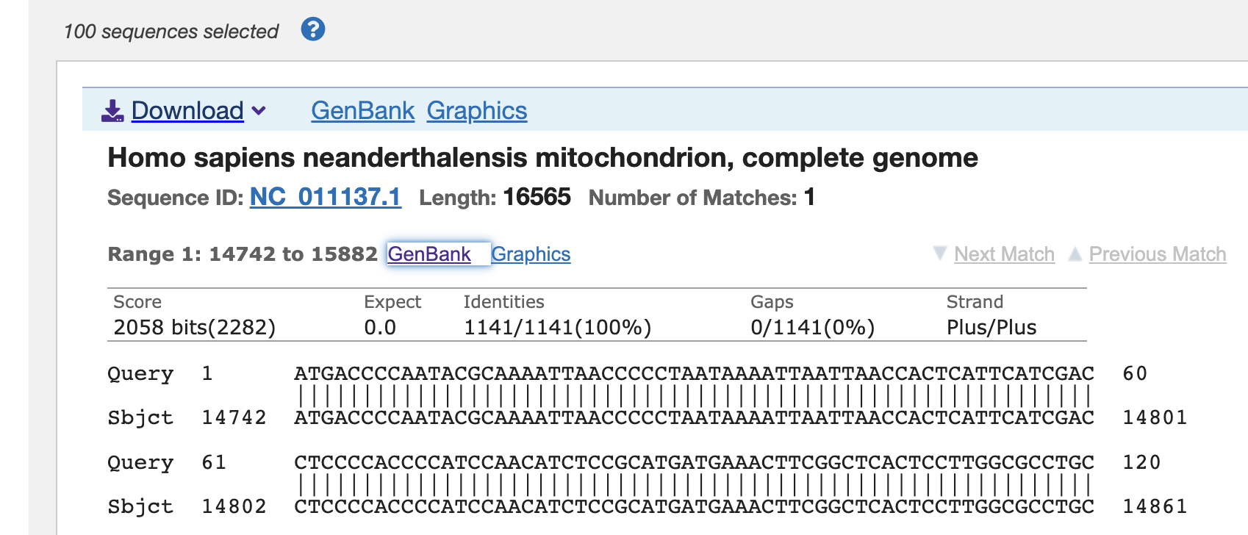

1. The page that pops up will have a description of the BLAST hit in question. Are there any known genes in the region? If so, click the link next to the “protein_id=YP…”.
2. Open a new tab and navigate to https://www.uniprot.org/. In the search bar there, search for the protein product you identified in the BLAST search. Scroll down to the human version and click the link.
3. Read through the resulting page. Write down any information that you think is interesting about the function of that protein.
4. Scroll down to the box labeled “Structure”. Once the image of the protein appears, use your mouse to rotate the protein structure three dimensionally. What kinds of structures do you observe? Helix? Pleated sheet? Loops?
5. Open a new tab and proceed to <https://genome.ucsc.edu/>. Cllick the Genome Browser link, and in the position search term, enter the gene name.

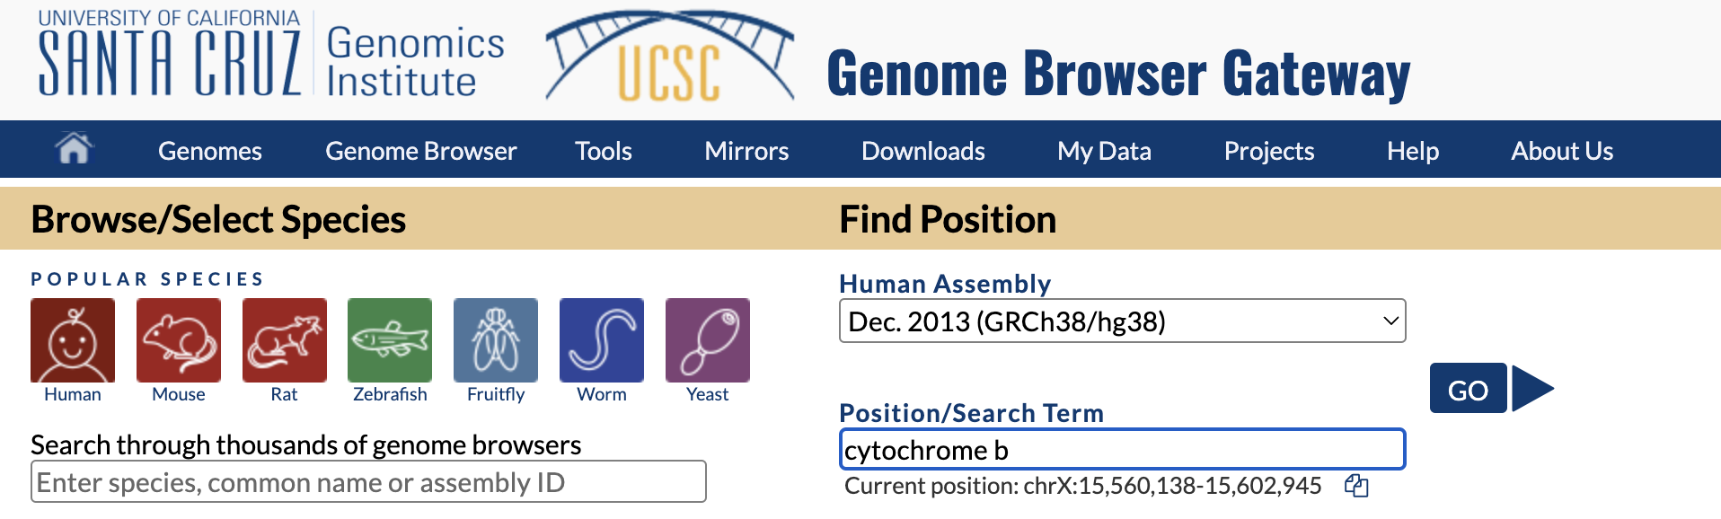

1. In the resulting page, click the link that says “MT-CYB”. What chromosome is the gene found on? Click on the blue bar:

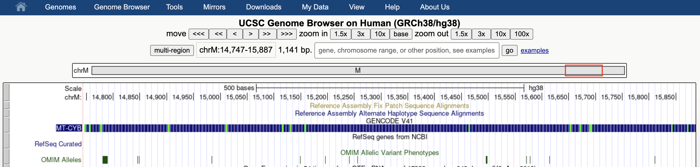

1. On the resulting page, scroll down to the graph of gene expression. In which human tissue is this gene expressed at the highest level? The lowest?