Joseph Sharp Halpin

**CPE301 – SPRING 2018**

Design Assignment 2

**DO NOT REMOVE THIS PAGE DURING SUBMISSION:**

The student understands that all required components should be submitted in complete for grading of this assignment.

|  |  |  |  |
| --- | --- | --- | --- |
| **NO** | **SUBMISSION ITEM** | **COMPLETED (Y/N)** | **MARKS**  **(/MAX)** |
| 1 | COMPONENTS LIST AND CONNECTION BLOCK DIAGRAM w/ PINS |  |  |
| 2. | INITIAL CODE OF TASK 1/A |  |  |
| 3. | INCREMENTAL / DIFFERENTIAL CODE OF TASK 2/B |  |  |
| 3. | INCREMENTAL / DIFFERENTIAL CODE OF TASK 3/C |  |  |
| 3. | INCREMENTAL / DIFFERENTIAL CODE OF TASK 4/D |  |  |
| 3. | INCREMENTAL / DIFFERENTIAL CODE OF TASK 5/E |  |  |
| 4. | SCHEMATICS |  |  |
| 5. | SCREENSHOTS OF EACH TASK OUTPUT |  |  |
| 5. | SCREENSHOT OF EACH DEMO |  |  |
| 6. | VIDEO LINKS OF EACH DEMO |  |  |
| 7. | GOOGLECODE LINK OF THE DA |  |  |
|  |  |  |  |
|  |  |  |  |

1. **COMPONENTS LIST AND CONNECTION BLOCK DIAGRAM w/ PINS**

Components used: ATmega328p chip, atmel studio, red LED, push button, and 10K resistors.

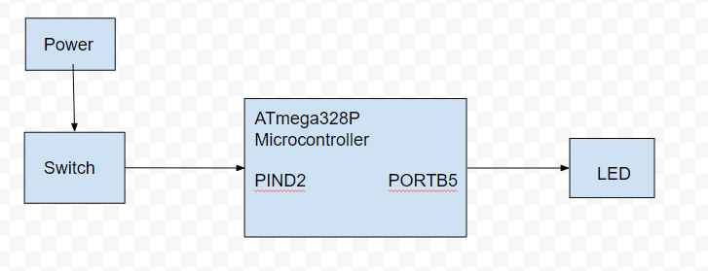

1. **DEVELOPED CODE OF TASK 1/A AND 1/C**

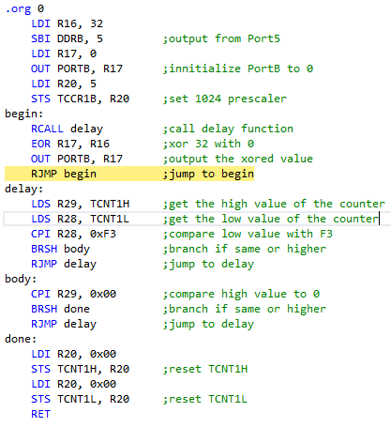

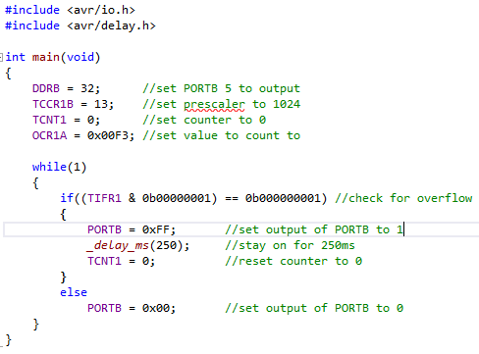

**DEVELOPED CODE OF TASK 2/A AND 2/C**

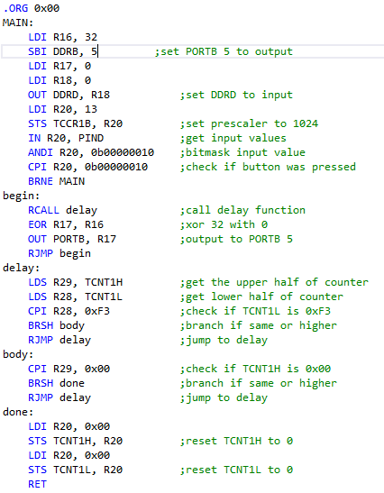

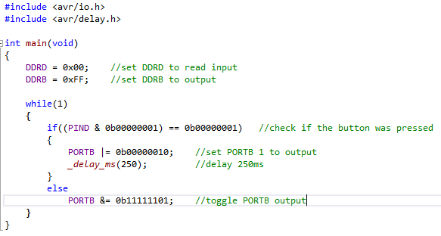

**DEVELOPED CODE OF TASK 3/A AND 3/C**

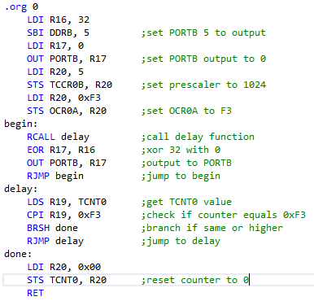

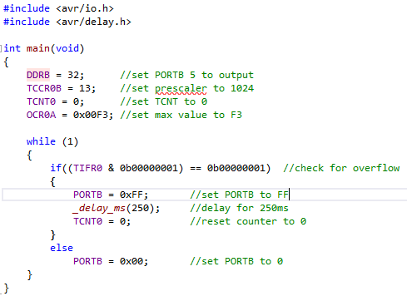

**DEVELOPED CODE FOR TASK 4/A AND 4/C**

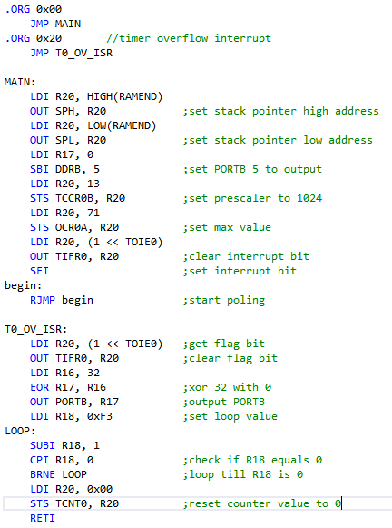

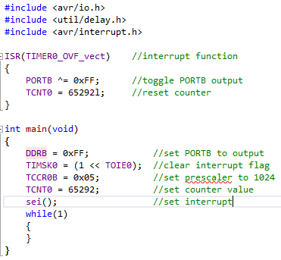

**DEVELOPED CODE FOR TASK 5/A AND 5/C**

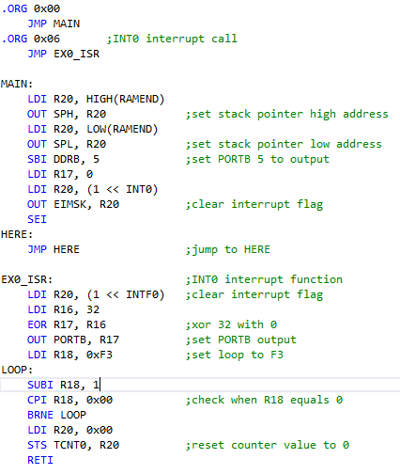

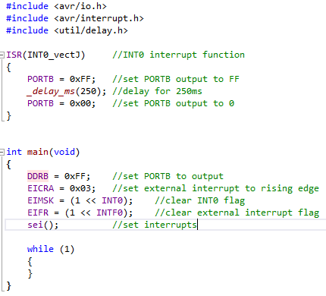

1. **SCHEMATICS**

Task 1, 3, and 4 schematic:

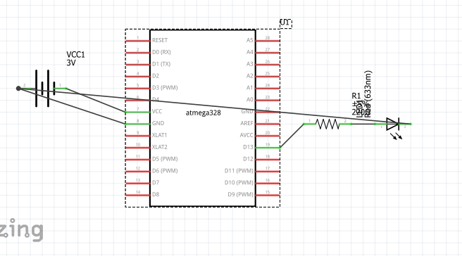

Task 2 and 5 schematic:

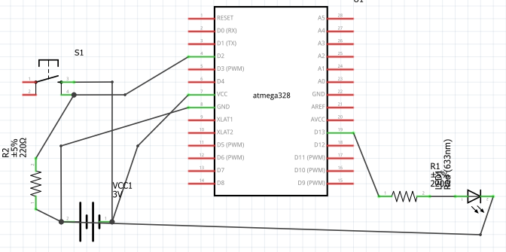

1. **PICTURES OF CIRCUIT SETUP**

TASK 1:

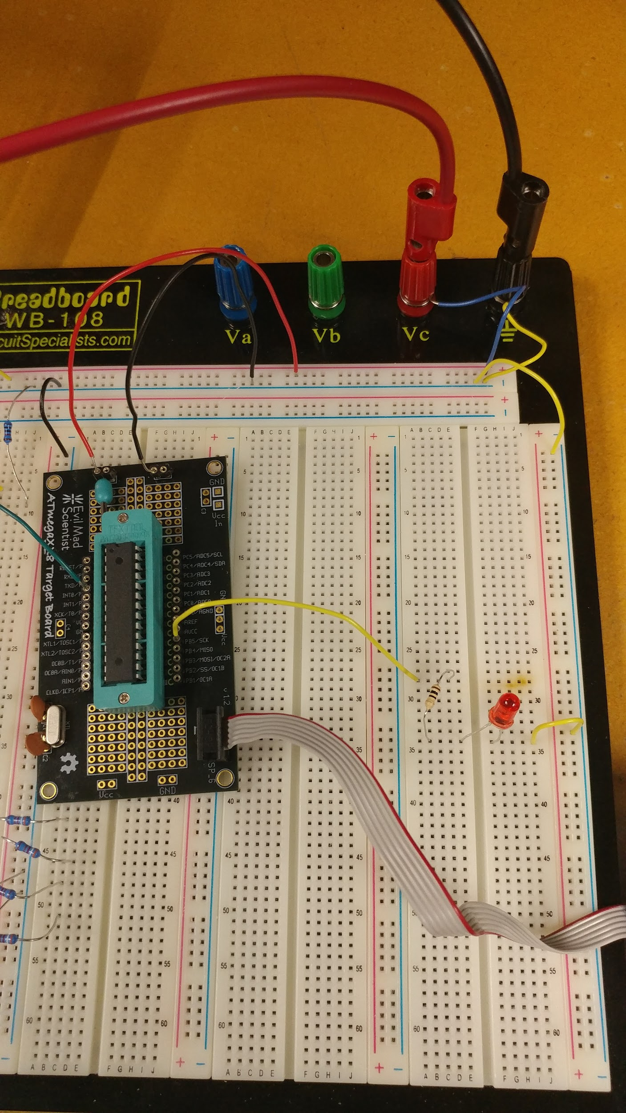

TASK 2:

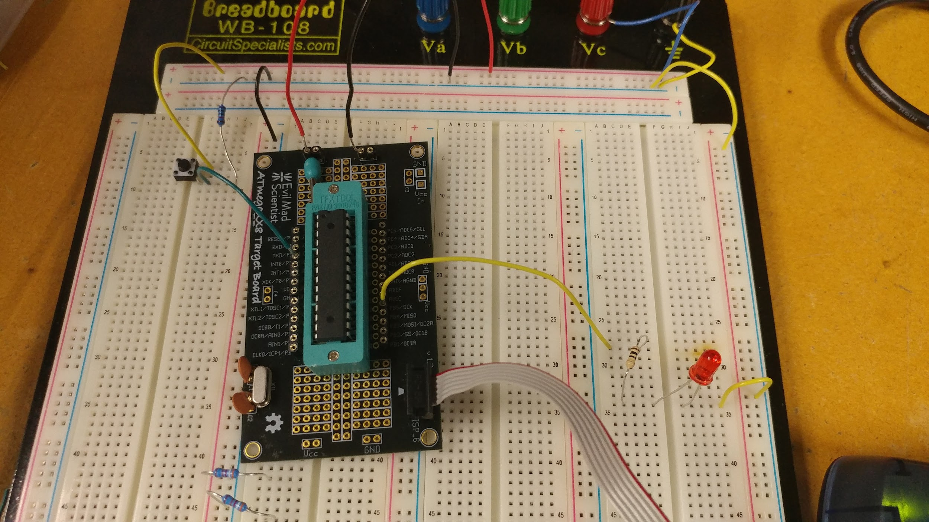

TASK 3:

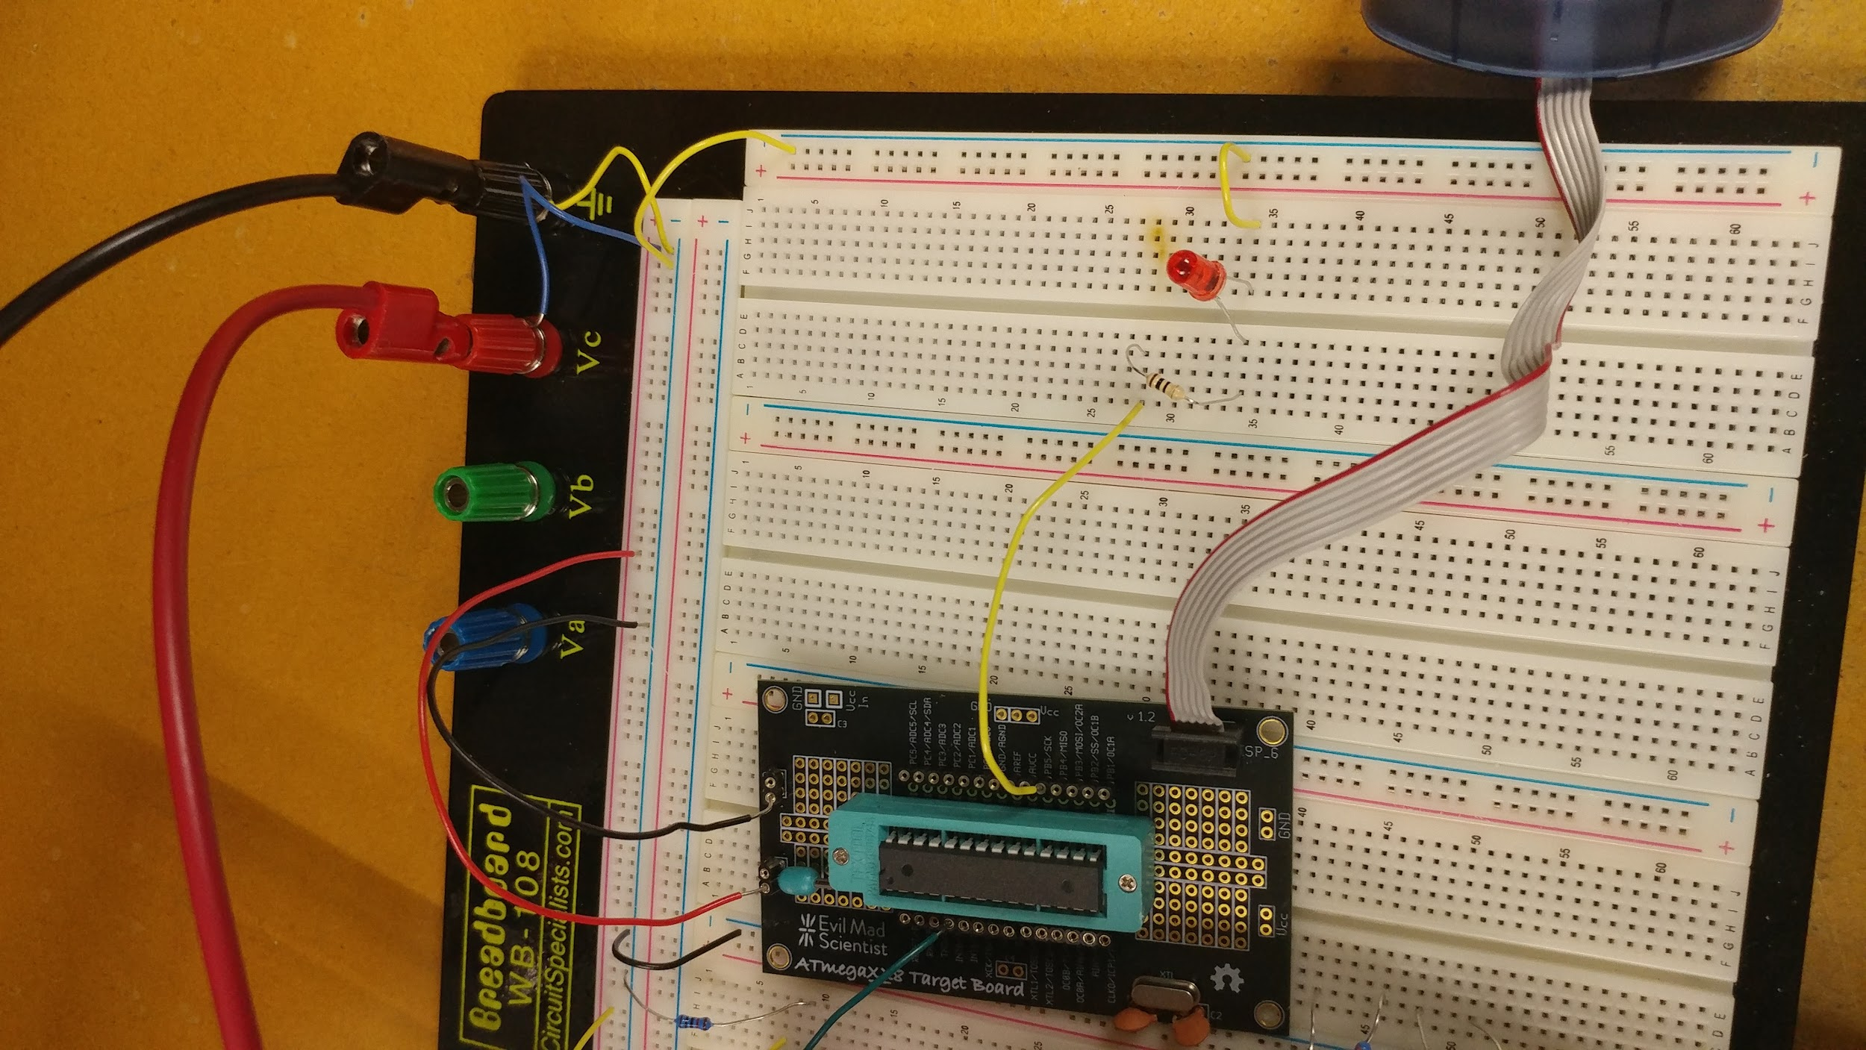

TASK 4:

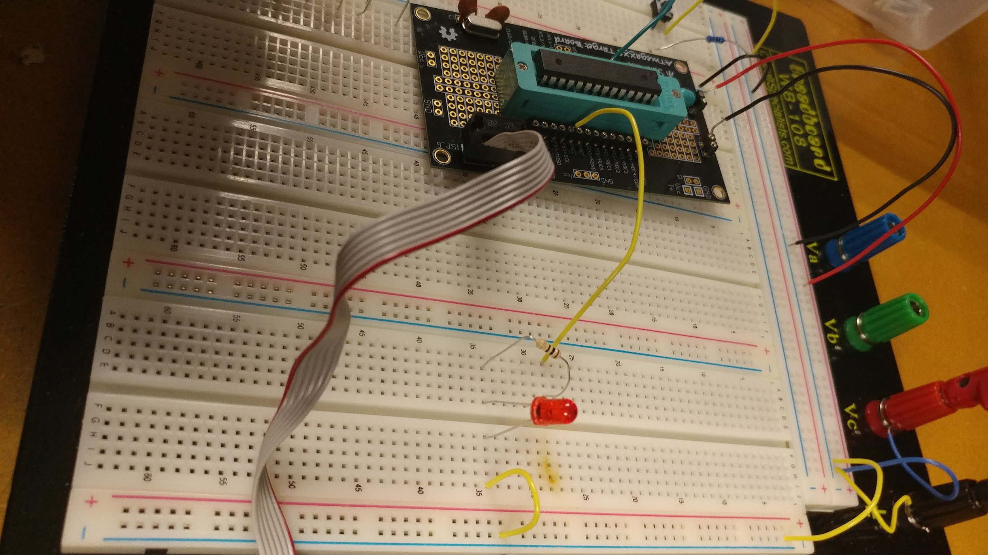

TASK 5:

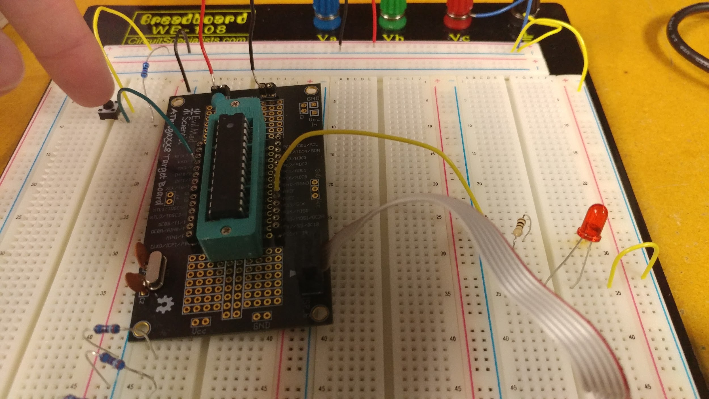

1. **VIDEO LINKS OF EACH DEMO**

<https://youtu.be/kPHP71xCFUY>

1. **GITHUB LINK OF THIS DA**

<https://github.com/jsharpin/My-Repos>

**Student Academic Misconduct Policy**

<http://studentconduct.unlv.edu/misconduct/policy.html>

“*This assignment submission is my own, original work*”.

Joseph Sharp Halpin