AI RESEARCH PORTFOLIO | UPDATED SEPTEMBER 2026

From Four-view Garment Images to Structured Sewing Patterns
Panel-aware visual pretraining and canonical boundary-configuration retrieval
I built a paired corpus that links neutral four-view garment renders to editable analytic sewing-pattern data, then tested which intermediate targets can be learned reliably before attempting full reconstruction. The latest controlled comparison shows that retaining panel interfaces in the mask target improves both boundary localization and downstream panel-level L/Q/C/A configuration selection.
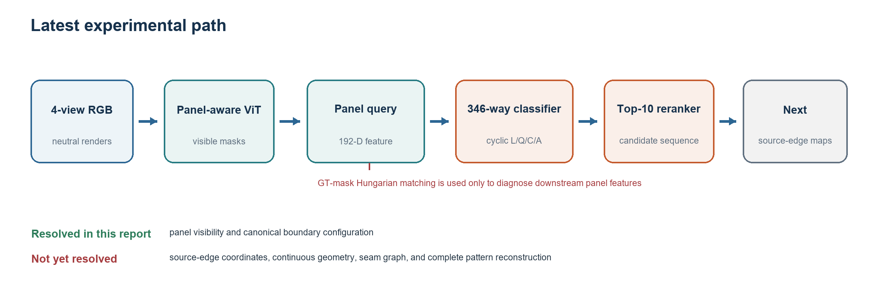
3,450  paired garments | 13,800  neutral RGB views | 0.681  matched-panel IoU | 58.95%  panel-level reranked top-1

Current result
The model identifies visible panel regions and selects a canonical edge-type cycle for a GT-matched panel query. It does not yet recover source-edge coordinates, continuous geometry, seams, fit, or a complete editable pattern.
github.com/jsharrylee/garment-benchmark

01 RESEARCH SCOPE

Research question
Can four neutral views of a draped garment provide enough visual evidence to recover the structure of its original 2D sewing pattern? I treat the output as an editable program rather than a raster outline.
Target hierarchy
garment views -> visible panels -> cyclic boundary primitives -> continuous curve geometry -> sewing graph

What one prediction must eventually contain
Level | Target | Why it matters
Panel set | How many panels and which visible regions belong together | Separates pieces without imposing a global order
Boundary cycle | Ordered L/Q/C/A edges within each panel | Preserves the closed contour and primitive types
Continuous geometry | Scale, directions, vertices, controls, arc parameters | Reconstructs the actual 2D contour
Sewing graph | Pairs of source edges | Defines how panels are assembled

Scope of the latest experiment
The latest model reaches the second level only. It predicts a canonical cyclic sequence such as 4:LLLC for each visible panel query. Start-edge rotation and traversal reversal are treated as equivalent. Coordinates and seams remain outside the evaluated output.
Input | Latest supervised output | Evaluation unit
Front, back, left, right RGB | Visible-panel mask and one of 346 cyclic L/Q/C/A classes | 2,027 internal selection panels after GT-mask matching

Interpretation
The reported 58.95% is panel-level line-configuration accuracy under diagnostic GT-mask matching. It is not a garment-level reconstruction rate.

02 DATA AND REPRESENTATION

Paired corpus and analytic target
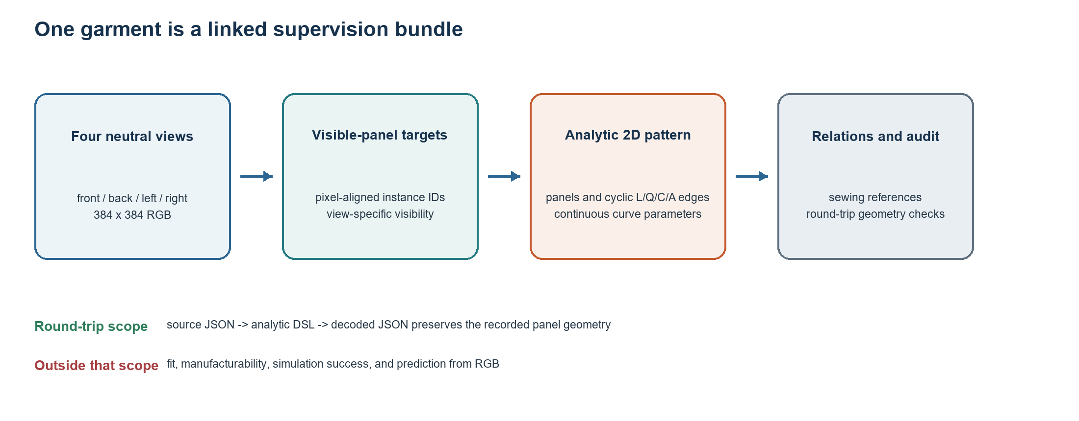
3,450  garments | 13,800  4-view RGB images | 37,031  panels | 251,335  source edges

Dataset inventory
Item | Count or format | Role
RGB | 4 x 3,450 = 13,800 at 384 x 384 | Neutral orthographic renders from existing simulated meshes
Patterns | 37,031 panels and 251,335 edges | Editable source geometry linked by garment ID
Sewing | 104,064 stitch records | Source-edge relations retained for later graph prediction
Primitives | L 190,505 / Q 22,191 / C 17,260 / A 21,379 | Line, quadratic/cubic Bezier, and circular arc
Fixed split | 2,613 effective train / 173 validation / 165 untouched test | Two exact training duplicates removed; test remains unused

Round-trip audit
For every source pattern, the converter stored panel-local analytic commands and decoded them back to geometry. The audit compared endpoints, 257 points along each curve, curve parameters, panel closure, edge partition, and sewing references.
What the audit proves
The stored analytic representation preserves the recorded source geometry. It does not prove that the garment fits, sews, simulates, or can be predicted from RGB.

03 TARGET AUDIT

Panel interfaces were missing from the loss
The first visible-panel target marked panel-to-panel interfaces as gray ignore pixels. Downsampling from 384 x 384 to 56 x 56 expanded those ignored regions, so the model could learn broad panel areas while receiving no penalty at many internal boundaries.
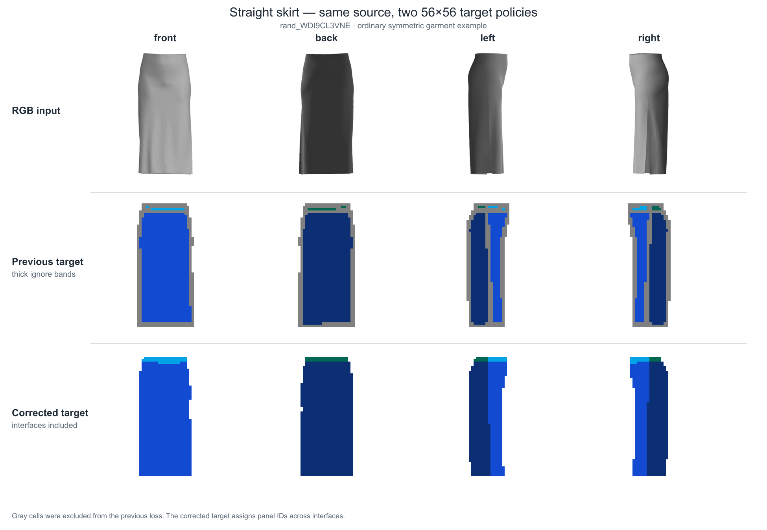
The gray band is an ignored target region, not an input feature or a predicted seam. The corrected target assigns each internal cell to the majority panel ID.

Boundary-inclusive target policy
Previous target | Corrected target
Ignored panel-to-panel bands | No ignore band between panels
Conservative all-valid rule after downsampling | Majority valid panel ID in each 56 x 56 cell
Ignore regions expanded around boundaries | Only genuinely ambiguous outer anti-aliasing pixels are excluded
Internal boundary localization was not directly scored | Internal boundary cells contribute to loss and IoU

Controlled change
The model family, ImageNet initialization, split, optimizer, and seed stayed fixed. Only the target-generation policy changed.

04 EXPERIMENT A

Boundary-inclusive panel-mask pretraining
A ViT-B/16 initialized from torchvision weights was fine-tuned on four-view RGB to predict sample-local visible panel instances. Training used 2,259 garments, checkpoint selection used 154 garments, and seed 17 selected epoch 14 after early stopping at epoch 19. The official test split was not evaluated.
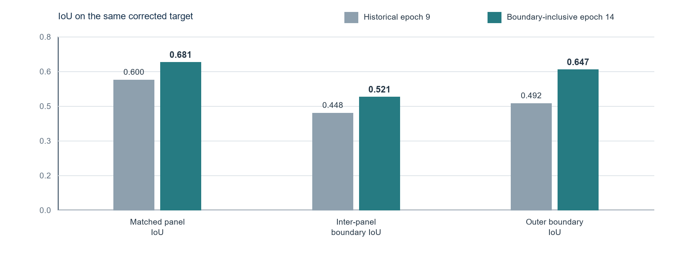
Metric on the same corrected target | Historical epoch 9 | Boundary-inclusive epoch 14 | Change
Matched-panel IoU | 0.6003 | 0.6813 | +0.0810
Inter-panel boundary-band IoU | 0.4475 | 0.5212 | +0.0737
Outer boundary-band IoU | 0.4924 | 0.6474 | +0.1550
Panel-count MAE | 1.5584 | 1.7727 | +0.2143, worse

Finding
The corrected target improved mask geometry and both boundary IoUs, but it did not improve every panel metric. Panel-count MAE became worse. The older reported IoU near 0.86 used the easier ignored-boundary target and is not comparable.

04 EXPERIMENT A

Qualitative panel-mask evidence
The selected ordinary garments show where the model works without relying on highly unusual silhouettes. The lower group shows the same checkpoint's weakest cases. All examples come from the internal selection split and were chosen after viewing the results.
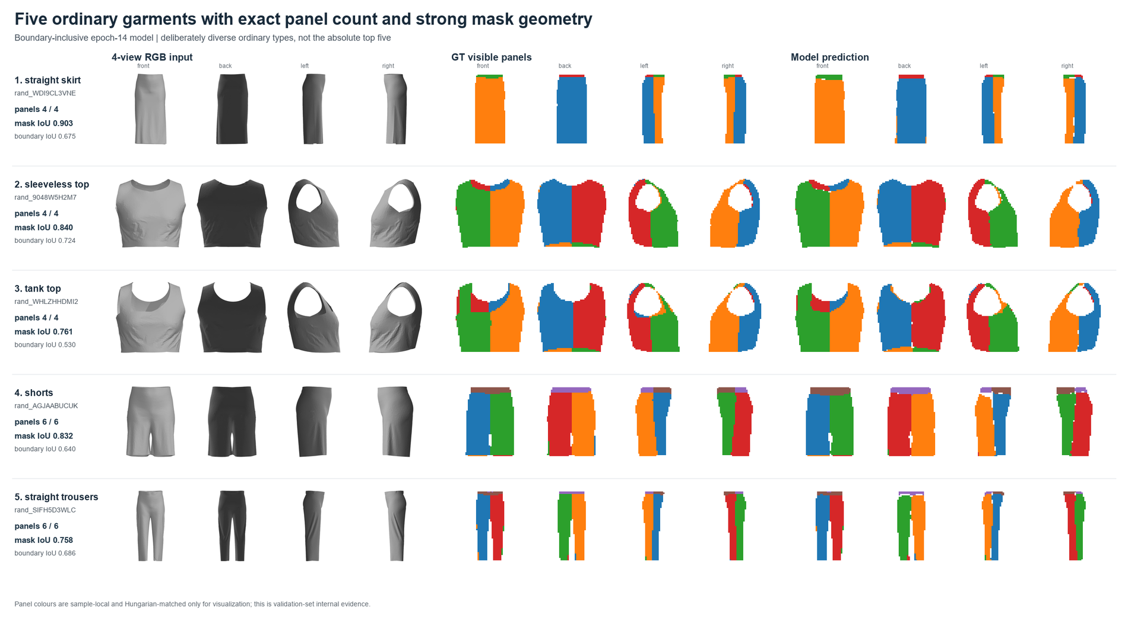
Ordinary garments with exact panel count and relatively strong matched-mask geometry. Colors are sample-local and matched to GT for visualization.
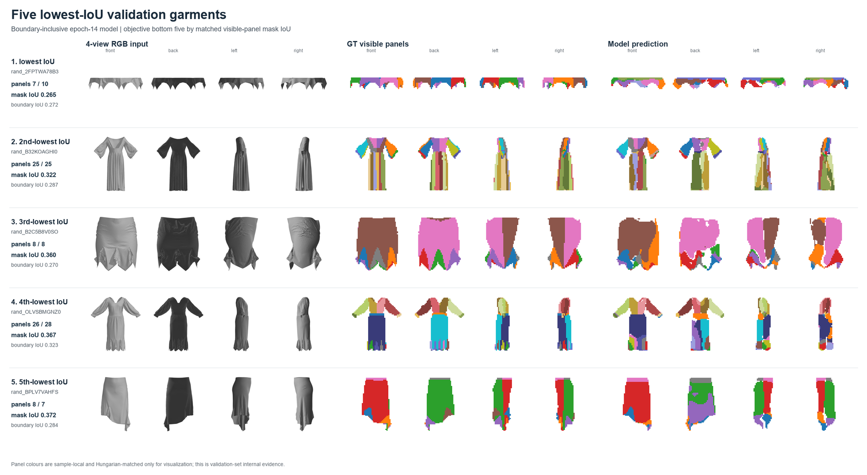
Low-IoU cases expose thin panels, occlusion, multiple small pieces, and over- or under-segmentation.

05 FAILED FULL-GENERATION BASELINES

Direct decoding failed before retrieval
I first asked a decoder to create the entire variable-topology pattern from a front RGB image. This was a useful failure: it separated good teacher-forced token accuracy from unstable free generation.

Autoregressive command sequence
Development metric | Generic ViT | Historical panel ViT
Teacher-forced command accuracy | 0.9320 | 0.9288
Panel-count MAE | 2.6590 | 2.5202
Edge-count MAE | 16.4046 | 14.4162
Mean maximum closure gap | 52.3205 cm | 47.7303 cm
Seam macro-F1 | 0.1056 | 0.0979
Valid pattern rate | 0 / 173 | 0 / 173

Set cycle and graph reformulation
I removed arbitrary panel ordering, represented each panel as a cyclic boundary, represented seams as an unordered graph, and enforced closure by construction. This reduced one source of error but did not solve topology, geometry, or seam prediction.
Metric | Generic ViT | Historical panel ViT
Panel and edge counts both exact | 2.89% | 6.94%
L/Q/C/A edge accuracy | 48.80% | 49.41%
Scale-normalized geometry error | 0.9752 | 0.9664
Quotient seam macro-F1 | 0.2274 | 0.2355

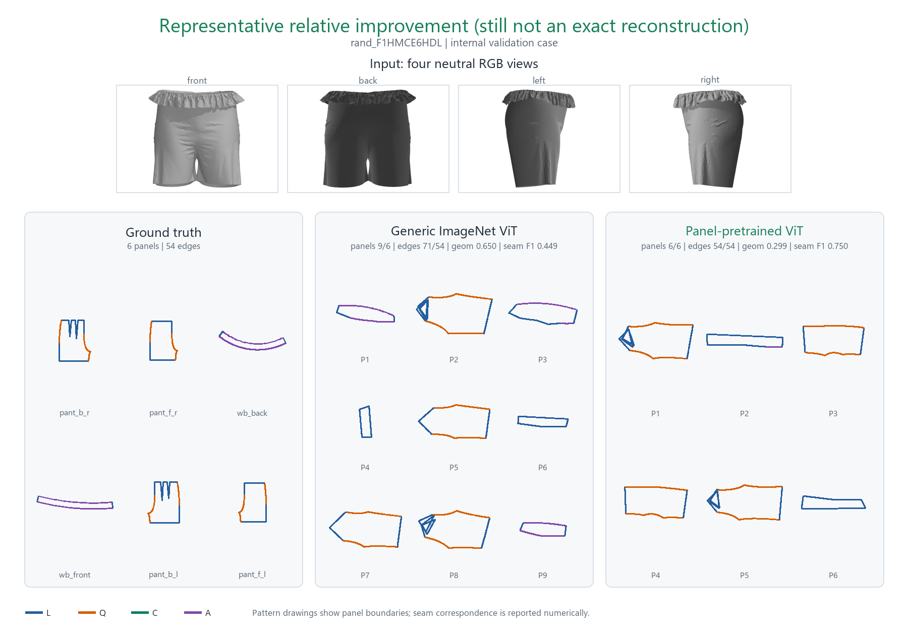 | 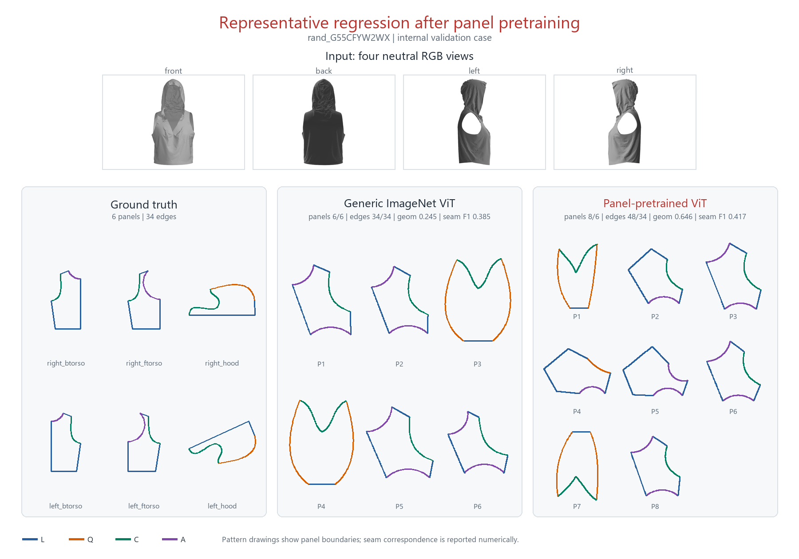
A relative improvement after the set/cycle/graph change. | A counterexample where the new representation still over-predicts structure.
Decision
Autoregressive exposure bias was not the only bottleneck. The next model would start from retrieved valid panels instead of generating every topology and coordinate from zero.

06 EXPERIMENT B

Panel-by-panel retrieval reduced the search space
A target garment does not need one training garment with the same complete pattern. Its bodice, sleeve, waistband, and other panels can each retrieve a different valid starting panel. This removes the unnecessary requirement that panel counts match at garment level.
12,613  bank garments | 129,308  bank panels | 99.89%  oracle panel-structure coverage | 98.84%  garments with every panel covered

Panel bank | Garments | Panels | Edges | RGB available
Effective training set | 2,613 | 27,098 | 186,935 | Yes
Generated extension | 10,000 | 102,210 | 705,599 | No
Total | 12,613 | 129,308 | 892,534 | Partly

Oracle coverage answered one question only
Using the target's known canonical edge-type cycle, 1,761 of 1,763 validation panels had at least one structurally matching bank candidate. This shows that useful starting structures exist. It does not show that an image model can select them.

Why continuous geometry was deferred
Retrieval target | Recall at 5 | Interpretation
Compatible structure | 41.44% | Visual query sometimes found the correct primitive cycle
Near continuous geometry | 0.99% | Scale, directions, vertices, controls, and arcs were too difficult to retrieve jointly

Revised task
First select the boundary count and cyclic L/Q/C/A configuration. Learn source-edge locations and continuous geometry only after the discrete structure is reliable.

07 EXPERIMENT C

Canonical line-configuration selection
Each panel was assigned one of 346 classes defined by edge count and the cyclic sequence of line primitives. Rotating the start edge or reversing traversal does not change the class. A small MLP proposes ten classes, then a GRU-based reranker compares the panel query with each candidate sequence.
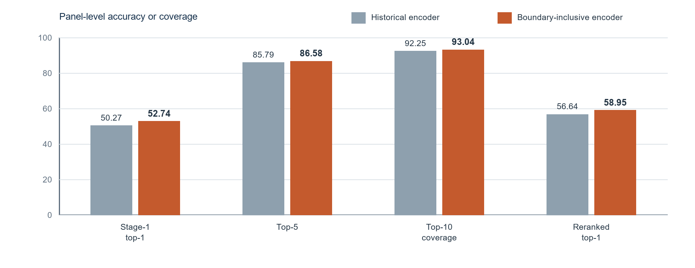
Same 17,744 train and 2,027 selection panels | Historical encoder | Boundary-inclusive encoder | Change
Stage-1 top-1 | 50.27% | 52.74% | +2.47 pp
Top-5 | 85.79% | 86.58% | +0.79 pp
Present-class macro recall | 20.01% | 23.97% | +3.97 pp
Target present in top 10 | 92.25% | 93.04% | +0.79 pp
Reranked top-1 | 56.64% | 58.95% | +2.32 pp
Conditional top-1 when covered | 61.39% | 63.36% | +1.97 pp

Controlled comparison
The exact same panel IDs, ordering, labels, classifier, reranker, and seed were reused. Only cached visual features from the two encoders changed.
Evaluation boundary
A GT visible-panel mask first Hungarian-matched model queries to source panels. This isolates the quality of the panel feature and line classifier; it is not an end-to-end panel discovery score.

07 EXPERIMENT C

What the classifier gets right and wrong
The center contour in each example is ground-truth geometry used to show where L/Q/C/A edges occur. It is not reconstructed by the model. The actual predictions are the Stage 1 and Final sequences shown beside it.
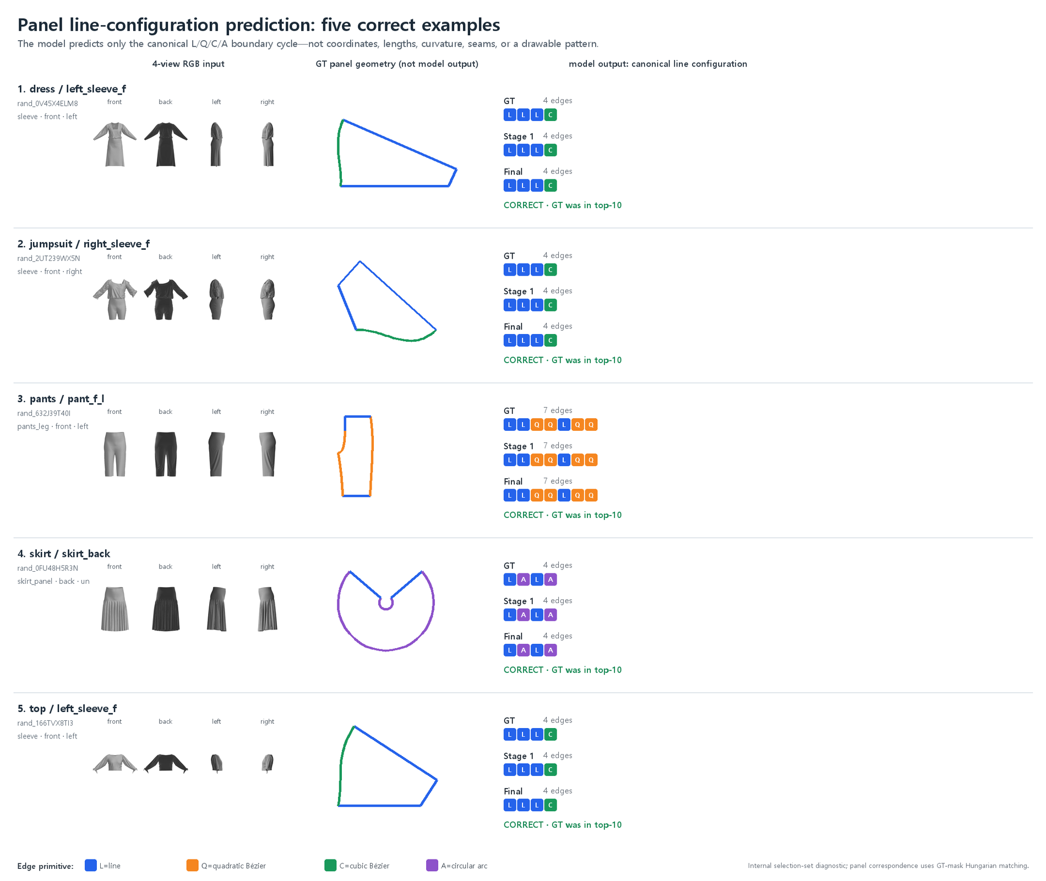 | 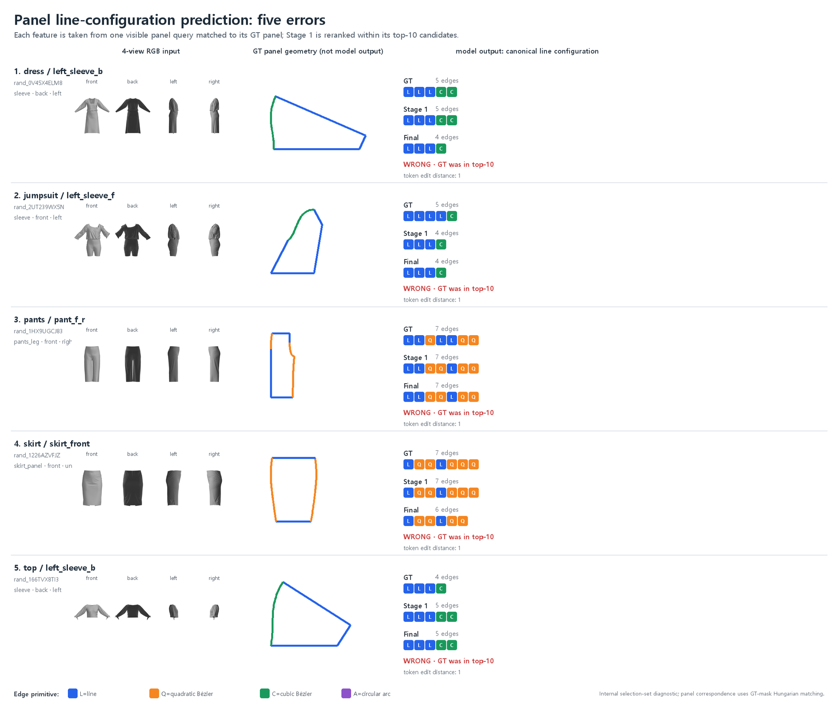
Correct panel-level configuration examples from the internal selection split. | Representative errors, often differing by one short edge or primitive type.

Error concentration
Selection outcome | Panels | Share or implication
Target present in top 10 | 1,886 / 2,027 | 93.04% candidate coverage
Final prediction correct | 1,195 / 2,027 | 58.95% panel-level top-1
Wrong although target was in top 10 | 691 | Candidate selection remains the main immediate error
Covered errors with edit distance at most 2 | 398 / 691 | 57.60% differ by few primitive edits
Covered errors with same or +/-1 edge count | 504 / 691 | 72.94% are close in edge count

The largest confusion was 4:LALA -> 4:LLLL (44 panels), followed by 4:LLLC -> 5:LLLCC (29) and 4:LLLL -> 4:LLLA (21). Panel-area supervision does not tell the encoder exactly where a source edge begins, where a short segment ends, or whether a local contour should be one curve or two.

08 NEXT EXPERIMENT

Source-edge supervision is the next controlled test
The latest errors point to edge boundaries rather than a lack of panel candidates. The next experiment will preserve panel-mask training and add automatically rendered source-edge centerlines, endpoint heatmaps, visibility masks, and an optional primitive-type head.
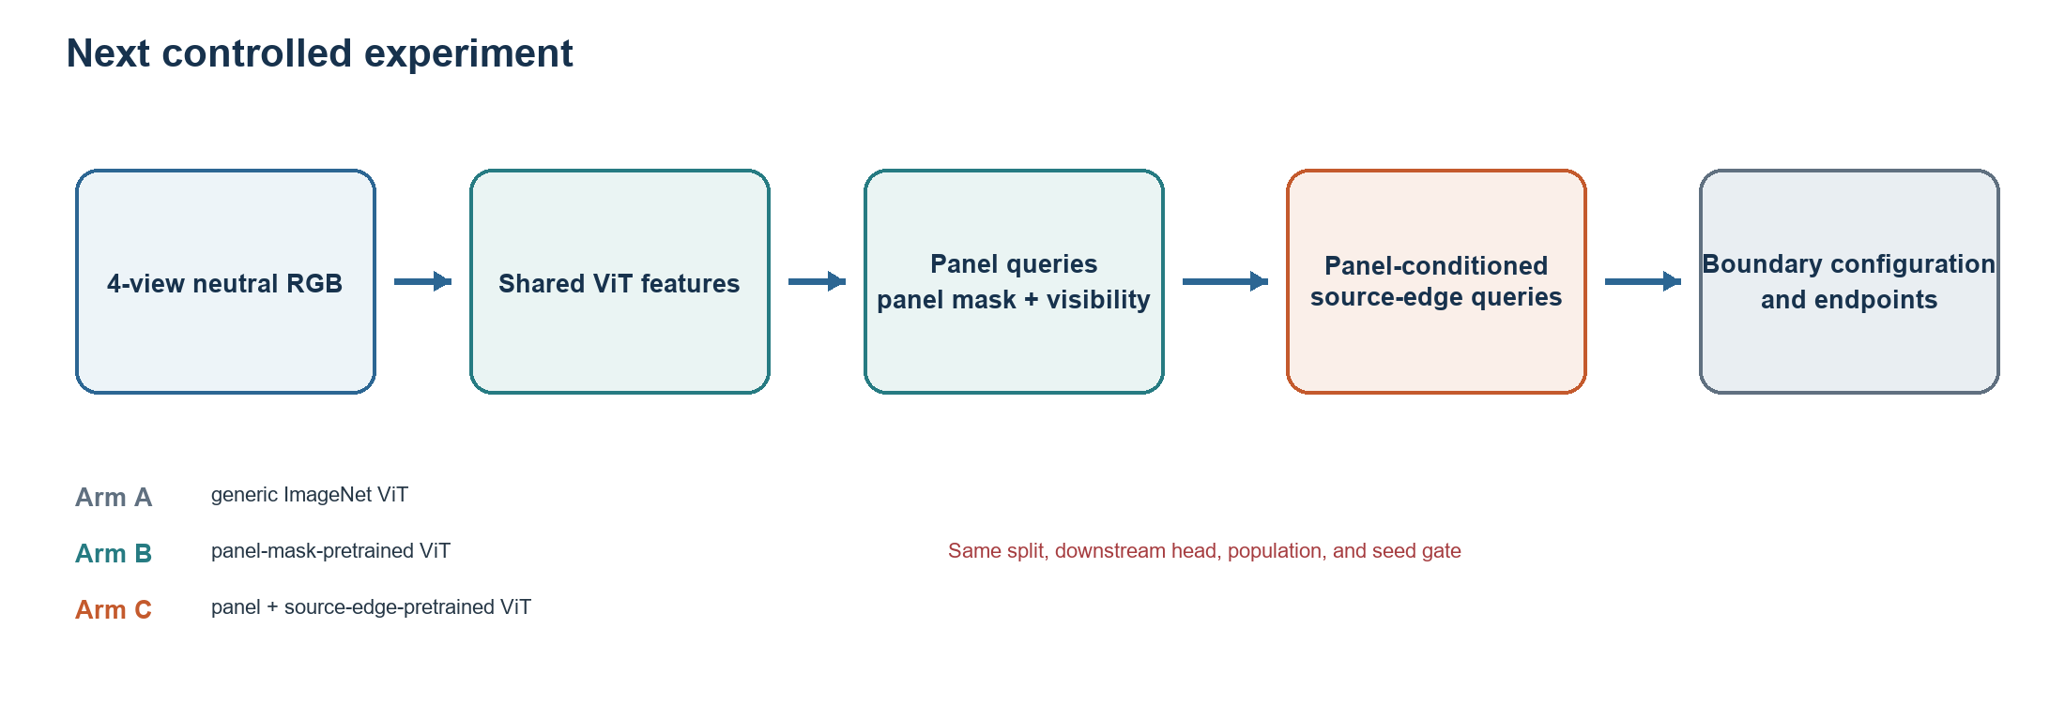

Pre-registered comparison
Arm | Encoder pretraining | Downstream comparison
A | Generic ImageNet ViT | Same panel query, classifier, reranker, and split
B | Visible-panel mask | Tests transfer from region-level supervision
C | Visible-panel mask plus source-edge supervision | Tests whether line localization raises configuration accuracy

Decision gates
- Run seed 17 first. Add common seeds only if source-edge pretraining improves held-out boundary and downstream configuration metrics.
- Keep checkpoint selection separate from downstream evaluation before opening the untouched 165-garment test split.
- If line configuration improves, add continuous source-edge geometry and seam prediction as separate modules rather than one coupled decoder.
Research decision
TokenLearner and flow-based refinement remain optional later stages. The current evidence supports testing target supervision and source-edge localization first.

09 EVIDENCE BOUNDARY

Current conclusion
The project now has a reproducible paired-data pipeline and a narrower, measurable learning result. Boundary-inclusive panel supervision improved mask geometry and raised canonical line-configuration selection on the same internal panel population. Complete sewing-pattern reconstruction remains unsolved.
Supported by current evidence | Not supported by current evidence
3,450 garments linked to 13,800 neutral renders and analytic patterns | End-to-end RGB-to-editable-pattern reconstruction
2,995 garments and 11,980 accepted visible-panel mask views | Recovery of continuous edge coordinates or curvature
Same-target mask and boundary A/B at one seed | Seam graph accuracy, manufacturability, fit, or simulation success
Panel-level 58.95% reranked cyclic L/Q/C/A top-1 under GT matching | Garment-level success or hidden-panel reconstruction
Oracle evidence that the panel bank covers 99.89% of validation structures | Generalization to real photos, other generators, or multiple seeds

Reproducibility and provenance
- Public repository: github.com/jsharrylee/garment-benchmark
- The repository publishes code, frozen manifests, aggregate metrics, and selected derived figures. Full source dataset archives and meshes are not redistributed.
- Latest numbers use a single internal seed and selection split. The official 165-garment test split remains untouched.
- GarmentCodeData v2 is used under its stated CC BY 4.0 terms; model and third-party code licenses are tracked separately.

References
[1] Korosteleva, M. et al. GarmentCodeData v2: 115,000+ made-to-measure garments with sewing patterns and simulated drapes. ETH Research Collection, 2024. https://doi.org/10.3929/ethz-b-000690432
[2] Dosovitskiy, A. et al. An Image is Worth 16x16 Words: Transformers for Image Recognition at Scale. ICLR, 2021.
[3] Carion, N. et al. End-to-End Object Detection with Transformers. ECCV, 2020.
[4] Ryoo, M. S. et al. TokenLearner: What Can 8 Learned Tokens Do for Images and Videos? NeurIPS, 2021.
Document status
Internal development portfolio updated 8 September 2026. All performance claims in this document are scoped to the experiments and populations stated on the same page.

