Portfolio Highlight — From Garment Views to
Editable 2D Sewing-Pattern Structure
Garment-benchmark | multiview garment understanding · vector pattern semantics · constrained editing
Problem
A visually plausible garment reconstruction can still be structurally wrong as a sewing pattern: the system may confuse panel roles, boundary functions, shared vertices, or seam partners. I built an inspectable semantic layer that separates these structural questions from raw contour geometry and can serve as an interface between visual reconstruction and pattern editing.
Approach
I first reproduced two released image-to-pattern systems on official evaluation data and on out-of-domain character inputs. Their failures showed that point moves and contour smoothing could close gaps but could not recover which panel was the front bodice, which curve was the armhole, or which edges should be sewn together. I therefore represented each pattern as a panel-local analytic DSL and trained a compact Transformer plus symbolic verifier to recover panel roles, edge semantics, landmark junctions, and seam candidates.
Key results
1,983  canonical vector  patterns | 0.930  panel-role  macro-F1 | 0.942  edge-role  macro-F1 | 0.928  landmark  set F1 | +10.10 pp  Topology@10  vs. raw FPN | −7.98%  4-view semantic  coordinate MAE
Current bottlenecks seam F1 0.593 | topology@1 15.66% | expert cross-source validation not yet measured
System status
IMPLEMENTED  • released-baseline reproduction & OOD diagnosis  • panel-local L/Q/C/A Pattern DSL  • 0.95M Transformer semantic parser  • symbolic role-cycle projection  • frozen-split evaluation | EXPERIMENTAL  • visual-to-DSL retrieval  • four-view semantic student  • validation-gated BasicBlock edit | NEXT  • target-conditioned topology selection  • constrained bipartite seam matching  • parametric drafting + shared-point solver  • simulation and expert validation
Takeaway
The core contribution is the implemented semantic parser/verifier, not a claim of finished end-to-end pattern generation. The experiments make structural failures inspectable and define a concrete path from visual candidates toward editable, constraint-checked, simulation-validated patterns.
Released baselines used in the benchmark: ReWeaver — multiview sewing-pattern reconstruction; Garment Particles — image-conditioned variable-topology garment generation.

Analytic 2D Sewing-Pattern Semantic Parser
Structural Semantics of Panels, Edges, Landmarks, and Seams
Garment-benchmark
Portfolio Technical Report
August 2026
Jinseob Lee

Abstract
A visually plausible reconstructed pattern can still be structurally unusable if panel roles, boundary order, shared vertices, or seam relations are wrong. This report therefore evaluates an intermediate task before end-to-end generation: semantic parsing of completed analytic vector patterns. From a 1,983-pattern top/skirt/pants subset of one official GarmentCodeData v2 batch, I constructed panel-local ordered L/Q/C/A programs that exclude absolute canvas coordinates, packed layout, source IDs, semantic-role labels, and stitch targets from neural input. On a 198-garment sample-ID-disjoint test split from the same generator, a 950,820-parameter Transformer obtained category accuracy 1.000, panel-role macro-F1 0.930, raw edge-role macro-F1 0.942, post-projection role-junction landmark F1 0.928, and post-projection seam F1 0.593. In a separate visual-to-DSL retrieval experiment, coverage of a target-matching primitive-cycle topology signature within the top ten candidates increased from 36.36% for a parameter-free raw-FPN nearest-neighbour baseline to 46.46% for a trained dual encoder, whereas top-1 changed only from 14.65% to 15.66%. A distinct 128-query four-view student, using precomputed spatial features plus known category, reduced normalized 2D semantic-coordinate MAE by 7.98% relative to a train-only category-mean baseline on 78 same-generator held-out garments. These are component-level, same-domain results; they do not establish expert drafting accuracy, cross-source generalization, end-to-end pattern generation, simulation readiness, or superiority to existing image-to-pattern systems.
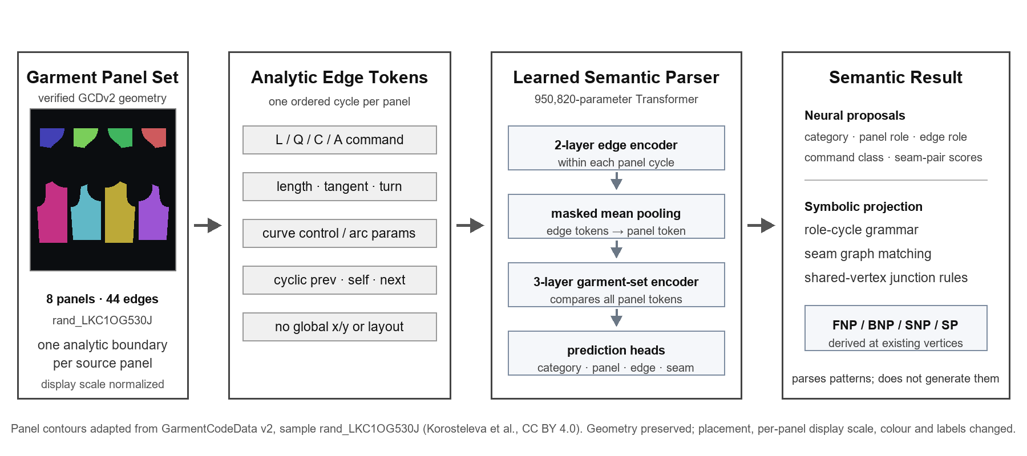

1. Introduction
The project began with a practical question: can front, back, left, and right views of a game character yield a 2D sewing pattern for a visually similar garment? To establish a concrete baseline, I reproduced two released image-to-pattern systems: ReWeaver, which reconstructs sewing patterns from multiview garment appearance, and Garment Particles, which predicts variable-topology garment structures conditioned on images. I adapted their public repositories and weights to Windows on an RTX 5070 12 GB, then ran local inference on official evaluation data and on SynBody, MPFB, and Blender characters [1,2].
ReWeaver achieved mean panel IoU 0.8004 on the first eight complete samples sequentially extracted from the official GCD-TS archive. This was close to the paper's reported 0.8221, but it was a bounded smoke test of installation, weights, and the default inference path rather than a full test-set reproduction. Applying the same checkpoint to out-of-domain characters led to excessive panel counts and open boundaries. I therefore treated the failure as a structural generalization problem caused by differences in training distribution and input representation, rather than as a failure to run the model.
Early repair experiments made this distinction clearer. Independent point moves and contour smoothing could reduce self-intersections and closure gaps, but they could not recover which panel was the front bodice, which curve was the armhole, or which edges should be sewn together. Treating geometry, topology, relations, and validity as one pixel loss obscures both the type of error and the module responsible for it.
I narrowed the research question to two stages. First, can a model read the structure of a completed vector pattern without relying on human conventions for absolute placement? Second, can that semantic space later serve as the interface between four-view observations and a pattern editor? The first question is the main empirical contribution of this report. The second is kept separate as a limited preliminary experiment with a different checkpoint.
The specific contributions are:
- A panel-local Pattern DSL corpus that converts 1,983 GCDv2 vector patterns into L/Q/C/A commands, tangents, turns, and local connectivity propositions, independent of global x/y placement and packed layout.
- A 0.95M-parameter Transformer parser and symbolic role-cycle verifier that jointly read panel roles, edge semantics, junction landmarks, and seam scores.
- Separate frozen-split evaluations of the parser, visual-to-DSL retrieval, and symbolic projection, with topology and seam bottlenecks reported alongside successful components.
- A reproducible claim boundary that distinguishes technical benchmarking from data redistribution rights, and same-generator performance from cross-source generalization.

2. Related Work and Problem Formulation
NeuralTailor, SewFormer, and PanelFormer reconstruct panel outlines and stitches from 3D point clouds or garment images [4-6]. ReWeaver reconstructs patterns from multiview appearance, while Garment Particles generates variable-topology garment structures conditioned on images [1,2]. These methods primarily create patterns from visual observations. In contrast, the present model reads an existing analytic 2D pattern and normalizes its internal semantic structure. Its role is therefore not to compete as a final decoder, but to inspect generated patterns and provide a structured interface for retrieval and editing modules.
Human-image generation has widely used explicit structural conditions such as skeletons, MANO/SMPL, semantic part maps, depth and normal maps, and scene graphs [7-10]. This project does not directly use those models. It adopts the same design principle - represent verifiable symbolic structure explicitly instead of asking pixels alone to encode every relation - and applies it to panels, boundaries, landmarks, and seams.
Table 1. Related problems and project scope
Problem | Input | Output | Relation to this project
Image-to-pattern reconstruction | RGB / 4-view / point cloud | New panel outlines and stitches | Existing baseline; can produce inputs for this parser
Vector-pattern semantic parsing | Completed analytic panel graph | Panel, edge, landmark, and seam semantics | Current core implementation
Pattern retrieval | Four-view visual feature | Existing DSL candidates from a train bank | Implemented; does not generate a new pattern
Parametric drafting edit | Target semantics + basic block | Topology-preserving residual edit | Provisional BasicBlock pilot; no CAD or simulation validity

2.1 Input and output contract
One training sample contains all individual panels that compose a garment. Each panel is a closed boundary with an ordered vertex sequence and analytic edges between consecutive vertices. The model does not receive the source sample ID, packed-canvas position, absolute x/y coordinates, or ground-truth role strings. It therefore cannot exploit shortcuts such as a front panel always being placed on the left or a sleeve always being rasterized at a fixed size.
Outputs are the garment category, a weak semantic role for each source panel, a semantic role for each edge, a landmark set derived from vertices shared by predicted edge roles, and scores for possible stitch partners. Labels such as FNP, SNP, and SP are not regressed as independent coordinates. They are defined as edge-role junctions, for example center front meeting neckline or neckline meeting shoulder. This preserves the real pattern structure in which multiple boundary segments share one vertex.

3. Dataset and Analytic Representation
The primary data source is the official vector sewing-pattern specification in GarmentCodeData v2 [3]. It contains panel vertices, line, quadratic/cubic Bezier and arc parameters, stitch pairs, simulated 3D drapes, and renders. The repository does not redistribute the complete dataset. It retains only lightweight manifests, splits, and canonical tokens extracted from one official batch for training and verification.
Table 2. Canonical Pattern DSL corpus
Item | Count / setting | Interpretation
Canonical vector patterns | 1,983 | Top/skirt/pants subset from one official batch; independent of global x/y and packed layout
Train / validation / frozen test | 1,587 / 198 / 198 | Sample-ID disjoint; within the same GCDv2 generator
Exact pattern-four-view intersection | 1,962 | Project-generated Blender views: top 923 / skirt 780 / pants 259
Visual retrieval train bank | 1,570 | Existing DSL library searched by test queries
Expert-approved cross-source test | 0 | Most important current validation gap

3.1 Panel-local canonical program
For each panel, the first vertex and traversal direction are canonicalized, and every boundary edge is stored as an L/Q/C/A primitive. Lengths and Bezier control points are normalized in a panel-local chord frame. Start and end tangents, turns into the next edge, and NEXT and SHARED_ENDPOINT facts form the neural input. SEWN_TO is retained only as supervision for the seam head. The representation emphasizes which segment follows which curve and which vertices are shared, rather than where the panel happens to sit on a page.
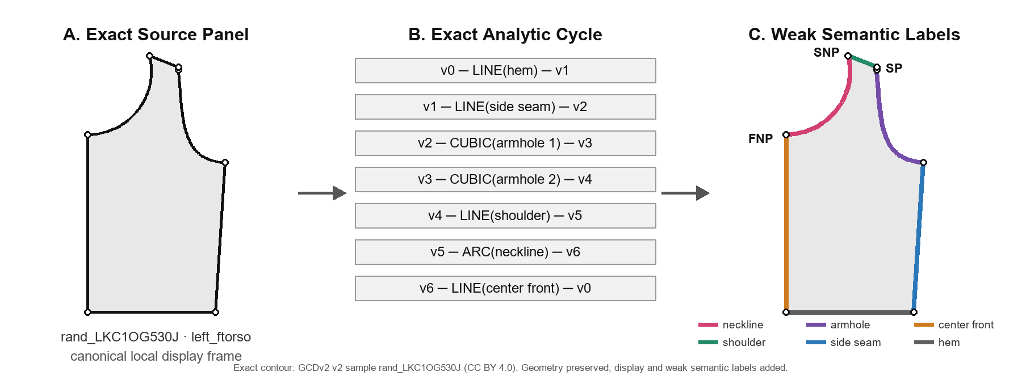
Figure 1. Exact left-front bodice panel from GCDv2 sample rand_LKC1OG530J. The center lists its seven source line, cubic-Bezier, and circular-arc commands; colors and FNP/SNP/SP on the right are automatically derived weak semantic labels. Geometry is unchanged; only layout, scale, color, and labels are adapted.

3.2 Label provenance
Panel and edge semantics were derived automatically from GCDv2 topology, panel names, stitch relations, boundary order, and a rule resolver. These labels are consistent weak ground truth within the same generator; they are not an industry-standard ontology approved by a pattern-making expert. Seam allowance, notches, grainlines, and grading rules were excluded because the source does not provide definitive targets for them.

4. Model and Evaluation Protocol
The canonical parser is a 0.95M-parameter Transformer that processes both cyclic primitive tokens within each panel and the full set of panels in a garment. Each primitive token contains a type embedding, normalized length, chord-frame curve parameters, start and end tangents, and turn. A panel encoder reads the ordered boundary, while a garment-set encoder compares role and stitch candidates across panels.
Table 3. Prediction heads and supervision
Head | Prediction unit | Target / metric
Garment category | garment set | cross-entropy / accuracy
Panel role | panel token | role class / macro-F1
Edge role | boundary primitive | neckline, armhole, side seam, etc. / macro-F1
Landmark | predicted role junction | junction set / set F1
Seam | edge-pair score | source stitch pair / symbolic F1

4.1 Symbolic constraints
Edges are not treated only as independent classes. A basic front bodice, for example, has an allowed role cycle: center front -> neckline -> shoulder -> armhole -> side seam -> hem. After inference, a finite-state projection repairs impossible role orders, and a landmark is emitted only when the posteriors of two edge roles meet at the same vertex. This stage checks semantic consistency without changing geometry.

4.2 Frozen evaluation
The 198 test garments were not used for model selection or early stopping. Panel, edge, and landmark performance is reported with macro-F1; seam performance uses symbolic F1 over the recovery of exact pairs among possible edge pairs. These results measure sample-ID-unseen performance within the same GarmentCode generator and renderer. Generalization to recipe-family-disjoint, body-disjoint, cross-generator, and scanned real-world patterns has not yet been measured.

4.3 Visual-to-DSL retrieval
A separate 0.89M visual bridge aligns front, back, left, and right FPN features with frozen DSL embeddings. Each test query retrieves the nearest existing patterns from a bank of 1,570 training garments. The topology signature contains only the category and panel-wise cyclic L/Q/C/A sequences; it does not include exact coordinates, semantic edge roles, or the complete seam graph. Raw FPN nearest-neighbour retrieval is parameter-free whereas the DSL lane is trained, so this is not an architecture-matched ablation.

5. Results

5.1 Semantic parsing of completed vector patterns
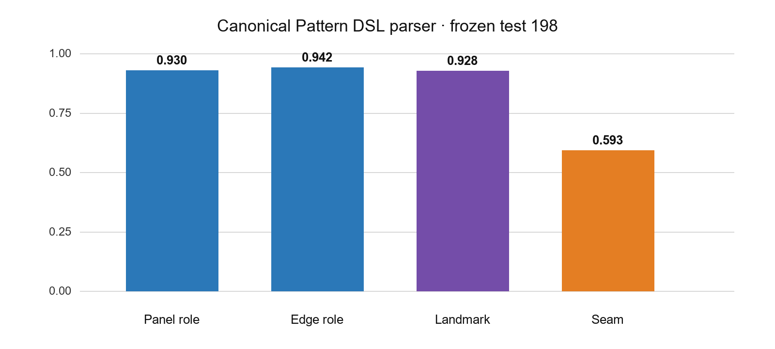
Figure 2. Semantic parsing on 198 frozen-test garments. Panel, edge, and landmark scores were approximately 0.93, while post-projection symbolic seam F1 was materially lower at 0.593.
Table 4. Canonical parser frozen-test metrics
1,983 patterns; train 1,587 / validation 198 / frozen test 198.
Output | Metric | Result | Interpretation
Garment category | Accuracy | 1.000 | Category classification within GCDv2
Panel role | Macro-F1 | 0.930 | Front/back bodices, sleeves, trouser panels, and related roles
Raw edge role | Macro-F1 | 0.942 | Neckline, shoulder, armhole, side seam, and related roles
Projected landmark set | F1 | 0.928 | Derived from predicted edge-role junctions
Projected symbolic seam | F1 | 0.593 | Global pair matching remains unresolved
The panel and edge metrics are not merely classifications of primitive shape. They measure panel roles and edge functions jointly within a garment set after removing absolute canvas coordinates and packed-panel location. Landmarks are not detected as independent heatmap points; they are derived from vertices where predicted roles meet. The result is consistent with the model using ordered primitives and their relations and rules out the most direct packed-canvas shortcut, although generator-specific shortcuts may remain.
Seam recovery requires garment-level one-to-one or one-to-many matching together with length, direction, and ease constraints; local edge similarity is not sufficient. The current pair scorer does not model this global assignment well enough. The parser is therefore reported as a usable 2D semantic teacher with a clear seam bottleneck, not as a system that understands patterns like a patternmaker.

5.2 Visual retrieval and topology constraints
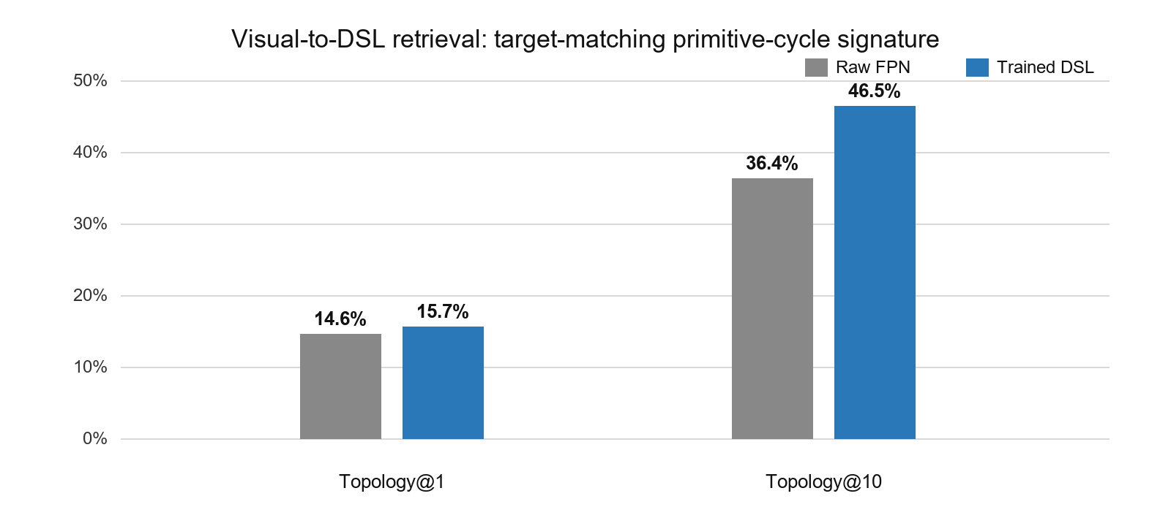
Figure 3. Raw FPN and trained visual-to-DSL retrieval. Coverage of the target-matching primitive-cycle topology signature at rank 10 rose from 36.36% to 46.46% on this fixed split, while rank-1 changed only from 14.65% to 15.66%.
Table 5. Visual-to-DSL retrieval on the frozen 198-garment test
Method | Category@1 | Topology@1 | Topology@10
Raw FPN nearest neighbour | 99.49% | 14.65% | 36.36%
Trained visual–DSL encoder | 98.48% | 15.66% | 46.46%
Difference | -1.01%p | +1.01%p | +10.10%p
The evidence-safe interpretation is that the trained DSL retriever broadened the candidate set available to a downstream verifier or editor without reliably selecting the final target at rank 1. Category@1 was already nearly saturated for raw FPN features and fell by 1.01 percentage points after training, so the main retrieval bottleneck is distinguishing topology within a category. The comparison is not architecture-matched: the raw nearest-neighbour baseline is parameter-free, while the DSL dual encoder is trained.
Applying symbolic projection to retrieved candidates reduced defined role-cycle violations from 168 to 0, but target-signature topology@1 remained 15.66%. This negative result separates two problems: eliminating candidates that violate the role grammar and selecting the candidate that matches the target four-view appearance. Projection did not repair geometry, prove sewability, or recover the target seam graph.

6. Experimental Four-view-to-Semantics Bridge
This is a separate experimental lane from the canonical parser above. To test whether four-view observations can enter a related semantic space, I ran a 128-query teacher-student experiment with a different ontology and checkpoint: a 3.23M vector-graph teacher and a 3.62M student with 9 panel, 35 path, 62 landmark, and 22 reference-line queries. The student receives four precomputed spatial feature tensors plus the known garment category and predicts query presence and normalized 2D coordinates. Seam queries are not included.
The student does not place FNP or SP on a 3D mesh surface. It predicts where the corresponding semantic point lies in the normalized [0,1] garment-union frame of the paired 2D pattern. The score is therefore a component test of sample-specific semantic-coordinate variation beyond a category mean, not direct recovery of CAD coordinates from pixels.
Table 6. Same-generator held-out 4-view pilot
517 strict-common records; natural split 361 / 78 / 78.
Method | Normalized coordinate MAE | Result
Train-only category mean | 0.046059 | Per-category mean-coordinate prior
4-view semantic student | 0.042384 | Precomputed four-view features + known category
Relative change | -7.98% | Lower error on this held-out split

6.1 Validation-gated BasicBlock editing
To test whether the student output could inform downstream editing, I applied residuals to a deterministic category-default provisional BasicBlock. Only queries that improved over the anchor on validation were eligible. Edits that failed topology-preserving projection or a 1.0/0.75/0.5/0.25 line search reverted to the anchor. Test ground truth was not used to choose the gate.
Table 7. Guarded semantic editing result
Item | Anchor | After edit | Interpretation
Test 78 coordinate MAE | 0.087695 | 0.085783 | 2.18% relative reduction
Samples improved | — | 51 / 78 | 65.4%
Edit status | — | 72 applied / 6 fallback | Applied does not mean improved
One-to-many path | — | 99 requests rejected | Instance identity was ambiguous
The 2.18% reduction is not an improvement in CAD geometry, sewability, fit, or simulation pass rate. It is the error after projecting the default and edited blocks into comparable semantic-query coordinates for the GCD target. The editor also uses a deterministic category-default provisional BasicBlock rather than the retrieved DSL anchor, so the parser/retrieval lane and the student/editor lane remain separate inference graphs.

7. Discussion
The experiments show that 2D pattern semantics can function as a learnable intermediate representation rather than only as descriptive labels. Strong panel, edge, and landmark scores after removing absolute canvas placement are consistent with the use of primitive order and relations and rule out the most direct packed-layout shortcut, although generator-specific shortcuts may remain. The higher top-10 retrieval coverage and the separate four-view pilot's lower error than a category prior provide limited evidence that visual observations can be aligned with this semantic space.
The limits are equally clear. Topology@1 of 15.66% shows that selecting the final target structure within a category remains largely unresolved. Post-projection seam F1 of 0.593 shows that strong local edge classification does not automatically recover the garment-level seam graph. Symbolic projection removes violations of the defined role-cycle grammar but cannot turn a different valid candidate into the target pattern.

7.1 Why the remaining errors occur
- A seam is a global matching problem, not an independent edge class. It must jointly satisfy lengths, directions, degree, ease, and one-to-many instances on both sides.
- The primitive-cycle topology signature compresses exact coordinates, curvature, edge semantics, and inter-panel layout, so multiple patterns can share the same signature.
- GCDv2-derived labels are internally consistent but are not equivalent to expert-approved industrial FNP/BNP/SNP/SP labels, seam allowances, notches, or grainlines.
- The four-view pilot is sample-ID unseen but uses the same generator, neutral body, and render style. It does not establish cross-source or real-image generalization.

7.2 Relation to released image-to-pattern baselines
The current parser cannot be claimed as a better end-to-end pattern generator than the released baselines (ReWeaver or Garment Particles). No same-input, same-split, same-metric comparison has been run between raw outputs and a parser-verifier-editor pipeline. A decisive next evaluation would run raw ReWeaver and ReWeaver plus the bridge on identical four-view inputs and compare closed-panel rate, seam violations, simulation pass rate, silhouette IoU, expert preference, and abstention rate.

8. Limitations and Future Work
First, the frozen test is an internal split from the same GarmentCode generator. A design-family-disjoint split is needed to control more strictly for similar recipe variants appearing across train and test. FreeSewing patterns and 30-100 expert-reviewed real patterns should form a separate cross-source test.
Second, the seam head should move from independent pair scores to bipartite graph matching with degree, direction, length, and ease as hard or soft constraints. For example, sleeve-cap length should match the sum of the front and back armholes plus specified ease. A solver should check this explicit sewing rule instead of asking the model to rediscover it unreliably from data.
Third, target-conditioned topology selection is required. Cross-attention between four-view semantic tokens and candidate DSL tokens should separate grammatical validity from target compatibility. Once a candidate is selected, the model should predict residuals for drafting parameters such as neck width and depth, shoulder slope, armhole depth, sleeve cap, and bodice length. A parametric decoder should then redraw shared vertices jointly instead of moving raw control points independently.
Table 8. Next decisive experiments
Step | Experiment | Pass criterion
1 | Target four-view token x candidate DSL cross-attention | Material increase in topology@1
2 | Bipartite seam matching + length/direction/ease | Improve seam F1 and constraint pass together
3 | Counterfactual four-view pairs with one drafting parameter changed | Held-out regression of change direction and magnitude
4 | Parametric drafting decoder + shared-point solver | Closed panels, symmetry, and armhole-sleeve relation satisfied
5 | Raw ReWeaver vs. ReWeaver + bridge A/B | Improved simulation, silhouette, and expert metrics
6 | FreeSewing + expert-approved real patterns | Reported cross-source frozen-test performance
The long-term goal is not to regenerate every output from an image-to-pattern model. It is to preserve valid patterns, flag semantically impossible structures with explainable errors, and abstain from editing when confidence is low. Separating the responsibilities of generation, constraint solving, simulation, and expert review is necessary to extend this portfolio prototype into a production workflow.

Appendix

Appendix A. Reproducibility map
The following files are the minimum evidence needed to recheck the report's core metrics and data contracts. Original datasets, checkpoints, caches, and large artifacts are excluded from Git; the public package retains code, lightweight manifests, this portfolio, and its project-generated figures.
Table 9. Tracked evidence and implementation entry points
Path | Purpose
data/manifests/gcdv2_pattern_dsl_v2.json | 1,983-pattern canonical DSL corpus and frozen split
data/manifests/gcdv2_pattern_dsl_v2_training_result.json | Panel·edge·landmark·seam parser metrics
data/manifests/gcdv2_visual_pattern_dsl_retrieval_v2.json | Raw-FPN vs. trained-DSL retrieval
data/manifests/basic_semantic_teacher_student_v3.json | Separate 128-query teacher/student and guarded editor
data/manifests/semantic_pattern_bridge_portfolio_proof.json | Final claim boundaries and evidence index
benchmark/scripts/train_gcdv2_pattern_dsl_transformer.py | Canonical parser training
benchmark/scripts/train_gcdv2_visual_dsl_retrieval.py | Visual-to-DSL bridge training
benchmark/scripts/train_basic_semantic_teacher_student.py | 128-query preliminary bridge

Appendix B. Result boundaries
Table 10. Result boundaries
Supported by the current evidence | Not supported yet
Learns analytic panel/edge/landmark semantics within GCDv2 | Fully recovers expert industrial-pattern semantics
DSL alignment increases top-10 coverage of target-matching topology signatures | Generates the exact pattern from four views or solves top-1 selection
Separate four-view student achieves 7.98% lower normalized-coordinate MAE than the train-only category-mean baseline | Generalizes to real photos, other generators, or bodies
Validation-gated editing reduces query error for 51/78 samples | Passes sewability, fit, simulation, or manufacturing checks
Bounded ReWeaver smoke test runs on eight official samples | Outperforms ReWeaver end to end

Appendix C. Data-use boundary
NOVA-Human is recorded with provenance_status=ARCHIVED_OFFICIAL_LINK_LIVE, license_status=UNRESOLVED, and usage_status=PRIVATE_EVALUATION_ONLY. No permission beyond private evaluation is assumed. This document contains no NOVA-Human source images, private contact sheets, live storage links, or samples with unclear redistribution rights. GarmentCodeData v2 and referenced public models require separate checks of their data, code, and checkpoint licenses. Passing a technical benchmark does not grant permission to redistribute or publicly display source data.
GarmentCodeData v2 was created by Maria Korosteleva, Timur Levent Kesdogan, Fabian Kemper, Stephan Wenninger, Jasmin Koller, Yuhan Zhang, Mario Botsch, and Olga Sorkine-Hornung, and released under CC BY 4.0 (https://doi.org/10.3929/ethz-b-000690432; https://creativecommons.org/licenses/by/4.0/). This project parses and normalizes the official vector specification into a panel-local analytic DSL and derives semantic labels, split metadata, and aggregate statistics. The original dataset archive, renders, and meshes are excluded from this document and the public ZIP; no endorsement by the original authors is implied.

References
[1] ReWeaver project and released GCD-TS benchmark. Project page: https://sii-liming.github.io/ReWeaver/ ; author dataset: https://huggingface.co/datasets/SII-LiMing/ReWeaver-GCD-TS
[2] Garment Particles. Official code repository: https://github.com/garment-particles/GarmentParticles ; released checkpoint repository: https://huggingface.co/georgeNakayama/GarmentParticles
[3] Korosteleva, M. et al. GarmentCodeData v2: 115,000+ made-to-measure garments with sewing patterns and simulated drapes. ETH Research Collection: https://www.research-collection.ethz.ch/handle/20.500.11850/690432
[4] Korosteleva, M. and Lee, S.-H. NeuralTailor: Reconstructing Sewing Pattern Structures from 3D Point Clouds of Garments. ACM Transactions on Graphics, 2022. https://github.com/maria-korosteleva/Garment-Pattern-Estimation
[5] SewFormer: Sewing Pattern Reconstruction from a Single Image. Project page: https://sewformer.github.io/
[6] Chen, X. et al. PanelFormer: Sewing Pattern Reconstruction from 2D Garment Images. WACV, 2024. https://openaccess.thecvf.com/content/WACV2024/html/Chen_Panelformer_Sewing_Pattern_Reconstruction_From_2D_Garment_Images_WACV_2024_paper.html
[7] Narasimhaswamy, S. et al. HanDiffuser: Text-to-Image Generation with Realistic Hand Appearances. CVPR, 2024. https://openaccess.thecvf.com/content/CVPR2024/html/Narasimhaswamy_HanDiffuser_Text-to-Image_Generation_With_Realistic_Hand_Appearances_CVPR_2024_paper.html
[8] Li, S. et al. CosmicMan: A Text-to-Image Foundation Model for Humans. CVPR, 2024. https://openaccess.thecvf.com/content/CVPR2024/html/Li_CosmicMan_A_Text-to-Image_Foundation_Model_for_Humans_CVPR_2024_paper.html
[9] Liu, X. et al. HyperHuman: Hyper-Realistic Human Generation with Latent Structural Diffusion. ICLR, 2024. https://openreview.net/forum?id=duyA42HlCK
[10] Johnson, J. et al. Image Generation from Scene Graphs. CVPR, 2018. https://openaccess.thecvf.com/content_cvpr_2018/html/Johnson_Image_Generation_From_CVPR_2018_paper.html

