**BIOS 10603 – Lab 4**

**Ubiquitin Simulation and Water Analysis**

**NAME:**

Please insert all answers and figures into this Word document, and then save the completed lab as “Lastname_Lab4.docx”. When you have completed the lab, submit it as an attachment to the Lab-4 assignment link on Canvas. The report is due by midnight the day after your lab period.

**Objectives:** In this week’s lab, we will analyze the minimization of the ubiquitin protein and will submit it for heating up and equlibration. We will also continue our analysis of the water box. We will also introduce you to two metrics used in analyzing protein trajectories: the **Root Mean Square Deviation and the Radius of Gyration**.

**Lab 4 Sections:**

1. Ubiquitin miniziation simulation analysis
2. Heating up and Equilibration of Ubiquitin
3. Analysis of water simulation

|  |  |  |  |
| --- | --- | --- | --- |
| **STEP** | | **DESCRIPTION** | **Lab** |
| 0 | Build PSF | Adding hydrogens to the protein structure | Lab 3 |
| Solvation | Putting the protein in a water box |
| Ionization | Adding salt at a specified concentration |
| Restraining | Adding restraints to the protein backbone |
| 1 | Energy Minimization | Using NAMD to move the protein into an energetically favorable conformation before kinetic energy is introduced to the system. Then heating up the system to the desired temperature. |
| 2 | Heating up | Gradually warm up the system and apply atmospheric pressure. | Lab 3 & 4 |
| Equilibration | Gradually remove the restraints on the protein backbone to make the system as close as possible to physiological conditions. |

**We will also perform simulation checks to make sure everyone is on track. These will be worth 10 pts; further details about when/where these will occur will be provided.**

**Part 1: Ubiquitin simulation analysis**

**For all plots that you submit, you are required to explain the plot in the context of its simulation. Explain all sections of the plot and why they are increasing, decreasing, or stay constant. Explain how different plots relate to one another. Also, be sure to generate these plots in R.**

Download your ubiquitin minimization .dcd and .log files from Midway to your computer.

**Q1.** Load your **solvate-ionize.psf** and the ubiquitin minimization trajectory .dcd into VMD (use the Load Data into Molecule option to load the dcd into the .psf), and describe what you see happening to your protein as the simulation progresses. **Hint: focus on the begining of the simulation and mainly on the protein by not showing the water; show the backbone as the new cartoon and then add another representation showing the protein using licorice to see the side chains.**

**Q2**. Using the **NAMD Plot** data, attach separate plots of the total and Van der Waals energies for ubiquitin over the simulation time and explain the trend(s) you observe.

1. What do each of these energies represent?
2. What did the minimization accomplish?
3. Why might it have been an issue if minimization were never run?

**As we learned in class, the protein function is related directly to its three-dimensional shape.** We are going to measure how the protein shape changes in the trajectory with respect to the intial structure by calculating the **root mean square displacement** (RMSD) at each frame. RMSD measures the root-mean-square distance of all atoms in the XYZ planes of the system from their respective starting locations. **This would allow us to quantify the the overall atomic positional changes throughout the course of the simulation.** For more information please see the [NAMD 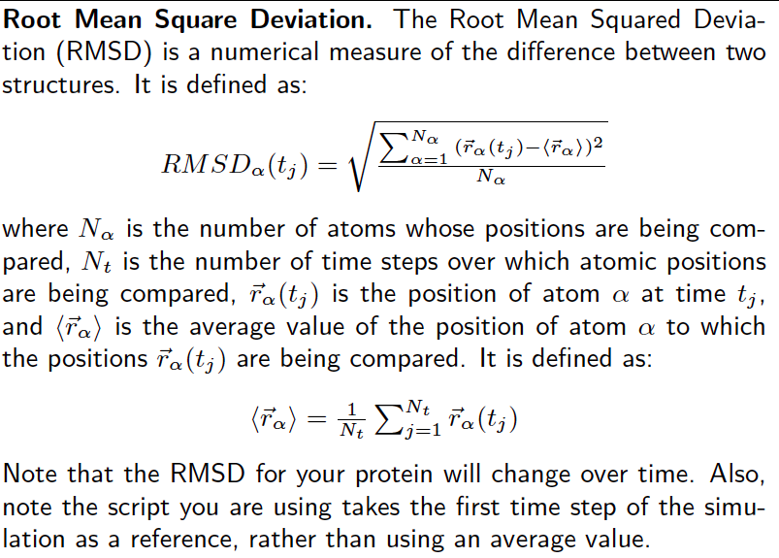tutorial:](http://www.ks.uiuc.edu/Training/Tutorials/namd/namd-tutorial-unix.pdf)

**Q3.** Download and open Rmsd.tcl. Fill in the missing lines of code, and copy the inserted lines below. Run the code in the Tk console using the command **source Rmsd.tcl and plot the RMSD values over time**.

Line 1:

Line 2:

Line 3:

Line 4:

Line 5:

Line 6:

Line 7:

Line 8:

Line 9:

Line 10:

We are going to compare your results with the tool used in VMD to calculate RMSD. With the **1UBQ minimization trajectory loaded**, open the RMSD trajectory tool (Extensions 🡪 Analysis 🡪 RMSD Trajectory Tool). After you have loaded the RMSD trajectory tool, make sure that “protein” is entered in the upper left-hand corner and that all **of the boxes in the picture (below) are checked.**

**Q4.** Click **align** and then **RMSD.** Plot the RMSD over time using R and attach and interpret the figure.

1. Explain the trends that you observe.
2. What does aligning the trajectory to the first frame do? What happens if we do not align the trajectory before computing RMSD?

**Q5.** Attach a plot showing both the RMSD output from your own script and the RMSD output from VMD. Do this in R via commands **read.table**, **plot**, and **lines**. Make sure that you use an appropriate scale for the y-axis.

**Q6.** Based on the description of RMSD above,

1. What is the minimum RMSD value possible? What trajectory would you expect is RMSD was a constant zero?
2. Why are side-chain atoms not included in the RMSD calculation?
3. Explain why we see low RMSD values during the minimization simulation.

# Another good quantitative measure of the protein’s structural (shape) change is the Radius of Gyration (*Rg*). The radius of gyration is an indicator of protein structure compactness. The square of the radius of gyration is defined as the average squared distance of all atoms of the protein from the center of mass of the protein and indicates the degree of compaction the protein is subject to

$$\frac{\sum_{i}^{N}{m_{i} {(r_{i}-r_{c})}^{2}}}{\sum_{i}^{N}{m_{i}}}$$

# Where ri is the position of atom *i* and rc is the center of mass of the protein, and *mi* is the mass of atoms *i*. For more info, check this [paper](https://link.springer.com/content/pdf/10.1134/S0026893308040195.pdf)

**Q7.** Would a folded protein have higher or lower Rg values compared to an unfolded protein? Explain.

**Q8.** What parts of the protein would you expect to have higher Rg values relative to the rest of the protein? Explain why this may be the case.

**Q9**. Open the **Rg.tcl** script. Fill in the missing lines to produce a working script, paste the code below. If you need help, take a look at your RMSD script, they are fairly similar.

**Q10**. Source the Rg script in VMD’s Tk Console. Plot the output .dat file via R to create a plot of Rg vs. Frame number. Attach the plot below **and interpret any trends that you see**. Does the protein radius of gyration change over the simulation? Why might it exhibit this behaviour?

**Part 2: Heating up and Equilibration of Ubiquitin**

So far, we have only minimized the potential energy of ubiquitin without applying any kinetic energy. To model a realistic protein at room temperature, we need to warm up the system gradually and apply atmospheric pressure. Then, we need to gradually remove the restraints on the backbone to make the system match physiological conditions as closely as possible. This step is called “heat up and equilibration”. The procedure is explained below:

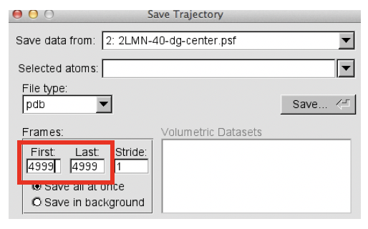

In VMD with your minimization trajectory loaded, go to File > Save Coordinates. It should open a window like the one in the right. For the “First” and “Last” Frames section, make them both equal to the original Last. Save this as 1UBQ-mini-LF.pdb and transfer this file to your Midway 1UBQ directory**.**

**Q11.**

1. Explain how the gradual backbone retrain removal has been achieved in the config file.
2. Why more simulation steps are needed toward the end of procedure?

After you have completed these steps, **download, and edit the file 1UBQ-mini-heatup-equil.conf** to contain your new file names and system parameters. This is explained in further detail in the configuration file.

Make a copy of your job submit script, and name it job-submit-equil.sh. **Edit it to point to this new configuration file for equilibration, changing the required time to 8 hours and the number of nodes to 4 and submit the job. If your job does not start to run immediately, please keep checking its status until tomorrow morning. If the job goes to completion, it should create a couple of files including name.log, name.dcd, name.coor, name.xst, name.xsc. If you do not see these files by Sunday morning, please notify Dr. Haddadian or your TA.**

**Part 3: Water Box Analysis**

Water density is one of its essential properties; we are going to see how the density changes in the course of the simulation. Delete all ubiquitin trajectories, and load the psf and dcd files for the ice melting simulation **from last week** (Ice-melt-100-grad2-01.psf and Ice-melt-100-grad2-01.dcd).

**Q12.** Download the density-script.tcl from Canvas (it measures water density during a given simulation) and put it in the same directory as your other input files. Read the script and describe how it measures the water density (describe the steps).

**Q13.** We have omitted several lines from the script, and you should be able to fill in the lines of code marked with: ## LINE _

After writing the script, copy and paste the lines you wrote below.

LINE 1:

LINE 2:

LINE 3:

LINE 4:

LINE 5:

LINE 6:

LINE 7:

**Q14.** Repeat the same calculations for your **own water heat-up simulation**.

1. Plot the data from the .dat files for both water systems; **attach screenshots of both plots and explain the features of each**. Using R, the following two lines of code will produce an attractive plot:

infile = read.table("/Path/To/File/density_water.dat",

header=T,

sep="\t")

plot(infile$Frame,

infile$Density,

type="l",

xlab="Frame",

ylab="Density")

1. Which system reaches a state of equilibrium faster? Why?

One of the parameters you used to set up your water system was periodic boundary conditions.

**Q15.** Explain why periodic boundary conditions are applied in the MD simulations (you need to provide two reasons).

**Q16.** VMD allows to view these boundaries:

1. After loading your water system trajectory, in the “Graphical Representations” window click on the periodic option. Then click on the “+x”, “-x”, “+y”, etc. options one at a time. Explain what happens on your screen.
2. Attach a screen shot of your VMD screen while all “x” and “y” options are selected.
3. Repeat part B for the first frame of the ice melting simulation.
4. Run the trajectory and zoom in at the boundaries of the periodic boxes; explain what you observe.

**Part 4: Salt Water Box Analysis**

Now delete the ice-melting simulation. Load the water-ionized.dcd file into the water-ionized.psf from Canvas. This system is a water box that has been prepared similarly to your water box. The key difference between this system and your water box is that this system was ionized with salt. The system was minimized, and the dcd you are viewing contains equilibration and a 5ns production run at 300K.

**Q17.** Zoom in on a sodium ion

1. Take a screenshot of the ion and the surrounding water molecules.
2. What do you notice about the orintation of the surrounding water molecules?
3. What is this an example of? What property of water makes this possible?

**Q18.** Now zoom in on a chloride ion.

1. Take a screenshot of the ion and the surrounding water molecules.
2. What do you notice about the orintation of the surrounding water molecules?
3. What is this an example of? What property of water makes this possible?