Diagram Explanation
The user interacts with an HTML web application hosted on AWS Amplify. The application communicates with the backend exclusively through REST API endpoints exposed via API Gateway.
The system includes 10 Lambda functions, 9 of which are directly callable through the UI. These are organized into four functional groups:
1. Order Management (DynamoDB)
Five functions handle CRUD operations against the orders DynamoDB table: createOrder, getAllOrders, getOrder, updateOrder, and deleteOrder.
2. Notification Management (SNS)
Two functions manage the notification subscription lifecycle: subscribeNotification and unsubscribeNotification, which add or remove email addresses from the SNS topic.
3. Storage & Reporting (S3)
One function, generatePdfSummary, reads all backed-up TXT files from S3, generates a PDF summary of deleted orders, stores it in S3, and returns a presigned download URL in the response.
4. Image Analysis (Rekognition)
One function, analyzeImage, accepts a base64-encoded product photo uploaded from the UI, sends the image bytes to Amazon Rekognition's DetectLabels API, and returns the detected labels with their confidence scores. The top labels are joined into a suggested order description, letting the user auto-fill a product description directly from a photo.
Delete Order Flow (Asynchronous)
The deleteOrder function removes the order from DynamoDB and immediately returns a response to the user. It then triggers the delete-order-fanout Step Function, which runs two branches in parallel: invoking the backupOrder Lambda to save the deleted order as a TXT file in S3, and publishing a notification to SNS which delivers an email to all subscribed users. This fan-out is fully asynchronous — the user never waits for it.

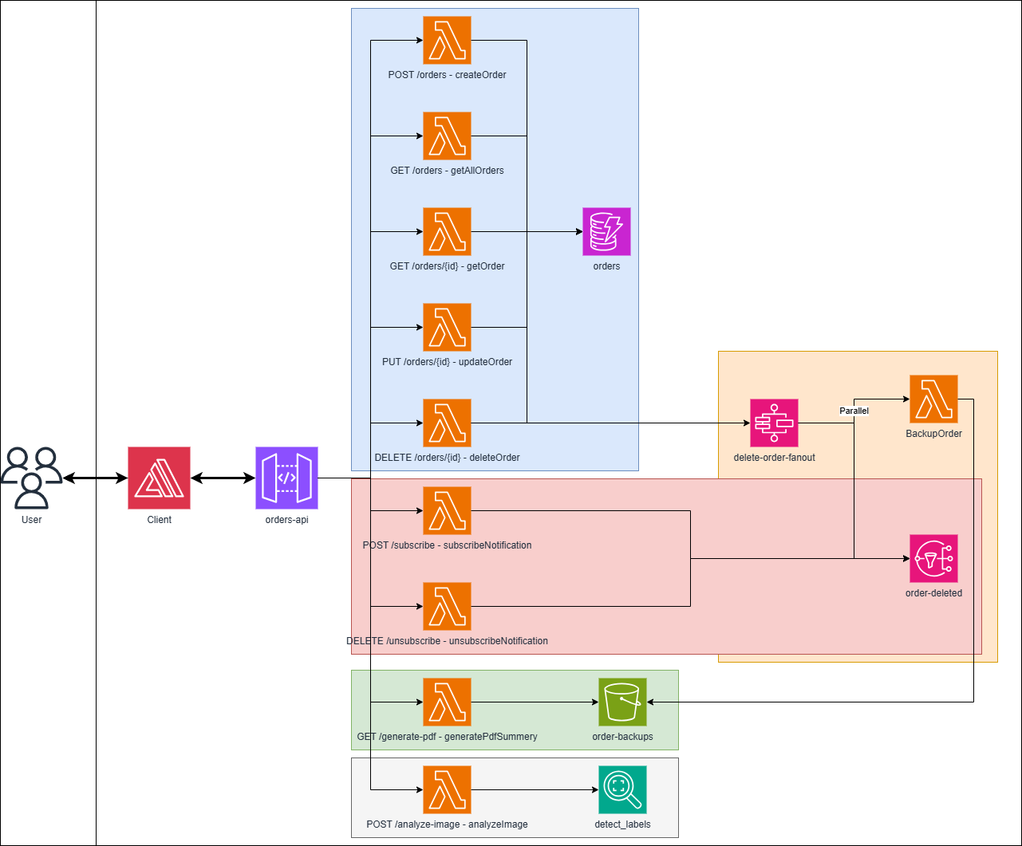
Architecture Diagram

AWS Services Used
Service | Why | CLI Command
DynamoDB | Serverless NoSQL store for the orders table, with a GSI (gsi-by-date) for sorted Query-based reads instead of full Scans. | aws dynamodb describe-table --table-name orders --region us-east-1
Lambda | Event-driven, pay-per-use compute running one function per endpoint, all under LabRole. | aws lambda list-functions --region us-east-1 --query "Functions[].FunctionName" --output table
API Gateway | Exposes every Lambda through a single HTTPS REST API (orders-api) with CORS as the client's one entry point. | aws apigateway get-rest-apis --region us-east-1 --query "items[?name=='orders-api']"
SNS | Fan-out pub/sub on the order-deleted topic that emails all subscribers when an order is deleted. | aws sns list-topics --region us-east-1 --query "Topics[?contains(TopicArn, 'order-deleted')]"
S3 | Durable storage for deleted-order TXT backups and the generated PDF summary, served via presigned download URLs. | aws s3api list-buckets --region us-east-1 --query "Buckets[?starts_with(Name, 'order-backups')]"
Step Functions | The delete-order-fanout state machine runs the SNS notify and S3 backup in parallel, making the delete asynchronous. | aws stepfunctions list-state-machines --region us-east-1 --query "stateMachines[?name=='delete-order-fanout']"
Rekognition | Powers the freestyle analyzeImage feature (DetectLabels) to suggest order descriptions; chosen because the lab allows it while denying Translate/Comprehend/Polly/Lex. | aws rekognition list-collections --region us-east-1
Amplify | Hosts the static web client (order-management-client) on managed HTTPS, deployed directly from deploy.py. | aws amplify list-apps --region us-east-1 --query "apps[?name=='order-management-client']"

REST API Endpoints
<base-url> = https://qetaaj1tgk.execute-api.us-east-1.amazonaws.com/prod
API name | Method | URL | Sample input | Sample output
Create order | POST | <base-url>/orders | {"price": 9.99, "description": "Wireless mouse"} | 201:  {"message": "Order created", "order": {"orderId": "3f2a9c4e-...", "gsiPk": "ORDER", "creationDate": "2026-06-13T10:00:00+00:00", "lastModifiedDate": "2026-06-13T10:00:00+00:00", "price": 9.99, "description": "Wireless mouse"}}
Get all orders | GET | <base-url>/orders | None | 200:  {"count": 1, "orders": [{"orderId": "3f2a9c4e-...", "gsiPk": "ORDER", "creationDate": "2026-06-13T10:00:00+00:00", "lastModifiedDate": "2026-06-13T10:00:00+00:00", "price": 9.99, "description": "Wireless mouse"}]}
Get order by id | GET | <base-url>/orders/{id} | None (order id in the URL path) | 200:  {"order": {"orderId": "3f2a9c4e-...", "gsiPk": "ORDER", "creationDate": "2026-06-13T10:00:00+00:00", "lastModifiedDate": "2026-06-13T10:00:00+00:00", "price": 9.99, "description": "Wireless mouse"}}  Returns 404 {"error": "Order '<id>' not found"} if it does not exist.
Update order | PUT | <base-url>/orders/{id} | {"price": 12.50, "description": "Wireless mouse (updated)"}  At least one of price or description. | 200:  {"message": "Order updated", "order": {"orderId": "3f2a9c4e-...", "gsiPk": "ORDER", "creationDate": "2026-06-13T10:00:00+00:00", "lastModifiedDate": "2026-06-13T10:05:00+00:00", "price": 12.5, "description": "Wireless mouse (updated)"}}
Delete order | DELETE | <base-url>/orders/{id} | None (order id in the URL path) | 200:  {"message": "Order deleted", "order": {"orderId": "3f2a9c4e-...", "gsiPk": "ORDER", "creationDate": "2026-06-13T10:00:00+00:00", "lastModifiedDate": "2026-06-13T10:05:00+00:00", "price": 12.5, "description": "Wireless mouse (updated)"}}  Deletion also triggers an async Step Functions fan-out: SNS email + S3 TXT backup.
Subscribe to notifications | POST | <base-url>/subscribe | {"email": "user@example.com"} | 201:  {"message": "Subscription requested; check your email to confirm", "subscriptionArn": "arn:aws:sns:us-east-1:123456789012:order-deleted:8f1d..."}
Unsubscribe from notifications | DELETE | <base-url>/unsubscribe | {"subscriptionArn": "arn:aws:sns:us-east-1:123456789012:order-deleted:8f1d..."} | 200:  {"message": "Unsubscribed"}
Analyze image | POST | <base-url>/analyze-image | {"image": "<base64-encoded JPEG or PNG>"} | 200:  {"labels": [{"name": "Mouse", "confidence": 98.2}, {"name": "Electronics", "confidence": 95.7}, {"name": "Hardware", "confidence": 88.4}], "suggestedDescription": "Mouse, Electronics, Hardware"}
Generate PDF summary | GET | <base-url>/generate-pdf | None | 200:  {"message": "Deleted orders summary generated (3 order(s))", "url": "https://order-backups-123456789012.s3.amazonaws.com/deleted-orders-summary.pdf?X-Amz-Signature=..."}
deleteOrder
"""
deleteOrder — DELETE /orders/{id}

Deletes an order from DynamoDB, then fires a Step Functions state machine
(fire-and-forget) that fans out in parallel to an SNS notification and an
S3 .txt backup.
"""

import json
import os
from decimal import Decimal

import boto3

dynamodb = boto3.resource("dynamodb")
table = dynamodb.Table(os.environ.get("ORDERS_TABLE", "orders"))
sfn_client = boto3.client("stepfunctions")

HEADERS = {
"Content-Type": "application/json",
"Access-Control-Allow-Origin": "*",
"Access-Control-Allow-Headers": "Content-Type",
"Access-Control-Allow-Methods": "OPTIONS,GET,POST,PUT,DELETE",
}

# HTTP status codes
STATUS_OK = 200
STATUS_BAD_REQUEST = 400
STATUS_NOT_FOUND = 404
STATUS_SERVER_ERROR = 500

def to_plain(obj):
"""Convert DynamoDB Decimals to floats so the item is JSON-serializable."""
if isinstance(obj, Decimal):
return float(obj)
if isinstance(obj, dict):
return {k: to_plain(v) for k, v in obj.items()}
if isinstance(obj, list):
return [to_plain(v) for v in obj]
return obj

def respond(status, body):
return {"statusCode": status, "headers": HEADERS, "body": json.dumps(body)}

# --- Named responses (so the handler reads like plain English) -------------
MISSING_ID_RESPONSE = respond(STATUS_BAD_REQUEST, {"error": "Missing order id in path"})

def order_not_found(order_id):
return respond(STATUS_NOT_FOUND, {"error": f"Order '{order_id}' not found"})

def order_deleted(item):
return respond(STATUS_OK, {"message": "Order deleted", "order": to_plain(item)})

def server_error(exc):
return respond(STATUS_SERVER_ERROR, {"error": str(exc)})

def start_fanout(item):
"""Fire-and-forget: start the Step Functions fan-out for the deleted order.

start_execution returns immediately without waiting for the workflow; a
failure to start it is logged and never fails the delete.
"""
state_machine_arn = os.environ.get("FANOUT_STATE_MACHINE_ARN")
if not state_machine_arn:
return
try:
sfn_client.start_execution(
stateMachineArn=state_machine_arn,
input=json.dumps(to_plain(item)),
)
except Exception as sfn_err:
print(f"Step Functions start_execution failed: {sfn_err}")

def lambda_handler(event, context):
"""Handle DELETE /orders/{id}: delete the order, then fan out the deletion.

Returns 400 if the id is missing, 404 if the order does not exist,
200 with the deleted order on success, and 500 on any unexpected error.
"""
try:
# Read the order id from the URL path; reject the request if it's absent.
order_id = (event.get("pathParameters") or {}).get("id")
if not order_id:
return MISSING_ID_RESPONSE

# Look the order up first so we can return 404 instead of silently
# "deleting" something that was never there.
item = table.get_item(Key={"orderId": order_id}).get("Item")
if not item:
return order_not_found(order_id)

# Delete the order, then hand it off to the fan-out workflow
# (fire-and-forget — see start_fanout) and return the deleted order.
table.delete_item(Key={"orderId": order_id})
start_fanout(item)
return order_deleted(item)
except Exception as e:
# Catch-all so any unexpected failure becomes a clean 500 response.
return server_error(e)

