Pokhara University

**Semester - Spring**

Level : Bachelor Years : 2014

Program : Civil(BDH) Time : 3 hrs

Subject : Basic Electronics Engineering FM : 100

* *Candidates are requested to give their answer as far as practicable in their own words.*
* *The figure in the margin indicates the full marks*
* ***Attempt ALL question***

1. a) Why is an intrinsic semiconductor not adequate for making semiconductor devices?Discuss the behavior of PN junction under forward and reverse biased conditions. (1+7)

(Semiconductor devices)

b) Determine the range of values of Vin that will maintain the Zener diode in the “ON” state. Also find the maximum power that can be dissipated to the diode. (7)

(Semiconductor Devices)

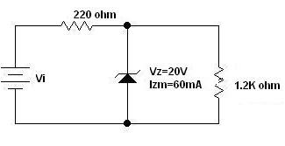

2. a) Draw the circuit diagram and waveform of full wave bridge rectifier. Calculate its rectification efficiency. (4+4)

(Semiconductor devices)

b) Draw the circuit diagram, input and output characteristics of CE connection of PNP transistor. Why the CE connection of a transistor is mot commonly used? (7)

(Bipolar Junction Transistor)

3. a) Why are collector and emitter currents nearly equal in a transistor? Differentiate BJT from FET. (2+5)

(Bipolar Junction Transistor0

b) In given circuit, silicon transistor with β = 100 is biased by base register method. Draw the d.c. load line and determine the operating point. What is the stability factor? (Vcc=20V) (8)

(Bipolar Junction Transistor)

. 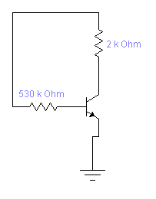

4 a) List out the ideal characteristics of an Op Amp. Derive the expression for output voltage in the inverting mode of an Op Amp. (8)

(Operational Amplifier and Oscillator)

b) Describe the advantages of negative feedback. Give the Barkhausen criteria required for undamped oscillation. (5+2)

(Operational Amplifier and oscillator)

5 a) Perform the following conversions: (8)

i) (415.375)10 = (?)2

ii) (2D50.CF)16 = (?)10

iii) (1101011010)2 = (?)8,(?)16

iv) (5371)8 = (?)2, (?)16

(Digital Electronics)

b) Simplify the Boolean function F(A,B,C) = $\sum{(3,5,6,7)}$ using K-map. Implement the function using logic gates. (7)

(Digital Electronics)

6 a) Draw the block diagram of communication system and explain the function of each block. Differentiate between AM and FM. (5+3)

(Communication System)

b) Discuss the application of electronics in civil engineering. Explain the ue of EDM in surveying. (7)

(Electronic Instruments0

7. Write short notes (any two) (2*5)

a) DC regulated power supply (Semiconductor devices)

b) Modulation (Communication systems)

c) Total station (Electronic Instruments)

d) Universality of NAND and NOR (Digital electronics)

Marks distribution table:

|  |  |  |  |  |
| --- | --- | --- | --- | --- |
| Units | Name | Hour | Questions | Marks |
| 1 | Semiconductor Devices | 6 | 1(a),(b),2(a).7(a) | 28 |
| 2 | Bipolar Junction Transistor | 6 | 2(b),3(a),(b) | 22 |
| 3 | Operational Amplifiers and Oscillators | 5 | 4(a0,(b) | 15 |
| 4 | Digital Electronics | 5 | 5(a),(b),7(d) | 20 |
| 5 | Communication system | 4 | 6(a),7(b) | 13 |
| 6 | Electronics Instruments | 4 | 6(b),7(c) | 12 |
|  |  |  |  |  |