**Name:** Jack Shenfield & William Watson

**Course Name:** Advanced System Analysis and Software Design

**Course Code:** ENSF 614

**Assignment Number:** Lab 04

**Submission Date:** 07/10/2025

Exercise A

UML Diagram (Created with Astah UML):

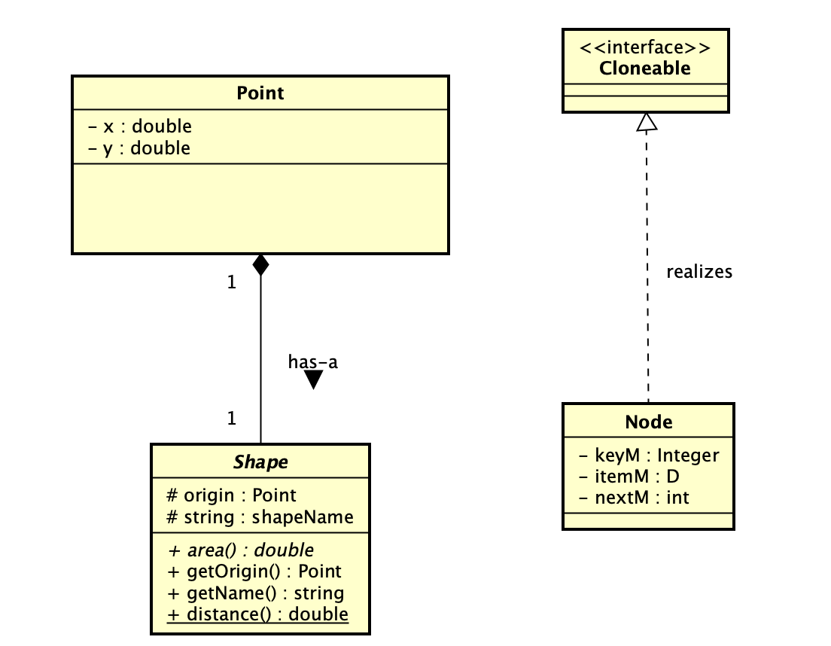

Exercise B

UML diagram:

Exercise C

/*

* File Name: EXC.cpp

* Assignment: Lab 4 Exercise C

* Lab Section: B01

* Completed by: Jack Shenfield & William Watson

* Submission Date: Oct 7, 2025

*/

// Class declaration similar to a .h file

using namespace std;

#include <string>

class Resizeable{

public:

void enlarge (int n);

void shrink (int n);

};

class Vehicle: public Resizeable, public Removeable{ // this class is abstract

protected:

string name;

public:

Vehicle(string name);

virtual void move() = 0; // pure virtual

};

class Car final : public Vehicle{

private:

int seats;

public:

void turn();

};

class Moveable{

public:

void forward() = 0; // pure virtual

void backward() = 0; // pure virtual

};

Exercise D

