Name: Jack Shenfield
Course Name: Advanced System Analysis and Software Design
Course Code: ENSF 614
Assignment Number: Lab 06
Submission Date: 04/11/2025

Exercise A

Source code:

/* ENSF 614 - Lab 6 Exercise A
* File Name: DemoDecoratorPattern.java
* M. Moussavi, October 2024
* Lab Section: B01
* Completed by: Jack Shenfield
* Submission Date: November 4th, 2025
*/

import java.awt.Font;
import java.awt.Graphics;

import javax.swing.JFrame;
import javax.swing.JPanel;

public class DemoDecoratorPattern extends JPanel {
private static final long serialVersionUID = 1L; // recommended solution from eclipse error message I was getting.
Component t;

public DemoDecoratorPattern() {
t = new Text("Hello World", 60, 80);
}

public void paintComponent(Graphics g) {
int fontSize = 10;
g.setFont(new Font("TimesRoman", Font.PLAIN, fontSize));

// Now lets decorate t with BorderDecorator: x = 30, y = 30, width = 100, and
// height 100
t = new BorderDecorator(t, 30, 30, 100, 100);

// Now lets add a ColouredFrameDecorator with x = 25, y = 25, width = 110,
// height = 110,
// and thickness = 10.
t = new ColourFrameDecorator(t, 25, 25, 110, 110, 10);

// Now lets draw the product on the screen
t.draw(g);
}

public static void main(String[] args) {
DemoDecoratorPattern panel = new DemoDecoratorPattern();
JFrame frame = new JFrame("Learning Decorator Pattern");
frame.getContentPane().add(panel);
frame.setSize(400, 400);
frame.setDefaultCloseOperation(JFrame.EXIT_ON_CLOSE);
frame.setLocationRelativeTo(null);
frame.setVisible(true);
}
}

/* ENSF 614 - Lab 5 Exercise A
* File Name: Component.java
* M. Moussavi, October 2024
* Lab Section: B01
* Completed by: Jack Shenfield
* Submission Date: November 4th, 2025
*/

import java.awt.Graphics;

public interface Component {

void draw(Graphics g);
}

/* ENSF 614 - Lab 5 Exercise A
* File Name: Text.java
* M. Moussavi, October 2024
* Lab Section: B01
* Completed by: Jack Shenfield
* Submission Date: November 4th, 2025
*/

import java.awt.Color;
import java.awt.Graphics;

public class Text implements Component {

int x, y;
String text;

public Text(String text, int x, int y) {
this.x = x;
this.y = y;
this.text = text;
}

public void draw(Graphics g) {
g.setColor(Color.BLACK);
g.drawString(text, x, y);
}

}

/* ENSF 614 - Lab 5 Exercise A
* File Name: Decorator.java
* M. Moussavi, October 2024
* Lab Section: B01
* Completed by: Jack Shenfield
* Submission Date: November 4th, 2025
*/

import java.awt.Graphics;

public abstract class Decorator implements Component {

Component cmp;
int x, y, width;
public int height;

public Decorator(Component cmp, int x, int y, int width, int height) {
this.cmp = cmp;
this.x = x;
this.y = y;
this.width = width;
this.height = height;
}

public void draw(Graphics g) {
cmp.draw(g);
}

}

/* ENSF 614 - Lab 5 Exercise A
* File Name: BorderDecorator.java
* M. Moussavi, October 2024
* Lab Section: B01
* Completed by: Jack Shenfield
* Submission Date: November 4th, 2025
*/

import java.awt.BasicStroke;
import java.awt.Color;
import java.awt.Graphics;
import java.awt.Graphics2D;
import java.awt.Stroke;

public class BorderDecorator extends Decorator {

public BorderDecorator(Component cmp, int x, int y, int width, int height) {
super(cmp, x, y, width, height);
}

public void draw(Graphics g) {
super.draw(g);

Graphics2D g2d = (Graphics2D) g;

// Save the old stroke and color so we can restore them later
Stroke oldStroke = g2d.getStroke();
Color oldColor = g2d.getColor();

// Set new stroke and color
// dashed line here
g2d.setStroke(new BasicStroke(2f, BasicStroke.CAP_BUTT, BasicStroke.JOIN_BEVEL, 0, new float[] { 5 }, 0));
g2d.setColor(Color.BLACK);

// draw rectangle
g2d.drawRect(x, y, width, height);

// reset stroke and color
g2d.setStroke(oldStroke);
g2d.setColor(oldColor);
}

}

/* ENSF 614 - Lab 5 Exercise A
* File Name: ColourFrameDecorator.java
* M. Moussavi, October 2024
* Lab Section: B01
* Completed by: Jack Shenfield
* Submission Date: November 4th, 2025
*
*/

import java.awt.BasicStroke;
import java.awt.Color;
import java.awt.Graphics;
import java.awt.Graphics2D;
import java.awt.Stroke;

public class ColourFrameDecorator extends Decorator {

float thickness;

public ColourFrameDecorator(Component cmp, int x, int y, int width, int height, float thickness) {
super(cmp, x, y, width, height);
this.thickness = thickness; // had to add this as my constructor was missing the 5th integer argument
}

// example method given, slightly modified for my use
public void draw(Graphics g) {
super.draw(g);
Graphics2D g2d = (Graphics2D) g;

// save old stroke and colour
Stroke oldStroke = g2d.getStroke();
Color oldColor = g2d.getColor();

// set stroke & colour
// plain coloured line with thickness
g2d.setStroke(new BasicStroke(thickness));
g2d.setColor(Color.RED); // red as per assignment requirements

g2d.drawRect(x, y, width, height);

// Restore old stroke and color
g2d.setStroke(oldStroke);
g2d.setColor(oldColor);
}

}

Output:

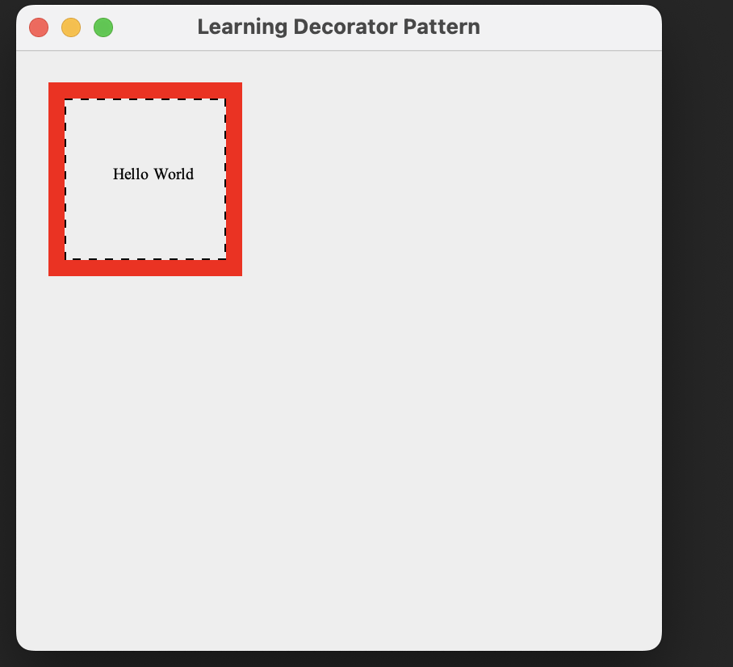

Exercise B:

Source code (Only added/modified parts):

Output:

Simply copy pasted the given code:
/* ENSF 614 - Lab 6 Exercise A/B
* File Name: DemoDecoratorPattern.java
* M. Moussavi, October 2024
* Lab Section: B01
* Completed by: Jack Shenfield
* Submission Date: November 4th, 2025
*/

import java.awt.Font;
import java.awt.Graphics;

import javax.swing.JFrame;
import javax.swing.JPanel;

public class DemoDecoratorPattern extends JPanel {
private static final long serialVersionUID = 1L; // recommended solution from eclipse error message I was getting.
Component t;

public DemoDecoratorPattern() {
t = new Text("Hello World", 60, 80);
}

public void paintComponent(Graphics g) {
int fontSize = 10;
g.setFont(new Font("TimesRoman", Font.PLAIN, fontSize));
// GlassFrameDecorator info: x = 25, y = 25, width = 110, and height = 110
t = new ColourGlassDecorator(
new ColourFrameDecorator(new BorderDecorator(t, 30, 30, 100, 100), 25, 25, 110, 110, 10), 25, 25, 110,
110);
t.draw(g);
}

public static void main(String[] args) {
DemoDecoratorPattern panel = new DemoDecoratorPattern();
JFrame frame = new JFrame("Learning Decorator Pattern");
frame.getContentPane().add(panel);
frame.setSize(400, 400);
frame.setDefaultCloseOperation(JFrame.EXIT_ON_CLOSE);
frame.setLocationRelativeTo(null);
frame.setVisible(true);
}
}

And created my new class, nearly identical to the other decorators. Just added the translucent rectangle logic given:

/* ENSF 614 - Lab 5 Exercise B
* File Name: ColourFrameDecorator.java
* M. Moussavi, October 2024
* Lab Section: B01
* Completed by: Jack Shenfield
* Submission Date: November 4th, 2025
*
*/

import java.awt.AlphaComposite;
import java.awt.Color;
import java.awt.Graphics;
import java.awt.Graphics2D;
import java.awt.Stroke;

public class ColourGlassDecorator extends Decorator {

public ColourGlassDecorator(Component cmp, int x, int y, int width, int height) {
super(cmp, x, y, width, height);
}

// example method given, slightly modified for my use
public void draw(Graphics g) {
super.draw(g);
Graphics2D g2d = (Graphics2D) g;

// save old stroke and colour
Stroke oldStroke = g2d.getStroke();
Color oldColor = g2d.getColor();

g2d.setColor(Color.GREEN);
g2d.setComposite(AlphaComposite.getInstance(AlphaComposite.SRC_OVER, 1 * 0.1f));
g2d.fillRect(25, 25, 110, 110);

g2d.drawRect(x, y, width, height);

// Restore old stroke and color
g2d.setStroke(oldStroke);
g2d.setColor(oldColor);
}

}

Output:

