Abstract— In this project, we will predict the daily number of confirmed COVID19 cases with the Transformer, a model architecture eschewing recurrence and instead relying entirely on an attention mechanism to draw global dependencies between input and output. The Transformer allows for significantly more parallelization. We think Transformer based model will surpass traditional RNN models. This is because, Transformer uses sequence to sequence learning and attention mechanism. This will help us find more precise relationships between features and predict value.
Using Transformer predict the daily number of COVID19 cases
First A. Author, Second B. Author, Jr., and Third C. Author, Member, IEEE
.

INTRODUCTION
A novel coronavirus, COVID-19 (formally known as 2019-nCoV), has emerged over the last few weeks since its outbreak in Wuhan City, China. This COVID-2019 has brought the worldwide threat to the living society. The whole world is putting incredible efforts to fight against the spread of this deadly disease in terms of infrastructure, finance, data sources, protective gears, life-risk treatments and several other resources. The artificial intelligence researchers are focusing their expertise knowledge to develop mathematical models for analyzing this epidemic situation using nationwide shared data. Thus predicting the number of new suspected or confirmed cases of novel coronavirus disease 2019 (COVID-19) is crucial in the prevention and control of the COVID-19 outbreak. In this project, we are going to utilize the machine learning and deep learning models with the aim for understanding its everyday exponential behavior along with the prediction of future reachability of the COVID-2019 across the nations by utilizing the real-time information data.
Statistical and machine learning methods leverage the ground truth data to learn the trends and patterns. One popular family of methods includes auto-regression (AR), autoregressive moving average (ARMA), and autoregressive integrated moving average (ARIMA). Additionally, deep learning approaches based on convolutional and recurrent neural networks have been developed to model time series data. These sequence-aligned models are natural choices for modeling time series data. However, due to “gradient vanishing and exploding” problems in RNNs and the limits of convolutional filters, these methods have limitations in modeling long-term and complex relations in the sequence data.
Neural networks are an effective tool for estimating time series due to their nonlinearity and their ability to be used for different time series without specific information of those. A variety of neural networks have been introduced so far, some of which have been used in forecasting time series. Encoder decoder Networks are an example of networks that can be used in COVID-19. An encoder network encodes the input data based on a particular pattern and then a decoder network decodes the output based on the encoded input to produce the desired output. Since these networks have a better understanding of the context, they provide a better performance. An example of this type of network is transformer. A transformer neural network based on the self-attention is presented that has special capability in forecasting COVID-19 cases.

Transformer

A. What is Transformer
Google's Transformer model was first used for machine translation tasks, when it achieved SOTA results. Transformer improves RNN's most vilified training weaknesses and uses self-attention mechanisms for fast parallelism. And Transformer can be added to a very deep depth to fully explore the characteristics of the DNN model and improve the accuracy of the model.
The Transformer is a deep learning model introduced in 2017 that utilizes the mechanism of attention, weighing the influence of different parts of the input data. It is used primarily in the field of natural language processing(NLP), but recent research has also developed its application in other tasks like video understanding. Like recurrent neural networks (RNNs), Transformers are designed to handle sequential input data, such as natural language, for tasks such as translation and text summarization. However, unlike RNNs, Transformers do not require that the sequential data be processed in order. Rather, the attention operation identifies context for any position in the input sequence. For example, if the input data is a natural language sentence, the Transformer does not need to process the beginning of it before the end. Rather, it identifies the context that confers meaning to a word in the sentence. Due to this feature, the Transformer allows for much more parallelization than RNNs and therefore reduces training times.

B. What are the differences between RNN and Transformer
LSTMs process tokens sequentially. This architecture maintains a hidden state that is updated with every new input token, representing the entire sequence it has seen. Theoretically, very important information can propagate over infinitely long sequences. However, in practice, this it not the case. Due to the vanishing gradient problem, the LSTM will eventually forget earlier tokens.
In comparison, Transformers retain direct connections to all previous timestamps, allowing information to propagate over much longer sequences. However, this entails a new challenge: the model will be directly connected to an exploding amount of input. In order to filter the important from the unimportant, Transformers use an algorithm called self-attention.
The problem we were trying to solve was to identify how multiple orthogonal time series sequences overlaid together can forecast an expected outcome (for example, a stock impending price action). Our hypothesis was that analyzing multiple time series together would be more informative than each one alone. RNN/LSTM is mainly designed to solve a single stream flow of information (such as text translation, NLP, and music sequence) and therefore wasn’t a good fit for our multiple time series input.
We found RNN to be very difficult to train even after we’ve added LSTM (long/short memory). We believe that the main reason for our challenge was the model’s inability to decide which information to save or discard when the input stream grew larger.
RNN was not parallelizable and so training took significantly longer compared to CNN, which is based on aggregating the scores of independent learning paths and thus can be easily parallelized.

B. Model description
In recent years Transformers have gained popularity due to their outstanding performance. Combining the self-attention mechanism, parallelization, and positional encoding under one hood provides usually an edge over classical LSTM and CNN models when working on tasks where semantic feature extraction and large datasets are required.
Like most seq2seq models, transformer structures are made up of encoder and decoder. The total model of transformer can be seen in the Figure 1.
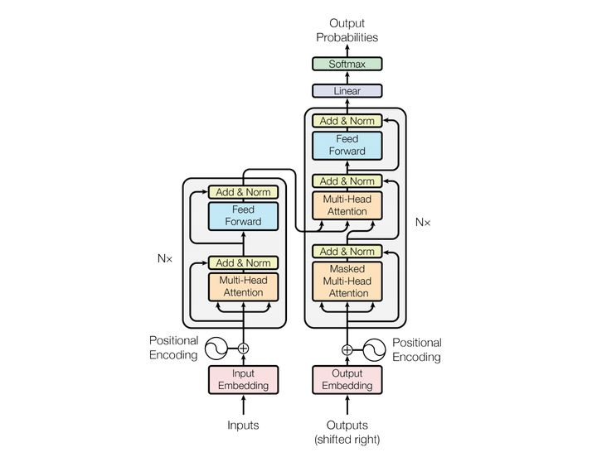
- The structure of Transformer
Encoder:
Encoder is made up of N-6 identical layers, and layer refers to the unit on the left side of the Figure 1, with an "Nx" on the far left, and x6 in this case. Each Layer consists of two sub-layers, the multi-head self-attention mechanism and the fully connected feed-forward network. Each of these sub-layers is added with residual connection and normality, so the output of sub-layer can be represented as
Multi-head self-attention:
In psychology, attention is the concentration of awareness on one stimuli while excluding others. Similarly, attention mechanisms are designed to focus on only the most important subsets of arbitrarily long sequences, that are relevant to accomplish a given task. The multi-head self-attention can be seen in the Figure 2.
Concretely, the model must decide what details from previous tokes are relevant for encoding the current token. The self-attention block encodes each new incoming input with respect to all other previous inputs, laying focus based on a calculation of relevancy with respect to the current token.
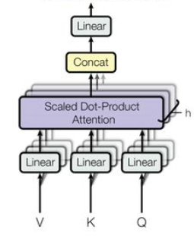
- Multi-head self-attention
Attention can be expressed in the following form:
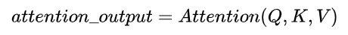
Multi-head focus projects Q, K, V through h different linear transformations, and finally stitches together different attention results. Self-attention is to take Q, K, V as the same. It can be shown in the following equation.
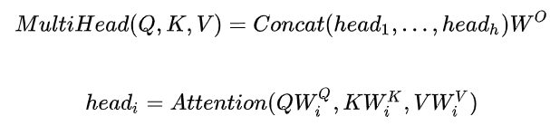
In addition, the calculation in the Transformer uses scaled dot-product, i.e.:
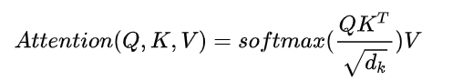
Position-wise feed-forward networks
This layer mainly provides nonlinear transformations. The dimensions of The Attention output are the seq_len, num_heads head_size, and the second sub-layer is a fully connected layer, and the reason is that the transformation parameters of each position i are the same when crossing the linear layer.
There is also a second challenge that needs to be addressed. The time series is not processed sequentially; thus, the Transformer will not inherently learn temporal dependencies. To combat this, the positional information for each token must be readded. In doing so, the self-attention block will have context of relative distance between a given time stamp and the current one, as an important indicator of relevance in self-attention.
Decoder
Decoder and Encoder are similar in structure, but with an extra sub-layer, here's a clear idea of decoder's input and decoder process: Output: The probability distribution of the output word corresponding to the i position. Input: The output of encoder . . . corresponds to the output of the i-1 position decoder. So the middle attention is not self-attention, it's K, V comes from encoder, Q comes from the output of the previous position decoder
Decoding: Be aware that training and forecasting are different. In training, decoding is a full decode out, with the previous step of the truth ground to predict (mask matrix will also change, so that decoding can not see the future token);

Prediction Using Transformer

A. Dataset
Our dataset are obtained from 2020.01.21 to 2021.04.25 in the USA. It contains reporting cases and deaths happened in every day. It’s can be seen in Figure 3. Our task is to use transformer to predict the future cases based on current data.
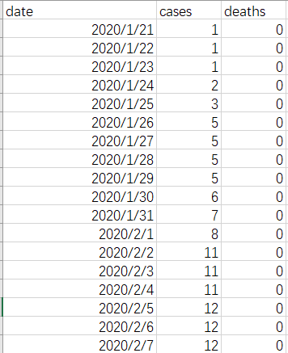
- Datasets description

B. Algorithm Implement
We construct our Transformer algorithm by using Pytorch. batch_size is set as 10, learning rate is set as 0.005, optimizer is Adam, and we select mean square error as our loss, and epoch is 100.

C. Results and Analysis
In Figure 4, we can see the training process. At the last epoch, our training loss is only 0.00341. This shows that our transformer model’s performance is excellent.
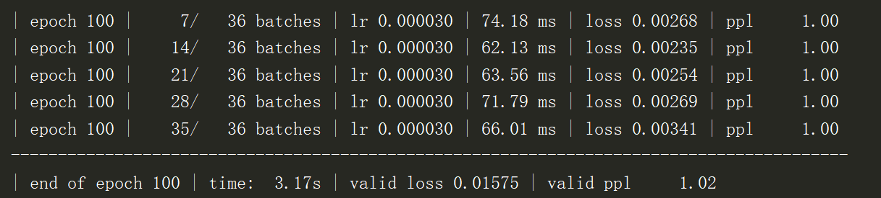
- Training process display
In the Figure 5, we can see the prediction results. The red line is our prediction and the blue line is the true value.
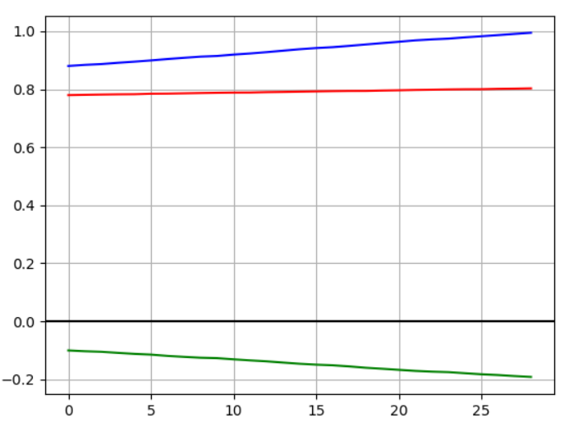
- Prediction results

Conclusion
In this work, we presented a Transformer-based approach to forecasting COVID-19 data. Compared to other sequence aligned deep learning methods, our approach leverages self attention mechanisms to model sequence data, and therefore it can learn complex dependencies of various lengths from time series data. Finally, although the current case study focuses on COVID-19 data, we hypothesize that our approach can be further extended to model spatio-temporal data indexed by both time and location coordinates. Self-attention mechanisms can be generalized to learn relations between two arbitrary points in spatio-temporal space. This is a direction we plan to explore in the future.

References
[1] Vaswani A, Shazeer N, Parmar N, et al. Attention is all you need[J]. arXiv preprint arXiv:1706.03762, 2017.
[2] Wu N, Green B, Ben X, et al. Deep transformer models for time series forecasting: The influenza prevalence case[J]. arXiv preprint arXiv:2001.08317, 2020.
[3] Shi X, Chen Z, Wang H, et al. Convolutional LSTM network: A machine learning approach for precipitation nowcasting[J]. Advances in neural information processing systems, 2015, 2015: 802-810.
[4] Canizo M, Triguero I, Conde A, et al. Multi-head CNN–RNN for multi-time series anomaly detection: An industrial case study[J]. Neurocomputing, 2019, 363: 246-260.
[5] Cirstea R G, Micu D V, Muresan G M, et al. Correlated time series forecasting using multi-task deep neural networks[C]//Proceedings of the 27th acm international conference on information and knowledge management. 2018: 1527-1530.
[6]Sagheer A, Kotb M. Time series forecasting of petroleum production using deep LSTM recurrent networks[J]. Neurocomputing, 2019, 323: 203-213.

 

