**Individual Assignment #1**

**Name: Jihui.Sheng**

**ID: 11539324**

**Course: Cpts 443**

**Good Design****: burner controls (In my apartment)**

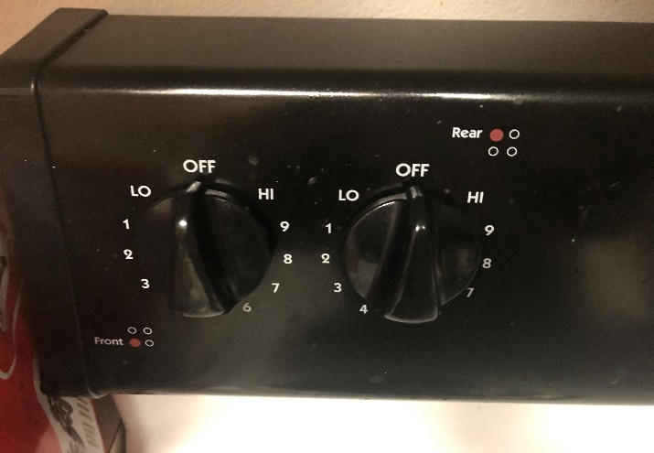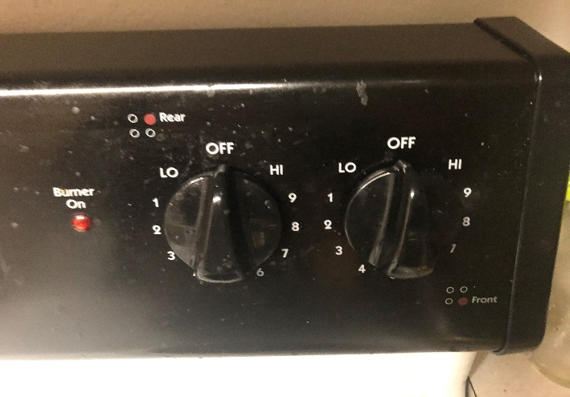

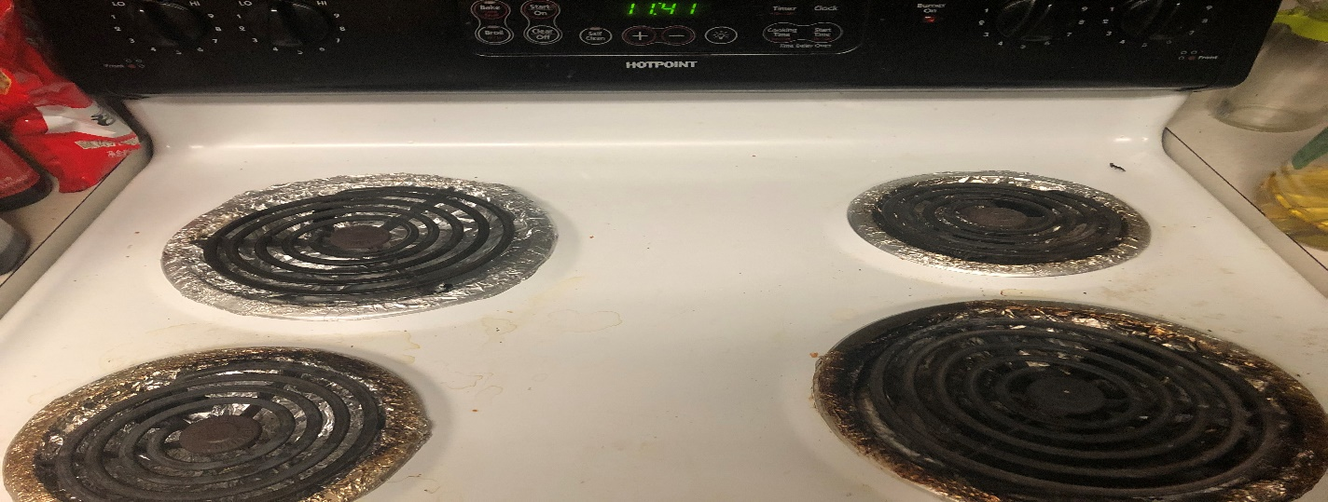

**The conceptual model:** The conceptual model of burner control is very simple. Turn the turntable so that its arrow points to the required heat. When the arrow does not point to OFF, heating starts.

**Affordances:** There are four circular knobs that corresponding to the four electric stoves, the indicator light that can judge whether it is in use.

**Signifiers:** Different words correspond to different temperatures, starting from OFF, starting from low to high counterclockwise

**Mappings:** Some of this interface conforms to the principle of natural mapping. The controller on the left corresponds to the electric stoves on the left, and the controller on the right corresponds to the right.

**Feedback:** When heating starts by rotating the circular knobs, the indicator light will indicate that it is heating. When heated to a certain level, the electric stove will turn from black to red.

**Constraints:** There is no physical constraints, the round knob can be rotated at will, as long as it does not point to OFF, it will start heating. The logical constraint is that HI, as the highest temperature, has its limits.

**Bad Design: Shower equipment (In my apartment)**

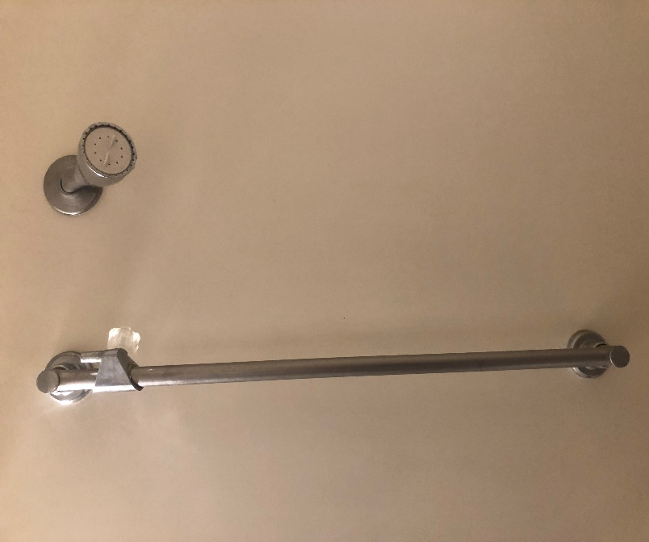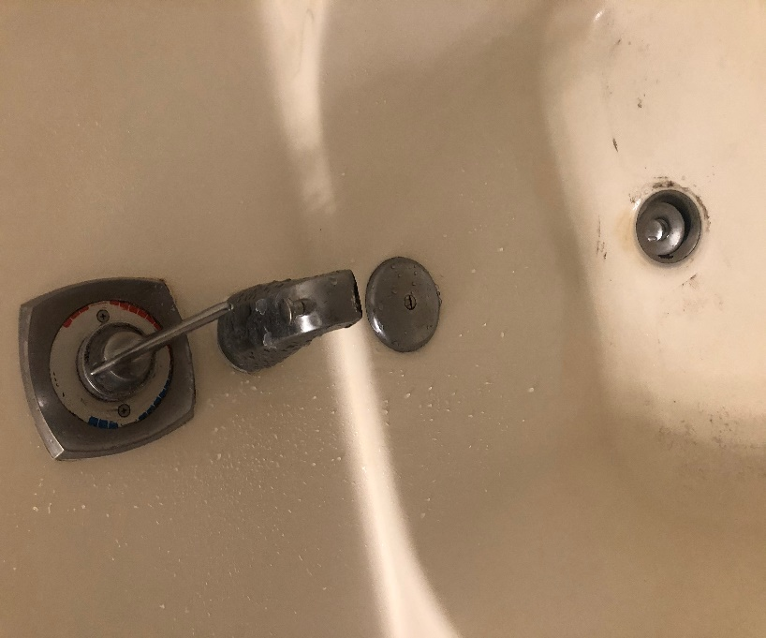

**The conceptual model:** This set of shower equipment adjusts the temperature by rotating the turntable. This shower equipment has the same function as other shower equipment. The main problem is that I do not know how to control the water temperature on the first contact. The turntable can rotate one and a half times. When the turntable points to the red scale, the water temperature is still cold. Only by continuing to rotate a half circle and let it point to the blue scale can you feel the hot water. (There is even something like a handrail next to the nozzle, and the knob on it cannot be twisted.)

**Affordances:** Shower head, bathtub, something for changing water outlet and draining (Do not know how to describe these things).

**Signifiers:** Only blue and red scales are displayed on the turntable. (I think this indicates the corresponding temperature, but not particularly clear.)

**Mappings:** Except for the turntable to control the water temperature and something similar to the handrail next to the shower head, other parts are common in the bathroom and conform to the natural mapping.

**Feedback:** Turn the turntable to get water; the water outlet can be switched by lifting and pressing down; able to release water by lifting the plug.

**Constraints:** The physical limitation is that the turntable can only rotate one and a half revolutions at most.

**Augmented Design: Multifunctional rice cooker**

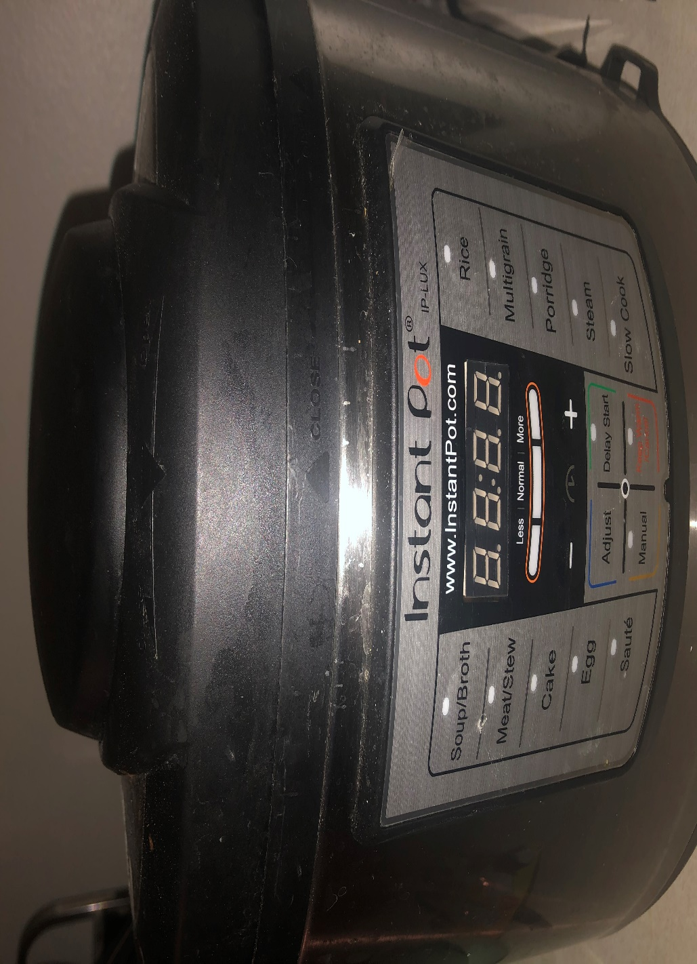

**The conceptual model:** There are many cooking functions corresponding to different cooking methods. Can be operated by clicking a button. But if you are using it for the first time, you will not know how to operate it. You need manual to help you become familiar with the design. Although it seems simple enough, unreasonable operation may lead to poor product use or damage.

**Affordances:** Different option buttons, which contain different function buttons.

**Signifiers:** Buttons with different functions are marked with words. There are also product-related websites and product sequences, which can be used to query related information online. Time also has a corresponding dispatch button.

**Mappings:** The function buttons are in different versions, the left and right are different cooking functions, and the lower middle is the time control. Click the corresponding button to perform the operation of the related function, which conforms to the natural mapping.

**Feedback:** When starting to cook, the countdown time will be displayed, and when starting to keep warm, the heat lamp will light up. There will be an audible feedback when the button is pressed, and there will be a music prompt when the cooking is completed.

**Constraints:** The physical limitation is that there will be other cooking methods that cannot be achieved. The logical limitation is that there will be a time limit, but cooking does not take that long. Regarding semantic constraints, corresponding functions can make cooking better. In other words, if you choose rice button for making cake, there is no guarantee what it will make.