HW2 - simple programmable thermostat

Name: Jihui. Sheng

ID: 11539324

Course: Cpts443

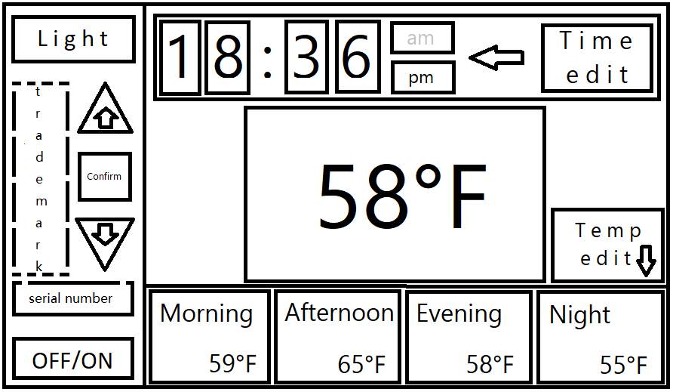

**Affordance:** touch screen

**Signifier:** Button words representing various functions, a section that identifies time and temperature, and a section that has a preset constant temperature. Black font means being displayed, gray font is the opposite.

**Feedback:** After you click the button, the button border will light up. When editing, the border of the edit button will light on until the edit is complete and click OK. When editing a number, the number will flash until you click the OK button, or wait for 3 seconds, the flashing will stop. Click the button to take effect, there will be a beep. The light button will illuminate the entire touchpad, which is different from the light of the frame.

**Natural mapping:** As a thermostat, the largest font in the middle of the screen represents the current temperature, which is the same as the set value constant temperature.

**Constraint:** There are logical limitations on time and temperature. The time is 00:00-23:59, if it exceeds 12:00, it is pm; if it is less than 12:00, it is am.

**Conceptual model:** Click the time **edit button** to make the **time plate** editable, and then click the number to perform **up and down button** operations on the number to adjust the time. When finished, click the **confirm button** to exit the editable state. Click the **temperature edit button** to edit the constant temperature of the 4 time periods. After clicking the button, the **temperature panel** becomes editable. Click the **different time blocks** to be edited to adjust the temperature up and down, and the **confirm button** to complete the editing. When the button is clicked, the frame will glow, which proves that it has been selected, and the numbers in the editing state are flashing. The thermostat can be turned on or off by the **switch button**.

**Visibility:** All settings are displayed in the interface, and there is no hidden function.