HW4

Name: Jihui.Sheng

Id: 11539324

Course: CPTS443

Main interface:

Interface setting: 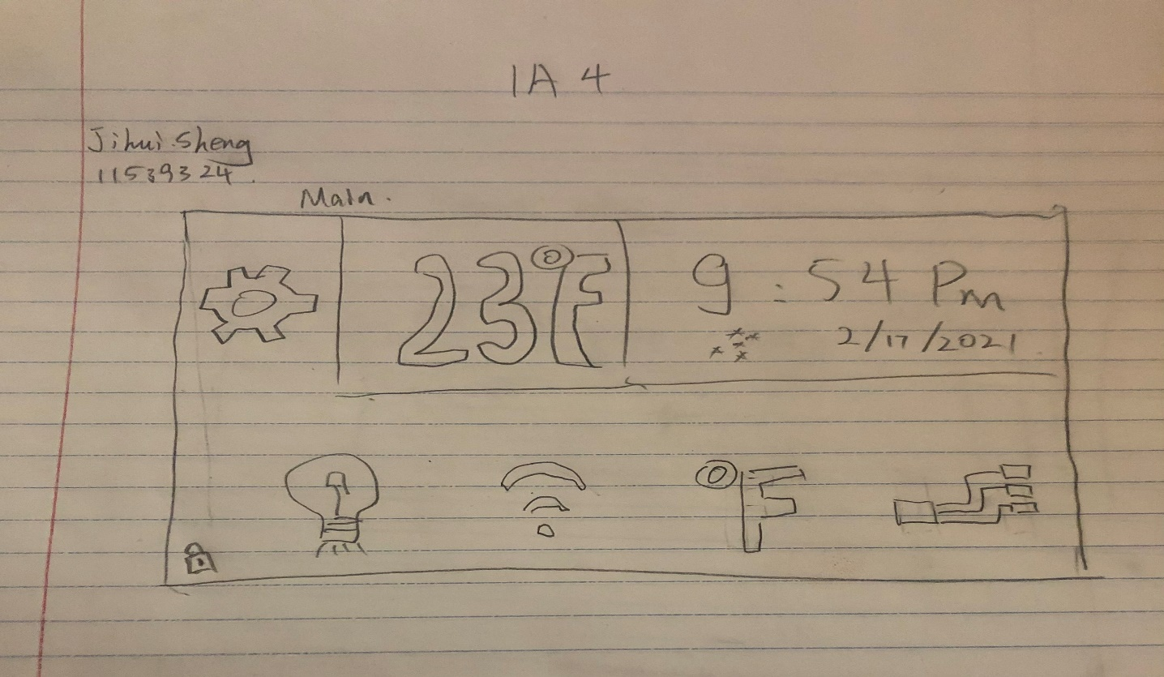

// **The settings icon** on the **top left** is responsible for the interface design, which includes the lighting settings and styles of the interface and layout design

//**The display column** in the **upper right** corner indicates the time, date and temperature

//**The lock** in the **lower left corner** displays the locked status of the screen, which requires user authentication to unlock, and you can make related settings in the interface settings. (It can also be called a child lock for prevent children from accidentally touching)

//**The icons below** are light setting, wifi setting, constant temperature setting and adding device setting.

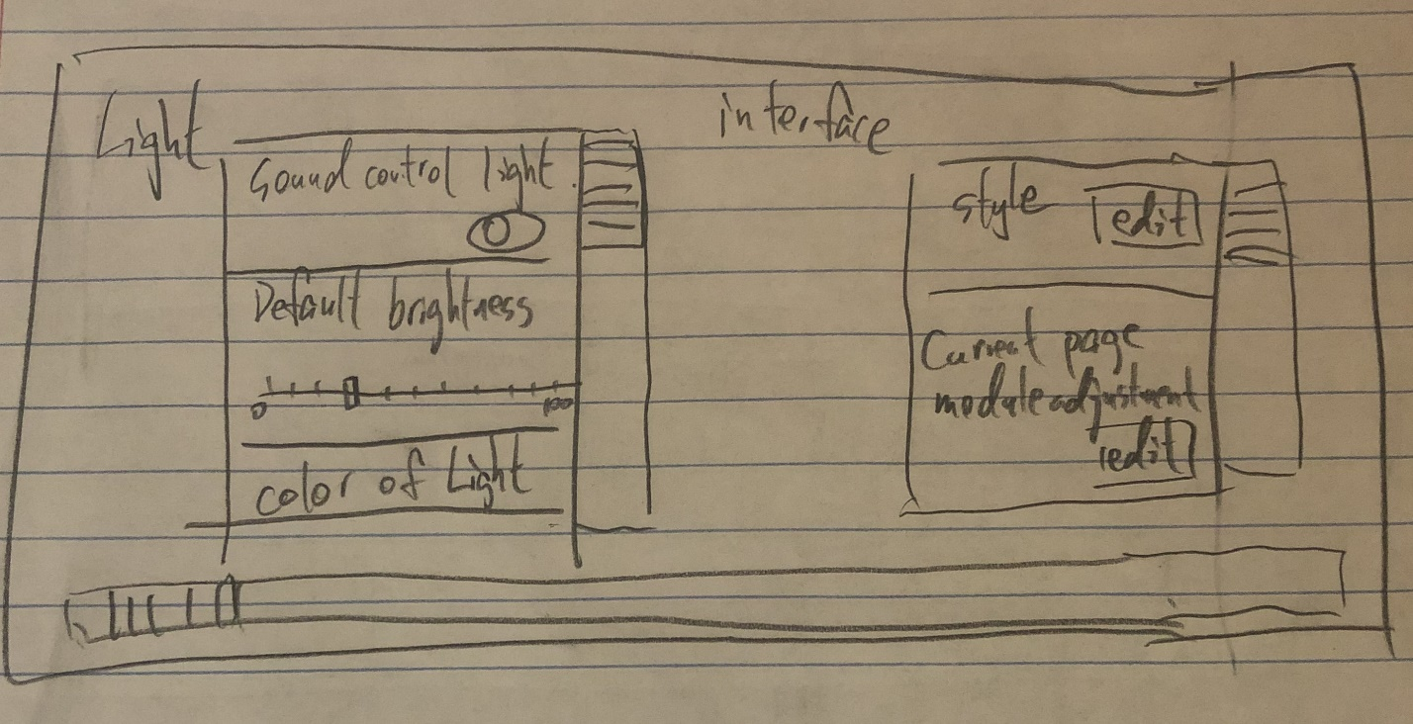

// Interface settings include interface lighting settings and interface template settings.

Light setting:

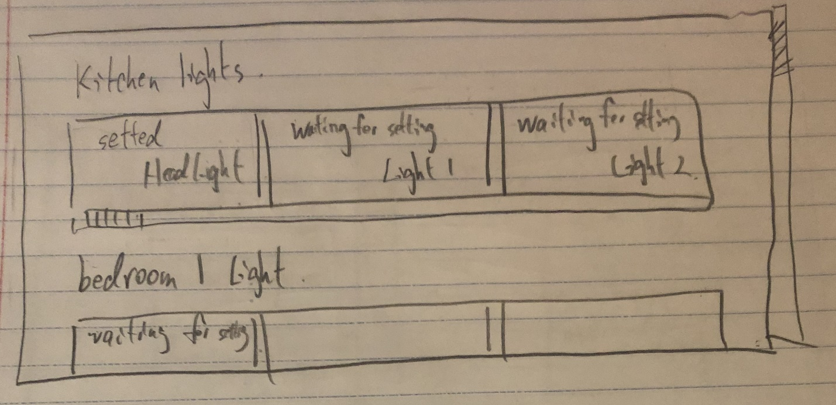

// The function of the lamp setting is to set all the linked lamps. When the lamp has been connected to the device and the setting is completed, it will display "Lamp Name-Connected". When the light is connected but not yet set, it will display "Waiting for setting". Click the corresponding section to edit the device.

Wifi setting:

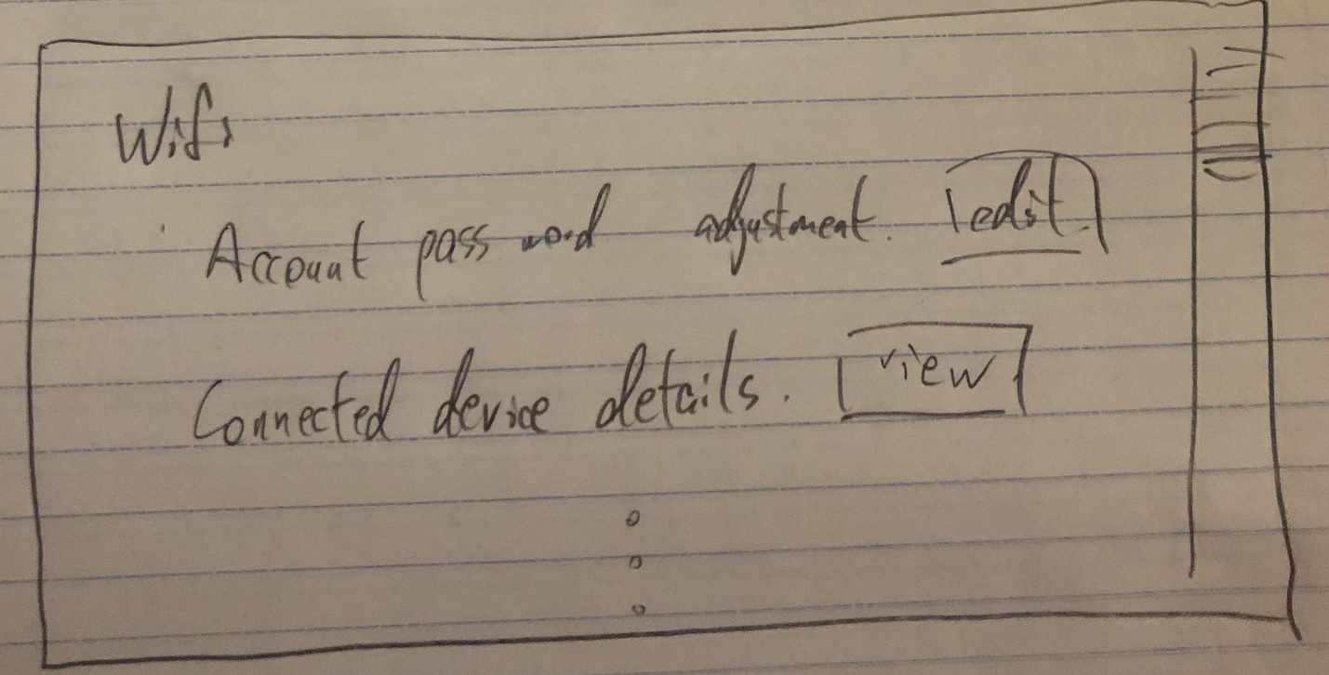

// Wifi settings display wifi related information and connected devices, and you can set the connected devices.

Constant temperature setting:

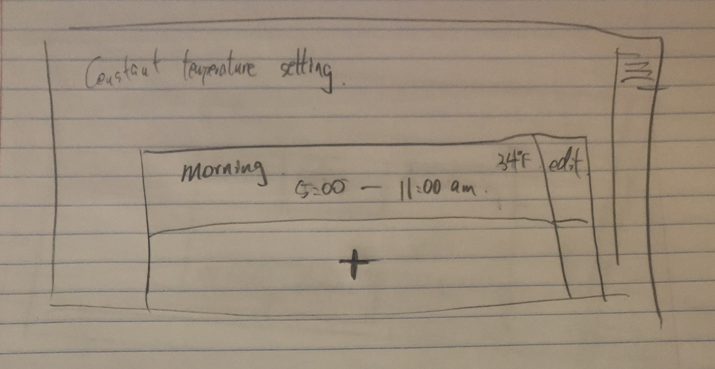

// The constant temperature setting can add the temperature of the corresponding time period.

Device setting:

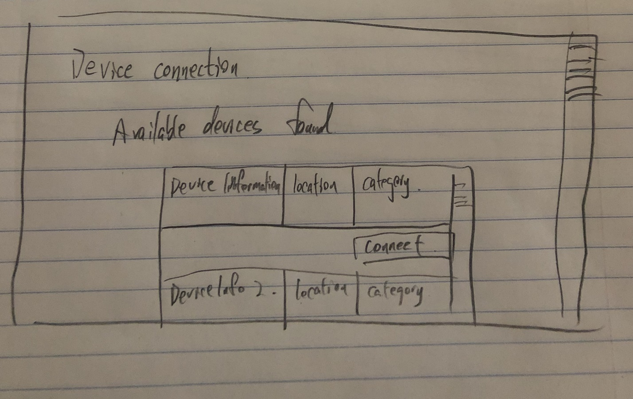

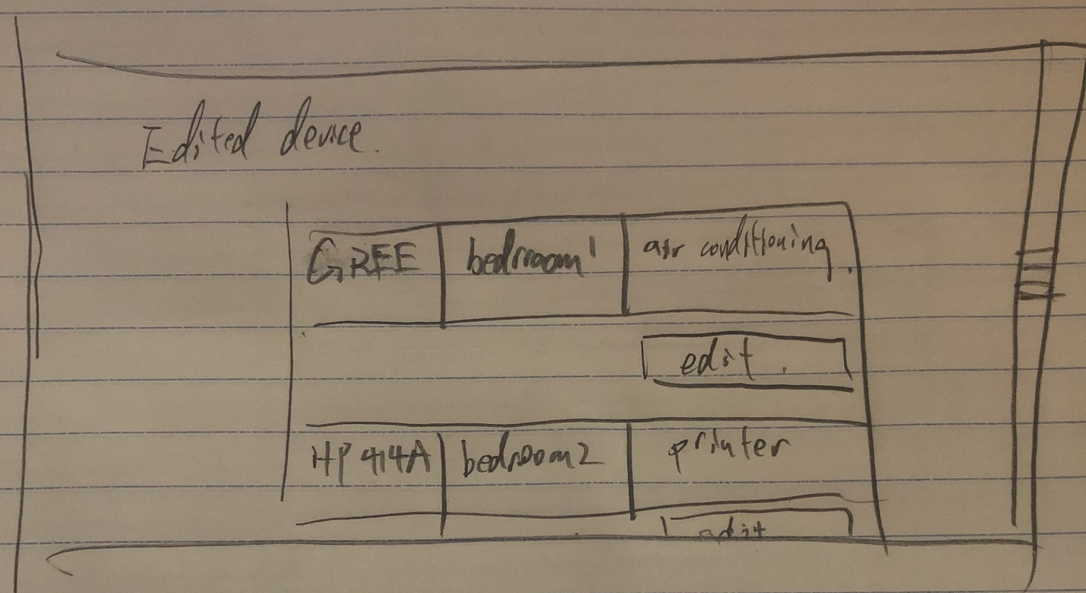

// The device connection setting includes all external devices. When who is searched, it will be displayed in the "optional device list". You can edit the current device and set the name, location, and category of the current device. When the device setting is completed, it will be displayed in "Finish editing device". It can be edited later.

Johnson text:

**Avoid ambiguity in information display:** The main page is composed of simple icons and numbers and try to avoid the appearance of text. In the configuration settings interface, try to keep the text concise and easy to read.

**Understand users’ goals:** Users need to add new equipment or schedule equipment in a simple way through a one-time operation. Therefore, editable devices and edited devices need to be distinguished. General users often use edited equipment, so it should put the scheduled equipment on top. Enable the add page when you need to add a new device.

**Impose visual structure on information displays:** Through the structured form, users can easily query detailed equipment information. The non-text format is more convenient for users' daily operations.

**Avoid unfamiliar words, difficult fonts, poorly contrasting backgrounds:** The design of the background can be defined by the user. Of course, you can prompt the user when the fonts and background are inappropriate and ask the user if they want to perform this operation. The words used are mainly concise and can be explained in a separate manual, but the content on the interface should be concise and clear.

Norman Text:

**Affordances:** The touch screen can slide up and down, the slider is mainly used to let users identify the size of the interface, Additional mobile devices (such as watches) can be added to be able to connect to the controller. Mainly implement devices that have been edited. (Perform operations similar to turning on and off lights, controlling curtains, etc.)

**Signifiers:** Icon buttons for different functions, a bar to adjust the percentage, a sliding bar representing the page size, and text showing time and temperature. Whether to unlock the status bar, indicating the title text of the setting content.

**Feedback:** Start to perform the operation, to confirm that the operation takes effect, add a prompt tone or complete operation indicator. Invalid operations must also have corresponding alarm sounds and warning lights.