1. Table should not be expanded when page loads
2. Submit button to be disabled and grayed out and it should not be clickable
3. Add New Student Button should add new student with dummy values and dummy values should be dynamically added e.g for row 4 the values will be Student 4, Teacher 4 etc. and for row 5 the values will be Student 5, Teacher 5 etc.
4. For newly added rows make sure existing CSS are applied too.
5. After successful add of the record display the pop-up message as Record added successfully (any user-friendly message is also fine) and display error message in case add of record addition failed.

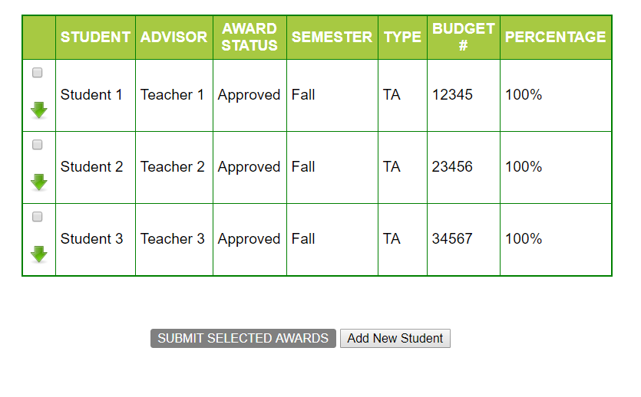

1. On selecting any of the check-boxes,  
   i] Background color to be changed for the particular row to “Yellow” and   
   ii] Submit button to turn orange.   
   iii]A delete button should get added dynamically in DELETE column and should delete the entire row when clicked. Also, pop-up message should be displayed by saying that Record deleted successfully.

iv) An Edit button should get added dynamically in EDIT COLUMN and should only display pop up box with message “Edit the details”. No need to display the field names

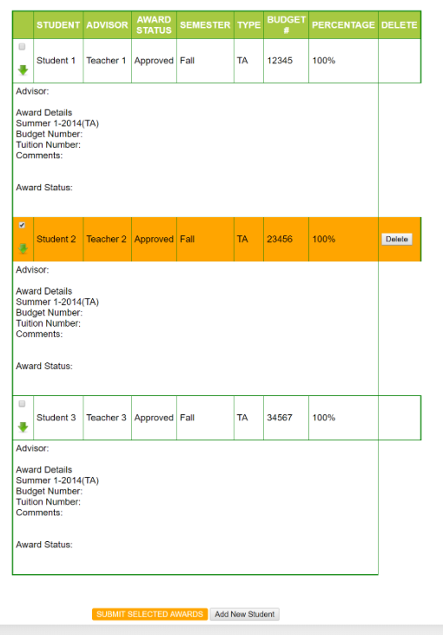

1. Deselecting the check box will
2. make the row background color white again.
3. Also, if none of the rows are selected, the Submit button should be Grayed out again(disabled). (i.e., if 1 or more of the check-boxes are selected, the Submit button will be enabled and background color will be yellow. If none are selected, it will be disabled and background set to Gray)
4. DELETE button in those de-selected rows will be hidden
5. EDIT button in those de-selected rows will be hidden

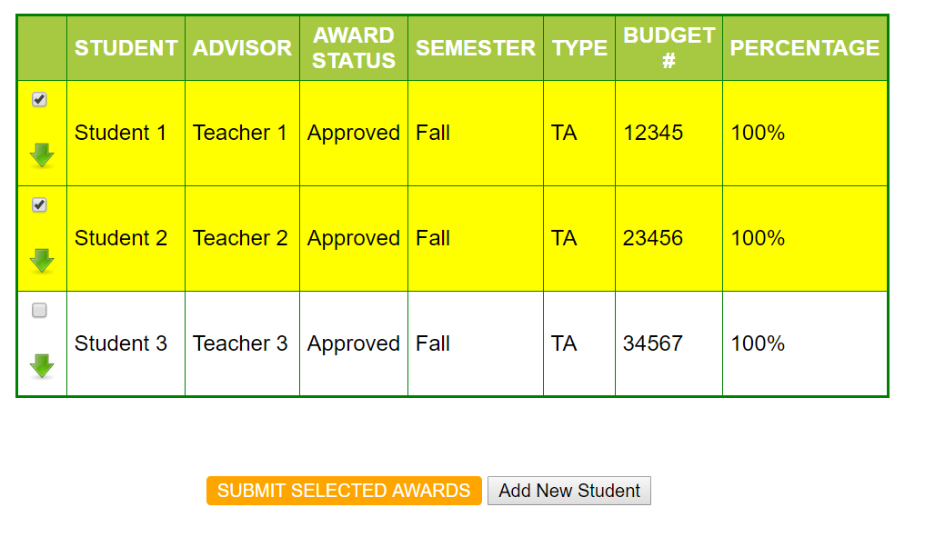

1. Clicking on any of the green arrows will expand the particular row. Clicking it again will collapse it (i.e., toggle view on click)

