1.What is a variable and what is it used for?
It can store something like depth or radius of the pool. it will change as users’ input varies.
2.How do you create a variable that can be accessed by any method in the form’s class? Where should this variable be declared?
Inner the form class but out of specific events like click
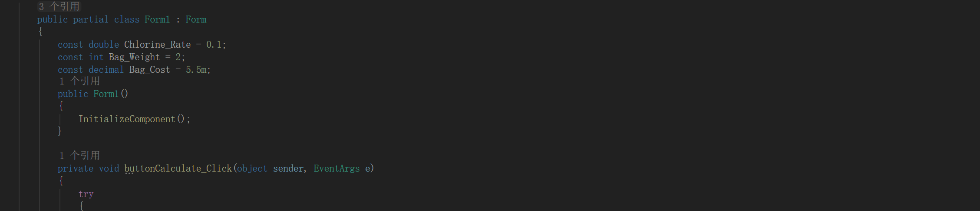
3.What is a constant and why would you use one?
Constant will not change when the program runs
4.What does the Parse method do? Give an example of how to use it.
Turn a string to a number.
