____________________________________________________________

KVSK Payroll
Attendance System

User Manual

____________________________________________________________

Version 1.0 | July 2026

Table of Contents
1. System Overview
2. Login and Logout
3. Dashboard
4. Payroll Processing
5. Attendance Management
6. Employee Management
7. Archive
8. Audit Trail
9. Dark Mode
10. Keyboard Shortcuts
11. Change Password
12. Bulk Print Payslips
13. Bale System (Cash Advance Flow)
14. Payroll Computation (as shown on Payslip)
15. Lock and Unlock Flow
16. Session and Security
17. Troubleshooting and FAQ

1. System Overview
The KVSK Payroll Attendance System is a web-based application designed for managing employee attendance, processing weekly payroll, handling cash advances (bale), and generating payslips. It supports two user roles: Admin (full access) and Hr (limited access). The system uses a PostgreSQL database and runs on a Node.js backend with an HTML/CSS/JavaScript frontend.
Ang KVSK Payroll Attendance System ay isang web-based na aplikasyon para sa pamamahala ng attendance ng empleyado, pagproseso ng weekly payroll, pangangasiwa ng cash advances (bale), at paggawa ng payslip. Sumusuporta ito sa dalawang user roles: Admin (buong access) at User (limitadong access).

Navigation
The sidebar on the left provides access to the main modules: Dashboard, Payroll, Attendance, Employees, and Archive. Each module corresponds to a numbered shortcut key (1–5).
Ang sidebar sa kaliwa ay nagbibigay ng access sa mga pangunahing modules: Dashboard, Payroll, Attendance, Employees, at Archive. Bawat module ay may katumbas na shortcut key (1–5).

User Roles
Role | Access | Responsibilities
Admin | Full system access | Manage all modules, audit trail, unlock payroll, delete records
HR | Limited access | View and manage attendance, record payments, limited payroll actions

2. Login and Logout

2.1 Logging In
1. Open your web browser and navigate to the system URL.
Buksan ang iyong web browser at pumunta sa URL ng sistema.
2. Enter your username and password in the login form.
Ilagay ang iyong username at password sa login form.
3. Click the Login button to access the dashboard.
I-click ang Login button upang makapasok sa dashboard.
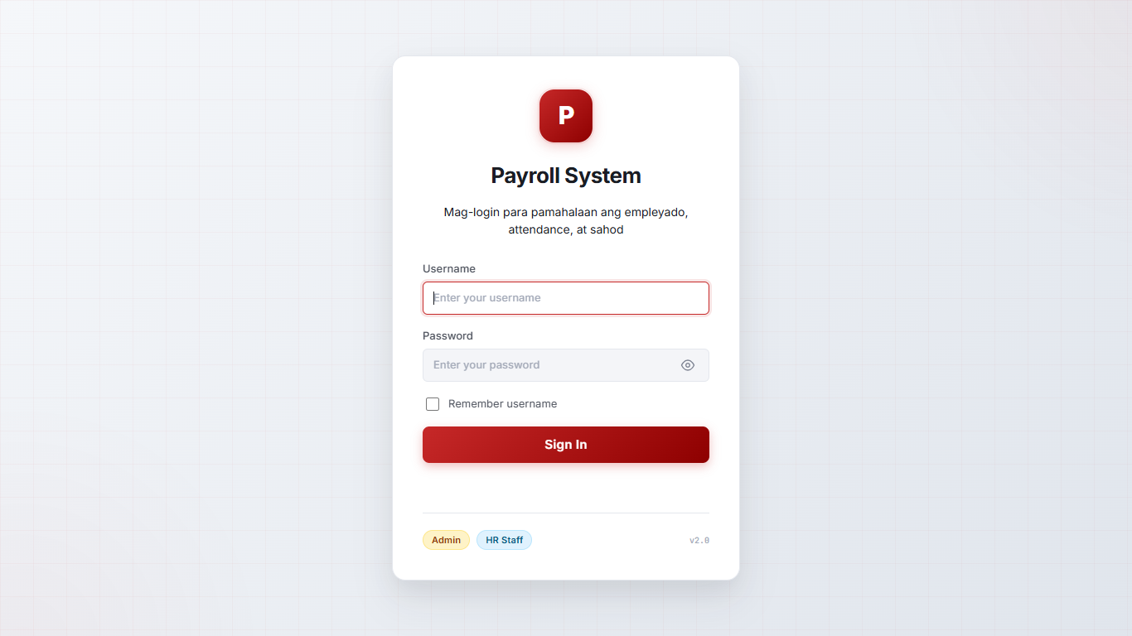
Figure 2.1: Login Screen
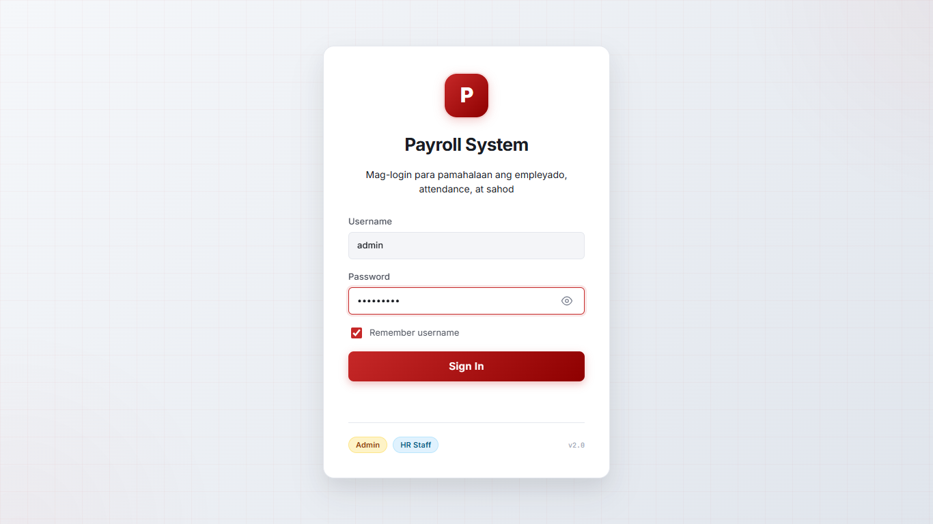
Figure 2.2: Login Form with Credentials

2.2 Logging Out
Click your username at the bottom of the sidebar, then select "Logout" from the menu. You can also press Ctrl+Shift+Q on your keyboard to log out instantly.
I-click ang iyong username sa ibabang bahagi ng sidebar, pagkatapos ay piliin ang "Logout" mula sa menu. Bilang alternatibo, pindutin ang Ctrl+Shift+Q para agad na mag-logout.

2.3 Session Timeout
Sessions expire after 8 hours of inactivity. You will be redirected to the login page automatically when your session expires.
Ang session ay mag-e-expire pagkatapos ng 8 oras na walang aktibidad. Awtomatiko kang ire-redirect sa login page.

3. Dashboard
The Dashboard is the main landing page after login. It displays summary cards with key metrics and two "Needs Attention" sections.
Ang Dashboard ay ang pangunahing pahina pagkatapos mag-login.

Summary Cards
Six cards show: total employees, today's attendance count, total paid amount, remaining salary balance, bale balance, and previous unpaid carryover.

Needs Attention
- No Attendance Today — Lists employees who have not clocked in today. Shows days since last attendance. Has a "Mark All Present" button and a "Take Attendance" link.
- Unpaid This Period — Lists employees with unpaid salary for the current week. Has a "Go to Payroll" link.
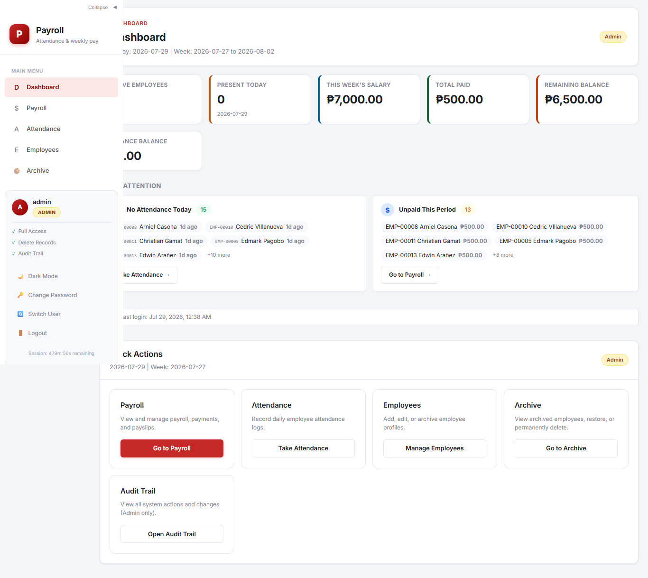
Figure 3.1: Dashboard Overview

4. Payroll Processing
The Payroll view (2) shows all active employees with their weekly payroll data. Use the date toolbar at the top to switch between pay periods (Weekly or Semi-Monthly). The table includes employee number, name, daily rate, days worked, gross salary, previous balances, cash advances, extra payments, paid amount, current balance, bale balance, and payment status.
Ang Payroll view ay nagpapakita ng lahat ng active na empleyado kasama ang kanilang weekly payroll data.
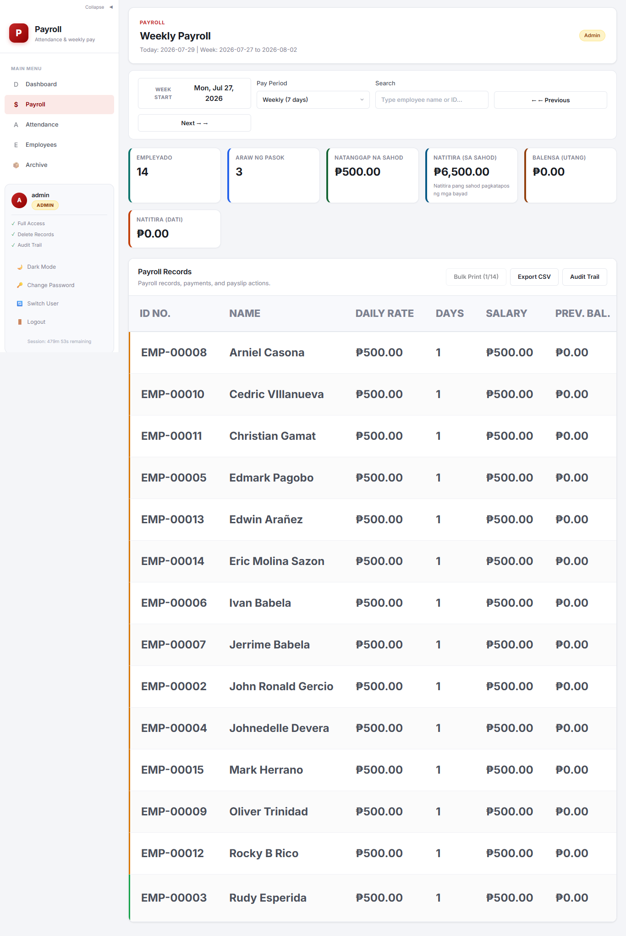
Figure 4.1: Payroll Records Table

4.1 Managing a Payroll Entry
Click the "Manage" button next to an employee to open the Payroll Entry Modal. From here you can:
- Record salary payments ("Bayad Sahod")
- Add cash advances ("Bale / Utang")
- Add extra payments ("Dagdag Sahod")
- Record bale repayments ("Bayad Bale")
- Preview the payslip ("Tingnan Payslip")
- Generate the official payslip ("Generate Payslip")
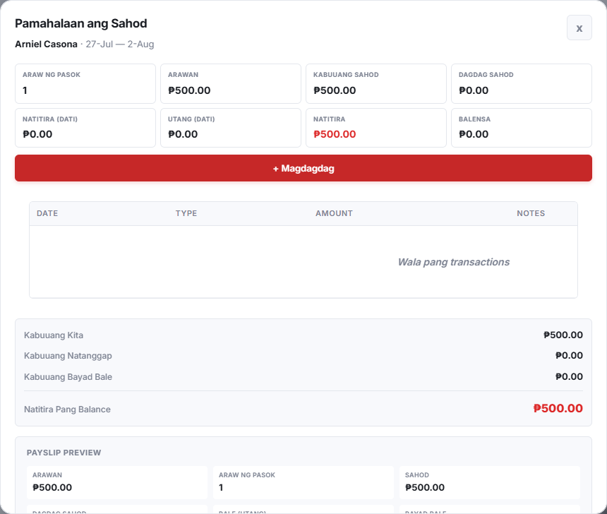
Figure 4.2: Payroll Entry Modal

4.2 Adding Transactions
Inside the Payroll Entry Modal, each section has an "Add" button. Click it to open a transaction form where you enter the amount, select a date, and add notes. Click "Save" to record.
Sa loob ng Payroll Entry Modal, bawat section ay may "Add" button. I-click ito para buksan ang transaction form.
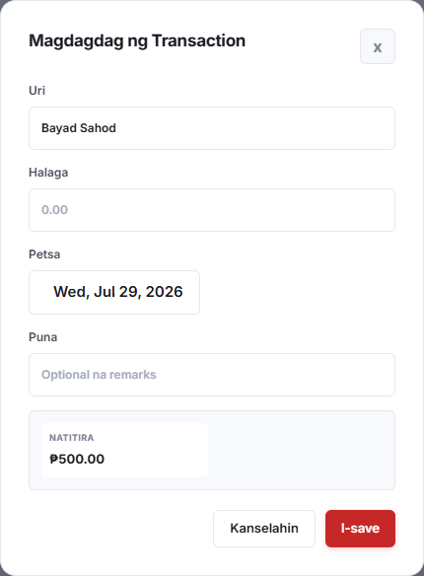
Figure 4.3: Add Transaction Form

4.3 Payslip Preview
Click "Tingnan Payslip" at the bottom of the modal to see the full payslip breakdown. From here you can print or download as PDF, or click "Generate Payslip" to finalize and lock the entry.
I-click ang "Tingnan Payslip" sa ibaba ng modal upang makita ang buong payslip breakdown.
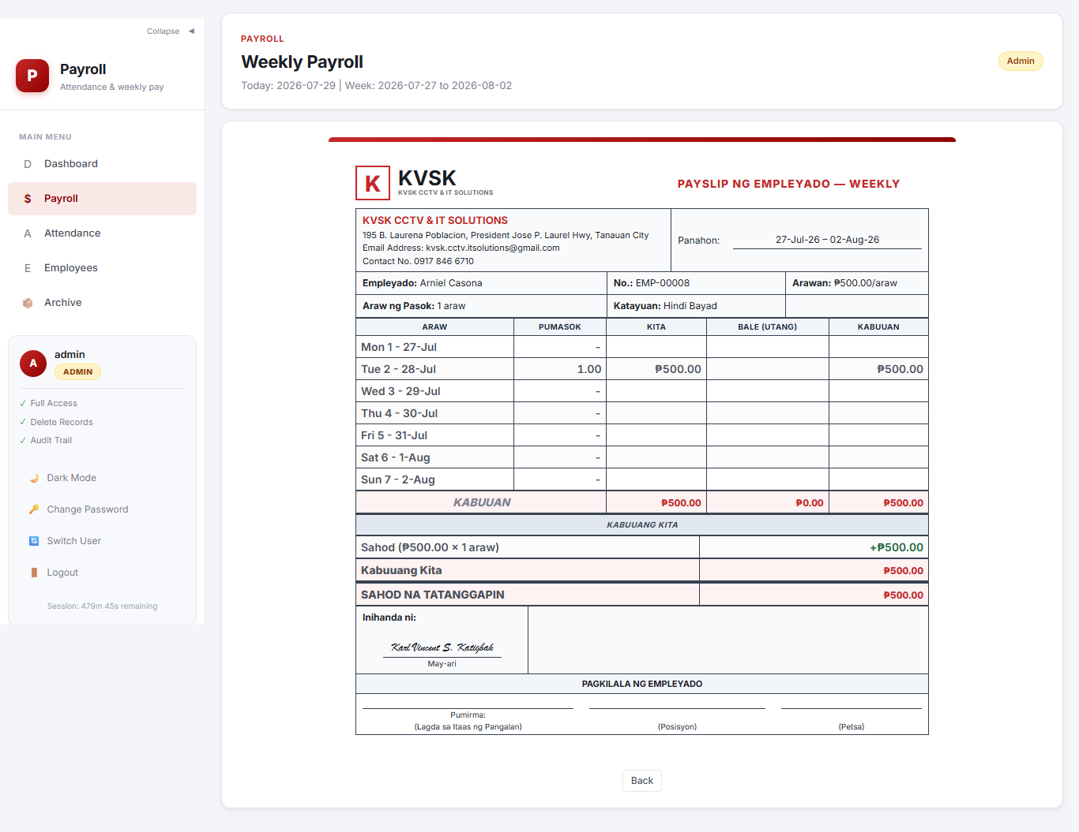
Figure 4.4: Payslip Preview

5. Attendance Management
The Attendance view (3) records daily attendance. Select a date, then click "Add Attendance" to log an employee. The table shows employee number, name, time-in, time-out, daily rate, and daily salary. You can search by employee name or filter by employee. Export to CSV using the Export button.
Ang Attendance view ay ginagamit para i-record ang daily attendance.
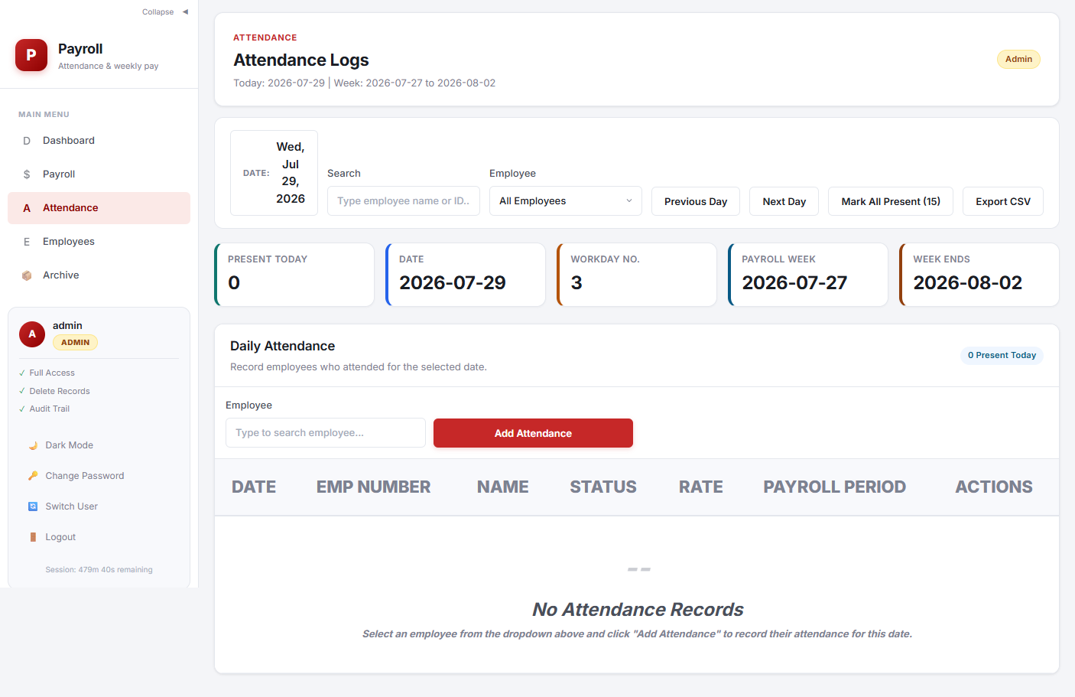
Figure 5.1: Attendance View

6. Employee Management
The Employees view (4) manages all employee records. Each record includes: employee number, name, daily rate, phone number, SSS/PhilHealth/Pag-IBIG/TIN numbers, and pay period (7, 14, 21, or 30 days). Search across any field using the search bar.
Ang Employees view ay nagbibigay-daan upang pamahalaan ang lahat ng record ng empleyado.
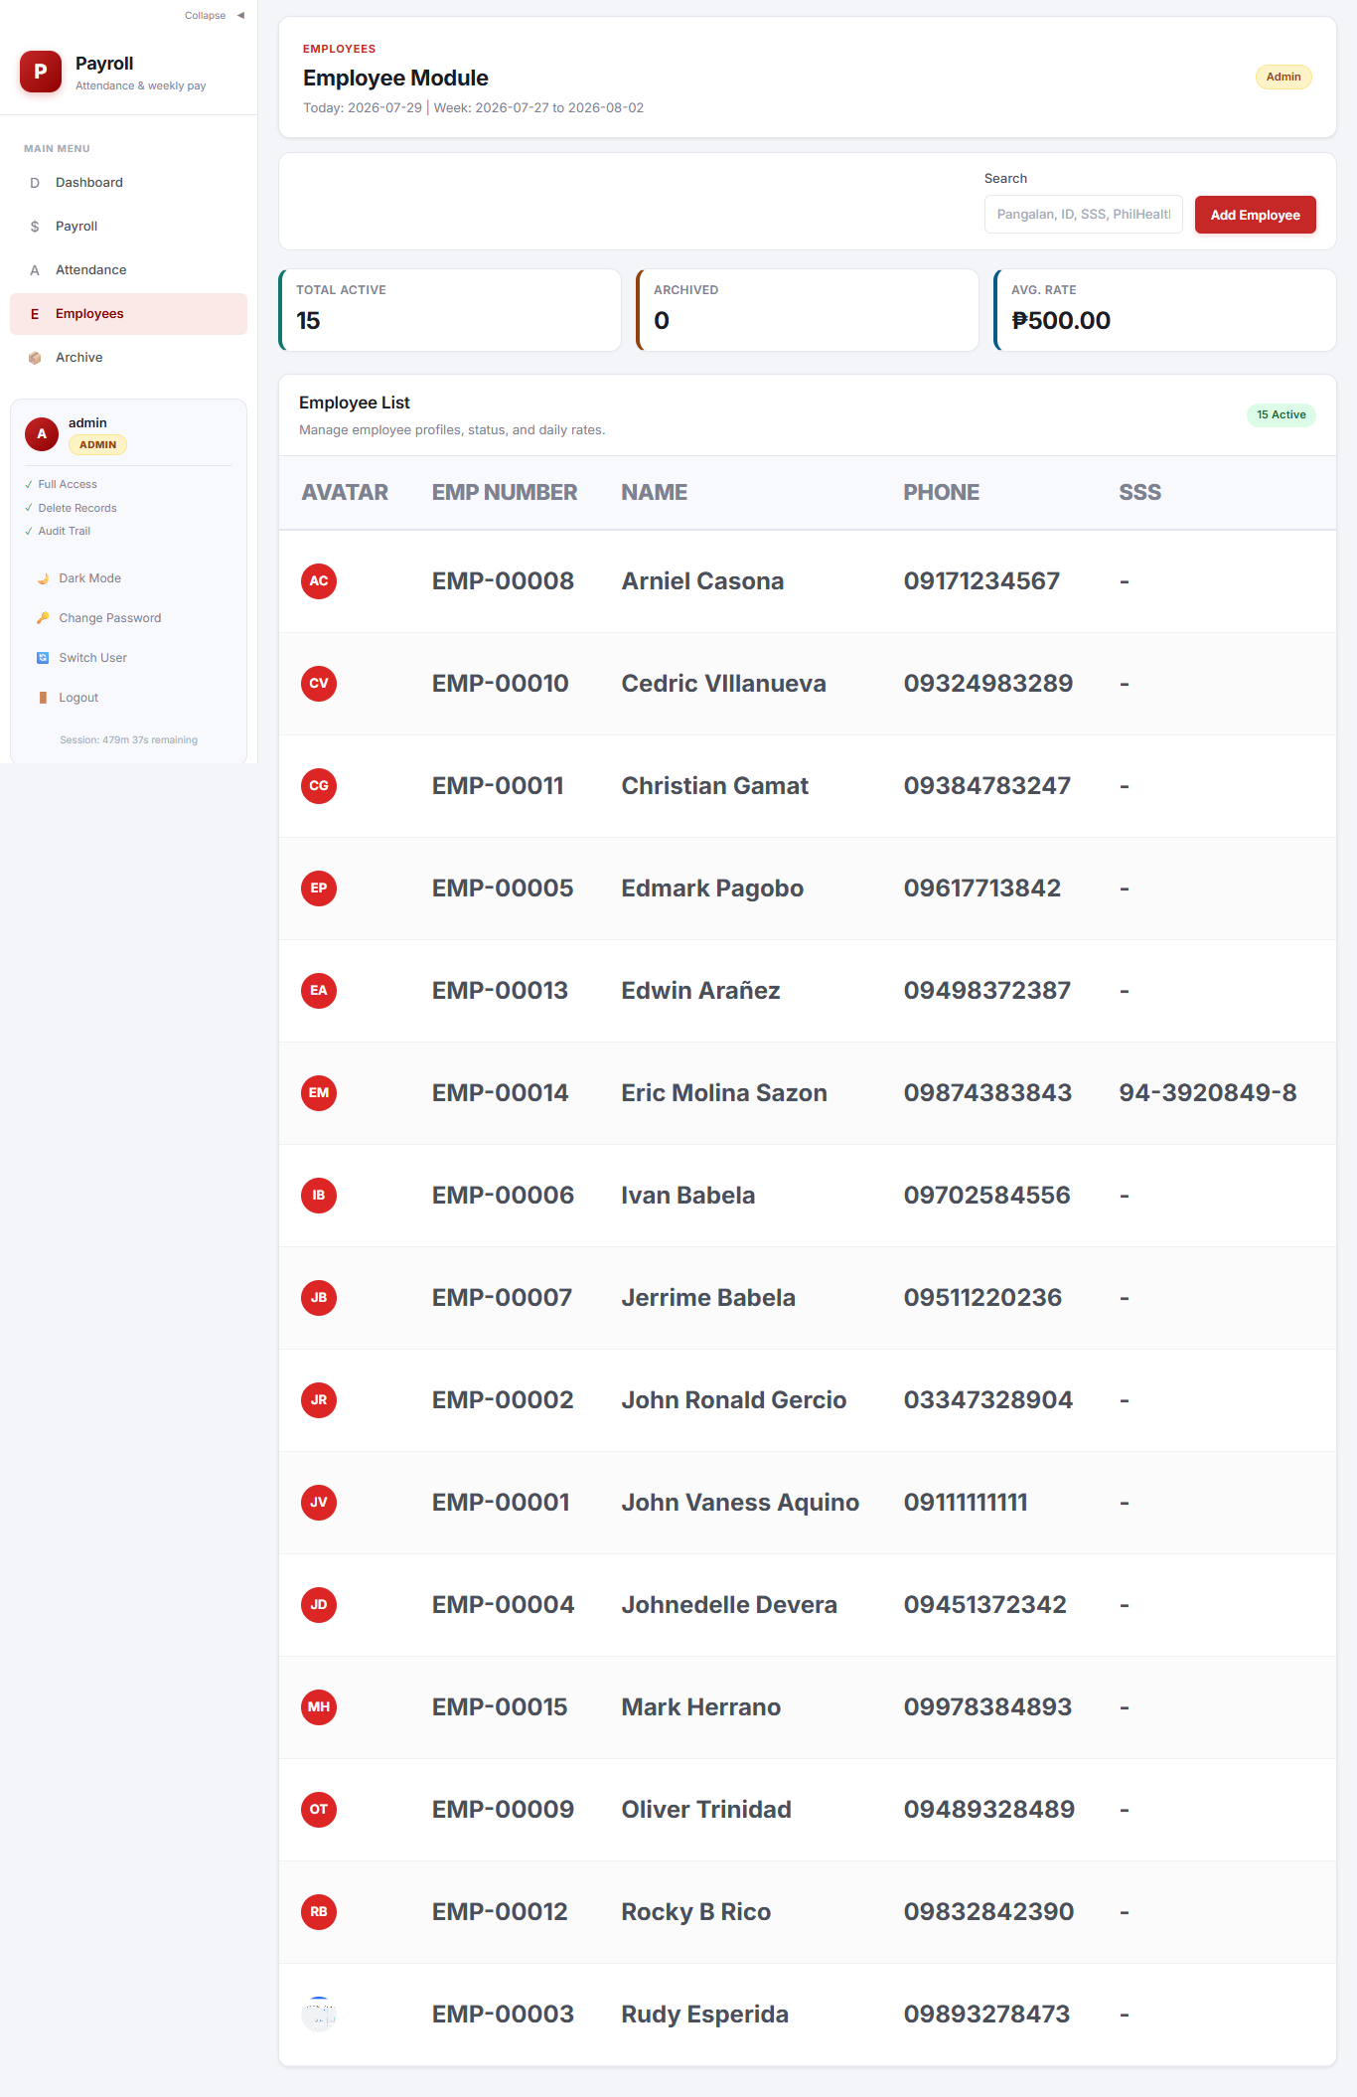
Figure 6.1: Employee List

6.1 Adding an Employee
Click "Add Employee" above the table to open the modal. Fill in all required fields and click "Save". The employee number is auto-generated as EMP-xxxxx.
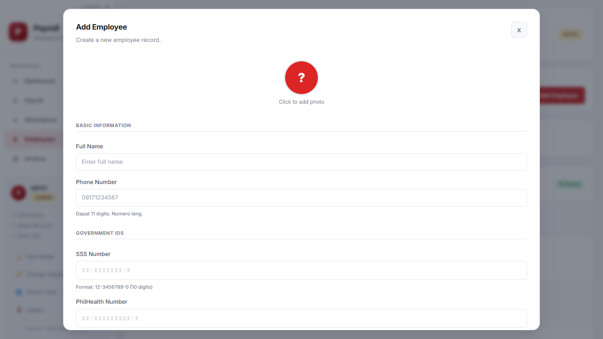
Figure 6.2: Add Employee Modal

6.2 Editing an Employee
Click the edit icon (pencil) next to any employee row. Modify the fields and click "Save" to update.
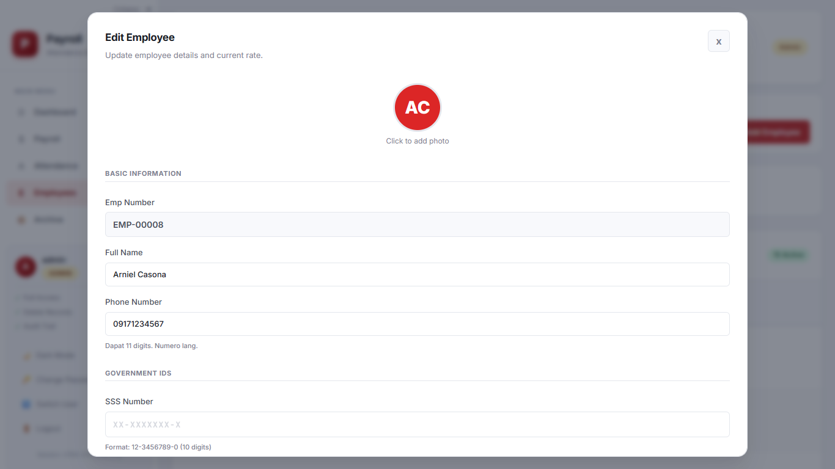
Figure 6.3: Edit Employee Modal

7. Archive
The Archive view (5) contains inactive employees. Restore an employee by clicking "Restore" to make them active again. Archived employees are excluded from attendance, payroll, and other operations.
Ang Archive view ay naglalaman ng mga inactive na empleyado.
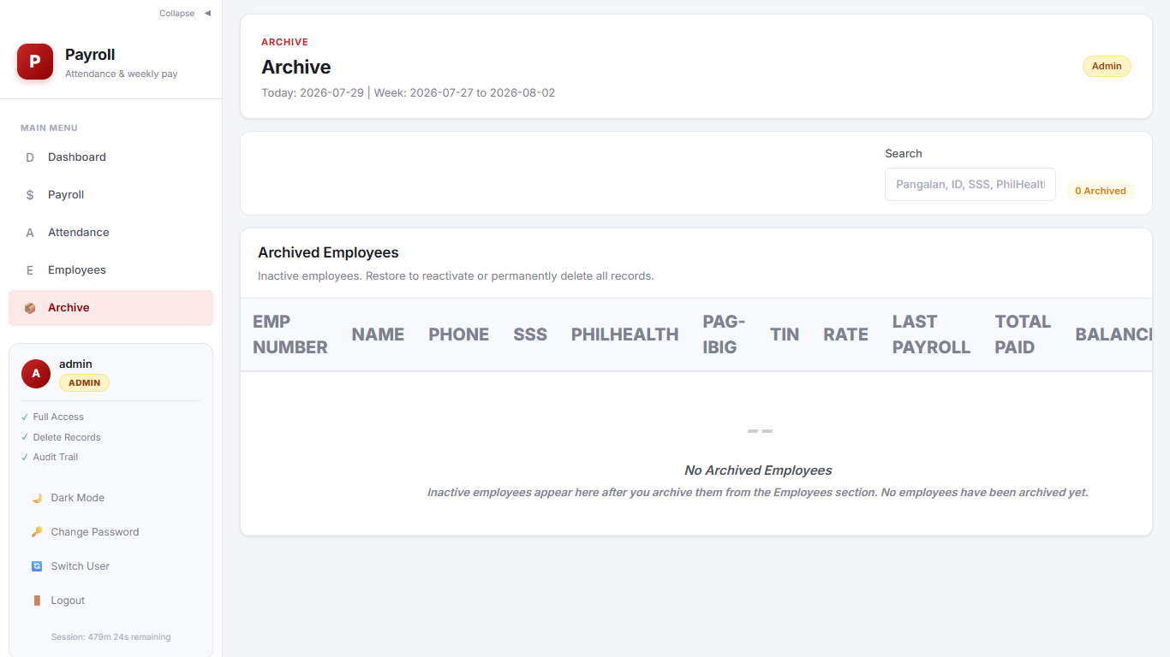
Figure 8.1: Archive View

8. Audit Trail
The Audit Trail (admin only, Ctrl+Shift+A) logs all system actions: logins, employee changes, payroll generation and unlock, payments, and more. You can filter by entity, action type, date range, and search text. Export results to CSV using the Export button.
Ang Audit Trail ay nagla-log ng lahat ng aksyon sa sistema. Admin users lang ang may access.
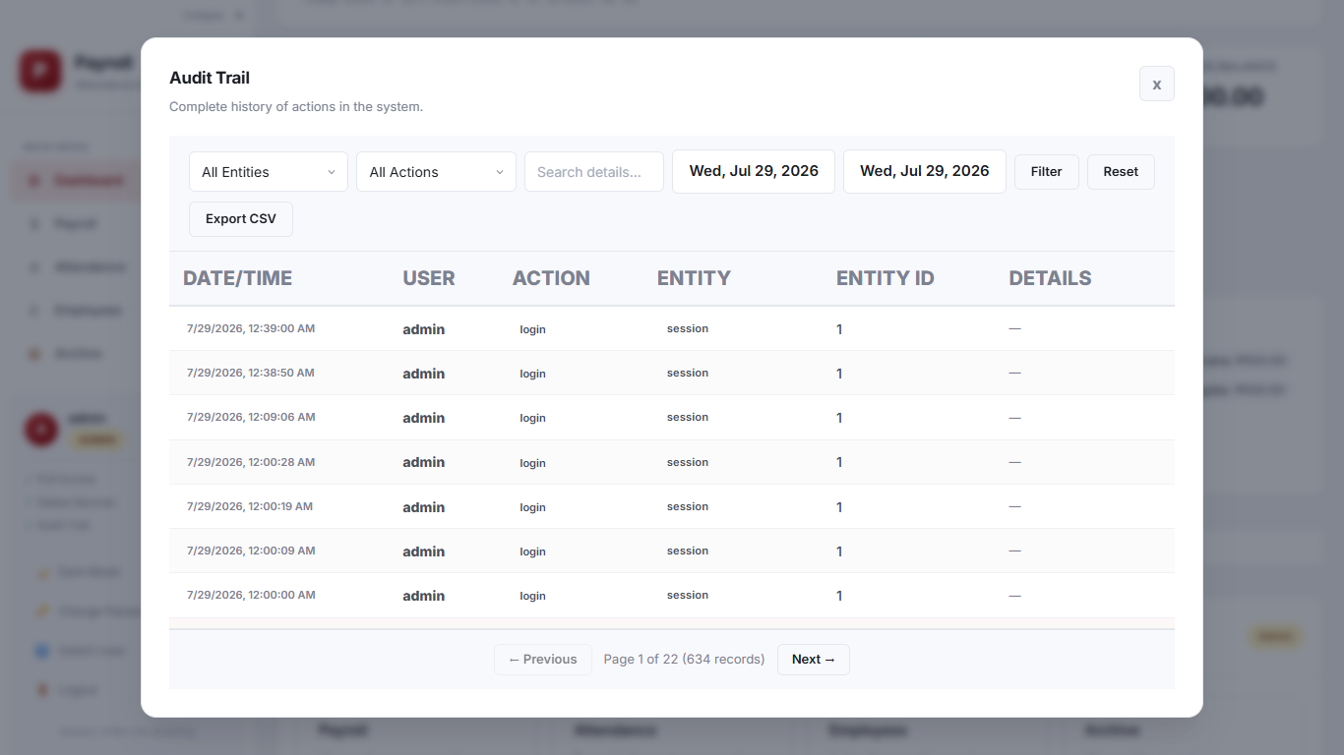
Figure 9.1: Audit Trail Modal

9. Dark Mode
Toggle dark mode using the moon/sun icon in the sidebar or the mobile top bar. Your preference is saved and persists across sessions.
I-toggle ang dark mode gamit ang moon/sun icon sa sidebar.
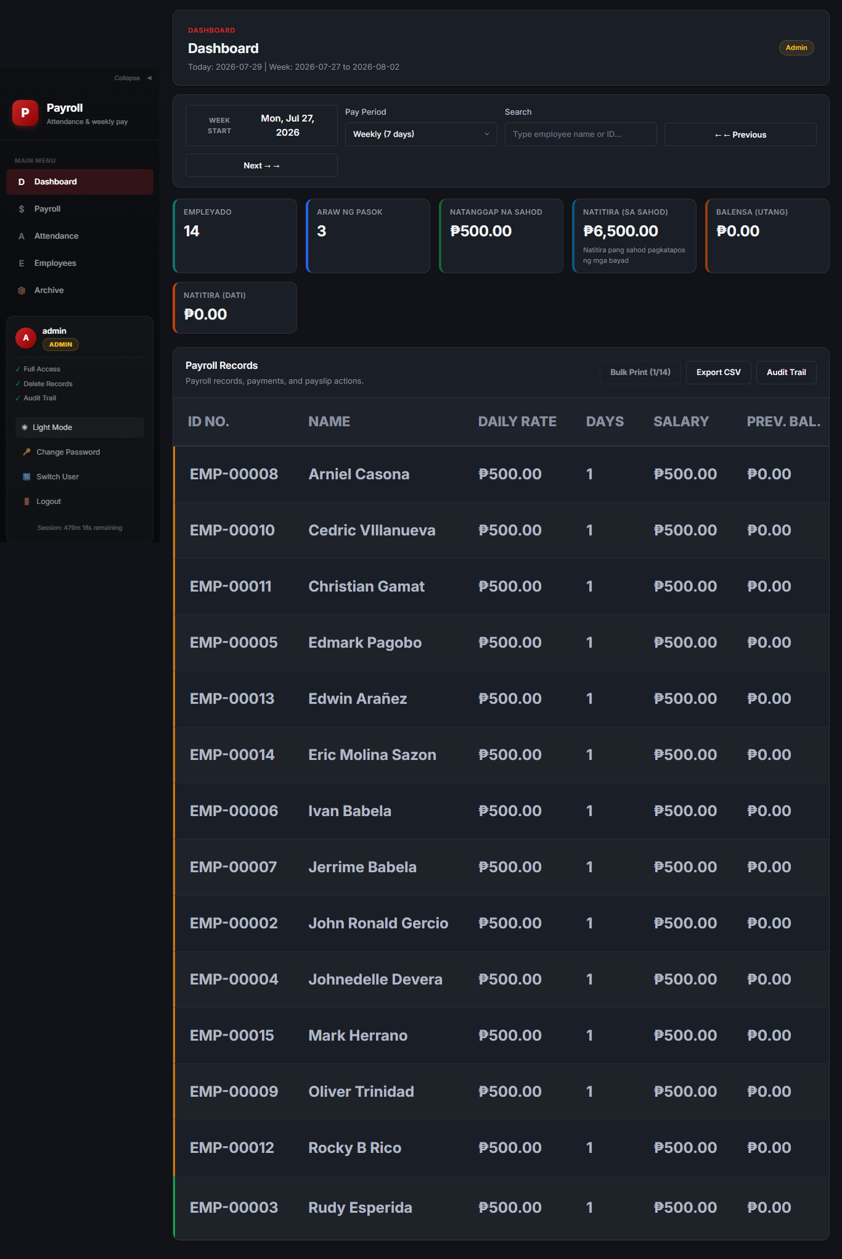
Figure 10.1: Dark Mode View

10. Keyboard Shortcuts
Press the ? key at any time to open the shortcuts help modal. Available shortcuts:
Pindutin ang ? key anumang oras upang makita ang shortcuts.
Key | Action
1–5 | Switch between Dashboard (1), Payroll (2), Attendance (3),  Employees (4), Archive (5)
/ | Focus the search bar
← / → | Previous / Next period in Payroll, Dashboard,  and Attendance views
? | Open this shortcuts help modal
Esc | Close modal, blur input, or cancel
Ctrl+Shift+Q | Logout
Ctrl+Shift+A | Open Audit Trail (admin only)
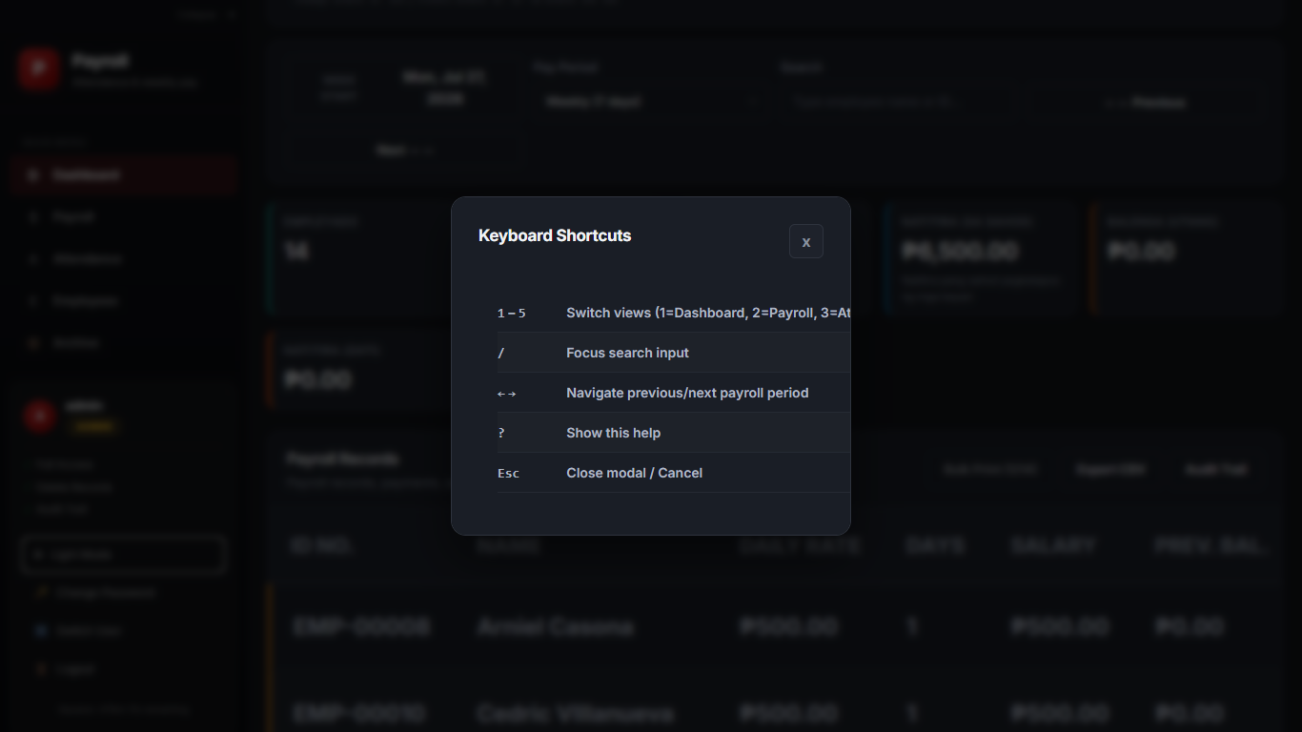
Figure 11.1: Keyboard Shortcuts Help

11. Change Password
Click your username at the bottom of the sidebar, then select "Change Password". Enter your current password, then your new password twice for confirmation. Click "Save" to apply. The change takes effect immediately.
I-click ang iyong username sa sidebar at piliin ang "Change Password". Ilagay ang iyong kasalukuyang at bagong password.
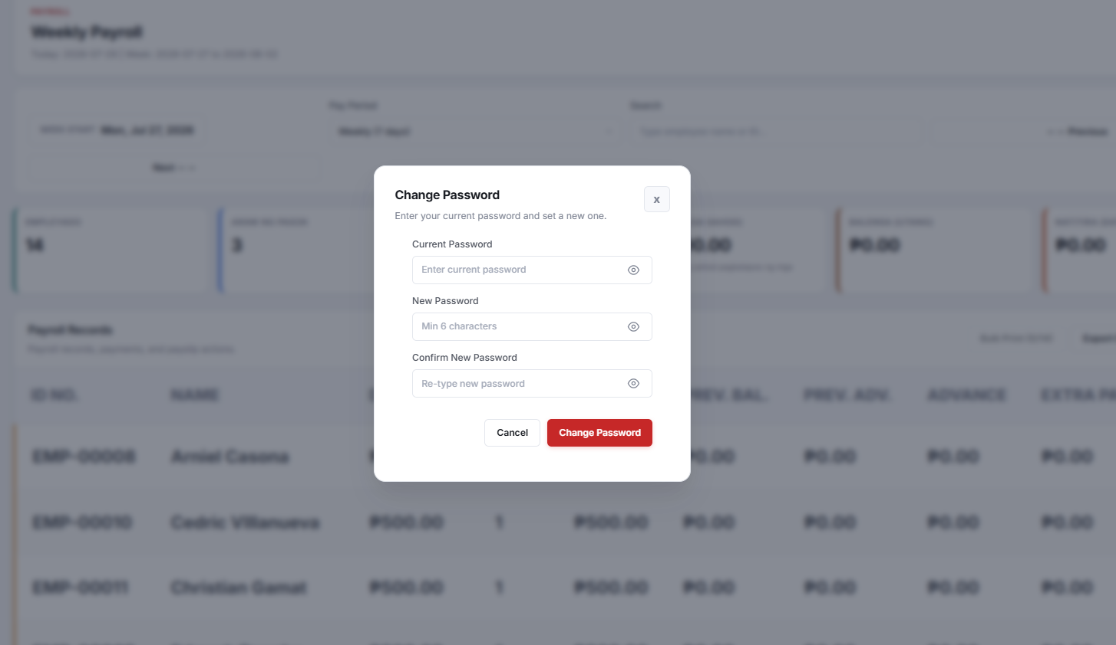

ℹ Default admin password is "admin123". Change it immediately after first login.

12. Bulk Print Payslips
The "Bulk Print Payslips" button in the Payroll view toolbar prints all generated payslips for the current week at once. The button shows a counter (e.g., "Bulk Print (5/8)") indicating how many payslips have been generated. All payslips must be generated before bulk printing is enabled.
Ang "Bulk Print Payslips" button ay nagpi-print ng lahat ng generated payslip sa isang batch.

13. Bale System (Cash Advance Flow)
The bale system lets employees take cash advances against future salary. The system tracks two separate balances: salary balance (unpaid salary) and bale balance (outstanding advances).

How It Works
- Taking an advance: In the Payroll Entry Modal, go to "Bale / Utang" and click Add. One advance per employee per day.
- Repaying: In the same modal, go to "Bayad Bale" and record the payment. The payment reduces the bale balance.
- Carryover: Bale balances carry over week to week until fully repaid.
- Display: The Payroll table shows "Total Adv." (current week advances) and "Adv. Bal." (running bale balance).

Bale Deduction Option
When processing payroll, you can check the "Bale Deduction" option to automatically apply the bale balance as a deduction from the employee's pay.

14. Payroll Computation (as shown on Payslip)
The payslip displays a complete breakdown of earnings and deductions. Below is the exact layout matching the printed payslip.
Ang payslip ay nagpapakita ng kumpletong breakdown ng kita at deductions.

Table A — Daily Breakdown
For each day in the pay period, the payslip lists: the date, whether the employee came in, the daily earnings, any bale taken that day, and the running total.
Column | Meaning
Araw | Date of the work day
Pumasok | Checked if the employee came in (1.00) or not (–)
Kita | Daily earnings (rate × 1 if present)
Bale (Utang) | Cash advance taken that day, if any
Kabuuan | Running total of earnings for the period

Table B — Kabuuang Kita (Total Earnings)
Line Item | How It Is Computed
Sahod (rate × days) | Days present × daily rate
Dagdag Sahod | Extra payments / bonuses added this period
Natitira mula sa Nakaraan | Unpaid salary carried over from previous periods
Kabuuang Kita | Sahod + Dagdag Sahod + Previous Unpaid
Bayad Bale (Utang) | Bale repayment amount (deduction)

Table C — Sahod na Tatangapin (Take-Home Pay)
Line Item | How It Is Computed
SAHOD NA TATANGGAPIN | Kabuuang Kita − Bayad Bale
Bayad Sahod | Salary payment made this period
BALANSA | Take-home pay − Bayad Sahod (remaining unpaid)

Table D — Balensa ng Bale (Bale Balance)
Line Item | How It Is Computed
Utang mula sa Nakaraan | Bale balance carried over from previous period
Bale ngayong Period | New cash advances taken this period
Kabuuang Utang (Bale) | Previous bale + new advances
Bayad Bale ngayong Period | Bale repayment this period
Natitirang Utang (Bale) | Total bale − bale payment (remaining)

Payment can also go first to any previous unpaid balance. The "Balance" column on the Payroll table shows remaining unpaid salary, while "Adv. Bal." shows remaining bale to repay. These are tracked separately.
Ang "Balance" column ay nagpapakita ng natitira pang hindi nababayarang sahod. Ang "Adv. Bal." ay natitira pang bale na kailangang bayaran.

15. Lock and Unlock Flow
Once a payslip is generated, the payroll entry becomes "Locked" to prevent further changes. This ensures data integrity after payroll finalization.
Kapag na-generate ang payslip, ang payroll entry ay nagiging "Locked" upang hindi na mabago.

Lock States
State | What It Means
Unlocked | Entry can be modified. "Manage" button is shown.
Generated (Locked) | Payslip finalized. Shows "Locked" badge. Admin can "Unlock".
Locked (Same Period) | Entry locked with matching period. Cannot be modified.

Unlocking
1. Find the locked employee in the Payroll table.
Hanapin ang naka-lock na empleyado sa Payroll table.
2. Click the "Unlock" button next to their row.
I-click ang "Unlock" button.
3. Make your changes.
Gawin ang mga pagbabago.
4. Re-generate the payslip.
I-generate muli ang payslip.

16. Session and Security

16.1 Session Management
Feature | Details
Storage | Server-side sessions via HTTP-only cookies
Duration | 8 hours of inactivity before automatic logout
Concurrency | One active session per user

16.2 Security Measures
- CSRF Protection — All modifying requests require a valid CSRF token.
- Rate Limiting — Max 10 login attempts per 15 minutes per IP.
- Audit Logging — All financial and admin actions logged with timestamps.
- Password Hashing — bcrypt with cost factor 12.
- Security Headers — CSP, HSTS, X-Frame-Options, and others enforced.

17. Troubleshooting and FAQ
Q: I forgot my password.
Contact your system administrator to reset it.
Q: Cannot log in.
Check your username and password. After 10 failed attempts, you will be locked out for 15 minutes.
Q: How to generate a payslip?
Go to Payroll, click "Manage" on the employee, review data, then click "Generate Payslip".
Q: What does "Locked" mean?
The payslip has been finalized. Click "Unlock" to make changes, then re-generate.
Q: How to undo a payment?
Admin users can delete a payment from the Payroll Entry Modal. Recorded in the audit trail.
Q: How to print multiple payslips?
Use "Bulk Print Payslips" in the Payroll view after generating all payslips.
Q: Default password?
"admin123". Change immediately after first login.
Q: System not loading?
Refresh (F5). If the problem persists, check that the server and database are running.

