C Sc 335 Analysis and Design Artifacts for the Final Project, Spring 2014
Due: 11:00pm Friday 11-April to the common repository in BitBucket as part of your Java project
1. Team Name: ________The Other Guys____________________
2. Team Members: Tyler Bernth
Jeremy Menke
Lorenzo Fusaro
Jason Stevings
3. Project Chosen: Circle your team's choice of final project
TRPG MUD Tower Defense Settlement Management

4. Candidate Objects or Class Hierarchies

List the seven most important objects, or the name of a hierarchy, and the main responsibility of each

Candidate Object | Single Responsibility in 1 or 2 sentences
1 Unit | The unit is a class which moves and battles other units
2 Game | The game class is what watches over all of the objects during a game. “The overseer”
3 Terrain | This class is used for various objects (like rocks) which units cannot pass through
4 BotPlayer | This class is used for the enemy team, and will make decisions on where to move as well as when to attack
5 Strategy (interface) | This interface will be used for the bots which will determine where to move and attack.
6 GameObject | Every gameObject will have a bufferedImage, as well as multiple stats to determine what type of object it is
7 GameBoard | This object will keep track of where all the units are on the board as well as keep of where they move to.

These Class and Sequence Diagrams may be written by hand and scanned or drawn with a UML editor such as Violet http://sourceforge.net/projects/violet/files/violetumleditor/

5. Class Diagram: Your team UML Class Diagram must show at least all of your candidate objects from above. Show any relationships between them the classes such as inheritance or interface implementation. Draw general associations such as dependency or aggregation. Label some to help explain things. Add any multiplicity adornments that seem appropriate. Use notes to explain things if you feel it will help. Each UML class must show the class name. For full credit, each class must have an average of at least one attribute per class. There must be an average of at least 2.0 methods per class, which may be implicit (no need to repeat methods) if the class implements a Java interface with methods shown there.

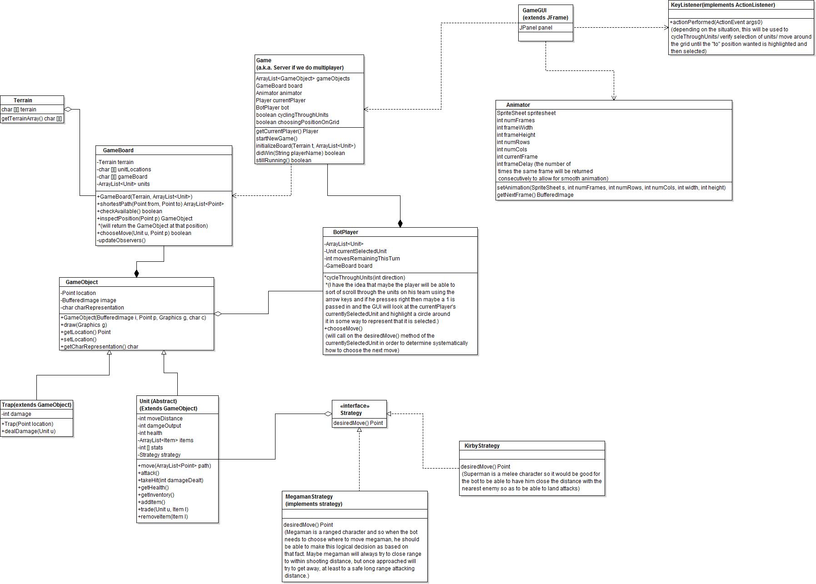

6. Sequence Diagram: Your team UML Sequence Diagram should show the most important scenario you can think of. Your sequence diagram should show most of your objects from above and how they communicate with each other.
