EX1: Finite State Transducers

Jing Huang (933-039-277)

[huanjing@oregonstate.edu](mailto:huanjing@oregonstate.edu)

# An FST for Pluralization

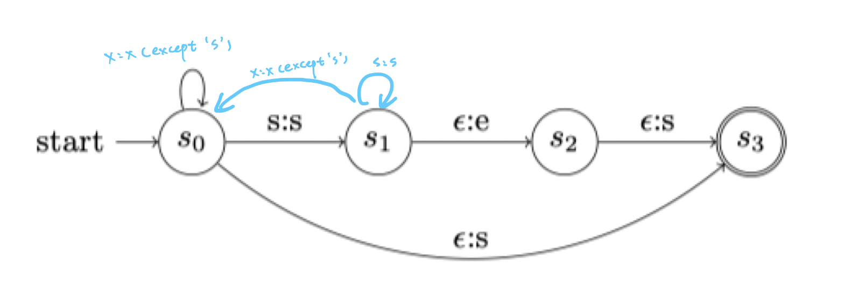

|  |  |
| --- | --- |
| **Test Case** | **Result** |
| bus |  |
| bass |  |
| sass |  |
| rise |  |

I fixed it by adding a loop at state s1 which is triggered by ‘s’. And also created a path to state s0 from s1 to let through all characters with the exception of ‘s’. Besides, the loop at state s0 is also changed to pass all characters except ‘s’. All test results show that this FST can handle inputs ending with ‘s’.

# Other Pluralizations

For regular plurals as shown in the table below, all of them can be covered by the above FST except ‘-sh’ and ‘-ch’. As a result, the loop at state s1 changed to be triggered by ‘s’, ‘c’ and ‘h’, the loop at state s0 changed to not be triggered by them, and the path to state s0 from s1 changed to all characters with the exception of these three characters.

|  |  |  |
| --- | --- | --- |
| Regular plurals |  |  |
| A singular noun ends in a sibilant sound—/s/, /z/, /ʃ/, /ʒ/, /tʃ/ or /dʒ/ |  |  |
|  | kiss | kisses |
| phase | phases |
| dish | dishes |
| massage | massages |
| witch | witches |
| A singular form ends in a voiceless consonant (other than a sibilant)—/p/, /t/, /k/, /f/ (sometimes) or /θ/ |  |  |
|  | lap | laps |
| cat | cats |
| clock | clocks |
| cuff | cuffs |
| death | deaths |
| For all other words (i.e. words ending in vowels or voiced non-sibilants) the regular plural adds /z/, represented orthographically by -s: |  |  |
|  | boy | boys |
| girl | girls |
| chair | chairs |

|  |  |  |
| --- | --- | --- |
| Plurals of nouns in -o |  |  |
| With nouns ending in o preceded by a consonant, the plural in many cases is spelled by adding -es (pronounced /z/): |  |  |
|  | hero | heroes |
|  | potato | potatoes |
|  | volcano | volcanoes or volcanos |
| However many nouns of foreign origin, including almost all Italian loanwords, add only -s: |  |  |
|  | canto | cantos |
|  | hetero | heteros |
|  | photo | photos |

For plurals of nouns in -o as shown in the table above, the nouns ending in o preceded by a consonant, I added a path as the picture below.

However, the nouns of foreign origin might need individual path for each noun. I’m looking forward to finding a better solution than this.

|  |  |  |
| --- | --- | --- |
| Plurals of nouns in -y |  |  |
| Nouns ending in a vocalic y (that is, used as a vowel) preceded by a consonant usually drop the y and add -ies (pronounced /iz/, or /aiz/ in words where the y is pronounced /ai/): |  |  |
|  | cherry | cherries |
|  | lady | ladies |
|  | sky | skies |
| Words ending in quy also follow this pattern: |  |  |
|  | soliloquy | soliloquies |
| Words ending in a y preceded by a vowel form their plurals by adding -s: |  |  |
|  | day | days |
|  | monkey | monkeys |

For words ending in a y preceded by a vowel, I add a path to s5 which is triggered by vowels excepts ‘o’. Besides, if ‘y’ or a vowel is not the end of the word, the FST needs to go back to the initial state, and to compatible with ‘s’, ‘c’, ‘h’, the FST needs move to s1 from s5 if the character is ‘s’, ‘c’ or ‘h’. Otherwise, it ends with ‘s’. And if the input of s4 is ‘y’, then the FST needs to jump to s6.

As for the noun ending in a vocalic y, I think it could be written by adding a non-vowel path and replacing ‘y’ with ‘ies’ if y is the ending. But I need to find out how to write backspace in FST.

|  |  |
| --- | --- |
| **Test Case** | **Result** |
| boy |  |
| cat |  |
| hero |  |
| day |  |
| apple |  |