# EX 2: Language Models and Entropy

Jing Huang (933039277)

## 1. Training Language Models

2.

unigram:

entropy: 4.11494

bigram:

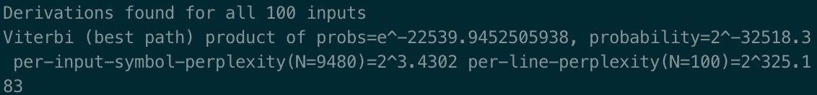

entropy: 3.4302

trigram:

entropy: 2.92538

3.

unigram:

bigram:

trigram:

4.

I used the Witten-Bell smoothing.

I used ‘train.txt’ for training, ‘dev.txt’ for fiddling , and ‘test.txt’ for testing.

5.

# 2. Using Language Models

1.

unigram: doesn’t make sense.

bigram: has correctly spelled a few words (me, be, the)

trigram: makes more sense, appears more correct words (them, hick, man)

2.

1. Use ‘sed -e 's/[aeiou]//g' test.txt > test.txt.novowels’ to remove vowels.

2. Use ‘carmel wfsa remove-vowels.fst > wfsa.fst’ to combine fsa and fst

3. Use ‘cat test.txt.novowels | sed -e 's/ /_/g;s/\(.\)/\1 /g' | awk '{printf("<s> %s </s>\n", $0)}' | carmel -sribIEWk 1 wfsa.fst > test.txt.vowel_restored.{uni,bi,tri}’ to restore.

4. Use ‘cat test.txt | sed -e 's/ /_/g;s/\(.\)/\1 /g' | awk '{printf("<s> %s </s>\n", $0)}' > test_formatted.txt’ to format the test.txt for evaluation.

5. Use ‘python eval.py test_formatted.txt test.txt.vowel_restored.uni’ to get the accuracy.

Unigram:

 Bigram:



Trigram:



3.

1. Use ‘sed -e 's/[ ]//g' test.txt > test.txt.nospaces’ to remove spaces.

2. Use ‘carmel wfsa remove-spaces.fst > wfsa.fst’ to combine fsa and fst

3. Use ‘cat test.txt.nospaces | sed -e 's/ /_/g;s/\(.\)/\1 /g' | awk '{printf("<s> %s </s>\n", $0)}' | carmel -sribIEWk 1 wfsa.fst > test.txt.space_restored.{uni,bi,tri}’ to restore.

4. Use ‘cat test.txt | sed -e 's/ /_/g;s/\(.\)/\1 /g' | awk '{printf("<s> %s </s>\n", $0)}' > test_formatted.txt’ to format the test.txt for evaluation.

5. Use ‘python eval.py test_formatted.txt test.txt.space_restored.uni’ to get the accuracy.

Unigram:

 Bigram:

 Trigram:



Sentences:

Unigram:

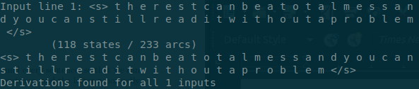

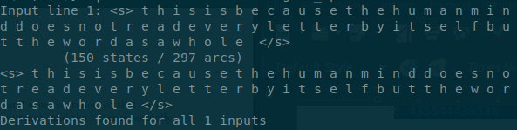

Bigram:

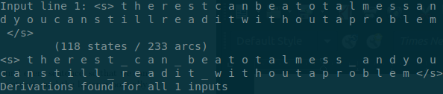

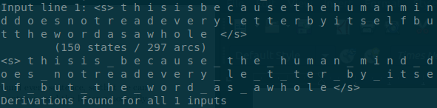

Trigram:

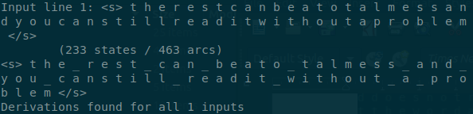

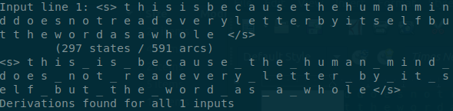

4. From the observations in these experiments, the accuracy results of restoring vowels are better than the results of restoring space. In addition, the number of states and arcs of generated vowels.fst are greater than the generated space.fst’s. In other words, the restoring of vowels has more conditions to judge than the restoring of space. As a result, restoring vowels is easier.