Name: __Jacob S. Howarth____  Covers Chapters 1 to Chapter 11 | CS 101 Computing and Algorithms I  Kettering University  Instructor: Changhua Wu

Answer sheet for Part I

1 d. 2 d. 3 d. 4 c. 5 d. 6 c. 7 b. 8 a. ← Answers to Multiple Choice Here

9 b. 10 d. 11 b. 12 c. 13 d. 14 a. 15 b. 16 b.

17 d. 18 b. 19 d. 20 e. 21 d. 22 b. 23 d. 24 b.

25 e. 26 b. 27 c. 28 d. 29 c. 30 b. 31 c. 32 a.

33 c. 34 c. 35 a. 36 a. 37 d. 38 c. 39 d. 40 c.

Part I Multiple choice questions. (2 points each)

1. To declare a constant PI, you write
a. final static PI = 3.14159;
b. final float PI = 3.14159;
c. static double PI = 3.14159;
d. final double PI = 3.14159;

2. Which of the Boolean expressions below has incorrect syntax?
a. (true) && (3 > 4)
b. !(x > 0) && (x > 0)
c. (x > 0) || (x < 0)
d. (x != 0) || (x = 0)

3. Which of these data types requires the least amount of memory?
a. float
b. double
c. short
d. byte

4. Suppose x=0 and y=0 what is x after evaluating the expression (y > 0) & (1 > x+ +).
a. 0
b. -1
c. 1

5. Suppose you define a Java class as follows:

public class Test {

}

In order to compile this class, the class should be stored in a file named
a. Test.class
b. Test.doc
c. Test.txt
d. Test.java
e. Any name with extension .java

6. The command to compile a class in the file Test.java is
a. java Test
b. java Test.java
c. javac Test.java
d. javac Test
e. JAVAC Test.java

7. What is y after the following switch statement?

int x = 0;
int y = 0;
switch (x + 1) {
case 0: y = 0;
case 1: y = 1;
default: y = -1
}

a. 1
b. -1
c. 0
d. None of the above

8. Analyze the following two code fragments.
(i)
int x = 5;
if (0 < x) && (x < 100)
System.out.println("x is between 1 and 100");
(ii)
int x = 5;
if (0 < x && x < 100)
System.out.println("x is between 1 and 100");

a. The first fragment has a syntax error.
b. The second fragment has a syntax error.
c. Both fragments produce the same output.
d. Both fragments compile, but produce different result.
a. None of the above.

9. Which of the loop statements always have their body executed at least once.
a. The while loop
b. The do-while loop
c. The for loop
d. None of the above

10. Analyze the following code.

double sum = 0;
for (double d = 0; d < 10; sum += sum + d) {
d += 0.1;
}

a. The code has a syntax error because the adjustment statement is incorrect in the for loop.
b. The code has a syntax error because the control variable in the for loop cannot be of the double type.
c. The code compiles but does not stop because d would always be less than 10.
d. The code compiles and runs fine.

11. What is x after evaluating

x = (2 > 3) ? 2 : 3;

a. 2
b. 3
c. 4
d. None of the above

12. A variable that is declared inside a method is called ________ variable.
a. a static
b. an instance
c. a local
d. a global
e. a class

13. Analyze the following code:

class Test {
public static void main(String[] args) {
System.out.println(xMethod((double)5));
}

public static int xMethod(int n) {
System.out.println("int");
return n;
}

public static long xMethod(long n) {
System.out.println("long");
return n;
}
}

a. The program displays int followed by 5.
b. The program displays long followed by 5.
c. The program runs fine but displays things other than given in a and b.
d. The program does not compile.
e. None of the above.

14. Analyze the following code.

public static void main(String[] args) {
for (int i = 1; i < 10; i++) {
int k = 3;
nPrint("A message", k);
}
System.out.println("k is " + k);
}

a. The code has a syntax error because k is not defined in System.out.println("k is " + k).
b. The code prints k is 0.
c. The code prints k is 1.
d. The code prints k is 2.
e. The code prints k is 3.

15. Analyze the following code.

public class Test {
public static void main(String[] args) {
int n = 2;
xMethod(n);

System.out.println("n is " + n);
}

void xMethod(int n) {
n++;
}
}

a. The code has a syntax error because xMethod does not return a value.
b. The code has a syntax error because xMethod is not declared static.
c. The code prints n is 1.
d. The code prints n is 2.
e. The code prints n is 3.

16. Which of the following is not an advantage of using methods.
a. Using methods makes program run faster.
b. Using methods makes reusing code easier.
c. Using methods makes programs easier to read.
d. Using methods hides detailed implementation from the clients.

17. Consider the following code fragment:

int[] list = new int[10];
for (int i = 0; i <= list.length; i++) {
list[i] = (int)(Math.random() * 10);
}

Which of the following statements is true?

a. list.length must be replaced by 10
b. The loop body will execute 10 times, filling up the array with random numbers.
c. The loop body will execute 10 times, filling up the array with zeros.
d. The code has a runtime error indicating that the array is out of bound.

18. Given the following declaration:
int[ ][ ] m = new int[5][6];
Which of the following statements is true?

a. The name m represents a two-dimensional array of 30 int values.
b. m[2][4] represents the element stored in the 2nd row and the 4th column of m.
c. m.length has the value 6.
d. m[0].length has the value 5.

19. Analyze the following code:

public class Test {
public static void main(String[] args) {
int[] x = new int[5];
for (int i = 0; i < x.length; i++)
x[i] = i;
System.out.println(x[i]);
}
}

a. The program displays 0 1 2 3 4.
b. The program displays 4.
c. The program has a runtime error because the last statement in the main method causes ArrayIndexOutOfBounds exception.
d. The program has syntax error because i is not defined in the last statement in the main method.

20. Analyze the following code:

public class Test {
public static void main(String args[]) {
Test nc = new Test();
nc.t = nc.t++;
}

int t;
Test() {
}
}
a. The program has a compilation error because t is not initialized.
b. The program does not compile because the parameter list of the main method is wrong.
c. The program compiles, but has a runtime error because t has no initial value.
d. The program has a compilation error because you attempt to create an object of the Test inside the Test class.
e. The program compiles and runs fine.

21. Analyze the following code:

class Test {
private int t;

public static void main(String[] args) {
Test test = new Test();
int x;
System.out.println(test.t);
}
}

a. The variable t is not initialized and therefore causes errors.
b. The variable t is private and therefore cannot be accessed in the main method.
c. The variable x is not initialized and therefore causes errors.
d. The program compiles and runs fine.

22. Analyze the following code:

class Test {
public static void main(String[] args) {
A a = new A("test");
a.print();
}
}

class A {
String s;

A(String s) {
this.s = s;
}

private void print() {
System.out.println(s);
}
}

a. The program compiles fine, but has a runtime error because the print() method is private.
b. The program has a compilation error because the print() method in class A is private.
c. The program runs fine and prints Test.
d. None of the above.

23. Suppose s1 and s2 are two strings. Which of the following statements or expressions are incorrect?

a. String s = new String("new string");
b. String s3 = s1 + s2;
c. String s3 = s1.concat(s2);
d. s1 >= s2
e. int i = s1.length();

24. What is wrong in the following code?
class Test {
public static void main(String[] args) {
C c = new C(5.0);
System.out.println(c.value);
}
}

class C {
int value = 2;
}
a. The program has a compilation error because class C does not have a default constructor.
b. The program has a compilation error because class C does not have a constructor with an argument of the double type.
c. The program compiles fine, but it does not run because class C is not public.
d. a and b.

25. A subclass inherits _____________ from its superclasses.

a. private data
b. protected data
c. public data
d. a and c
e. b and c

26. When you implement a method that is defined in a superclass, you __________ the original method.

a. overload
b. override
c. copy
d. call

27. What is the output of running class C?

class A {
public A() {
System.out.println(
"The default constructor of A is invoked");
}
}

class B extends A {
public B(String s) {
System.out.println(s);
}
}

public class C {
public static void main(String[] args) {
B b = new B("The constructor of B is invoked");
}
}
a. none
b. "The constructor of B is invoked"
c. "The default constructor of A is invoked"
"The constructor of B is invoked"
d. "The constructor of B is invoked"
"The default constructor of A is invoked"
e. "The default constructor of A is invoked"

28. Show the output of running the class Test in the following code:

interface A {
void print();
}

class C {}

class B extends C implements A {
public void print() { }
}

public class Test {
public static void main(String[] args) {
B b = new B();
if (b instanceof A)
System.out.println("b is an instance of A");
if (b instanceof C)
System.out.println("b is an instance of C");
}
}

a. Nothing.
b. b is an instance of A.
c. b is an instance of C.
d. b is an instance of A followed by b is an instance of C.

29. Analyze the following code.

class Test {
public static void main(String[] args) {
Object x = new Integer(2);
System.out.println(x.toString());
}
}

a. The program has syntax errors because an Integer object is assigned to x.
b. When x.toString() is invoked, the toString() method in the Object class is used.
c. When x.toString() is invoked, the toString() method in the Integer class is used.
d. None of the above.

30. Analyze the following code.

class Test {
public static void main(String[] args) {
Object x = new Integer(2);
System.out.println(x.doubleValue());
}
}

a. The program has syntax errors because an Integer object is assigned to x.
b. The program has syntax errors because doubleValue() is not a method in the Object class.
c. The program compiles and runs fine.
d. None of the above.

31. What is the best suitable relationship between House and Address?

a. Association
b. Aggregation
c. Composition
d. Inheritance

32. What is the best suitable relationship between Student and Course?

a. Association
b. Aggregation
c. Composition
d. Inheritance

33. In the Java programming language, an argument is used to ________________.

a. override the object’s default method definition
b. define constants in any given program
c. provide values in messages to specify what is to be done by an object’s methods
d. perform mathematical tasks (especially algebraic) in Java

34. In Java, what is meant by garbage collection?

a. Deallocation of unused memory space.
b. Going through the program and remove unnecessary code.
c. Deletion of objects from memory.
d. Deleting temporary files from the disk.

35. Polymorphism allows us to _____________.

a. have the same message execute a different method depending on the receiving object
b. hide the internal workings of a Java program from the client programmer
c. overload methods and allow the same method name to be used multiple times
d. extend and modify code

36. Suppose truck and motorcycle are subclasses of vehicle. Which of these declarations are invalid?

I Truck t = new Vehicle();
II Vehicle v = new Truck();
III Motorcycle m1 = new Vehicle();
IV Motorcycle m2 = new Truck();

a. I, III, and IV
b. II and III
c. II and IV
d. I, II, III, and IV

37. What does the instanceof operator do?

a. Creates an object of a certain class
b. Casts the object to a certain class
c. Checks to see if the object is of a certain class.
d. None of the above

38. In the following program:

class Truck extends Vehicle{
public Truck(){
super();
}
}

What does super do?

a. Makes a call to the Object() constructor.
b. Makes a call to the Truck() constructor.
c. Makes a call to the Vehicle() constructor.
d. Makes a call to the superclass of Vehicle’s constructor.

39. Which of the following statements is true?
a. To compile Java code into bytecode, we use command java.
b. To run a compile java program Prog.class, we use java Prog.class.
c. The java bytecode is directly executed by the CPU.
d. Java's bytecode is independent of particular hardware platforms, and is explained by Java virtual machine.

40. Which of the following is not valid for loop?
a. for (int i=0; ; i++) {...}
b. int i=0; for (; ;i++) {...}
c. for ( int i=0, j=0; i<10, j<100; i++, j++) {...}
d. for (int i=0; i<5; ) {...}

Part II. Explain why the underlined code is wrong. (2 points each)

A. (Syntax errors)
public class Test {
private int x;

public static void main(String[] args) {
new Test();
}

public Test(int x) {
this.x = x;
}
}

Explaination: There is no zero-arg constructor in class Test because a constructor with argument int x is present and explicitly declared. If a constructor is explicitly declared with parameters, the JVM does not implicitly declare one for the user. To fix the error, place an argument inside the parentheses of the Test constructor call in main or declare a zero-arg constructor in Test class.

B. (Syntax errors)

public class Test {
public static void main(String[] args) {
A a = new A(5.5);
System.out.println(a.x);
}
}

public class A {
private x;

public void A(double x) {
this.x = x;
}
}

Explaination: The data field “x” present in class A has a private modifier in it’s declaration. Therefore, this data field can only be used by this class and no other class. When accessing the field from an object in the Test classes main method, there will be a compiler error. Also, the data field “x” does not have a primitive type declared in it’s declaration, causing a compiler error. To fix the errors, define and implement a get method for the data field “x” in class A and declare “x” as a double data type.

Part III: Show the printout of the following code. (2 points each )

a)
public class Test {
public static void main(String[] args) {
T t = new T();
swap(t);
System.out.println("e1 = " + t.e1 + " e2 = " + t.e2);
}

public static void swap(T t) {
int temp = t.e1;
t.e1 = t.e2;
t.e2 = temp;
}
}

class T {
int e1 = 1;
int e2 = 2;
}

Output: e1 = 2 e2 = 1

b)
public class Test {
public static void main(String[] args) {
T t1 = new T();
T t2 = new T();
System.out.println("t1's i=" + t1.i + " and j=" + t1.j);
System.out.println("t2's i=" + t2.i + " and j=" + t2.j);
}
}

class T {
static int i = 0; // Please note that i is static
int j = 0;

T() {
i++;
j++;
}
}

Output: t1’s i=2 and j=1
t2’s i=2 and j=1

C) The java.util.Date class implements java.lang.Cloneable and overrides the equals method to return true if two objects have the same date and time. Show the output of the following code.

import java.util.*;
public class Test extends Object {
public static void main(String[] args) {
Date d1 = new Date();
Date d2 = new Date(349324);
Date d3 = d1;
Date d4 = (Date)d1.clone();
System.out.println("(1) " + (d1 == d2));
System.out.println("(2) " + (d1 == d3));
System.out.println("(3) " + d1.equals(d2));
System.out.println("(4) " + d1.equals(d3));
}
}

Output: false
true
false
true

d)

class Test {
public static void main(String[] args) {
Count myCount = new Count();
int times = 0;

for (int i = 0; i < 10; i++)
increment(myCount, times);

System.out.println(
"myCount.count = " + myCount.count);
System.out.println("times = " + times);
}

public static void increment(Count c, int times) {
c.count++;
times++;
}
}

class Count {
int count;

Count(int c) {
count = c;
}

Count() {
count = 1;
}
}

Output: myCount.count = 11
times = 0

Part IV Write programs. (4 points each)

1. (4 pts) Write a method to find the max in an array of comparable objects (Assume that the objects in the argument are instances of Comparable). The method signature is as follows:

public static Object max(Object[] a)

public class FindMaxObject {
public static void main(String[] args) {

...

// Assuming the array has a defined size and is named objects
Object o = max(objects);

System.out.println(“The maximum object in the array is “ + o.toString());

}

public static Object max(Object[] a) {
Object max = a[0];

for (int i = 0; i <= a.length – 1; i++) {

if (max.compareTo(a[i]) > 0)
max = a[i];

}

return max;
}
}

2. (4 pts) Suppose that the Loan class is given as shown in the following UML. Write a test program that creates a Loan object with loan amount $40000, annual interest rate 5.5%, and number of years 15, and displays the monthly payment and total payment.

Step 1: Create Loan object with
- loan amount = 40000
- annual interest rate = 5.5
- number of years = 15
Step 2: Display monthly payment and total payment in console

Code:

public class TestLoan {
public static void main(String[] args) {

Loan loan1 = new Loan(5.5, 15, 40000);

System.out.println(“Monthly payment on loan1: “ + loan1.monthlyPayment());
System.out.println(“Total payment on loan1: “ + loan1.totalPayment());

}
}
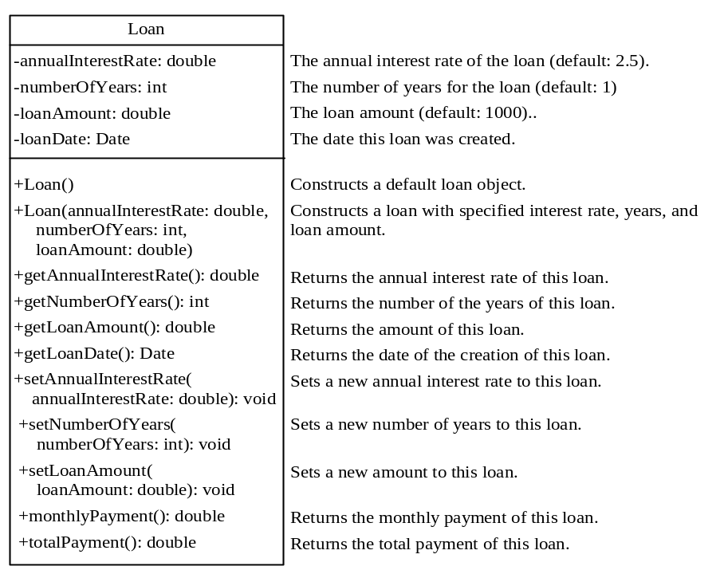

ANSWER KEY

1 D 2 D 3 D 4 A 5 D 6 C 7 B 8 A

9 B 10 D 11 B 12 C 13 D 14 A 15 B 16 A

17 D 18 A 19 D 20 E 21 D 22 B 23 D 24 B

25 E 26 B 27 C 28 D 29 C 30 B 31 C 32 A

33 C 34 A 35 A 36 A 37 C 38 C 39 D 40 C

