Jacob Howarth
CS-202: Systems Programming Concepts
Lab 2 – Book Inventory Database
Changhua Wu

Lab 2 Report

Assignment Description

The assignment was to create a book inventory database program using the linked list data structure. The program would allow a user to read in a book inventory from a file, save the inventory to a file, add a new book, and compute the average price of the books in the inventory.

Assignment Challenges

The main challenge in this program was understanding how to parse the comma delimited fields in the text file. Since the C language doesn't have many functions to manipulate strings, there wasn't a direct way for me to parse the delimited fields into their appropriate variables. The first attempt was to use the strtok function in the string library which originally worked, however it was hard to manipulate the returned pointer to the string, because the pointer just pointed to the first character in the string and returned only the first character when it was dereferenced. This made it difficult to add the terminating null character to the string and it took longer to get the information because extra code was needed. In the end, the situation was remedied with just a simple for loop that parsed each character from each field on each line of text in the file. The for loop stopped when it encounters the delimited character, in this case a comma, and stored each field in a string designated for it.

Data Structures

The only data structure used in the program was a simple linked list with a head and a tail node. This allowed the use of dynamic memory to create an array of linked data by reference. This data structure has the advantage of a variable length which arrays do not have. Each node in the list contained a book structure which defined three strings, a title, an author, and a price and each string had a maximum length of 100 characters. A node structure was defined for the linked list to store a book structure and a pointer to the next node in the list. Each book was added to the end of the list and no ordering was specified by the assignment.

Program Functions

There are a total of eight functions used by the program with the userInterface function being the main function of the program that the user has the most interaction with. The userInterface function allowed the user to enter commands and information into the program and was primarily used to direct program flow control. The readFile function was used to read in a list of book records from an existing text file and parse them into the appropriate title, author, and price fields each delimited by a comma as presented in the file. The function then called the add function which does the sole job of creating the new node with the given title, author, and price information read from each line of the file and append it to the end of the linked list. The addBook function performed the operation of collecting the title, author, and price information entered by the user for the new book and appending it to the inventory list. The saveFile function saves the linked list elements to an existing file specified by the user, including the new elements added by addBook. The saveFile function calls the printInventory function which serves as a function to print the list to the file specified by saveFile or to standard output. This is accomplished by passing a character argument called option which contains two modes, 'f' for printing the list to the file specified by the user in the saveFile function or 's' which prints the current instance of the list to the console. The computeAvgPrice function converts the price string for each book in the list and sums the price up and divides the total sum by the number of elements in the list computed by the sizeOf function.

Requirements Not Met

All requirements for the lab were met.

Test Run

Reading a text file

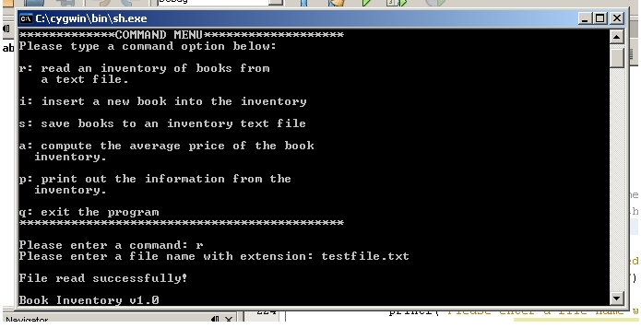

Saving a text file

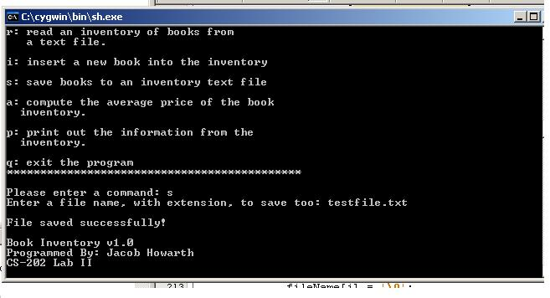
Printing the inventory to the console

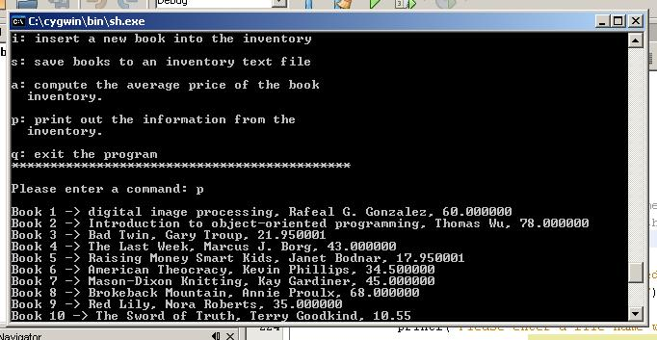

Computing the average price of the inventory

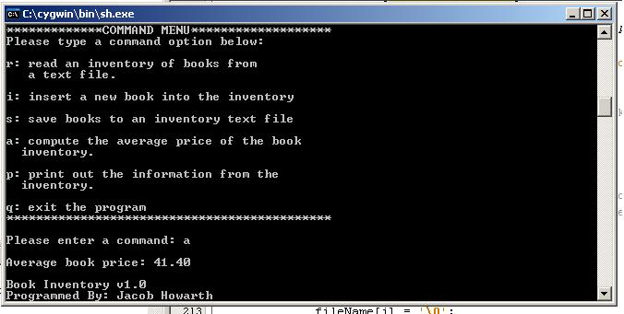
Adding a book to the inventory
