LAB 5 REPORT
CS-202: Systems Programming
Professor: Changhua Wu

Jacob Howarth

ASSIGNMENT DESCRIPTION:

The assignment was to write a 2D, one sided, console version of the classic video game pong.

CHALLENGES MET:

The major challenge of this assignment was trying to figure out how to handle so many things at once. Often times the steps required to move objects such as the ball and paddle required precise interval timing and signal handling to simulate motion. Along with initiating the motion, the ball and paddle had to be redrawn after every change and sometimes the redrawing was not fast enough and often produced several bugs such as random characters being erased and drawn at different positions on the board. This probably had to do with the timing of the redraw versus the timing of the signal not being very consistent. Another problem was accurately conveying the situation when the paddle intercepted the ball. Sometimes when the top or bottom part of the paddle collided with the moving ball, the ball would sail through the paddle, deleting some of the paddle characters which was probably the result of a redraw issue. These issues were hard to diagnose and weren't fully deduced before submission. Another challenge was understanding how the ball moved through the used of timers and how the signal handled the timers for the x and y component of the ball to simulate seamless movement.

THINGS LEARNED:

The importance and principles of how Unix handles event driven programming through the use of signals and interval timers. Signals are handle many ways across different Unix platforms through mouse trapping, blocking, etc. and are implemented several different ways through signal(), sigaction(), etc. The importance of signals is the ability for processes and the kernel to communicate with each other and are essential to current modern day programs and operating systems. Using the curses library was also an important tool to learn as it allows users to draw and simulate object movement across the console. It also implements like clearing the console and provides functions that easily turn off echoing and turn on canonical input which makes it perfect for video games and direct response to user input.

REQUIREMENTS NOT MET:

All requirements were met for the assignment.

SAMPLE OUTPUT:

IN GAME PLAY 1:

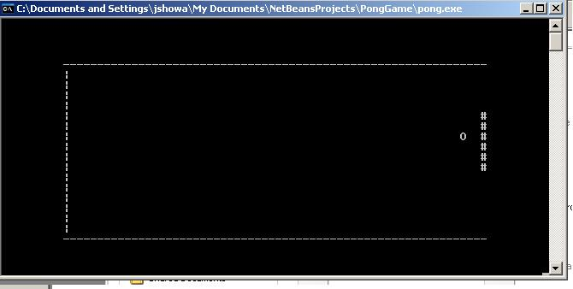
IN GAME PLAY 2 (PADDLE MOVED):

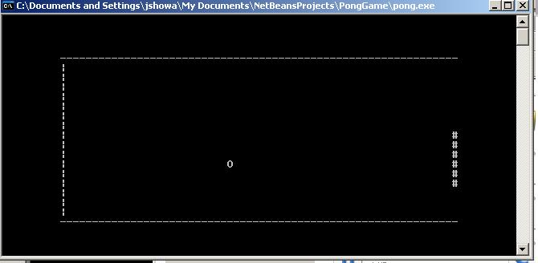

INCERCEPT POINT (HARD TO CAPTURE AND PRODUCED REDRAW BUG):

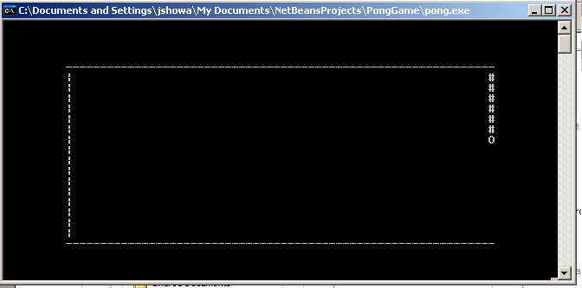

GAME OVER SCREEN:

