Jacob S. Howarth
Microcomputers I – Lab 4
Professor Foster
CE-320, Fall ‘08
Question 1 Answer:
The percent error between the actual (unfiltered) value and the measured (filtered) value in the divide before multiplying assembly sequence is 17.18% error as calculated using the following formula:

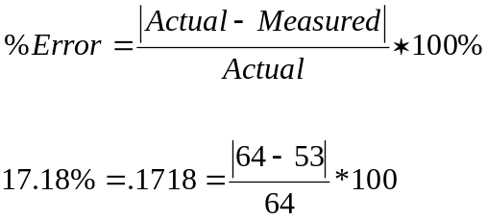

The percent error between the actual (unfiltered) value and the measured (filtered) value in the multiply before divide assembly sequence is 4.68% error as calculated below:

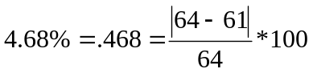

As we can see, dividing before multiplying has a 12.5% increased chance for error then multiplying before dividing which is quite significant.

Question 2 Answer:
In the breakpoint trace for the ABA instruction in the divide and multiply assembly sequence the X register and the B register were never the same and continuously had the same value for the majority of the loop execution time. This makes it seem like during this time, the code was never changing which could have lead to an increase in the present error of the answer. This could have been due to the fractional values of the division being truncated to zero causing the loop to repeat and generate an incorrect answer.

In the breakpoint trace for the ABA instruction in the multiply and divide assembly sequence, the X register values and the B register values were always the same meaning the input was probably followed more closely in this assembly sequence. Also the X and B register values were changing regularly meaning the code was doing something for most of the loop execution instead of burning up processor cycles. Because the code was altering mostly through the trace, it can be safely inferred that computations were being done more accurately and precisely leading to a lower percent error while the loop was executing.

