Week 8 Assignment
Saravanan Janarthanan
DSC680 Applied Data Science, Bellevue University
Professor: Amirfarrokh Iranitalab

- Business Problem
Scene classification from images is an essential component in numerous fields such as autonomous navigation, digital media management, and remote sensing. The challenge lies in efficiently categorizing vast amounts of image data into meaningful classes without relying on manual tagging, which is time-consuming and inconsistent. This project aims to solve that challenge by developing a deep learning-based system that classifies natural scenes accurately and efficiently.

- Background / History
Convolutional Neural Networks (CNNs) have revolutionized computer vision, particularly in image classification. Transfer learning, which leverages pre-trained models like MobileNetV2 and ResNet50, has further improved performance and reduced training time. This project builds on those developments to demonstrate the power of CNNs and transfer learning in classifying scenes using the Intel Image Classification dataset.
- Data Explanation
Source:
The dataset used in this project is the Intel Image Classification Dataset, a publicly available collection of natural scene images.

Folder Structure:
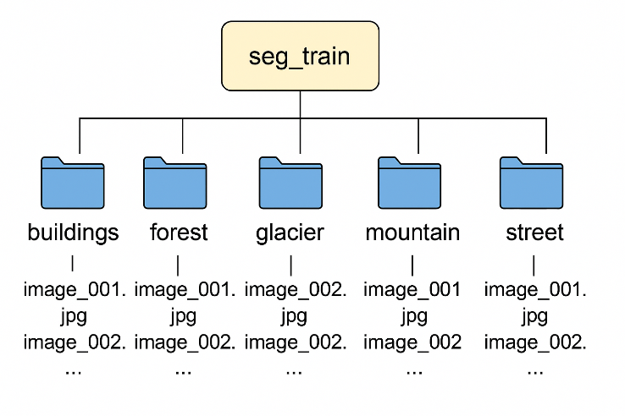
The images are organized in folders corresponding to each class label. Each folder name, such as buildings, forest, glacier, mountain, sea, and street represent a category, and the dataset is split into separate training and testing directories, maintaining this structure.

Dataset Breakdown:
To understand class distribution, a bar chart was generated showing the number of images per category. This helps identify potential class imbalances and ensures that the training process does not favor any one category disproportionately.

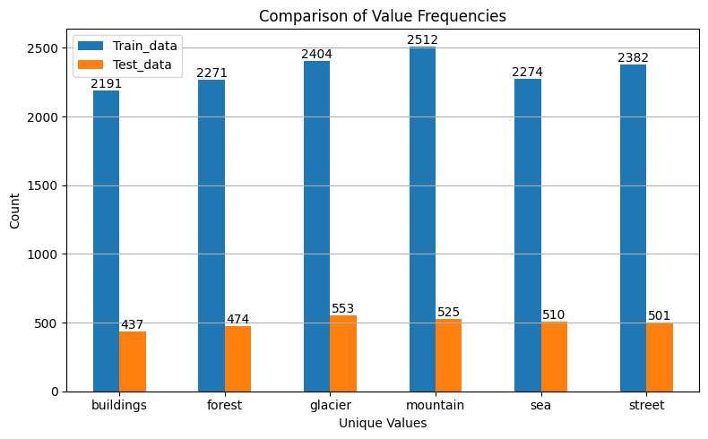
Training Data:
- Classes (buildings, forest, glacier, mountain, sea, street) have counts ranging from 2191 to 2512.
- The highest count is for mountain (2512) and the lowest is buildings (2191).
Test Data:
- Counts range from 437 to 553.
- Again, glacier has slightly higher test samples (553), and buildings has the least (437).
Observation:
- The data is reasonably balanced.
- The difference between classes is around 300 samples (at most), which is not very severe.
- Both training and testing sets maintain this balance fairly consistently.

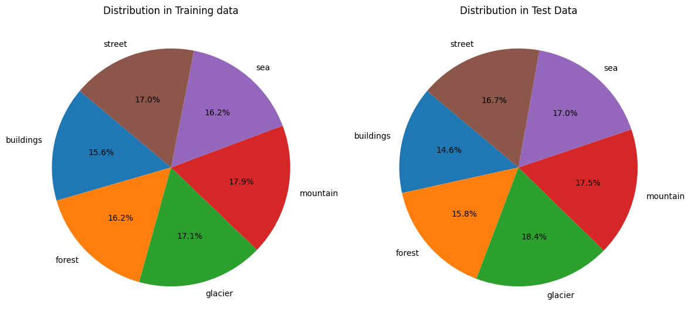
Training Set:
- Each class is roughly around 15-18%.
- Mountain (17.9%) and Glacier (17.1%) are a bit dominant.
- Buildings (15.6%) is slightly underrepresented.
Test Set:
- Very similar distribution.
- Glacier is slightly higher (18.4%), Buildings again lower (14.6%).
Observation:
- Good stratification between training and testing splits.
- No class severely overpowers others (>20%), and no class falls too low (<10%).

Dataset balance for Model training
- CNNs are sensitive to class imbalance, but since dataset is relatively balanced, training should be smooth.
- Slight difference (like buildings being a bit lower) may cause a tiny bias in prediction (e.g., model might slightly underpredict buildings).
- MobileNet is designed for efficiency; small imbalance is less critical.
- ResNet handles imbalance better because, they have better feature extraction and they are less prone to overfitting compared to shallow networks.

Preprocessing Steps:
All images are resized to a uniform shape (150x150 for CNN and 224 X 224 for Mobilenet and Resnet) to match the model input requirements. Pixel values are normalized to improve convergence during training. The images are loaded using TensorFlow’s ImageDataGenerator, which also applies on-the-fly augmentation during training to improve generalization.
- Image resizing (150×150 for CNN, 224×224 for transfer learning models)
- Pixel normalization to [0,1]
- Apply data augmentation (random rotations, flips, brightness adjustments) using ImageDataGenerator to enhance model generalization.
- Methods
Custom CNN
A custom CNN architecture was built from scratch using Keras. It includes several convolutional and pooling layers followed by fully connected layers
Input Image (150x150x3) (Input Shape w 150, h 150, and 3 color channels (RGB).
↓
Conv2D(32) + ReLU (with ReLU activation and same padding)
↓
MaxPooling2D (reduces spatial dimensions by a factor of 2.)
↓
Conv2D(64) + ReLU
↓
MaxPooling2D
↓
Conv2D(128) + ReLU
↓
MaxPooling2D
↓
Conv2D(256) + ReLU
↓
MaxPooling2D
↓
Conv2D(512) + ReLU
↓
MaxPooling2D
↓
Flatten (Convert the feature maps into a 1D vector fed into fully connected layers).
↓
Dense(512) + ReLU (To Combine high-level features for classification.)
↓
Dense(num_classes) + Softmax
(num_classes = 6, and softmax is used as classification is non-binary)

- Built using Keras Sequential() API
- Layers: Conv2D → MaxPooling2D → Flatten → Dense
- Loss: categorical_crossentropy
- Optimizer: Adam
Transfer Learning with MobileNetV2
To improve accuracy and reduce training time, MobileNetV2 was employed as a feature extractor. The pre-trained layers were frozen, and only the final layers were trained for this task. This approach takes advantage of rich feature representations learned from large datasets like ImageNet, improving the model’s ability to generalize on our dataset.

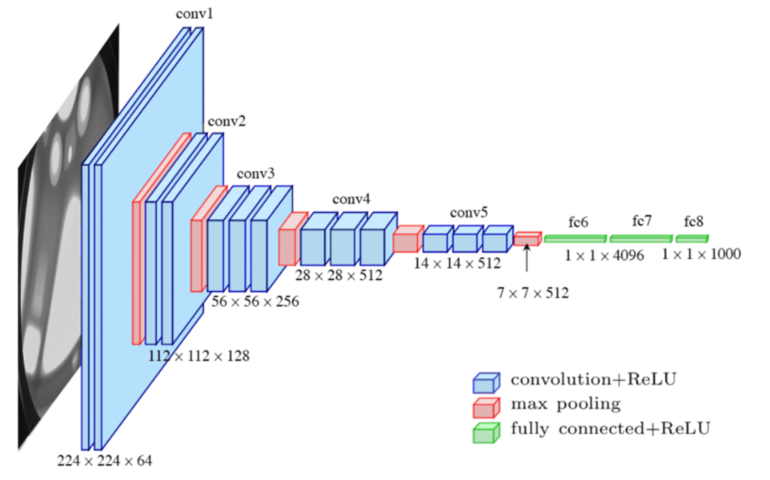
- Since MobileNet is pre-trained on 1.2M images over 1000 classes, its pretrained weights ‘ImageNet’ is leveraged, rather training from scratch.
- Input Shape resize to 224 X 224 X 3
- Base layers are frozen so the training does not impact them, only top layers will be trained
- Add a fully connected layer to learn this new dataset specific pattern
- The final output layer will provide probabilities of 6 classes through SoftMax activation function
Input Image (224x224x3) (Input Shape w 224, h 224, and 3 color channels (RGB).
↓
MobileNetV2 Base (Pre-trained )
↓
Global Average Pooling
↓
Dense(128) + ReLU (To Combine high-level features for classification.)
↓
Dense(num_classes) + SoftMax
(num_classes = 6, and SoftMax is used as classification is non-binary)

- Used MobileNetV2(include_top=False) pretrained on ImageNet
- Added GlobalAveragePooling → Dense → SoftMax
- Only custom head trained initially; base frozen

Transfer Learning with ResNet50
Unlike MobileNetV2, which is optimized for lightweight deployment, ResNet50 is a deeper network that leverages skip connections (residual learning) to enhance feature extraction and performance at the cost of greater computational resources.
Input Image (224x224x3)
↓
ResNet50 Base (frozen)
↓
GlobalAveragePooling2D
↓
Dense(128, ReLU)
↓
Dense(len(class_names), SoftMax)

- Analysis
The models were evaluated using training and validation accuracy and loss. The MobileNetV2 model achieved better accuracy in fewer epochs compared to the custom CNN. Charts were generated to visualize training dynamics, and prediction accuracy was assessed by running the model on random images from the test set. These analyses confirmed that the pretrained MobileNetV2 performed reliably and was better suited for deployment.

CNN
Epochs | Training Accuracy | Validation Accuracy | Training Loss | Validation Loss
1 | 47.5% | 63.6% | 1.28 | 0.91
5 | 78.9% | 84.3% | 0.57 | 0.43
10 | 83.8% | 86.7% | 0.46 | 0.36

- Training loss dropped consistently
- Validation loss decreases steadily, no overfitting
- Gap between training and validation accuracy is small (~2-3%) ; Model seems generalizing well.
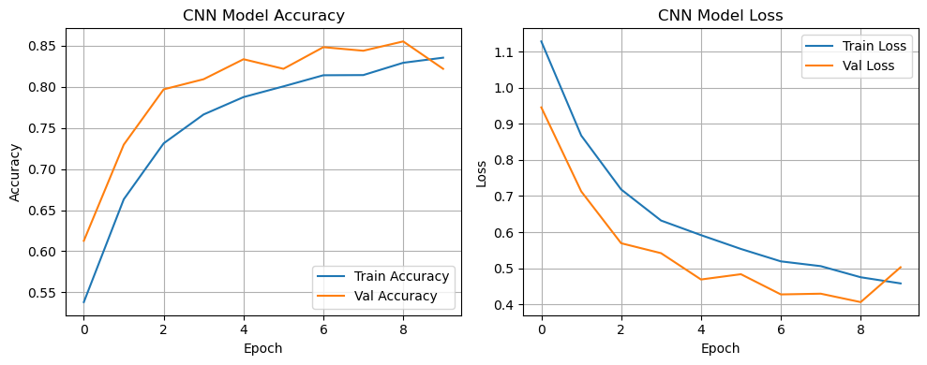
MobileNet
Epochs | Training Accuracy | Validation Accuracy | Training Loss | Validation Loss
1 | 80.5% | 89.8% | 0.52 | 0.27
2 | 87.3% | 90.4% | 0.33 | 0.26
4 | 89.6% | 90.3% | 0.27 | 0.26
- Very high validation accuracy right from the first epoch
- Validation loss is very low (~0.26) — model fits the data extremely well
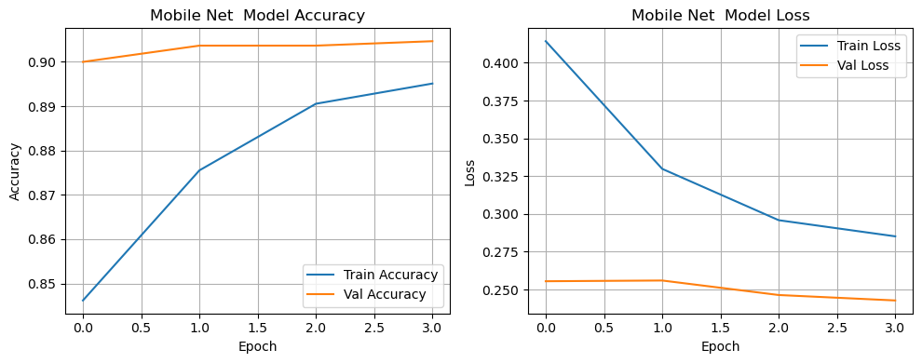
ResNet50
Epochs | Training Accuracy | Validation Accuracy | Training Loss | Validation Loss
1 | 30.2% | 46.6% | 1.64 | 1.25
2 | 44.4% | 52.1% | 1.31 | 1.14
5 | 52.8% | 61.3% | 1.15 | 1.01
- Slow learning curve — very low starting accuracy (~30%).
- Validation accuracy improves, but only to ~61% after 5 epochs.
- Loss is decreasing, but not as steeply as CNN or MobileNetV2.
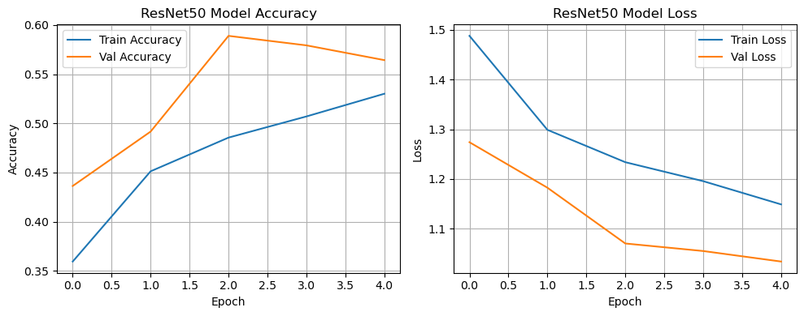

Confusion Matrices
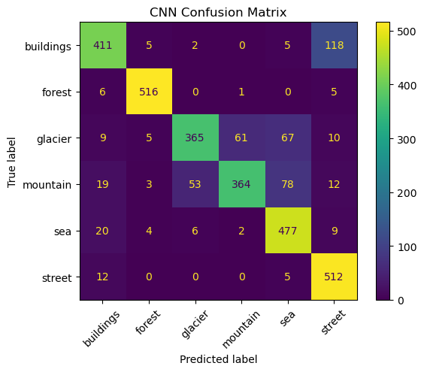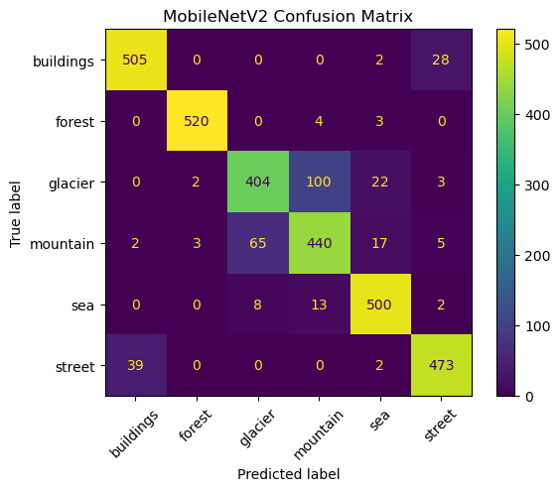
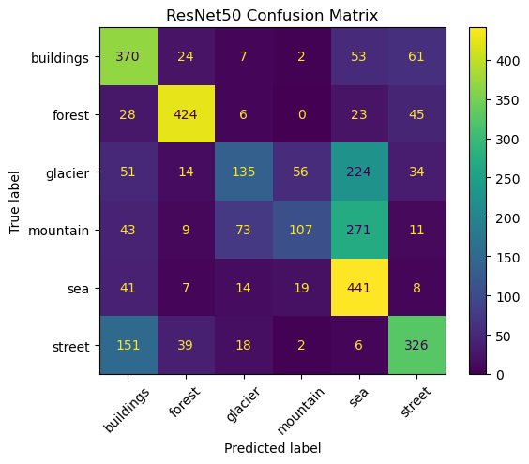

- In CNN some misclassifications were observed—particularly between buildings and streets, as well as among glaciers, mountains, and seas. (False positives and false negatives)
- MobileNetV2 delivered the most accurate results, with strong performance across all classes. However, it still showed occasional confusion between streets and buildings, and between mountains and glaciers.
- ResNet50 struggled to generalize, with a high number of false positives and false negatives across nearly all categories.

Metrics
Model | Accuracy | Precision | Recall | F1 Score
CNN | 84% | 0.8437 | 0.8365 | 0.8337
MobileNetV2 | 90% | 0.8986 | 0.8988 | 0.8982
ResNet50 | 59% | 0.5965 | 0.5737 | 0.5505

- Conclusion
The results demonstrate that both custom CNNs and pretrained models like MobileNetV2 can effectively classify natural scenes. However, pretrained models offer superior accuracy and faster convergence. This validates the use of transfer learning for similar image classification tasks, especially when dealing with structured image data and limited compute resources.
Model | Final Validation Accuracy | Pros | Cons | Comments
Custom CNN | 86.7% | Good generalization, no overfitting | Needs longer training, basic feature extraction | Good for learning, not the best for production
MobileNetV2 | 90.3% | Fast convergence, very high accuracy, low overfitting | Needs careful fine-tuning for max performance | Best choice currently
ResNet50 | 61.3% (frozen) | High potential with fine-tuning | Poor when frozen, slow training | Fine-tune for better results

While both the custom CNN and pretrained transfer learning models successfully classified natural scenes, MobileNetV2 demonstrated superior performance by achieving the highest validation accuracy (~90%) within fewer epochs, with minimal overfitting. Although MobileNetV2 required moderately longer time per epoch compared to the custom CNN, its overall efficiency and accuracy were significantly better. In contrast, ResNet50, due to its deeper architecture, exhibited slower training progress and higher computational demands without immediate performance benefits in its frozen state. However, with careful fine-tuning, ResNet50 holds strong potential for achieving greater accuracy.

Sample Prediction using custom image
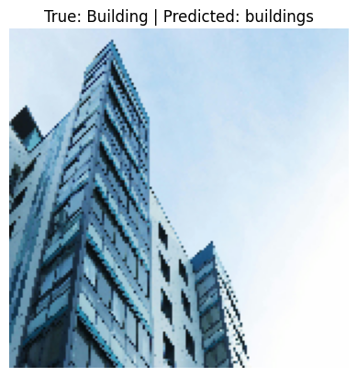

- Assumptions

It is assumed that the folder names correctly represent the classes of the images they contain. The model also assumes that the images are labeled correctly and consistently, and that classes are mutually exclusive with no overlapping labels.

- Limitations
Training was limited to a small number of epochs due to resource constraints. The model also used fixed image sizes, which may result in the loss of some fine-grained details. Additionally, the models were trained using default parameters without extensive hyperparameter tuning.

- Challenges
Working with a large number of images required efficient data handling and batch loading. There were also challenges in ensuring a balanced class distribution and maintaining generalization without overfitting, particularly when using the custom CNN.

- Future Uses / Applications
This model can be extended for use in terrain detection for autonomous vehicles, environmental monitoring from satellite imagery, and intelligent media classification systems. With minor modifications, the model can be deployed on mobile or edge devices using lightweight variants like TensorFlow Lite.

- Recommendations
It is recommended to fine-tune the pretrained models, MobileNet and ResNet50 , by unfreezing selected layers to further improve accuracy. Adding explain ability tools such as Grad-CAM would help visualize how the model makes predictions. Moreover, using EfficientNet or ResNet could be explored for even better results.

- Ethical Assessment
The model uses only publicly available, non-sensitive image data, and does not involve personal information. Still, ethical considerations include ensuring fairness across scene types and transparency in model performance. This model should not be used for surveillance or any privacy-infringing application without proper safeguards.

- References
- TensorFlow. (2024). TensorFlow: An end-to-end open-source platform for machine learning. Retrieved from https://www.tensorflow.org/
- Keras Team. (2024). Keras Applications Documentation. Retrieved from https://keras.io/api/applications/
- Kaggle. (2018). Intel Image Classification Dataset. Retrieved from https://www.kaggle.com/datasets/puneet6060/intel-image-classification
- Sandler, M., Howard, A., Zhu, M., Zhmoginov, A., & Chen, L. C. (2018). MobileNetV2: Inverted Residuals and Linear Bottlenecks. In Proceedings of the IEEE Conference on Computer Vision and Pattern Recognition (CVPR), 4510–4520.
- He, K., Zhang, X., Ren, S., & Sun, J. (2016). Deep Residual Learning for Image Recognition. In Proceedings of the IEEE Conference on Computer Vision and Pattern Recognition (CVPR), 770–778.

- Questions Audience would ask

- Why did you choose MobileNetV2 and ResNet50 specifically for transfer learning?
We chose MobileNetV2 and ResNet50 due to their proven track record as high-performing architectures with readily available pretrained weights from ImageNet. MobileNetV2's low-latency design suits edge deployment, while ResNet50's depth and expressiveness make it a standard benchmark in computer vision. This selection enabled a comparison between a lightweight and a heavyweight model for our specific application.

- What were the main challenges you faced when training your custom CNN compared to using pretrained models?
Developing our custom CNN demanded considerable iterative design to pinpoint the right architecture and integrate optimal convolutional and max-pooling layers for convergence. Generalization proved challenging, particularly with limited data. In contrast to pretrained models that already possess learned robust low-level features, our custom CNN had to learn everything from the ground up, resulting in longer training times, a tendency to overfit

- How exactly did you perform data augmentation, and what types of augmentations were applied?
used data augmentation to increase variability and reduce overfitting. Techniques included random rotations (±15°), horizontal flips, zoom (up to 20%), brightness adjustments, and small translations. These transformations helped simulate different scene perspectives and lighting conditions.

- Did you try fine-tuning ResNet50, and if not, why?
No, we did not fully fine-tune ResNet50. We initially froze most layers to use it as a feature extractor. When we observed poor performance (F1 ∼0.55), we planned fine-tuning but deferred it due to time constraints. It likely would have improved results, but required careful learning rate control and longer training.

- How would model performance change if you trained for more epochs?
Training for more epochs may slightly improve performance, especially if paired with early stopping or learning rate scheduling. However, without sufficient regularization or data, the risk of overfitting increases. For MobileNetV2, the gains would likely plateau quickly; for ResNet50, there might be more room for improvement with fine-tuning.

- Which evaluation metrics beyond accuracy did you consider (e.g., F1-score, confusion matrix)?
We used F1-score to balance precision and recall, especially due to class imbalance. The confusion matrix helped visualize per-class performance and detect misclassifications. We also monitored validation loss and precision/recall per class.

- Would EfficientNet or another newer architecture outperform MobileNetV2 here?
Potentially, yes. EfficientNet is designed to balance accuracy and efficiency using compound scaling. It could outperform MobileNetV2, particularly in terms of accuracy, while remaining relatively lightweight. However, inference time and memory footprint would need to be evaluated for edge deployment.

- How big of a difference would it make if you trained MobileNetV2 or ResNet50 from scratch rather than using pretrained weights?
Training from scratch would significantly degrade performance unless a massive labeled dataset is available. Pretrained weights give a strong initialization based on generic features (edges, textures), which drastically accelerates convergence and improves generalization on small to medium datasets.

- Could this model be deployed to edge devices like mobile phones or Raspberry Pi?
Particularly MobileNetV2—it’s designed for mobile efficiency and can be easily quantized and deployed using frameworks like TensorFlow Lite. ResNet50 would be more challenging due to higher computational and memory demands.

- What ethical issues could arise if this scene classification system is misused?
Misuse could include surveillance or profiling without consent, biased classifications due to non-diverse training data, and false alerts in critical systems (e.g., disaster detection). Transparency, fairness, and proper governance are crucial to avoid unintended consequences.

