Inverter

Specifications:

INPUT: Time period =20ns, Pulse Width=10ns,Amplitude=1.2V

Layout: Height=1.4um

Schematic

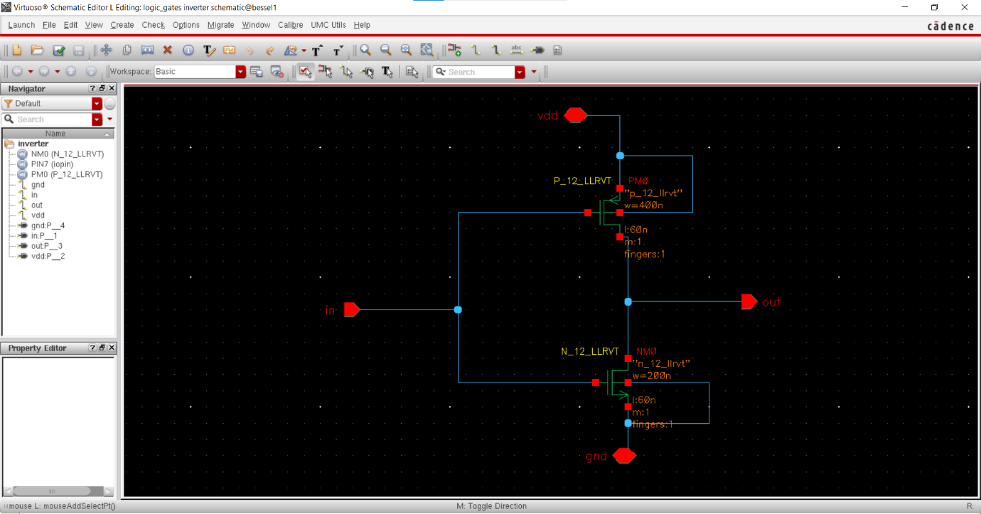

Layout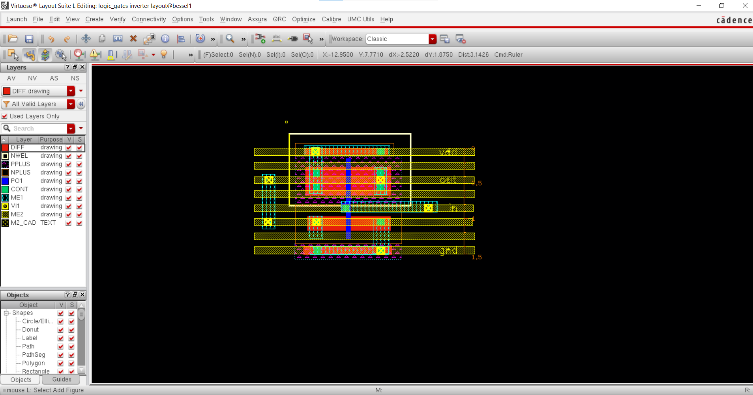

Output

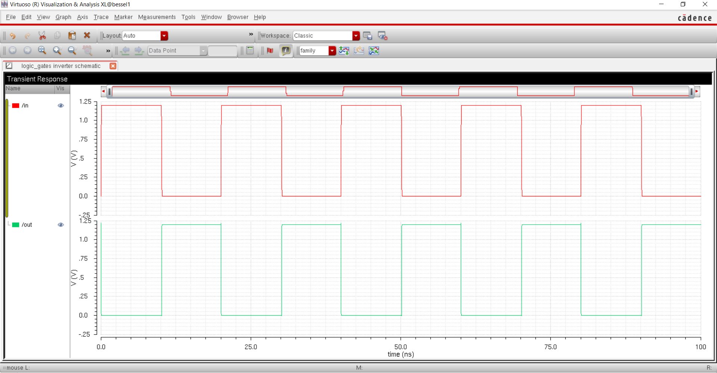

Two Input Nand Gate

Input Pins: A, B ; Output Pins: out; Power: vdd, gnd

Specifications: Height: 1.4um

Schematic

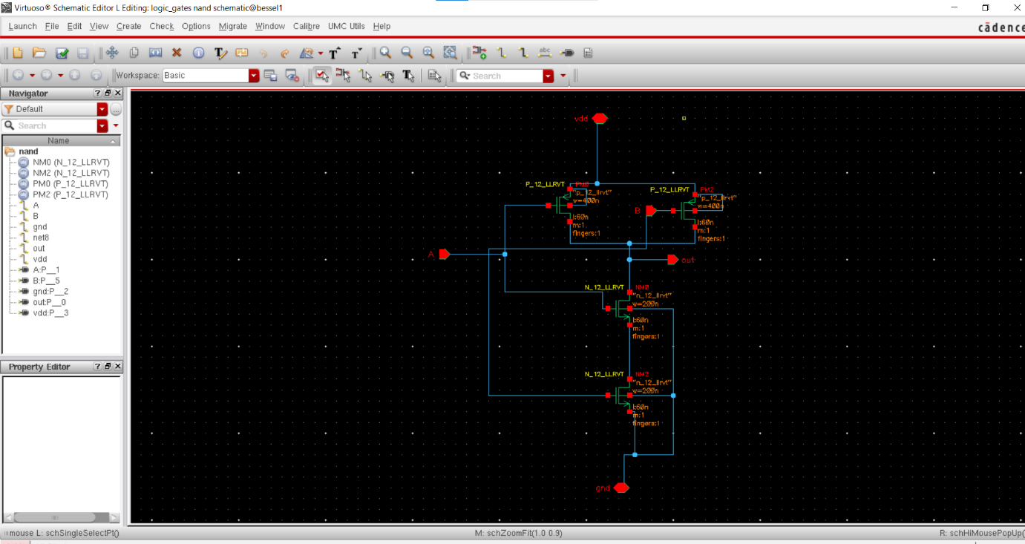

Layout

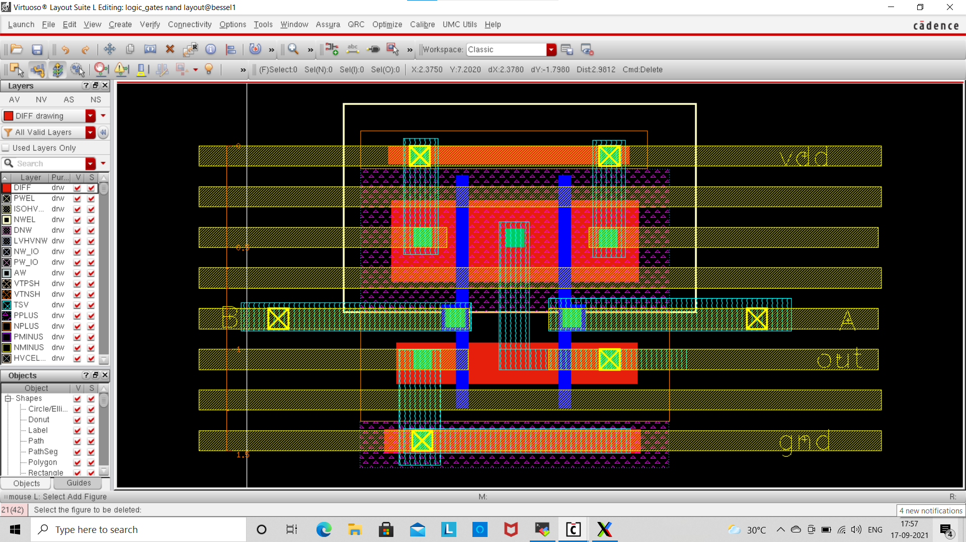

Output

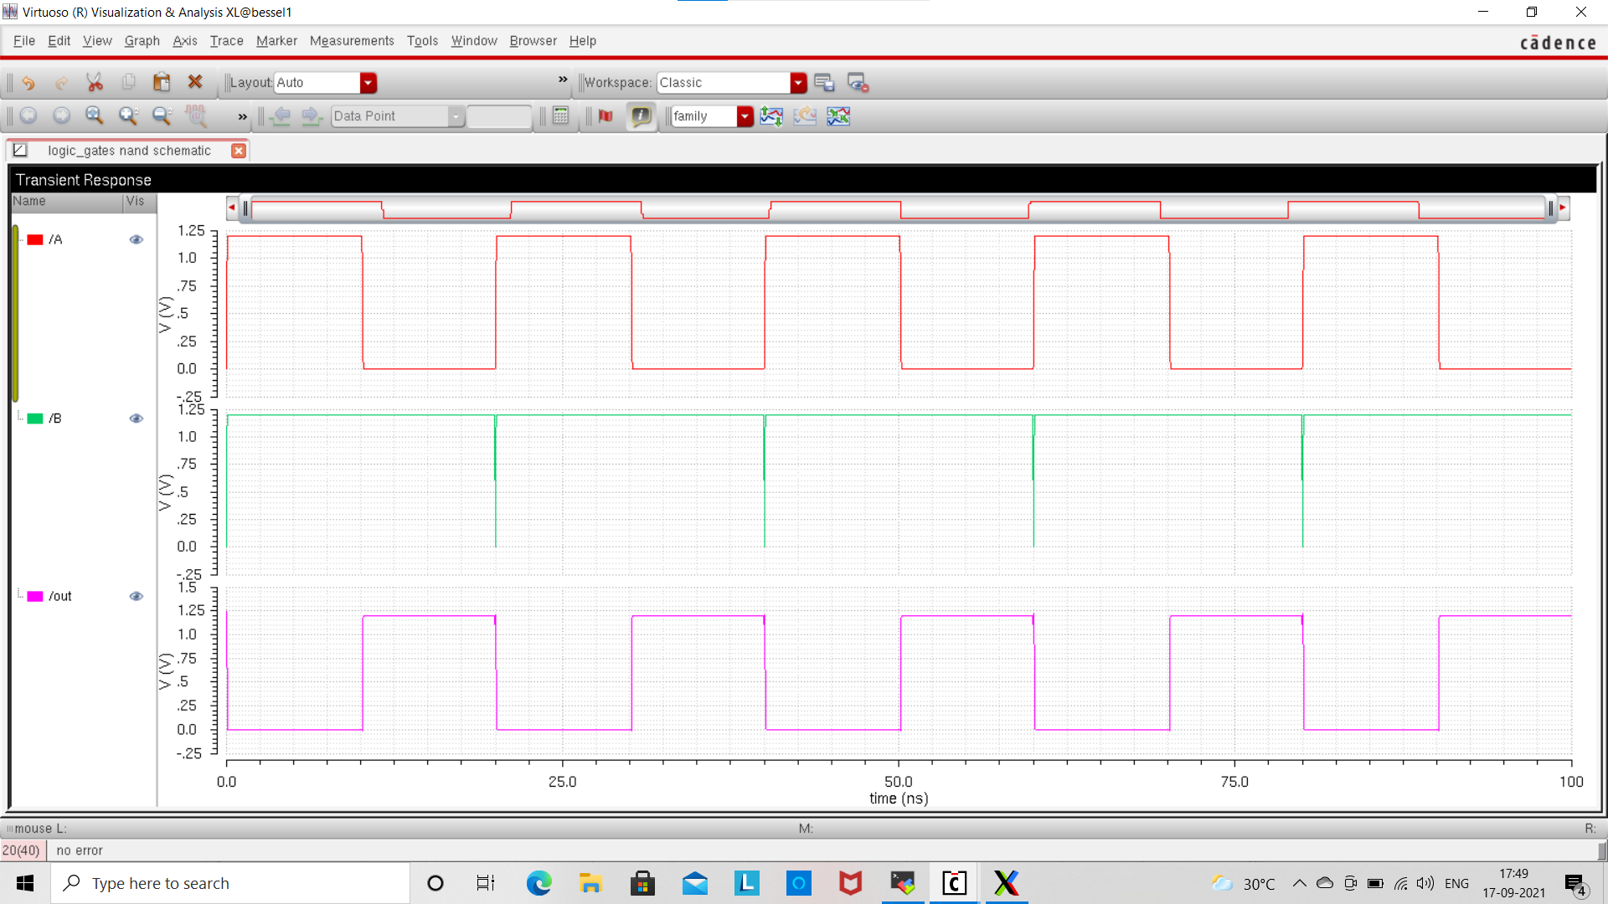

Three Input Nand Gate

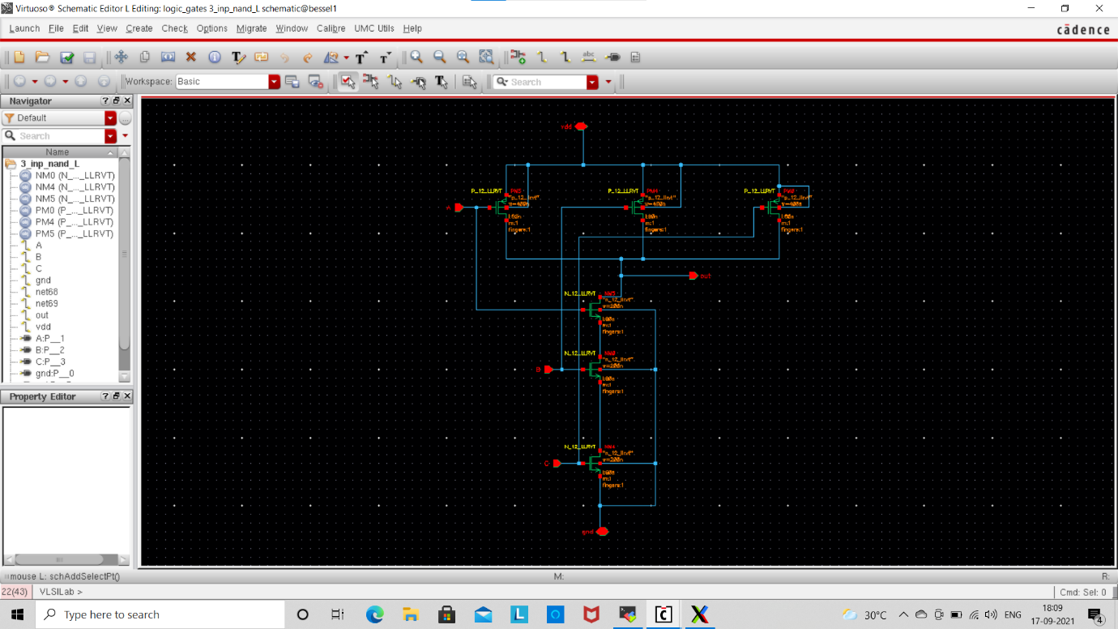

Layout

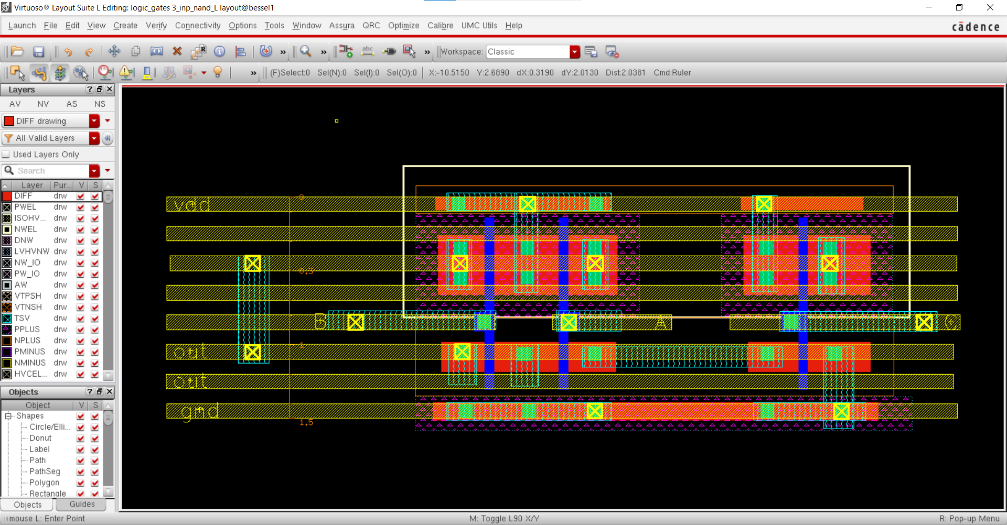

Output

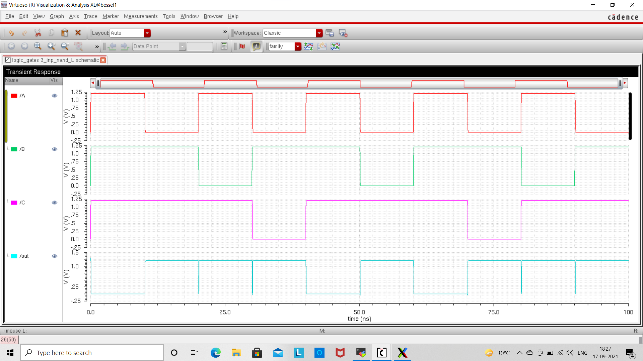

SR Latch

Schematic

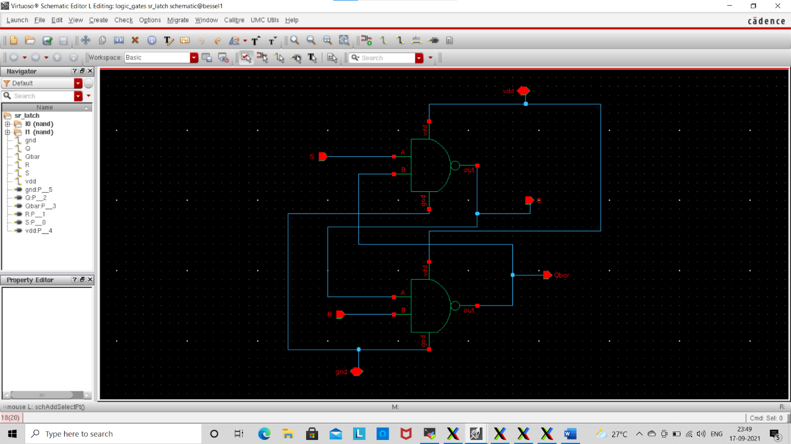

Layout

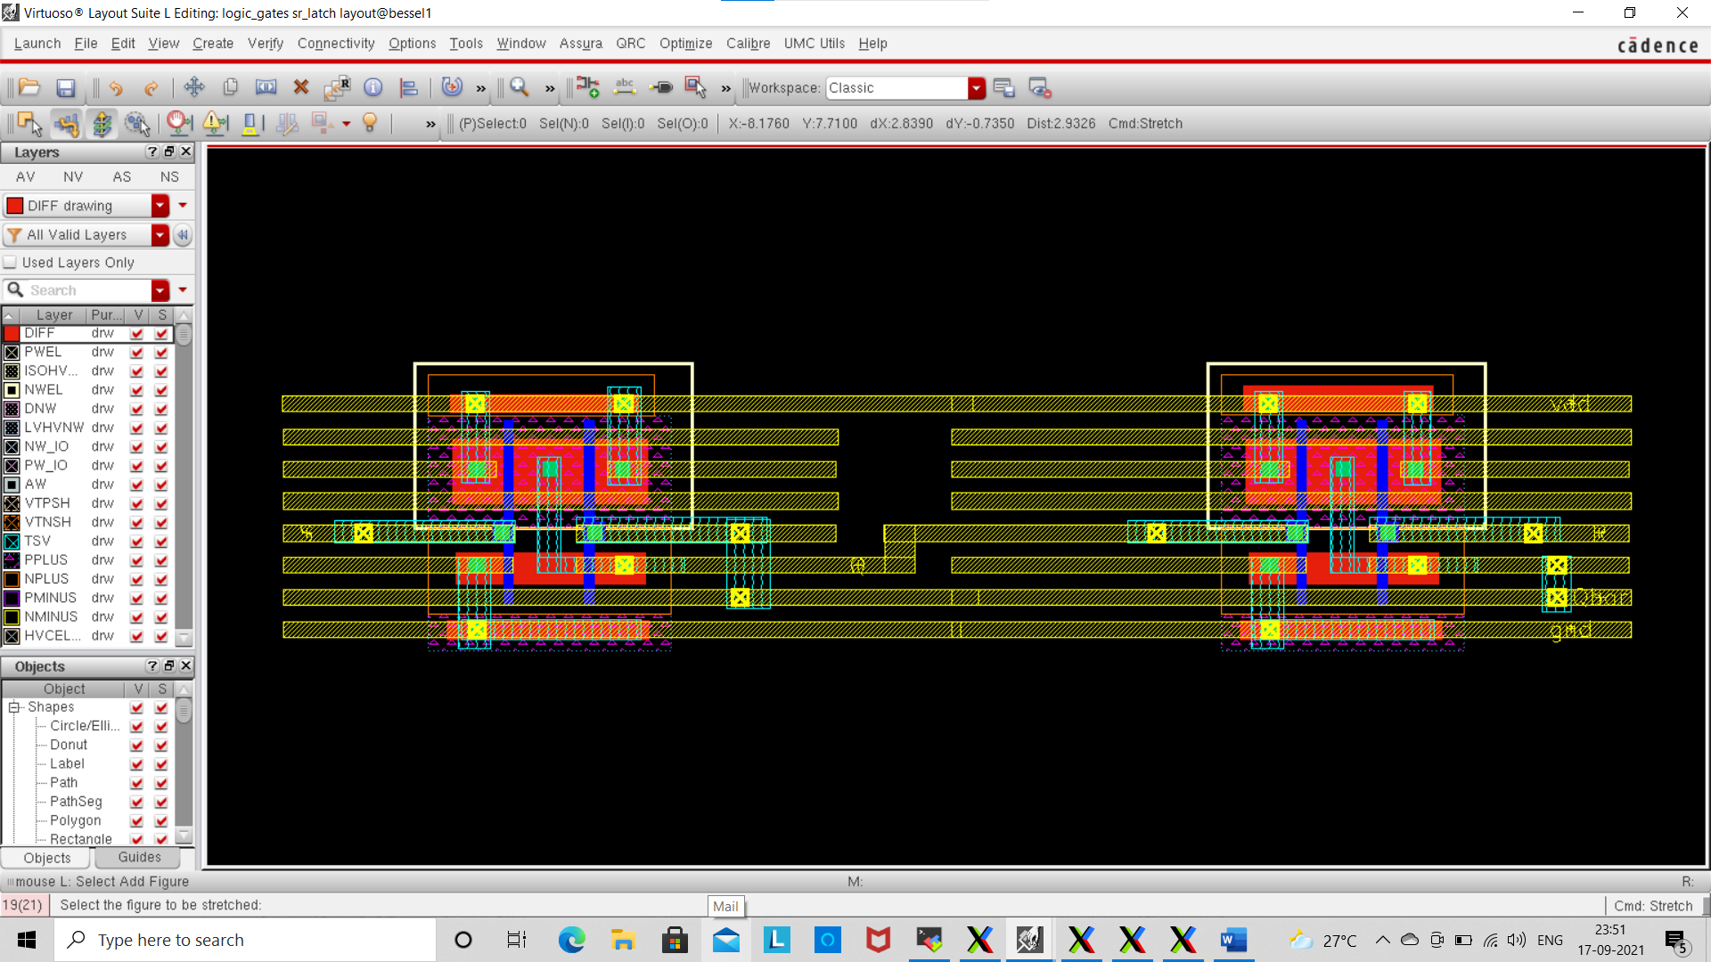

Master-Slave JK Flip Flop with Preset and Clear Controls

Schematic

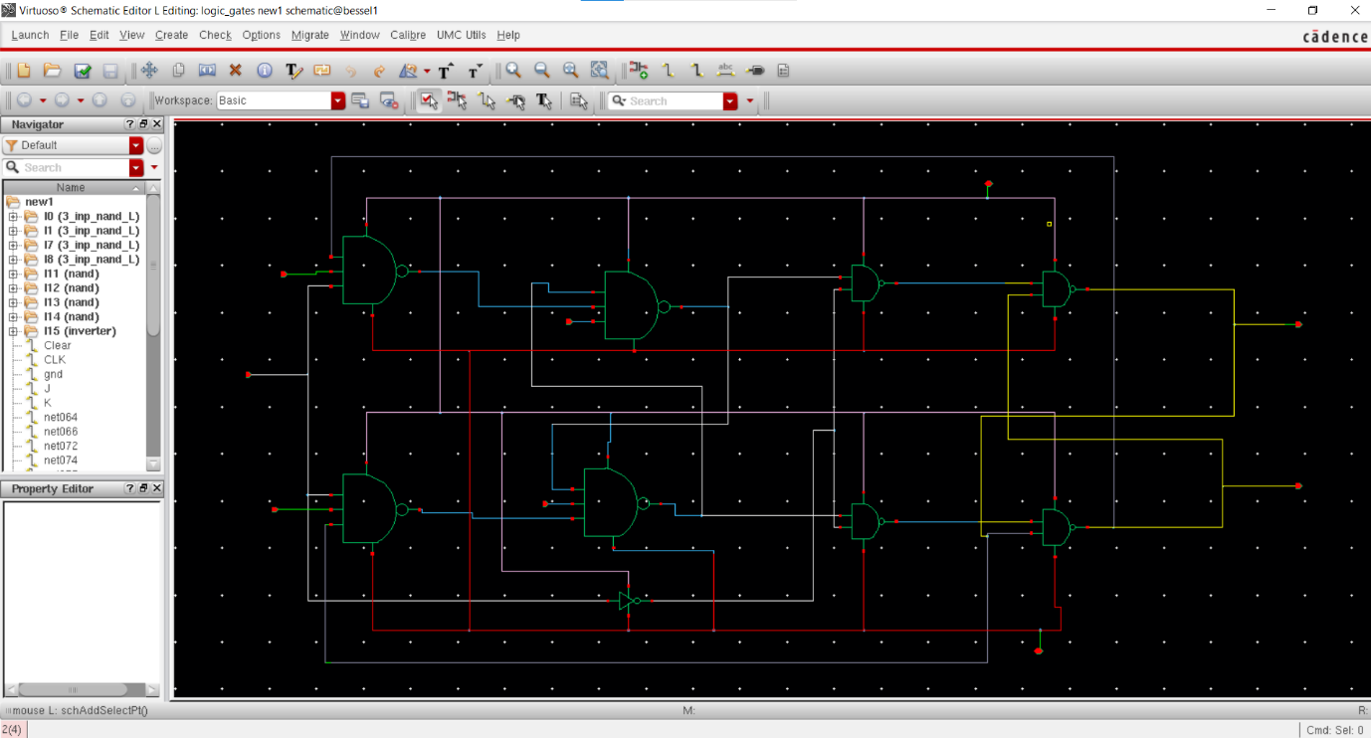

Layout

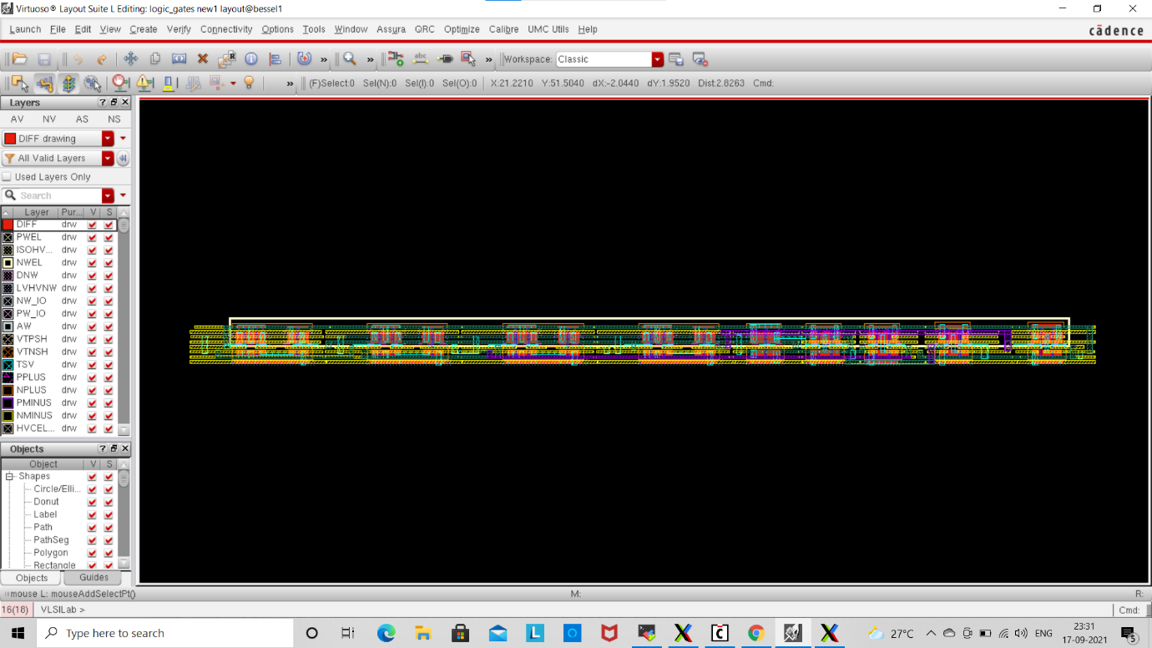

MOD -5 Counter

Schematic

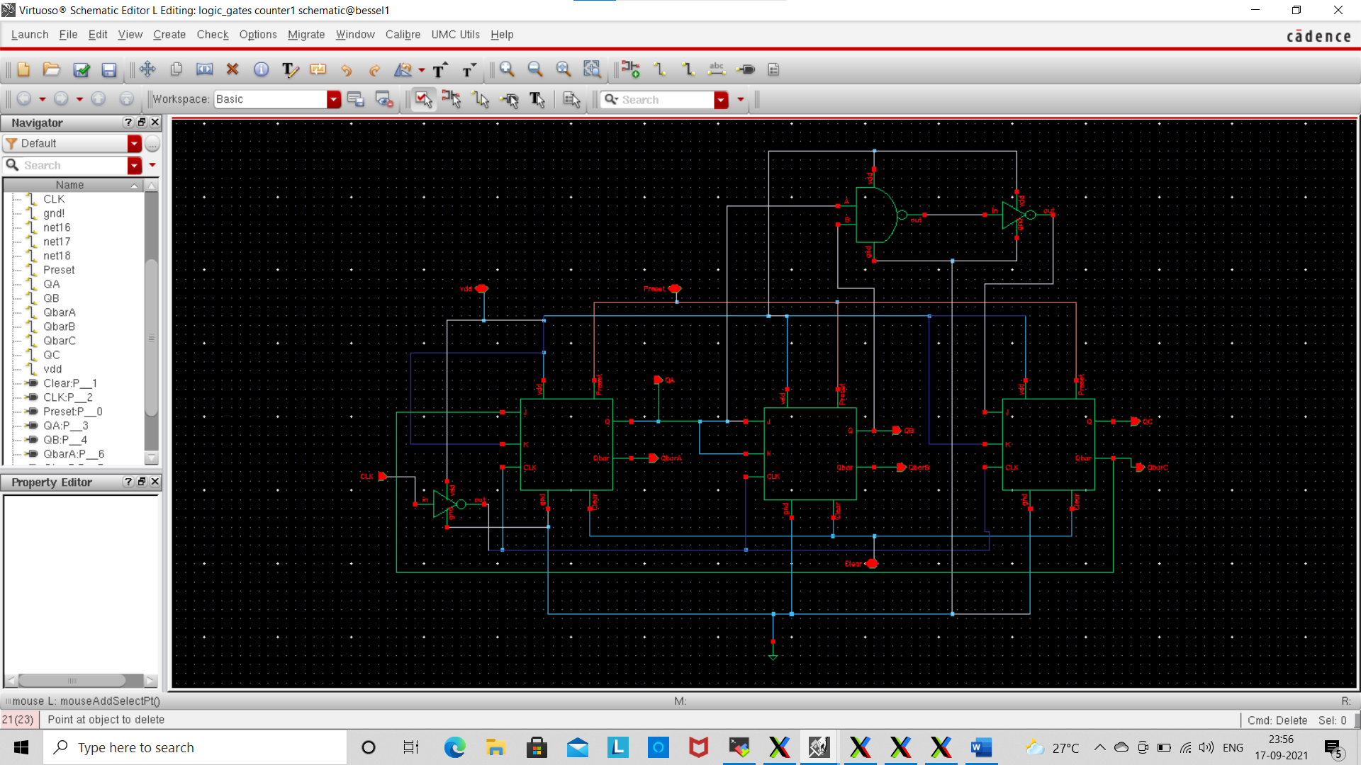

Layout

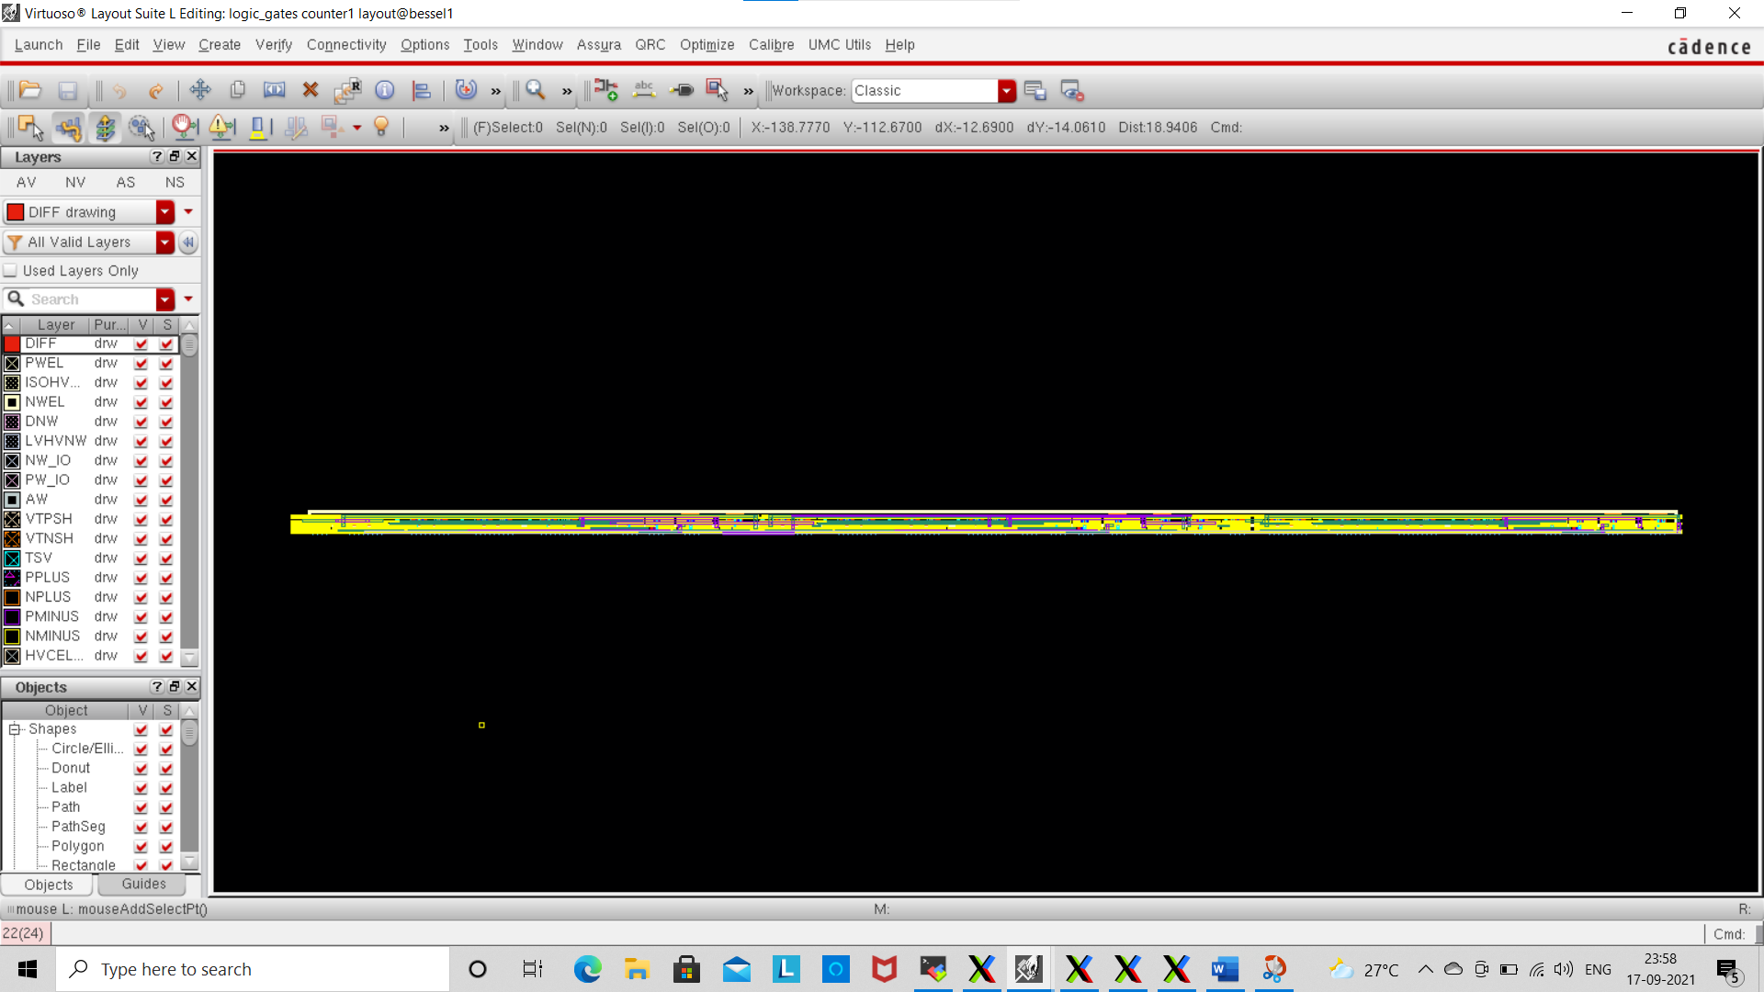

\*\* All drc and lvs reports are given in another document attached to the repository.