Enterprise Architecture Document
Dynamic Dashboard - Industrial IoT Platform
Industry: Water Utilities / Industrial Automation

1. Executive Summary
This document defines the authoritative enterprise architecture for the Dynamic Dashboard IoT Platform. The system is a multi-tenant, microservices-based, event-driven industrial IoT platform designed for real-time telemetry ingestion, workflow orchestration, ISA-18.2 alarm management, and EPA-compliant data retention.

2. Service Level Objectives
SLA: 99.9% uptime (≤ 43 minutes downtime per month).
RPO: ≤ 1 minute (MongoDB Replica Set with journaling + majority writes).
RTO: ≤ 30 minutes (automated container restart + documented failover procedures).

3. Layered Architecture Overview

The platform follows a layered industrial IoT architecture separating edge ingestion, transport, messaging, API governance, microservices processing, persistence, and presentation.

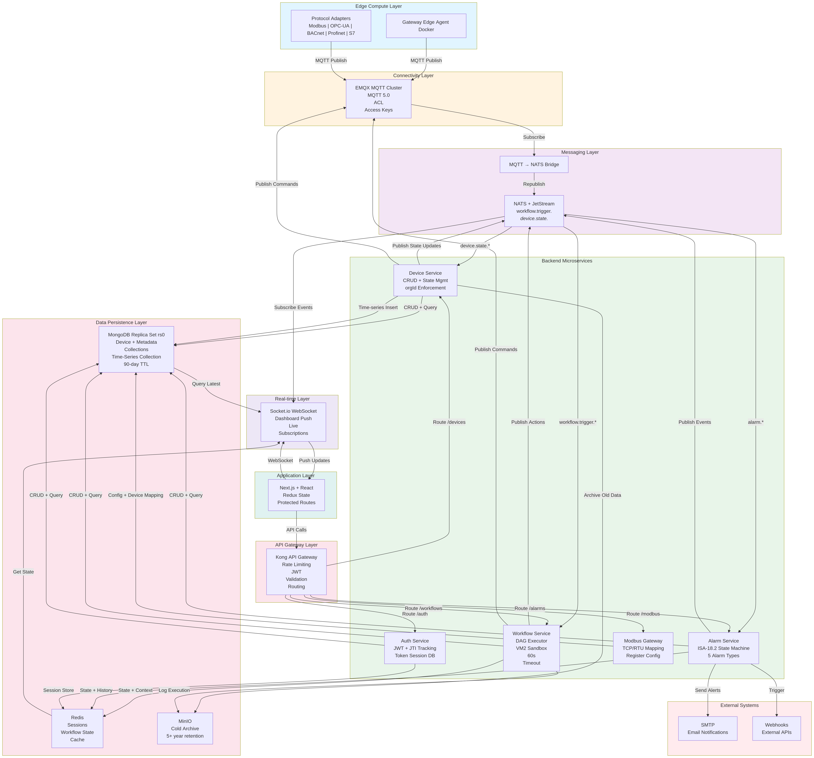

4. Backend Microservices & Event-Driven Processing
Core Services:
- Device Service: CRUD + State Management + orgId enforcement.
- Workflow Service: Validation, DAG execution, VM2 sandbox, 60s timeout, 5MB payload limit.
- Alarm Service: ISA-18.2 compliant state machine with 5 alarm types.
- Auth Service: JWT (15m) + Refresh (7d) + JTI tracking with immediate revocation.
- Modbus Gateway: TCP/RTU protocol translation and register mapping.
- Messaging: EMQX for device connectivity; NATS JetStream for internal events.

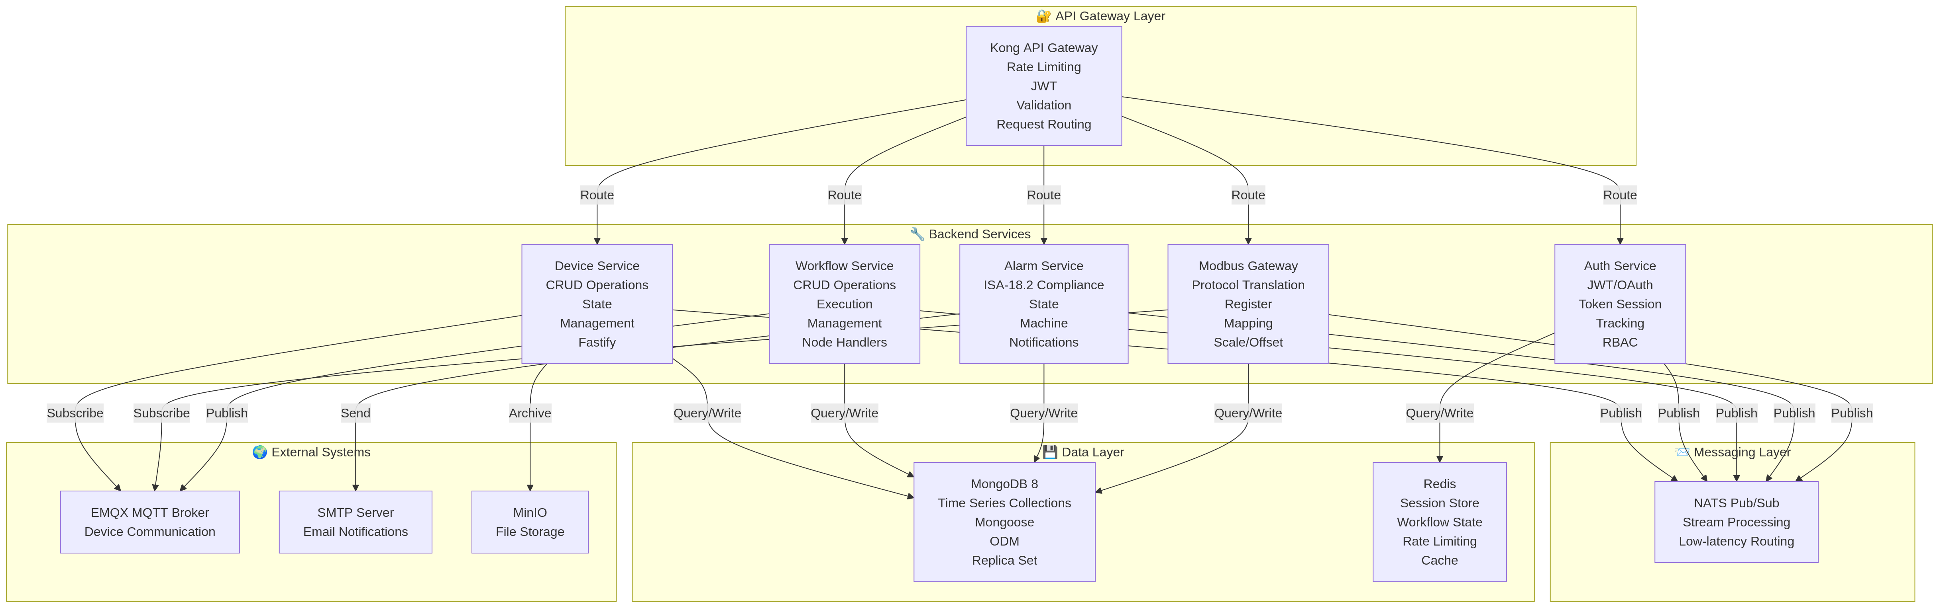

5. Data Persistence & High Availability
MongoDB 8 Replica Set (rs0) provides high availability and time-series collections with TTL-based retention. Redis supports session storage, workflow state, and caching. MinIO provides cold archival storage.
Retention: 90-day TTL (current baseline). 5-year and 10-year roadmap tiers planned.

6. Security, Multi-Tenancy & Compliance
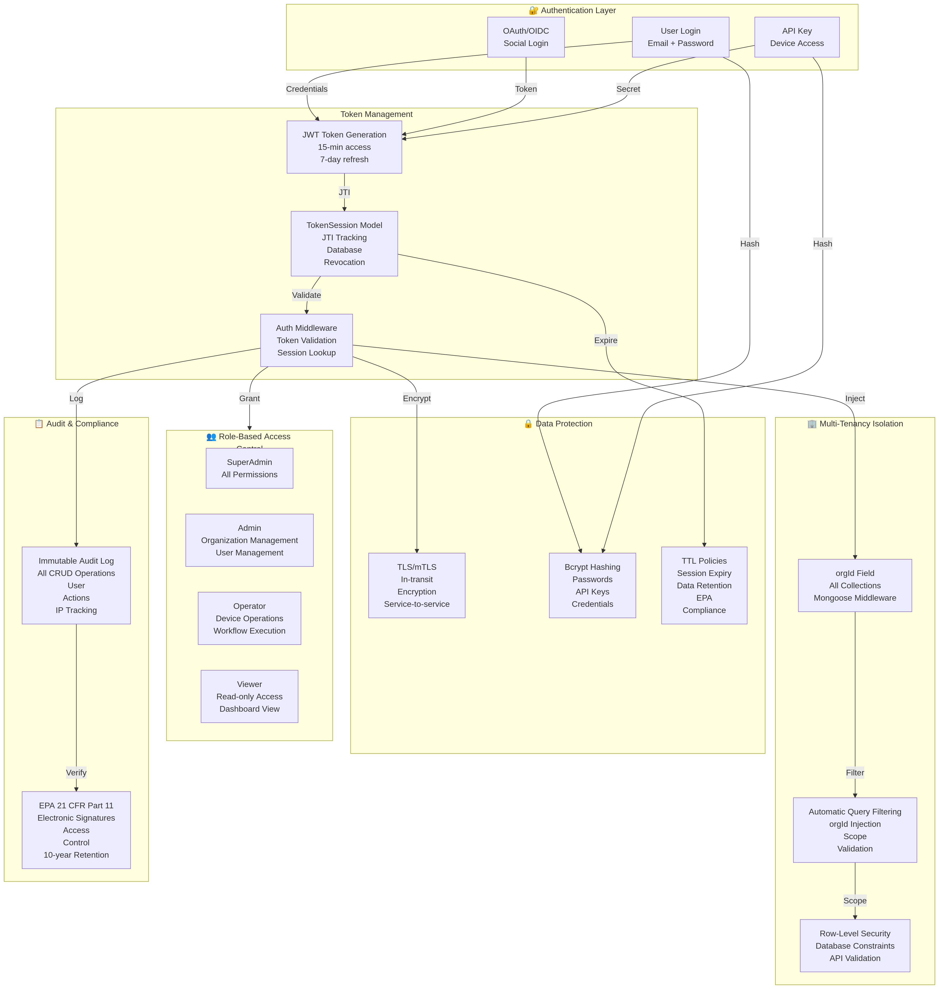

Security Architecture:
- Kong API Gateway boundary enforcement.
- JWT validation + JTI TokenSession tracking.
- Role-Based Access Control (SuperAdmin, Admin, Operator, Viewer).
- orgId automatic injection and row-level security.
- Immutable audit logs aligned with EPA 21 CFR Part 11.
- ISA-18.2 alarm compliance.
- ISA/IEC 62443 defense-in-depth alignment.

7. Observability & Governance
- Structured logging for workflows and services.
- Audit trail with IP + user action tracking.
- Quality scoring and validation monitoring.
- Alert generation and compliance reporting.

8. Enterprise Evolution Roadmap
- OAuth2 / OIDC migration.
- Multi-region deployment.
- 5-year hot/warm/cold tiered retention.
- OTA Edge Update Pipeline.
- Advanced analytics and Jupyter integration.

9. Conclusion
The v3 architecture represents a production-grade, enterprise-ready industrial IoT platform with strong regulatory alignment, high availability guarantees, secure multi-tenancy, and a scalable event-driven microservices foundation.

