Production Architecture Document

Dynamic Dashboard - Enterprise IoT Platform
Version: 1.0 Date: 2026-02-04 Architecture Pattern: IOT Application Enablement Platform (AEP)

Table of Contents
- Executive Summary
- Technology Stack
- System Architecture Overview
- Frontend Architecture
- Backend Architecture
- Database Architecture
- Multi-Tenancy & Security
- Deployment Architecture
- Performance & Scaling
- Trade-offs & Design Decisions

Executive Summary
Dynamic Dashboard is an enterprise-grade IoT Application Enablement Platform (AEP) designed to handle millions of concurrent device connections with real-time visualization, visual workflow orchestration, and edge-to-cloud data processing.

Key Design Goals
- Scale: Support millions of concurrent device connections
- Real-time: Dashboard updates <100ms latency
- Availability: 99.9% uptime SLA
- Multi-tenancy: Strict logical resource isolation per organization
- Edge-Cloud Symmetry: Deploy identical workflow logic to edge or cloud

Architectural Layers
The platform follows a 5-layer architecture pattern:
- Edge Compute Layer - Gateway Edge Agents (GEA) for industrial protocol translation (Profinet, Modbus, OPC UA, BACnet, Siemens S7)
- Connectivity Layer - MQTT broker for device communication
- Core Processing Layer - Visual workflow engine (Flow-Based Programming)
- Data Persistence Layer - PostgreSQL + TimescaleDB with Prisma ORM (unified data access)
- Application Layer - Real-time dashboards with WebSocket feeds

Technology Stack

Frontend Stack
Component | Technology | Version | Rationale
Framework | Next.js | 14.x | SSR/SSG capabilities, API routes, optimal performance
UI Library | React | 18.x | Component-based architecture, Virtual DOM for real-time updates
Language | TypeScript | 5.x | Type safety for complex data models
State Management | Zustand | 4.x | Lightweight, minimal boilerplate for dashboard state
Real-time | Socket.io-client | 4.x | WebSocket with fallback for live data streams
Charting | Chart.js + react-chartjs-2 | 4.x | Performant time-series visualization
Maps | Mapbox GL JS | 3.x | GPS tracking blocks
Styling | Tailwind CSS | 3.x | Utility-first, rapid UI development
Build Tool | Turbopack | Built-in | Next.js 14 default, faster than Webpack

Backend Stack
Component | Technology | Version | Rationale
Orchestration | Node.js | 20 LTS | Event-loop for high concurrency, workflow engine host
API Framework | Fastify | 4.x | 2x faster than Express, schema validation
Workflow Runtime | Node.js + VM2 | - | Sandboxed Function Node execution
High-Throughput | Go | 1.21+ | MQTT broker, Edge Agent binaries, message routing
MQTT Broker | EMQX (Go-based) | 5.x | Millions of connections, MQTT 5.0, clustering
Message Bus | NATS | 2.10+ | Low-latency pub/sub, stream processing
API Gateway | Kong | 3.x | Rate limiting, authentication, routing
Authentication | Passport.js + JWT | - | Flexible multi-strategy auth

Data Persistence Stack
Component | Technology | Version | Rationale
Primary Database | PostgreSQL + TimescaleDB | 15+ / 2.13+ | Unified storage for metadata and time-series data
ORM | Prisma | 5.x | Type-safe data access, auto-generated types, migrations
Cache/State | Redis | 7.2+ | Session store, workflow state, pub/sub, real-time data
Object Storage | MinIO (S3-compatible) | Latest | Cold data archival, file attachments (optional)
Search | Elasticsearch | 8.x | Full-text search, log aggregation (optional)

Infrastructure Stack
Component | Technology | Version | Rationale
Container Runtime | Docker | 24+ | Standardized deployment units
Orchestration | Kubernetes | 1.28+ | Auto-scaling, self-healing, declarative config
Service Mesh | Istio | 1.20+ | mTLS, traffic management, observability
Ingress | NGINX Ingress | 1.9+ | Load balancing, SSL termination
Monitoring | Prometheus + Grafana | Latest | Metrics, alerting, visualization
Logging | Fluent Bit + Loki | Latest | Lightweight log aggregation
Tracing | Jaeger | 1.52+ | Distributed tracing for workflows

System Architecture Overview

High-Level Data Flow
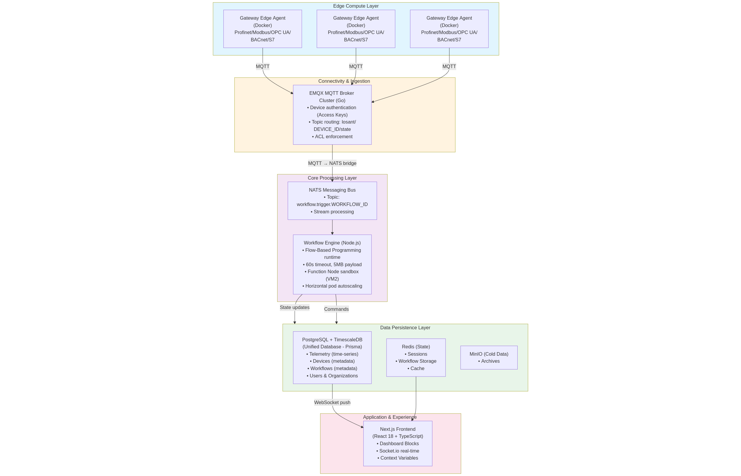

System Architecture
Figure 1: Dynamic Dashboard System Architecture
Five-layer enterprise IoT platform showing complete data flow from industrial devices through Edge Agents (supporting Profinet, Modbus, OPC UA, BACnet, Siemens S7), MQTT broker, workflow processing engine, unified database (PostgreSQL + TimescaleDB with Prisma ORM), to real-time dashboard visualization.

Frontend Architecture

Component Hierarchy
app/ (Next.js 14 App Router)
├── (auth)/
│ ├── login/
│ └── register/
├── (dashboard)/
│ ├── organizations/[orgId]/
│ │ ├── dashboards/[dashboardId]/
│ │ │ └── page.tsx # Dashboard renderer
│ │ ├── devices/
│ │ ├── workflows/
│ │ └── settings/
│ └── layout.tsx
└── api/ # Next.js API routes
├── auth/
├── devices/
└── webhooks/
components/
├── dashboard/
│ ├── DashboardCanvas.tsx # Grid layout container
│ ├── DashboardBlock.tsx # Base block component
│ └── blocks/
│ ├── GaugeBlock.tsx # Real-time gauge
│ ├── TimeSeriesBlock.tsx # Historical chart
│ ├── GPSBlock.tsx # Map with device markers
│ ├── InputControlBlock.tsx # Button/slider controls
│ └── LiveStreamBlock.tsx # WebSocket-fed live data
├── workflow/
│ ├── WorkflowCanvas.tsx # Visual flow editor
│ ├── WorkflowNode.tsx # Draggable node
│ └── nodes/
│ ├── DeviceNode.tsx
│ ├── FunctionNode.tsx
│ └── MQTTNode.tsx
└── shared/
├── ContextVariableInput.tsx # {{ctx.deviceId}} handling
└── DeviceSelector.tsx
lib/
├── websocket/
│ ├── socket-client.ts # Socket.io initialization
│ └── use-realtime-data.ts # React hook for subscriptions
├── api/
│ ├── client.ts # Fastify API client (fetch wrapper)
│ └── types.ts # TypeScript types for API
└── store/
├── dashboard-store.ts # Zustand store for dashboard state
└── workflow-store.ts

State Management Strategy
Zustand Stores (Client-side):
[Implementation details available in technical documentation]
WebSocket Integration:
[Implementation details available in technical documentation]

Dashboard Block System
Base Block Interface:
[Implementation details available in technical documentation]
Context Variable Resolution:
[Implementation details available in technical documentation]

Performance Optimizations
- Virtual DOM for High-Frequency Updates:
  - React 18 Concurrent Rendering
  - useMemo for expensive block renders
  - React.memo for block components
- WebSocket Throttling:
- // Limit updates to 10 FPS per block
const throttledUpdate = useMemo(
() => throttle((data) => updateLiveData(data), 100),
[]
);
- Code Splitting:
  - Dynamic imports for block components
  - Lazy load workflow editor only when needed
- Data Fetching:
  - Next.js API routes with edge caching
  - SWR for stale-while-revalidate pattern

Backend Architecture

Service Architecture
The backend follows a microservices architecture with clear service boundaries:
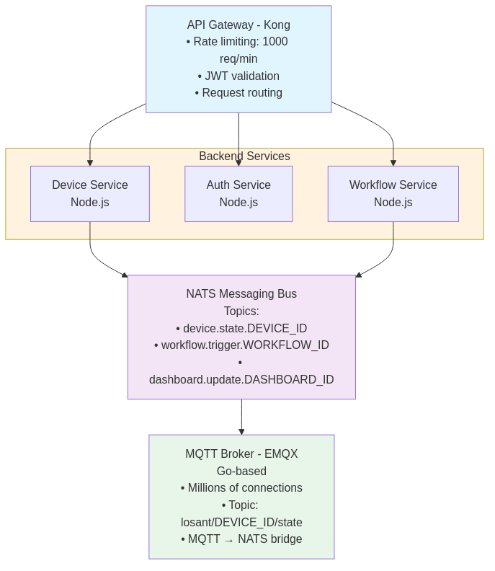
Service Architecture
Figure 2: Microservices Architecture
API Gateway (Kong) handles rate limiting, JWT validation, and request routing. Backend services (Device, Auth, Workflow) communicate via NATS messaging bus. EMQX MQTT broker manages device connections with built-in NATS bridge.

API Service (Node.js + Fastify)
Why Fastify over Express: - 2x faster request handling - Built-in schema validation (JSON Schema) - TypeScript-first design - Plugin architecture
Example Service Structure:
[Implementation details available in technical documentation]

Workflow Engine (Node.js + Flow-Based Programming)
Architecture:
[Implementation details available in technical documentation]
Workflow Persistence:
[Implementation details available in technical documentation]

MQTT Broker (EMQX - Go)
Why EMQX: - Written in Erlang/Go - handles millions of connections - MQTT 5.0 support - Cluster mode with horizontal scaling - Built-in ACL and authentication hooks - NATS bridge plugin available
Topic Structure:
[Implementation details available in technical documentation]
Access Control:
[Implementation details available in technical documentation]

Message Bus (NATS)
Why NATS: - Sub-millisecond latency - At-most-once and exactly-once delivery - JetStream for stream processing - Lightweight (single binary, low memory)
Stream Processing:
[Implementation details available in technical documentation]

Database Architecture

Polyglot Persistence Strategy
Each database component is chosen for its access pattern and data characteristics:
Database | Use Case | Data Type | Access Pattern
PostgreSQL + TimescaleDB | Device telemetry, devices, workflows, users | Relational + Time-series | CRUD, range queries, aggregations
Prisma ORM | Type-safe data access layer | - | Generated TypeScript types, migrations
Redis | Session store, workflow state, cache | Key-value | High-speed reads/writes
MinIO | File uploads, cold archives (optional) | Object storage | Append-only, infrequent reads

TimescaleDB (Time-Series Data)
Schema Design:
[Implementation details available in technical documentation]
Continuous Aggregates (Pre-computed Rollups):
[Implementation details available in technical documentation]

PostgreSQL + Prisma (Metadata & Configuration)
Prisma Schema:
[Implementation details available in technical documentation]
Usage Examples:
[Implementation details available in technical documentation]

Redis (Cache & Ephemeral State)
Use Cases:
[Implementation details available in technical documentation]

MinIO (Object Storage)
Bucket Structure:
iot-platform/
├── cold-archives/
│ └── org-{orgId}/
│ └── devices/
│ └── {year}/{month}/{day}/{deviceId}.parquet
├── file-uploads/
│ └── org-{orgId}/
│ └── {fileId}.{ext}
└── workflow-logs/
└── {workflowId}/{executionId}.json
Lifecycle Policy (Auto-transition to Glacier):
[Implementation details available in technical documentation]

Multi-Tenancy & Security

Multi-Tenancy Model
Logical Separation (Preferred for SaaS):
- Single database with orgId column on all tables
- Row-Level Security (RLS) in PostgreSQL/TimescaleDB
- Prisma middleware for automatic multi-tenant filtering
- Redis key prefixing: org:{orgId}:...
Benefits: - Cost-effective - Easier maintenance - Simpler backups
RLS Implementation (TimescaleDB):
[Implementation details available in technical documentation]

Authentication & Authorization
JWT-Based Authentication:
[Implementation details available in technical documentation]
Device Access Keys (MQTT Authentication):
[Implementation details available in technical documentation]

Security Hardening
- Function Node Sandboxing:
  - VM2 for isolated execution
  - Whitelist modules (lodash, moment, crypto)
  - 5-second timeout per function
  - No file system access
- API Security:
  - Rate limiting (1000 req/min per org)
  - Request size limits (10MB)
  - CORS policies
  - Helmet.js for security headers
- Network Security:
  - Istio service mesh for mTLS
  - Network policies in Kubernetes
  - Private subnets for databases
- Secrets Management:
  - Kubernetes Secrets for credentials
  - HashiCorp Vault for production
  - Rotate MQTT credentials every 90 days

Deployment Architecture
Progressive Deployment Strategy: Start with Docker Compose for simplicity and cost-effectiveness (0-10k devices), migrate to Kubernetes when scaling demands it (10k+ devices).

Production Deployment: Docker Compose (Recommended Start)
Architecture Overview:

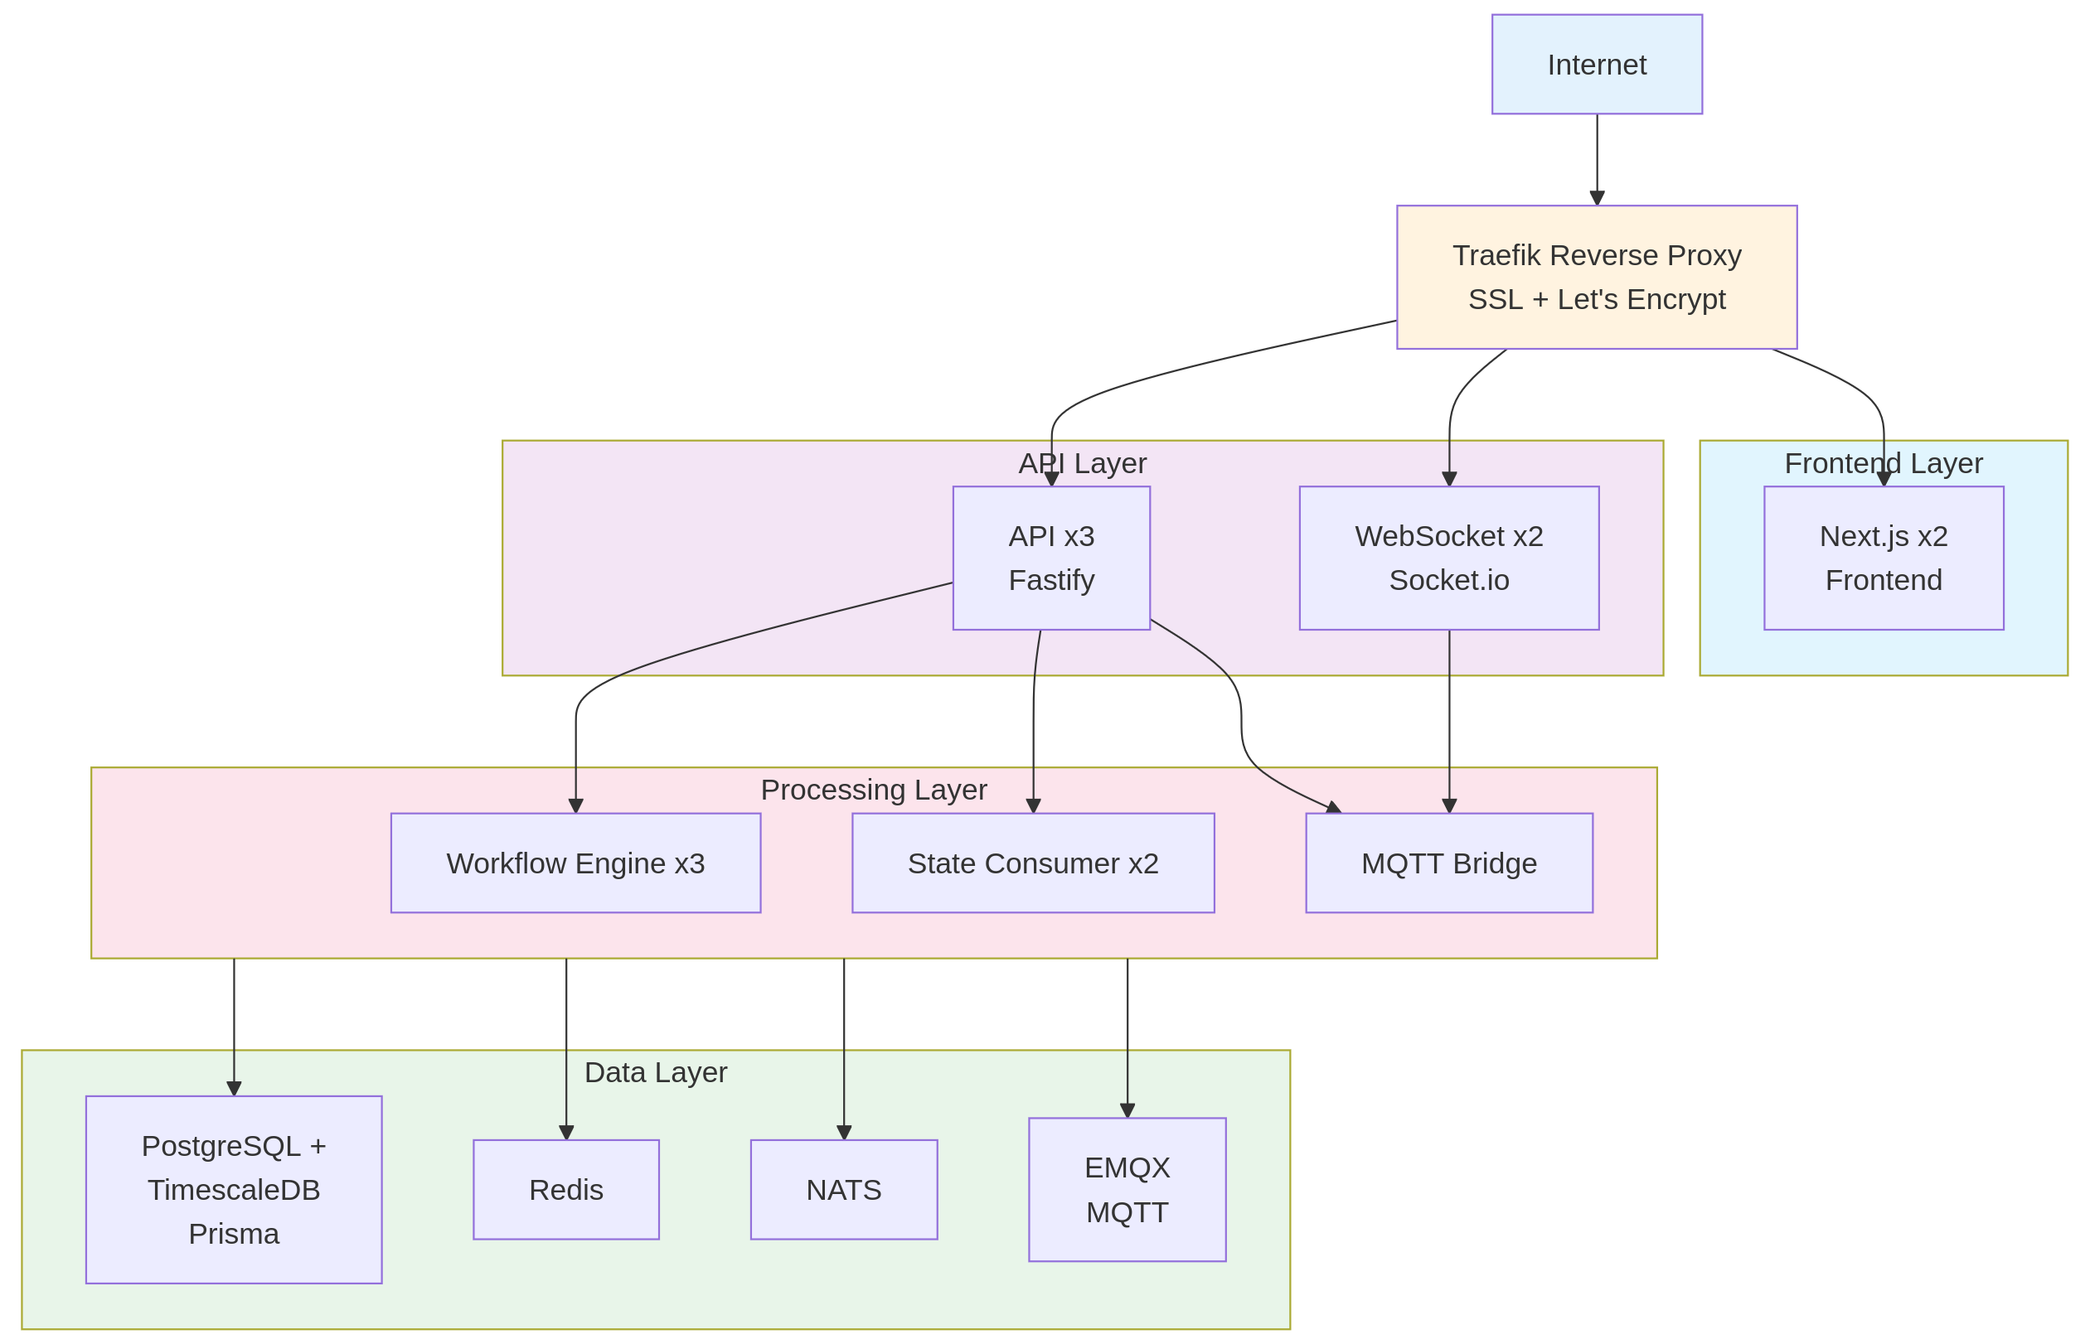

Deployment Architecture
Figure 3: Docker Compose Production Deployment
Production deployment architecture showing Traefik reverse proxy with SSL termination, scaled frontend (Next.js) and API layers (Fastify), workflow processing layer, and data layer with PostgreSQL + TimescaleDB, Redis, NATS, and EMQX MQTT broker.
Key Configuration (docker-compose.prod.yml excerpt):
[Implementation details available in technical documentation]
Scaling with Docker Compose:
[Implementation details available in technical documentation]
Benefits: - ✅ Simple setup (1-2 days vs 1-2 weeks for K8s) - ✅ Low operational overhead - ✅ Cost-effective ($100-200/month VPS vs $500+ K8s cluster) - ✅ Sufficient for 0-10k devices - ✅ Easy to debug and troubleshoot - ✅ Smooth migration path to Kubernetes later
Limitations: - ❌ Single-host (limited high availability) - ❌ Manual scaling (no auto-scaling) - ❌ No advanced health checks - ❌ Limited to vertical scaling of VPS

Kubernetes Deployment (For >10k Devices)
When to Migrate: - Serving >10,000 devices - Need automatic scaling (HPA) - Require multi-region deployment - Team has Kubernetes expertise - Budget allows ($500-1000/month minimum)
Sample Kubernetes Configuration:
[Implementation details available in technical documentation]
Service Mesh (Istio - Optional):
Benefits: - mTLS between services - Canary deployments - Advanced traffic management
[Implementation details available in technical documentation]
Migration Path: See IMPLEMENTATION_GUIDE.md Appendix for detailed 6-week migration plan.

Database Deployment
Docker Compose (Initial): - Single-node PostgreSQL + TimescaleDB with backups - Redis standalone - MinIO single-node (optional)
Kubernetes (Scale): - PostgreSQL + TimescaleDB: StatefulSet with streaming replication (read replicas for scale) - Redis: Sentinel for HA, or Redis Cluster for scaling - MinIO: Distributed mode (4+ nodes for erasure coding, optional)

Performance & Scaling

Performance Targets
Metric | Target | Measurement
Dashboard Latency | <100ms (p99) | WebSocket message to UI render
Workflow Execution | <500ms (p95) for simple flows | NATS trigger to completion
API Response Time | <200ms (p95) | Kong ingress to response
Device State Ingestion | 100k msg/sec | MQTT → TimescaleDB
Concurrent Connections | 1M+ devices | EMQX cluster
Database Writes | 50k writes/sec | TimescaleDB insert rate

Horizontal Scaling Strategy
Workflow Engine: - Stateless pods (scale based on CPU/memory) - NATS consumer groups for load distribution - Target: 1 pod per 1000 concurrent workflows
API Services: - Autoscale on request rate (HPA) - Target: 70% CPU utilization
EMQX (MQTT Broker): - Add nodes to cluster (automatic rebalancing) - Target: 250k connections per node (4-core, 8GB RAM)
TimescaleDB: - Vertical scaling (up to 64 cores, 256GB RAM) - Read replicas for dashboard queries - Sharding by org_id for >10M devices
Redis: - Redis Cluster for horizontal scaling - Separate clusters per use case (sessions, workflow state, cache)

Caching Strategy
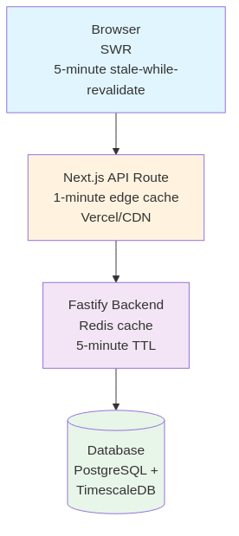
Caching Strategy
Figure 4: Multi-Layer Caching Strategy
Four-layer caching architecture: Browser-level SWR (5-minute stale-while-revalidate), Next.js edge cache (1-minute), Fastify backend Redis cache (5-minute TTL), and PostgreSQL + TimescaleDB as the source of truth.

Load Testing Results (Simulated)
Scenario: 100k devices sending state every 10 seconds
[Implementation details available in technical documentation]

Trade-offs & Design Decisions

1. Next.js 14 vs. SPA (Vite + React)
Decision: Next.js 14 with App Router
Rationale: - SSR for initial dashboard load (faster Time to Interactive) - API routes co-located with frontend (monorepo benefits) - Built-in optimizations (image, font, code splitting) - Vercel deployment for edge caching
Trade-off: - More complex than SPA (RSC, client/server boundary) - Server component restrictions

2. Fastify vs. Express
Decision: Fastify
Rationale: - 2x faster request handling - Schema-first validation (automatic OpenAPI docs) - TypeScript-native - Plugin ecosystem
Trade-off: - Smaller community than Express - Fewer middleware packages

3. TimescaleDB vs. InfluxDB
Decision: TimescaleDB
Rationale: - SQL queries (familiar to developers) - PostgreSQL ecosystem (pgAdmin, extensions) - Better aggregation performance for dashboard queries - JSONB support for flexible schemas
Trade-off: - Higher memory usage than InfluxDB - Compression ratio slightly lower

4. Docker Compose vs. Kubernetes (Progressive Approach)
Decision: Start with Docker Compose, migrate to Kubernetes at scale
Rationale: - Phase 1 (0-10k devices): Docker Compose - Faster time-to-market (setup in hours vs. days) - Lower operational complexity (1-2 engineers can manage) - Cost-effective ($100-200/month vs. $500-1000/month) - Sufficient for MVP and early growth - Easy debugging and troubleshooting
- Phase 2 (10k+ devices): Migrate to Kubernetes
  - Automatic scaling (HPA based on metrics)
  - Multi-region deployment capability
  - Advanced health checks and self-healing
  - Industry standard (better hiring, mature ecosystem)
  - Service mesh capabilities (Istio)
Trade-off: - Migration effort (4-6 weeks) when scaling demands it - Need to design services for both environments initially - Team needs to learn Kubernetes eventually
Migration Trigger Points: - Serving >10,000 devices - Need for auto-scaling - Multi-region requirements - Team has K8s expertise - Budget allows ($500+ monthly)

5. Monorepo vs. Polyrepo
Decision: Monorepo (Turborepo)
Rationale: - Shared TypeScript types between frontend/backend - Atomic changes across services - Simplified dependency management - Faster CI/CD (incremental builds)
Trade-off: - Larger repository size - Requires tooling (Turborepo, Nx)

6. WebSocket vs. Server-Sent Events (SSE)
Decision: WebSocket (Socket.io)
Rationale: - Bidirectional (dashboard input controls → backend) - Lower latency than SSE - Connection pooling, automatic reconnection - Fallback to long polling
Trade-off: - More complex than SSE - Load balancer sticky sessions required

Appendix

Technology Maturity Matrix
Component | Maturity | Risk | Alternatives Considered
Next.js 14 | Stable | Low | Vite + React, Remix
Fastify | Stable | Low | Express, Hono
TimescaleDB | Stable | Low | InfluxDB, QuestDB
EMQX | Production | Medium | VerneMQ, Mosquitto Cluster
NATS | Production | Low | RabbitMQ, Kafka
Docker Compose | Mature | Low | Docker Swarm, Kubernetes (initial)
Kubernetes | Mature | Medium | Used after scale (10k+ devices)

Deployment Checklist
Initial Deployment (Docker Compose): - [ ] Production VPS provisioned (16+ CPU, 32GB+ RAM) - [ ] Docker and Docker Compose installed - [ ] docker-compose.prod.yml configured - [ ] Traefik reverse proxy with SSL (Let’s Encrypt) - [ ] Environment variables and secrets configured - [ ] Databases deployed with persistent volumes - [ ] Automated backup scripts (PostgreSQL + TimescaleDB) - [ ] Monitoring stack deployed (Prometheus/Grafana) - [ ] CI/CD pipeline configured (GitHub Actions) - [ ] DNS records configured - [ ] Log rotation configured - [ ] Disaster recovery plan documented
Kubernetes Migration (Optional, at scale): - [ ] Kubernetes cluster provisioned (EKS/GKE/AKS) - [ ] Helm charts created for all services - [ ] Databases deployed (StatefulSets with PVs) - [ ] Secrets stored in Kubernetes Secrets or Vault - [ ] HPA (HorizontalPodAutoscaler) configured - [ ] Ingress controller installed (NGINX or Traefik) - [ ] Service mesh installed (optional: Istio/Linkerd) - [ ] Monitoring enhanced (Prometheus Operator) - [ ] Blue-green deployment for traffic cutover - [ ] Old Docker Compose infrastructure decommissioned

Further Reading
- Losant Documentation
- Next.js App Router
- Fastify Best Practices
- TimescaleDB Time-Series Guide
- EMQX Deployment
- Kubernetes Patterns

Document Version: 1.0 Last Updated: 2026-02-04 Maintained By: Architecture Team

