1. Given the provided data, what are three conclusions we can draw about Kickstarter campaigns?

Theatre, Music, Technology, Film & Video seem to comprise > 50% of the overall # of Kickstarter campaigns.

 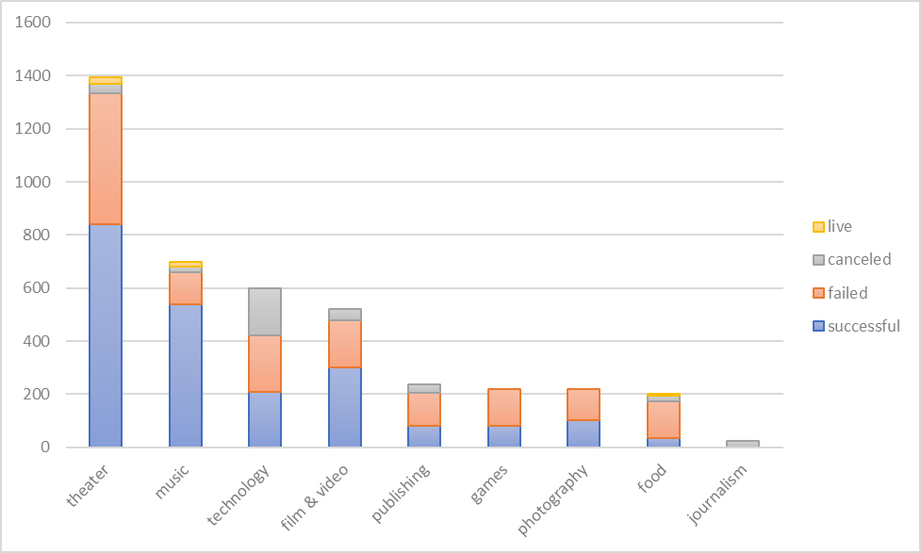

If we filter for just “successful” campaigns, theater, music, film & video still seem to comprise > top 50% of all campaigns, with film & video overtaking technology.

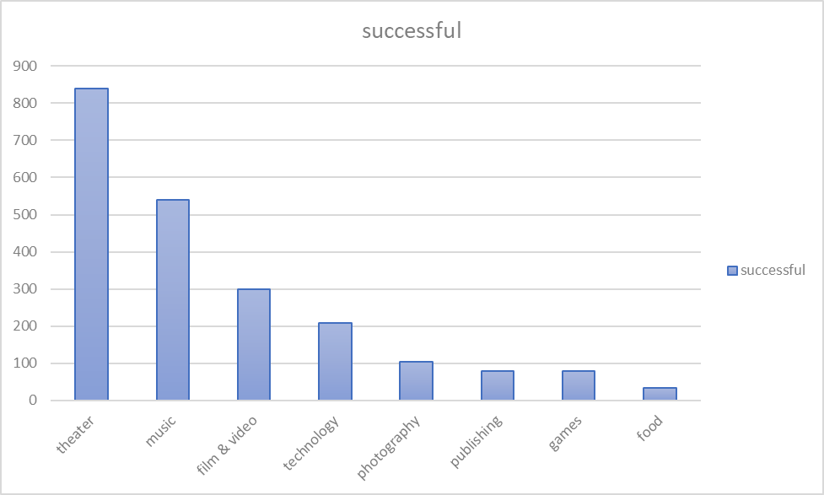

When we bucket the campaigns by their goals, there generally seems to be an inverse relationship between campaign goals & success rate (i.e. the higher the goal, the more likely a campaign is to fail.)

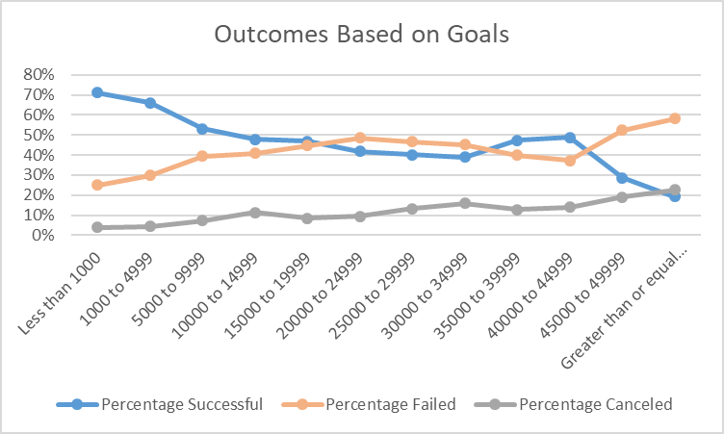



1. What are some limitations of this dataset?

In this dataset, donations are aggregated by KickStarter campaign, therefore, we are unable to look at the distribution and timing of donations for a specific campaign.

We're unable to answer questions like: did the campaign get the most donations at the inception of a campaign, or from say after a social media push?

We also don't know exactly where the donations are coming from (so if we wanted to do a targeted campaign, we're unable to directly address a specific demographic of backers to market towards).

1. What are some other possible tables and/or graphs that we could create?

Some other types of charts we can create are a histogram, specifically for when we bucket the campaign goals against the number of successful, failed, or canceled campaigns. It would be easier to see the distribution of campaigns (either by # of campaigns, # of backers, or total donations).

We could also create a pie graph to show the proportion of successful/failed/canceled campaigns and then filter that by category/subcategory, however it doesn’t do a good job of illustrating any sort of trend.

Another type of chart we could have created is a pareto chart (y axis by dollar donated or # of backers) and x-axis as category, subcategory, or perhaps country, to take a look at which types of campaigns accounted for the top 10-20% of overall campaigns.