PROGRESSIVE FEATURE ENGINEERING AND IMBALANCED MACHINE LEARNING FOR CREDIT CARD FRAUD DETECTION

BY
[Student Name]
Matriculation Number: [Matriculation Number]

A RESEARCH PROJECT SUBMITTED TO
[Department]
[Faculty]
UNIVERSITY OF IBADAN

IN PARTIAL FULFILMENT OF THE REQUIREMENTS FOR THE AWARD OF
[Degree Programme]

SUPERVISOR: [Supervisor Name]
DATE: [Month Year]

CERTIFICATION PAGE
This page is reserved for the certification statement, supervisor endorsement, and required signatures after review by the supervisor and department.

DEDICATION PAGE
This page is reserved for the dedication statement to be completed by the student before final submission.

ACKNOWLEDGMENT PAGE
This page is reserved for acknowledgments to the supervisor, department, family, colleagues, and other contributors as appropriate before final submission.

ABSTRACT
Credit card fraud detection is an important binary classification problem because fraudulent transactions are usually less frequent than legitimate transactions but have significant financial and operational consequences. This study developed a reproducible tabular machine-learning workflow using a researcher-generated synthetic credit card transaction dataset. The cleaned master dataset contained 499,985 transactions, consisting of 62,500 fraudulent transactions and 437,485 legitimate transactions, with a fraud ratio of 12.5004%. Five progressively enriched dataset versions were constructed from the same transaction population in order to examine the effect of feature engineering without changing the underlying sample. The models evaluated were Logistic Regression, Decision Tree, Random Forest, XGBoost, and CatBoost. The experimental design used a stratified 60/20/20 train-validation-test split, 5-fold cross-validation on the training split, PR-AUC implemented as average precision for hyperparameter tuning, validation-based model-family selection, and untouched test-set reporting. SMOTE was evaluated only inside the training pipeline after preprocessing and inside cross-validation folds. At the default threshold, the best result was obtained by v3 SMOTE Random Forest, with precision 0.998525, recall 0.758080, fraud-class F1 of 0.861846, and PR-AUC of 0.855235. After validation-based threshold optimization, the best operating point was v5 No-SMOTE Random Forest at threshold 0.80, with precision 0.999156, recall 0.758000, and fraud-class F1 of 0.862030. The findings indicate that progressive feature engineering improved fraud-class performance and that the observed benefit of SMOTE was threshold-dependent. The report also emphasizes reproducibility, transparent dataset auditing, and cautious interpretation of small performance differences. The study is limited by the synthetic dataset, absence of external validation, and leakage-risk proxy indicators such as MerchantRisk and CardRisk.

TABLE OF CONTENTS
Title Page
Certification Page
Dedication Page
Acknowledgment Page
Abstract
List of Figures
List of Tables
List of Abbreviations
Chapter One: Introduction
Chapter Two: Literature Review
Chapter Three: Methodology
Chapter Four: Results and Discussion
Chapter Five: Conclusion and Recommendations
References
Appendices

LIST OF FIGURES
Figure 1.1: Conceptual digital payment fraud context and need for analytical detection.
Figure 1.2: High-level research workflow for the study.
Figure 2.1: Conceptual framework linking transaction evidence, feature engineering, imbalance handling, model learning, and fraud-class performance.
Figure 3.1: Methodology framework for the University of Ibadan MSc project.
Figure 3.2: Progressive dataset version design from v1 to v5.
Figure 3.3: Experimental pipeline for dataset preparation, model tuning, evaluation, SMOTE comparison, and threshold optimization.
Figure 4.1: Class distribution of the cleaned synthetic transaction dataset.
Figure 4.2: Fraud-class F1 comparison between No-SMOTE and SMOTE results.
Figure 4.3: Fraud precision comparison between No-SMOTE and SMOTE results.
Figure 4.4: Fraud recall comparison between No-SMOTE and SMOTE results.
Figure 4.5: PR-AUC comparison between No-SMOTE and SMOTE results.
Figure 4.6: Threshold optimization curve for the v5 No-SMOTE Random Forest model.
Figure 4.7: Tuned test confusion matrix for the v5 No-SMOTE Random Forest model at threshold 0.80.
Figure 4.8: Feature importance for the selected v5 No-SMOTE Random Forest model.

LIST OF TABLES
Table 2.1: Empirical Review Comparison Matrix
Table 3.1: Dataset Summary
Table 3.2: Dataset Versions
Table 3.3: Experimental Configuration
Table 4.1: Best Default-Threshold Results Without SMOTE
Table 4.2: Best Default-Threshold Results With SMOTE
Table 4.3: Threshold-Tuned Results
Table 4.4: Key Findings Summary

LIST OF ABBREVIATIONS
AI | Artificial Intelligence
ANN | Artificial Neural Network
AUC | Area Under the Curve
CV | Cross-Validation
F1 | F1-score
FN | False Negative
FP | False Positive
ML | Machine Learning
PR-AUC | Precision-Recall Area Under the Curve
ROC-AUC | Receiver Operating Characteristic Area Under the Curve
SMOTE | Synthetic Minority Oversampling Technique
TN | True Negative
TP | True Positive
XGBoost | Extreme Gradient Boosting

CHAPTER ONE: INTRODUCTION

1.1 Background of the Study
A hostile methodological reading of the study shows that the background must make the imbalance problem more explicit. In fraud detection, the minority class is not merely a statistical inconvenience; it determines whether the model can identify the cases that matter most to the investigation. For this reason, the study prioritizes fraud precision, fraud recall, fraud-class F1, and PR-AUC instead of relying on accuracy alone.
The study also addresses a reproducibility problem. Fraud-detection experiments can become difficult to defend when the dataset lineage is unclear, when duplicate transactions are present, or when different dataset versions contain different populations. The present study therefore treats dataset cleaning, version control, and audit reporting as part of the research method rather than as a preliminary technical step.
Digital payment channels generate large streams of transaction records. Within these records, fraudulent activity is often a minority event that must be detected without overwhelming legitimate transaction activity. This makes credit card fraud detection a suitable case for imbalanced binary classification, where the aim is not simply to obtain high accuracy but to identify fraud with useful precision and recall.
Machine learning has become an important approach for fraud analysis because it can learn statistical patterns from transaction-level attributes. However, the quality of the results depends heavily on dataset preparation, feature engineering, class-imbalance handling, model selection, and evaluation metrics. Figure 1.1 provides a conceptual view of the digital payment fraud context without making unsupported numerical claims.
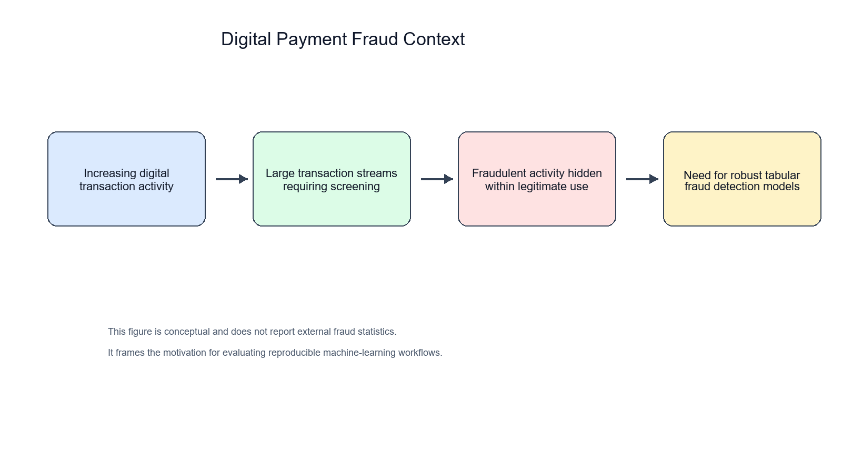
Figure 1.1: Conceptual digital payment fraud context and need for analytical detection.
This study focuses on a researcher-generated synthetic credit card transaction dataset. The work is therefore an academic and reproducibility-oriented investigation of tabular fraud classification, not a operational banking infrastructure.
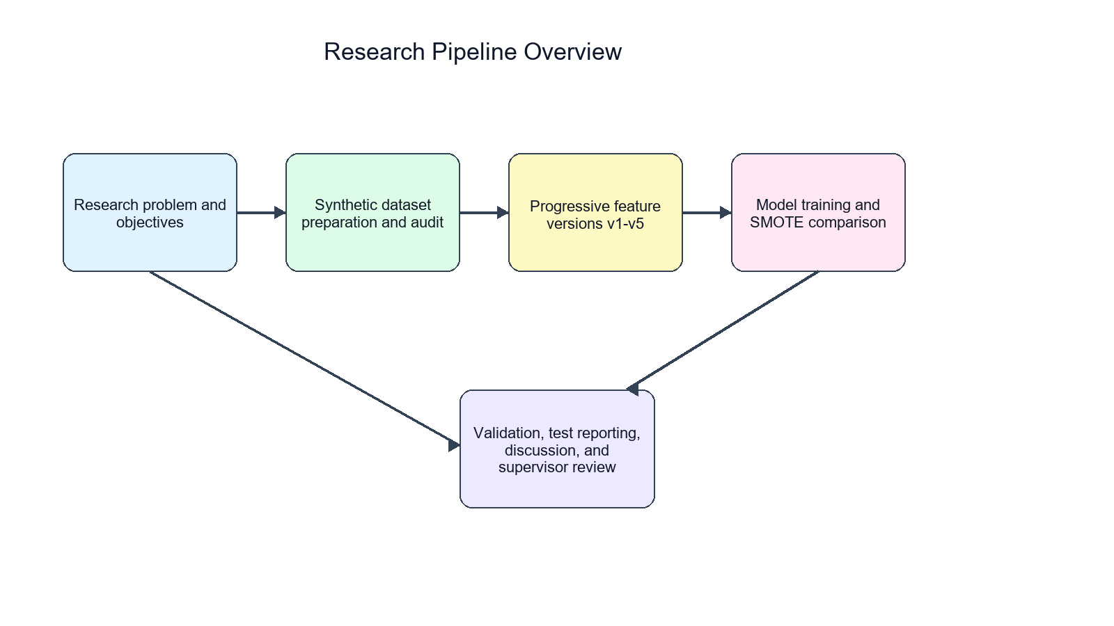
Figure 1.2: High-level research workflow for the study.

1.2 Statement of the Problem
The specific research problem is that model comparisons are not defensible unless the dataset population, feature sets, class balance, preprocessing, and validation protocol are controlled. If these elements are not controlled, an observed improvement may be caused by duplicated records, leakage-risk variables, or sample-size differences rather than by a genuinely better modelling strategy.
Fraud detection research can be weakened by unclear dataset provenance, duplicated transactions, inconsistent feature sets, and overreliance on accuracy. In the project repository, legacy and merged data artifacts existed alongside newer cleaned datasets. A defensible supervisor-submission report therefore requires a clear statement of which datasets were used, how duplicates were handled, how features were progressively introduced, and how model performance was evaluated.
The problem addressed in this study is how to build and evaluate a reproducible tabular machine-learning pipeline for credit card fraud detection while controlling for dataset population, class imbalance, and possible leakage-risk features.

1.3 Aim and Objectives of the Study
The aim of the study is to evaluate the effect of progressive feature engineering and imbalanced machine-learning strategies on credit card fraud detection using a cleaned synthetic transaction dataset.
1. To prepare and validate a clean master transaction dataset for fraud classification.
2. To create five progressively enriched dataset versions from the same transaction population.
3. To train and compare Logistic Regression, Decision Tree, Random Forest, XGBoost, and CatBoost models.
4. To compare No-SMOTE and SMOTE training settings under a leakage-aware pipeline.
5. To evaluate default-threshold and threshold-tuned model performance using fraud-class metrics and PR-AUC.

1.4 Research Questions
1. How does progressive feature engineering affect fraud-class performance across v1 to v5?
2. How do No-SMOTE and SMOTE training settings compare at the default threshold?
3. Does threshold optimization change the practical advantage observed under SMOTE?
4. Which model families provide the strongest fraud-class performance on the cleaned synthetic dataset?
5. What limitations affect interpretation of the study results?

1.5 Significance of the Study
For a supervisor or examiner, the significance of the study lies less in claiming external deployment performance and more in demonstrating a transparent research workflow. The study shows how a synthetic transaction dataset can be audited, versioned, and evaluated in a way that separates feature-engineering effects from population changes.
The study is significant because it demonstrates a reproducible workflow for preparing, validating, and evaluating progressively enriched fraud-detection datasets. It also shows why minority-class metrics, threshold policies, and transparent limitation statements are important in imbalanced fraud-detection research.

1.6 Scope of the Study
The study is limited to binary tabular classification on a researcher-generated synthetic credit card transaction dataset. It evaluates five dataset versions, five model families, No-SMOTE and SMOTE settings, and threshold optimization based on validation predictions. It does not evaluate live transaction streams, institutional data, or deployment infrastructure.

1.7 Limitations of the Study
The main limitations are the synthetic nature of the dataset, absence of external validation, possible leakage risk in MerchantRisk and CardRisk, static offline splitting, and the absence of repeated-seed or confidence-interval analysis.

1.8 Definition of Key Terms
FraudFlag: The binary target label indicating whether a transaction is fraudulent or legitimate.
SMOTE: A resampling technique that creates synthetic minority-class examples during training.
PR-AUC: A metric that summarizes the precision-recall relationship and is useful in imbalanced classification.
Feature engineering: The process of creating or transforming variables to improve predictive performance.
Threshold optimization: The process of selecting a probability cutoff based on validation predictions before test evaluation.

1.9 Organization of the Study
Chapter One introduces the study. Chapter Two reviews relevant literature. Chapter Three presents the methodology. Chapter Four reports and discusses the results. Chapter Five concludes the study and provides recommendations.

CHAPTER TWO: LITERATURE REVIEW

2.1 Conceptual Review
The conceptual basis of the study connects four ideas: fraud as a minority-class event, transaction data as structured tabular evidence, engineered variables as model inputs, and threshold selection as an operating decision. These concepts are linked because fraud-detection performance depends not only on the classifier but also on how transaction information is represented and how predicted probabilities are converted into class labels.

2.1.1 Credit Card Fraud
Credit card fraud involves unauthorized or deceptive use of payment-card information. Prior fraud-detection literature emphasizes that fraud patterns are dynamic and that detection systems must distinguish suspicious behavior from legitimate high-volume transaction activity [1], [2].

2.1.2 Fraud Detection Systems
Fraud detection systems traditionally use business rules, thresholds, manual reviews, and risk indicators. Rule-based systems are interpretable but may require frequent updating when fraudulent behavior changes [1], [2].

2.1.3 Machine Learning in Fraud Detection
Machine-learning systems estimate fraud risk by learning relationships between transaction attributes and labels. Prior studies have used linear classifiers, tree-based methods, ensemble learning, and boosting methods for fraud detection [3]-[8].

2.1.4 Imbalanced Classification
Fraud detection is usually imbalanced because fraudulent transactions occur less frequently than legitimate transactions. Imbalanced learning literature recommends focusing on minority-class performance, resampling strategies, and cost-sensitive evaluation [9]-[14].

2.1.5 Feature Engineering
Feature engineering transforms raw variables into more informative predictors. In fraud detection, transaction amount, time, merchant, card, category, and risk-derived indicators can influence model performance [5], [29], [30].

2.1.6 Evaluation Metrics
Accuracy is often insufficient in imbalanced classification because a model can perform well on the majority class while missing minority-class cases. F1, ROC-AUC, and PR-AUC are therefore commonly used to assess classifier behavior [15]-[17].

2.2 Theoretical Review
Supervised learning theory supports the use of labelled transaction records to estimate a mapping from predictors to FraudFlag. However, supervised learning also assumes that training and test data are drawn from compatible distributions. Since this project uses synthetic data, the theory supports internal model comparison but does not by itself establish external validity.
Imbalanced learning theory explains why fraud-class metrics are emphasized. When one class dominates, a classifier may perform well on aggregate metrics while failing to identify enough minority-class cases. This justifies the use of PR-AUC, fraud-class F1, and SMOTE as part of the experimental design [9]-[17].
Ensemble learning theory explains why Random Forest, XGBoost, and CatBoost are plausible strong candidates. These models combine multiple tree structures or boosting iterations and are able to capture nonlinear relationships among amount, category, merchant, card, location, and time-derived variables [18]-[22].
The risk-based fraud detection framework is used cautiously. MerchantRisk and CardRisk may summarize useful behavioural information, but they may also encode target-proximal signals if their construction is not available before prediction. The study therefore treats these variables as proxy risk indicators and discusses leakage risk rather than assuming that they are automatically safe.
The study is grounded in supervised learning theory, where models learn a mapping from input features to a known target label. It also draws on imbalanced learning theory, which explains why class distribution affects model training and evaluation. Ensemble learning theory is relevant because Random Forest, XGBoost, and CatBoost combine multiple decision structures to improve predictive performance [18]-[22]. Finally, the risk-based fraud detection framework motivates the use of transaction and proxy risk indicators while requiring caution about feature provenance.

2.3 Conceptual Framework for the Study
This MSc study requires a conceptual framework because the experiment is not merely a collection of model runs. The framework clarifies how transaction evidence is transformed into feature versions, how class imbalance and preprocessing are controlled, how model families learn from the same population, and how fraud-class performance is judged. In the framework, the progressive feature set and imbalance-handling strategy are the main experimental conditions, while fraud-class precision, recall, F1 and PR-AUC are the outcome indicators. The same cleaned master population, fixed split, deterministic identifiers, and leakage controls serve as control conditions.
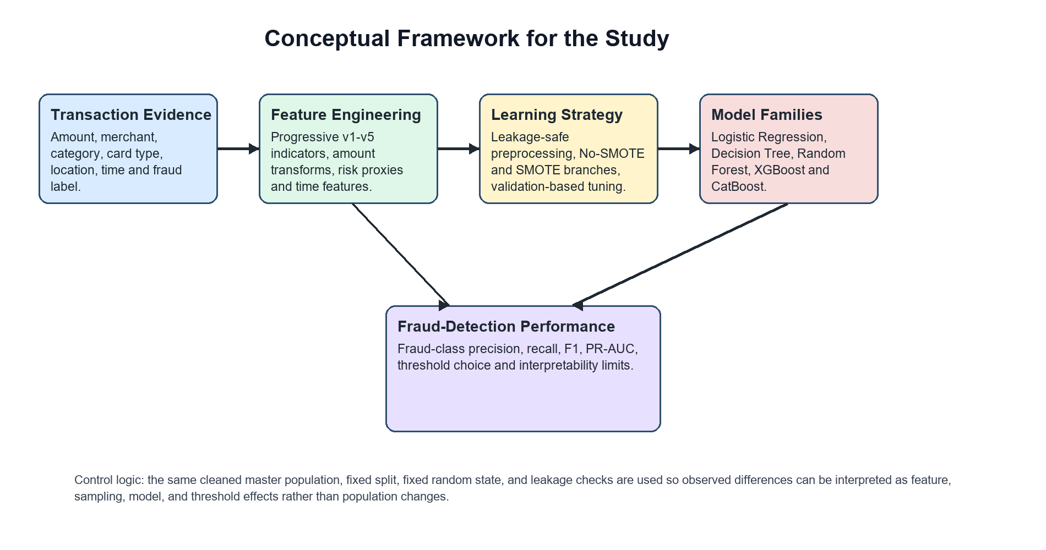
Figure 2.1: Conceptual framework linking transaction evidence, feature engineering, imbalance handling, model learning, and fraud-class performance.
Figure 2.1 shows that the study's logic moves from structured transaction evidence to engineered explanatory variables, then through a controlled learning strategy to fraud-detection performance. This helps a supervisor see that the comparison of v1 to v5 is a controlled feature-engineering investigation rather than an uncontrolled stacking of datasets.

2.4 Empirical Review
The empirical literature indicates that no single classifier is universally best for fraud detection. Instead, performance depends on feature design, class distribution, validation strategy, and operating threshold [3]-[8]. This supports the decision to compare multiple model families rather than relying on one algorithm.
Studies on SMOTE and class imbalance show that resampling can improve minority-class learning, but can also change probability calibration and the precision-recall trade-off [9]-[14]. The present study therefore compares SMOTE and No-SMOTE results at both default and tuned thresholds.
Feature-engineering studies in fraud detection show that amount, time, aggregation, and risk-derived variables can improve prediction [5], [29], [30]. The present study contributes an internally controlled versioning strategy by evaluating v1 to v5 on the same cleaned transaction population.
Evaluation literature supports the use of PR-AUC in imbalanced settings because precision-recall analysis focuses directly on the positive class [15], [16]. This justifies the repository choice of average precision as the hyperparameter tuning metric.
Empirical studies in credit card fraud detection have shown that model performance depends on data preparation, feature construction, class imbalance handling, and evaluation design [3]-[8]. SMOTE and related methods are widely used to address minority-class scarcity, but their benefit depends on the model, data distribution, and operating threshold [9]-[14].
Tree-based and boosting models are often competitive on tabular fraud data because they can model nonlinear feature interactions [18]-[22]. Prior work also emphasizes careful model selection and validation to avoid overfitting and biased performance estimates [23]-[28].
To make the empirical foundation explicit, Table 2.1 compares key credit-card fraud, imbalanced-learning, feature-engineering, and evaluation studies that directly shaped the present research design. Where a cited source is a review or methodological paper rather than a single dataset experiment, the dataset column reports the evidence base rather than pretending that a single dataset was used.
Table 2.1: Empirical Review Comparison Matrix
Author | Year | Dataset / Evidence Base | Model / Method | Findings Relevant to This Study | Limitation
Bolton and Hand | 2002 | Fraud-detection literature | Statistical fraud detection methods | Showed fraud detection as a supervised outlier/rare-event problem requiring careful validation. | Review-oriented; not a single modern card-transaction benchmark.
Ngai et al. | 2011 | Financial fraud literature | Classification framework for data mining | Mapped financial-fraud detection methods and confirmed classification as a dominant research approach. | Broad review across fraud domains; limited direct comparison under one dataset.
Bhattacharyya et al. | 2011 | Credit-card transaction data | Logistic regression, random forest, SVM and others | Compared multiple classifiers and showed that model choice affects credit-card fraud performance. | Dataset access and institutional context limit replication.
Whitrow et al. | 2009 | Credit-card transaction data | Transaction aggregation with classifiers | Found that aggregation of transaction history can improve fraud-detection performance. | Aggregation may introduce leakage if computed without strict temporal controls.
Bahnsen et al. | 2016 | Credit-card fraud data | Feature-engineering strategies | Showed that feature construction is central to credit-card fraud prediction. | Feature usefulness depends on dataset construction and operational availability.
Dal Pozzolo et al. | 2015 | Highly imbalanced card-fraud data | Undersampling and probability calibration | Showed that imbalance handling affects probability calibration and classifier interpretation. | Focuses on calibration/undersampling rather than all resampling strategies.
Jurgovsky et al. | 2018 | Card transaction sequences | Sequence classification | Demonstrated value of sequential transaction information for credit-card fraud detection. | Requires temporal customer histories not available in this project dataset.
Phua et al. | 2010 | Data-mining fraud literature | Survey of fraud-detection models | Highlighted supervised, unsupervised and hybrid fraud-detection approaches. | Survey evidence is broad and not limited to Nigerian or synthetic data.
Chawla et al. | 2002 | Imbalanced classification benchmarks | SMOTE | Introduced synthetic minority oversampling to improve learning under class imbalance. | Not fraud-specific; synthetic samples can distort probability estimates.
He and Garcia | 2009 | Imbalanced-learning literature | Sampling and cost-sensitive learning | Showed that imbalance changes evaluation priorities and requires minority-class metrics. | General imbalanced-learning review, not a project-specific fraud experiment.
Japkowicz and Stephen | 2002 | Imbalanced classification experiments | Systematic imbalance study | Showed that class imbalance can degrade classifier learning and evaluation. | Older benchmark settings may not reflect modern transaction data.
Galar et al. | 2012 | Class-imbalance literature | Bagging, boosting and hybrid ensembles | Reviewed ensemble approaches as strong candidates for imbalanced classification. | Review evidence varies across datasets and imbalance ratios.
Branco et al. | 2016 | Imbalanced-domain literature | Predictive modelling survey | Explained how imbalance affects modelling choices, validation, and metric selection. | Not limited to credit-card fraud and does not prescribe one best model.
Davis and Goadrich | 2006 | Binary classification benchmarks | ROC and precision-recall analysis | Established that PR analysis gives different insight from ROC analysis when positives are rare. | Metric-focused study rather than a fraud-detection application.
Saito and Rehmsmeier | 2015 | Imbalanced binary datasets | ROC and PR curve evaluation | Showed that PR curves can be more informative than ROC curves for imbalanced datasets. | Not fraud-specific; supports metric choice rather than model design.
Breiman | 2001 | Tabular benchmark datasets | Random Forest | Demonstrated ensemble-tree robustness and strong nonlinear classification performance. | General method paper; fraud-specific validity depends on transaction features.
The table shows that the present project is most strongly justified by three strands of prior work: fraud-feature engineering, imbalanced-classification evaluation, and controlled model comparison. It also shows why the study must avoid unsupported claims about deployment or external validity.

2.5 Research Gap
The sharper research gap is therefore not simply that machine learning can be used for fraud detection. The gap is the need for a defensible, reproducible experiment that tests feature enrichment, imbalance handling, and threshold tuning while holding the transaction population fixed. This gap is important because many apparent performance gains in fraud experiments can be caused by dataset leakage, duplicate records, or unreported validation decisions.
The gap addressed in this study is the need for a controlled comparison of progressive feature engineering across the same cleaned transaction population. This design helps separate feature effects from changes caused by sample size, duplicate records, or class-ratio differences.

2.6 Summary of Literature Review
The literature supports the use of machine learning, feature engineering, and minority-class metrics in fraud detection. It also cautions that resampling, model selection, and proxy risk indicators must be handled carefully to avoid unsupported claims.

CHAPTER THREE: METHODOLOGY

3.1 Research Design
The study adopted an experimental quantitative design. Five dataset versions were prepared from the same cleaned master population and evaluated using the same train-validation-test protocol.

3.1.1 Methodology Framework
Figure 3.1 presents the methodology framework used for the University of Ibadan MSc project. The framework links dataset auditing, clean-master construction, progressive feature versioning, model training, validation, threshold optimization, and supervisor-facing interpretation. It is deliberately sequential because each later modelling claim depends on earlier data-cleaning and leakage-control decisions.
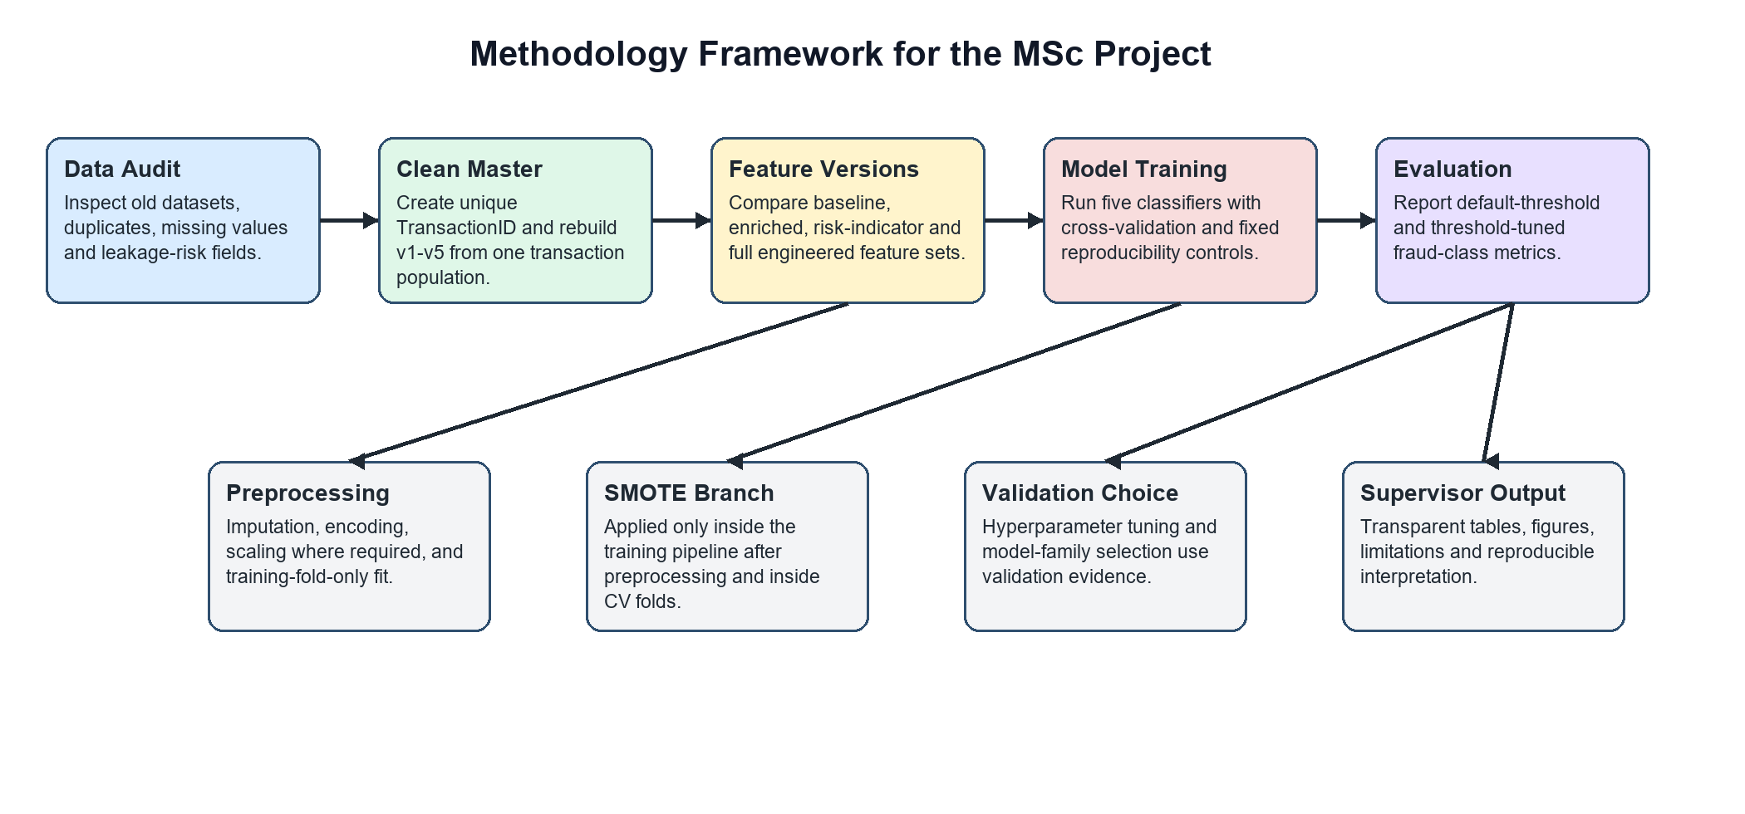
Figure 3.1: Methodology framework for the University of Ibadan MSc project.
The framework also separates the No-SMOTE and SMOTE branches so that the supervisor can see that resampling is an experimental condition inside the modelling pipeline, not a change to the underlying research population.

3.2 Dataset Generation and Description
The master dataset was data/research_master_dataset.csv. It contained 499,985 transactions, with 62,500 fraud cases and 437,485 legitimate cases. The target label was FraudFlag. Language-processing features were not present; the task was binary tabular classification.
Table 3.1: Dataset Summary
Property | Value
Dataset file | data/research_master_dataset.csv
Dataset type | Researcher-generated synthetic transaction dataset
Task | Binary tabular classification
Target label | FraudFlag
Total transactions | 499,985
Fraud transactions | 62,500
Legitimate transactions | 437,485
Fraud ratio | 12.5004%
Missing values in final datasets | 0
Exact duplicate rows in final datasets | 0
Duplicate TransactionID values in final datasets | 0
Language-processing features | Not present

3.3 Dataset Cleaning and Validation
The cleaning process is central to the defensibility of the study. The raw merged provenance file contained 849,999 rows and 350,014 exact duplicate rows. The cleaned master dataset retained 499,985 unique transaction records. The raw merged file is discussed only as provenance and was not treated as an additional experimental dataset.
The deterministic TransactionID was used for uniqueness and overlap checks. It was excluded from model features so that the model could not learn from an identifier. FraudFlag was used only as the target label and was also excluded from the feature matrix.
The raw merged provenance file had 849,999 rows and 350,014 exact duplicate rows. It was not used as an additional main experiment. The final datasets had zero missing values, zero exact duplicate rows, and zero duplicate TransactionID values.

3.4 Dataset Versioning Strategy
The five versions were designed to be progressively feature-rich while retaining the same transaction population. This improved experimental control because model changes could be interpreted in relation to feature availability.
Table 3.2: Dataset Versions
Version | Rows | Columns | Added Feature Group | Purpose
v1 | 499,985 | 8 | Baseline transaction, categorical, and time fields | Baseline comparator
v2 | 499,985 | 11 | High-amount flag, night-transaction flag, subcategory | Assess simple risk indicators
v3 | 499,985 | 13 | Merchant-risk and card-risk indicators | Assess proxy risk enrichment
v4 | 499,985 | 21 | Amount and time engineered features | Assess advanced engineered predictors
v5 | 499,985 | 23 | Night-high-amount flag and composite risk score | Assess full engineered feature set

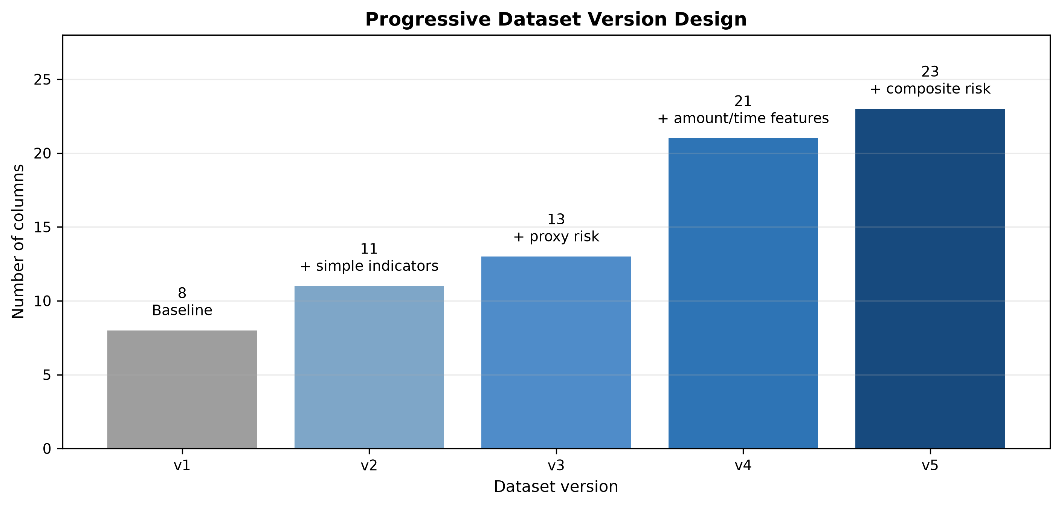
Figure 3.2: Progressive dataset version design from v1 to v5.

3.5 Feature Engineering
The v1 dataset contained baseline transaction fields. Version v2 added high-amount, night-transaction, and subcategory indicators. Version v3 introduced MerchantRisk and CardRisk. Version v4 added amount and time engineered variables, including amount-log, category-relative amount measures, and amount percentile. Version v5 added NightHighAmountFlag and RiskScoreComposite.
Distribution-dependent engineered variables were recomputed inside the modelling pipeline using training-fold information. This is important because full-dataset quantiles, medians, z-scores, and percentiles can leak held-out distribution information into validation or test evaluation if computed before splitting.
The feature engineering strategy introduced high-amount flags, night transaction indicators, subcategory information, merchant and card proxy risk indicators, amount transformations, time-derived features, and composite risk scores. MerchantRisk and CardRisk were treated cautiously because they may be target-proximal proxy features.

3.6 Data Preprocessing
The implemented pipeline used a FrequencyEncoder for categorical variables in tree-based models. This encoder was fitted only on training data inside cross-validation folds, reducing the risk that validation or test category frequencies leaked into training.
For Logistic Regression, categorical variables were one-hot encoded and numeric variables were scaled. For tree-based models and XGBoost, categorical variables were frequency encoded and numeric variables were imputed without scaling. CatBoost used the repository's CatBoost-specific fitting workflow and leakage-safe feature engineering before fitting and prediction.
Logistic Regression used imputation, one-hot encoding, and numeric scaling. Decision Tree, Random Forest, and XGBoost used imputation and frequency encoding for categorical variables. CatBoost followed the repository implementation, with preprocessing and feature handling integrated according to the final pipeline.

3.7 Train/Validation/Test Split
The split was stratified at a 60/20/20 ratio. The training set contained 299,991 records, the validation set contained 99,997 records, and the test set contained 99,997 records. Model selection used the validation split, while final reporting used the untouched test split.

3.8 Class Imbalance Handling with SMOTE
In the repository implementation, SMOTE used random_state=42 and k_neighbors=5. It was placed after preprocessing inside the imblearn pipeline. This placement matters because applying SMOTE before splitting would allow synthetic minority examples to influence validation or test data and would weaken the reported performance estimates.
SMOTE was applied only inside the imblearn training pipeline, after preprocessing and inside cross-validation folds. It was not applied before the train-validation-test split.

3.9 Machine Learning Algorithms

3.9.1 Logistic Regression
Logistic Regression served as a linear baseline for tabular fraud classification.

3.9.2 Decision Tree
Decision Tree models created rule-based splits over preprocessed transaction features.

3.9.3 Random Forest
Random Forest used an ensemble of decision trees to reduce variance and capture nonlinear feature interactions.

3.9.4 XGBoost
XGBoost used gradient-boosted decision trees and was evaluated as a strong tabular classifier.

3.9.5 CatBoost
CatBoost was evaluated because of its suitability for datasets containing categorical variables and nonlinear relationships.

3.10 Justification for Model Selection
The selected algorithms were chosen to give a defensible range of model families rather than to favour one method in advance. Logistic Regression was included as a transparent linear baseline. It helps establish whether the engineered features are separable under a simple decision surface before more flexible methods are considered.
Decision Tree was included because it provides an interpretable nonlinear rule-based learner. In a fraud-detection project, a tree model is useful for showing whether simple transaction thresholds and feature interactions can explain part of the classification problem.
Random Forest was selected because ensemble trees reduce the instability of a single decision tree and are commonly strong on heterogeneous tabular data. It is also suitable for comparing feature-rich versions because it can capture nonlinear interactions among amount, merchant, card, location, and time-derived variables.
XGBoost was selected as a regularized gradient-boosting method that often performs strongly on structured tabular classification tasks. Its inclusion provides a high-performance boosting benchmark against Random Forest and CatBoost.
CatBoost was selected because the datasets contain categorical variables and CatBoost is designed to handle categorical information effectively. In this study it is treated as one candidate model family within the same validation protocol, not as an automatically superior method.
Together, the five models provide a balanced comparison across linear baseline, interpretable tree, bagged ensemble, gradient boosting, and categorical boosting approaches. This design strengthens MSc-level methodological defensibility because the final result is not based on a single unchallenged algorithm.

3.11 Hyperparameter Tuning
The repository used randomized hyperparameter search with StratifiedKFold cross-validation. The cross-validation folds were created only from the training split. Average precision was used as the tuning objective, while final model-family selection used validation fraud-class F1 with documented tolerance-based tie-breaking.
Hyperparameter tuning used 5-fold cross-validation on the training split, with PR-AUC implemented as average precision as the tuning metric.

3.12 Threshold Optimization
Threshold tuning used validation predictions to search probability thresholds from 0.10 to 0.90 in steps of 0.01. The selected threshold was then evaluated on the untouched test predictions. This procedure prevents choosing the threshold directly on the test set.
Threshold optimization selected probability cutoffs on validation predictions and then evaluated the selected cutoffs on test predictions.

3.13 Evaluation Metrics
The study reported fraud precision, fraud recall, fraud-class F1, ROC-AUC, and PR-AUC. Fraud-class F1 and PR-AUC were emphasized because the problem was imbalanced.

3.14 Experimental Pipeline
The complete workflow is shown in Figure 3.3. It includes dataset preparation, feature versioning, preprocessing, cross-validated tuning, validation selection, test evaluation, SMOTE comparison, and threshold tuning.
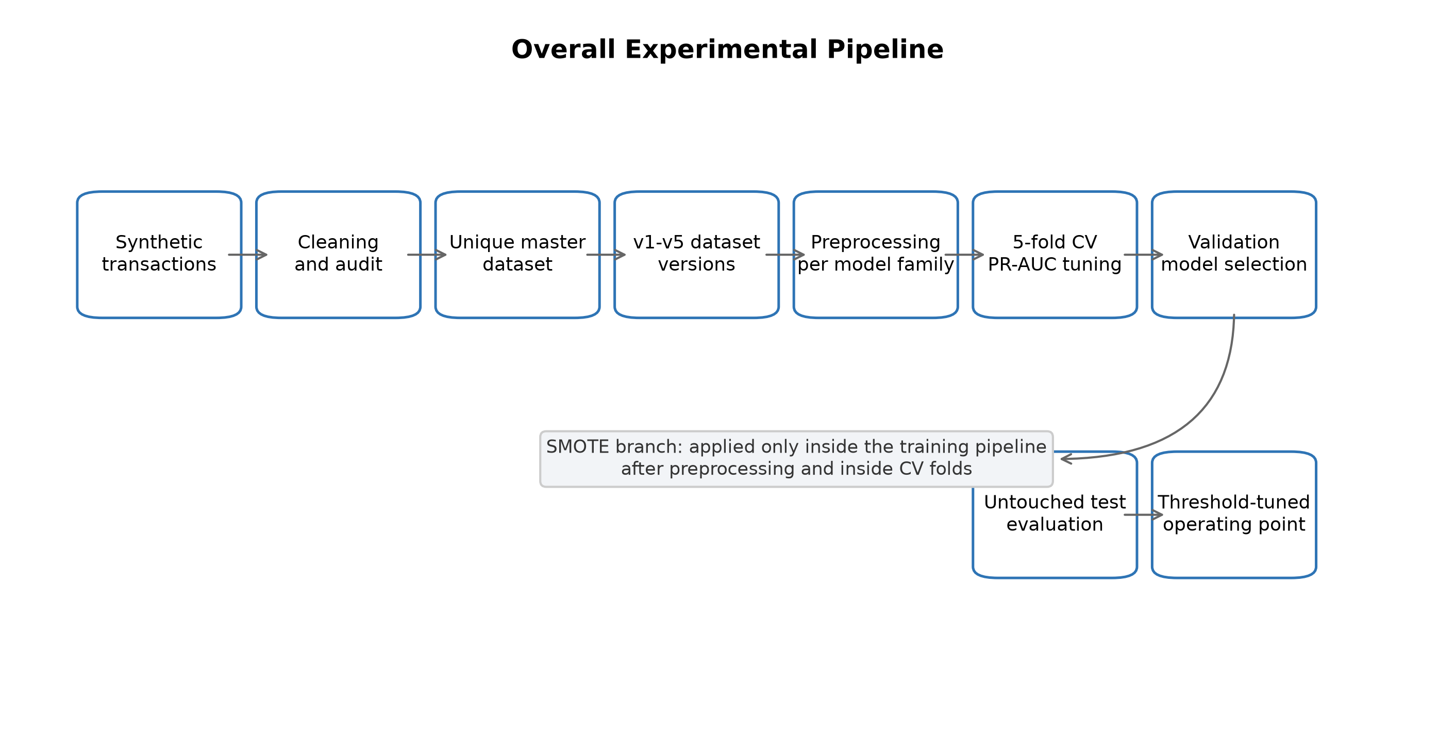
Figure 3.3: Experimental pipeline for dataset preparation, model tuning, evaluation, SMOTE comparison, and threshold optimization.

Table 3.3: Experimental Configuration
Component | Configuration
Split strategy | Stratified train/validation/test split
Split ratio | 60/20/20
Training records | 299,991
Validation records | 99,997
Test records | 99,997
Cross-validation | 5-fold CV on training split
Hyperparameter tuning metric | PR-AUC / average precision
Model-family selection | Validation split
Final reporting | Untouched test split
SMOTE placement | Inside imblearn pipeline, after preprocessing, inside CV folds
Excluded model features | FraudFlag, TransactionID, Time, DayOfWeek, Month, IsWeekend, IsWeekendDerived

3.15 Tools and Software
The repository used Python scripts for dataset generation, validation, model training, threshold tuning, and reporting. The active scripts included scripts/generate_all_versions.py, scripts/ml_pipeline_core.py, and scripts/run_experiments_standard.py.

3.16 Ethical Considerations
The study used synthetic transaction data and did not use personally identifiable customer information or live bank records.

3.17 Reproducibility Measures
Reproducibility was strengthened by using a fixed random state of 42, deterministic TransactionID generation, saved validation and test predictions, documented model-selection rules, and archived result summaries. The analysis still requires repeated-seed experiments before strong statistical claims can be made.
Reproducibility was supported through deterministic dataset files, synthetic TransactionID values, fixed dataset summaries, validation outputs, saved prediction files, and documented audit reports.

CHAPTER FOUR: RESULTS AND DISCUSSION

4.1 Introduction
This chapter presents dataset audit results, class distribution, model performance under No-SMOTE and SMOTE settings, threshold optimization, feature importance, and answers to the research questions.

4.2 Dataset Audit Results
The final datasets passed validation checks for missing values, duplicate rows, and duplicate TransactionID values. The cleaned master dataset contained 499,985 unique transactions.

4.3 Class Distribution
The final class distribution consisted of 437,485 legitimate transactions and 62,500 fraudulent transactions.
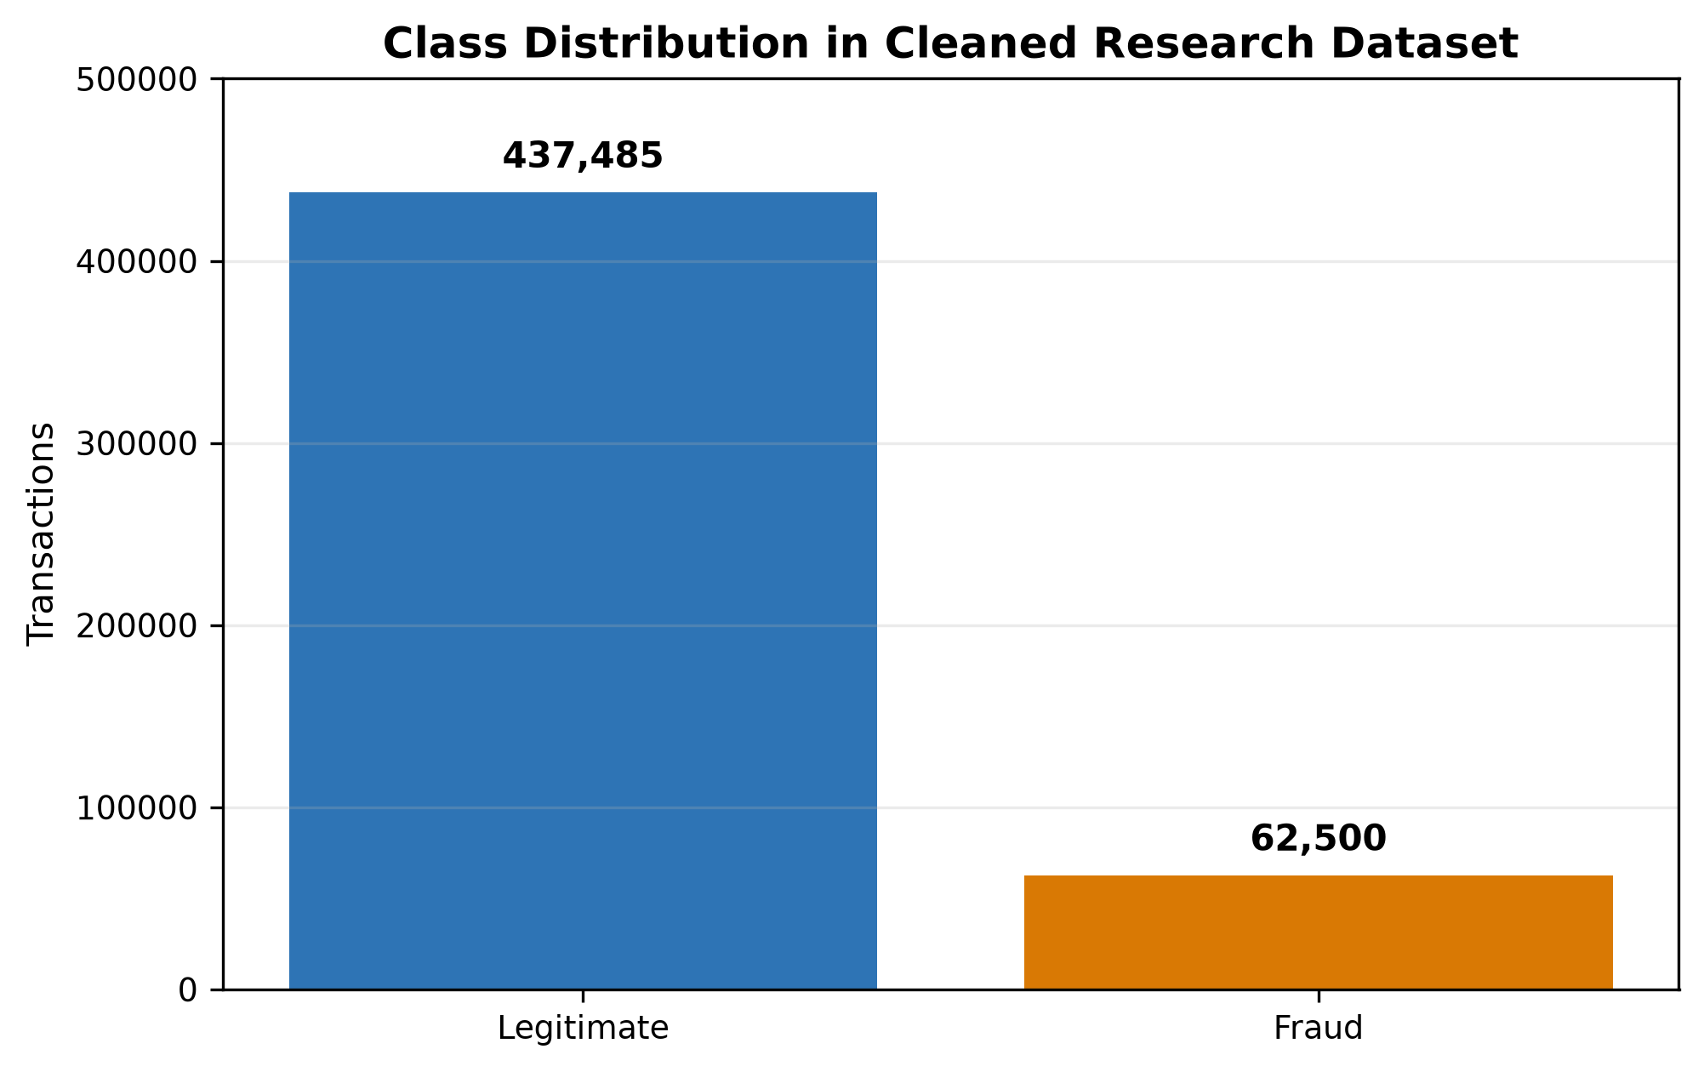
Figure 4.1: Class distribution of the cleaned synthetic transaction dataset.

4.4 Dataset Version Summary
All five versions used the same transaction population. The versions differed only by feature availability, from baseline transaction attributes in v1 to a full engineered feature set in v5.

4.5 No-SMOTE Model Results
The No-SMOTE results show that v1 and v2 produced similar fraud-class F1 scores, while v3 introduced a substantial improvement. This pattern suggests that the added merchant and card proxy risk indicators contributed strongly to predictive separation. However, because these variables may be target-proximal, the improvement should be interpreted with caution.
Table 4.1 presents the selected default-threshold No-SMOTE results. Performance improved substantially after v2, with v3-v5 outperforming v1-v2.
Table 4.1: Best Default-Threshold Results Without SMOTE
Version | Best Model | Precision | Recall | Fraud-Class F1 | PR-AUC
v1 | XGBoost | 0.8062 | 0.7502 | 0.7772 | 0.8268
v2 | XGBoost | 0.8094 | 0.7500 | 0.7786 | 0.8274
v3 | CatBoost | 0.9219 | 0.7739 | 0.8414 | 0.8558
v4 | DecisionTree | 0.9537 | 0.7678 | 0.8507 | 0.8337
v5 | RandomForest | 0.9418 | 0.7713 | 0.8480 | 0.8561

4.6 SMOTE Model Results
The SMOTE results improved default-threshold fraud-class F1 in all five versions. The improvement was not mainly a recall improvement; in several versions recall decreased while precision increased. This means that SMOTE changed the selected operating behaviour and should not be described as improving all fraud-detection outcomes.
Table 4.2 presents the selected default-threshold SMOTE results. The best default-threshold result was v3 SMOTE Random Forest, with precision 0.998525, recall 0.758080, fraud-class F1 of 0.861846, and PR-AUC of 0.855235.
Table 4.2: Best Default-Threshold Results With SMOTE
Version | Best Model | Precision | Recall | Fraud-Class F1 | PR-AUC
v1 | DecisionTree | 0.9760 | 0.7040 | 0.8180 | 0.8237
v2 | RandomForest | 0.9527 | 0.7153 | 0.8171 | 0.8265
v3 | RandomForest | 0.9985 | 0.7581 | 0.8618 | 0.8552
v4 | CatBoost | 0.9998 | 0.7570 | 0.8616 | 0.8564
v5 | CatBoost | 0.9999 | 0.7571 | 0.8617 | 0.8558

4.7 Comparative Analysis of No-SMOTE and SMOTE Results
A stronger interpretation is that SMOTE was useful under the default 0.50 decision threshold, but its advantage was partly a threshold artefact. This is why the study reports a separate threshold-tuned analysis rather than stopping at default-threshold results.
SMOTE improved default-threshold fraud-class F1 across all five dataset versions. However, it did not improve recall in every selected model, showing that resampling affected the precision-recall trade-off rather than improving all metrics simultaneously.
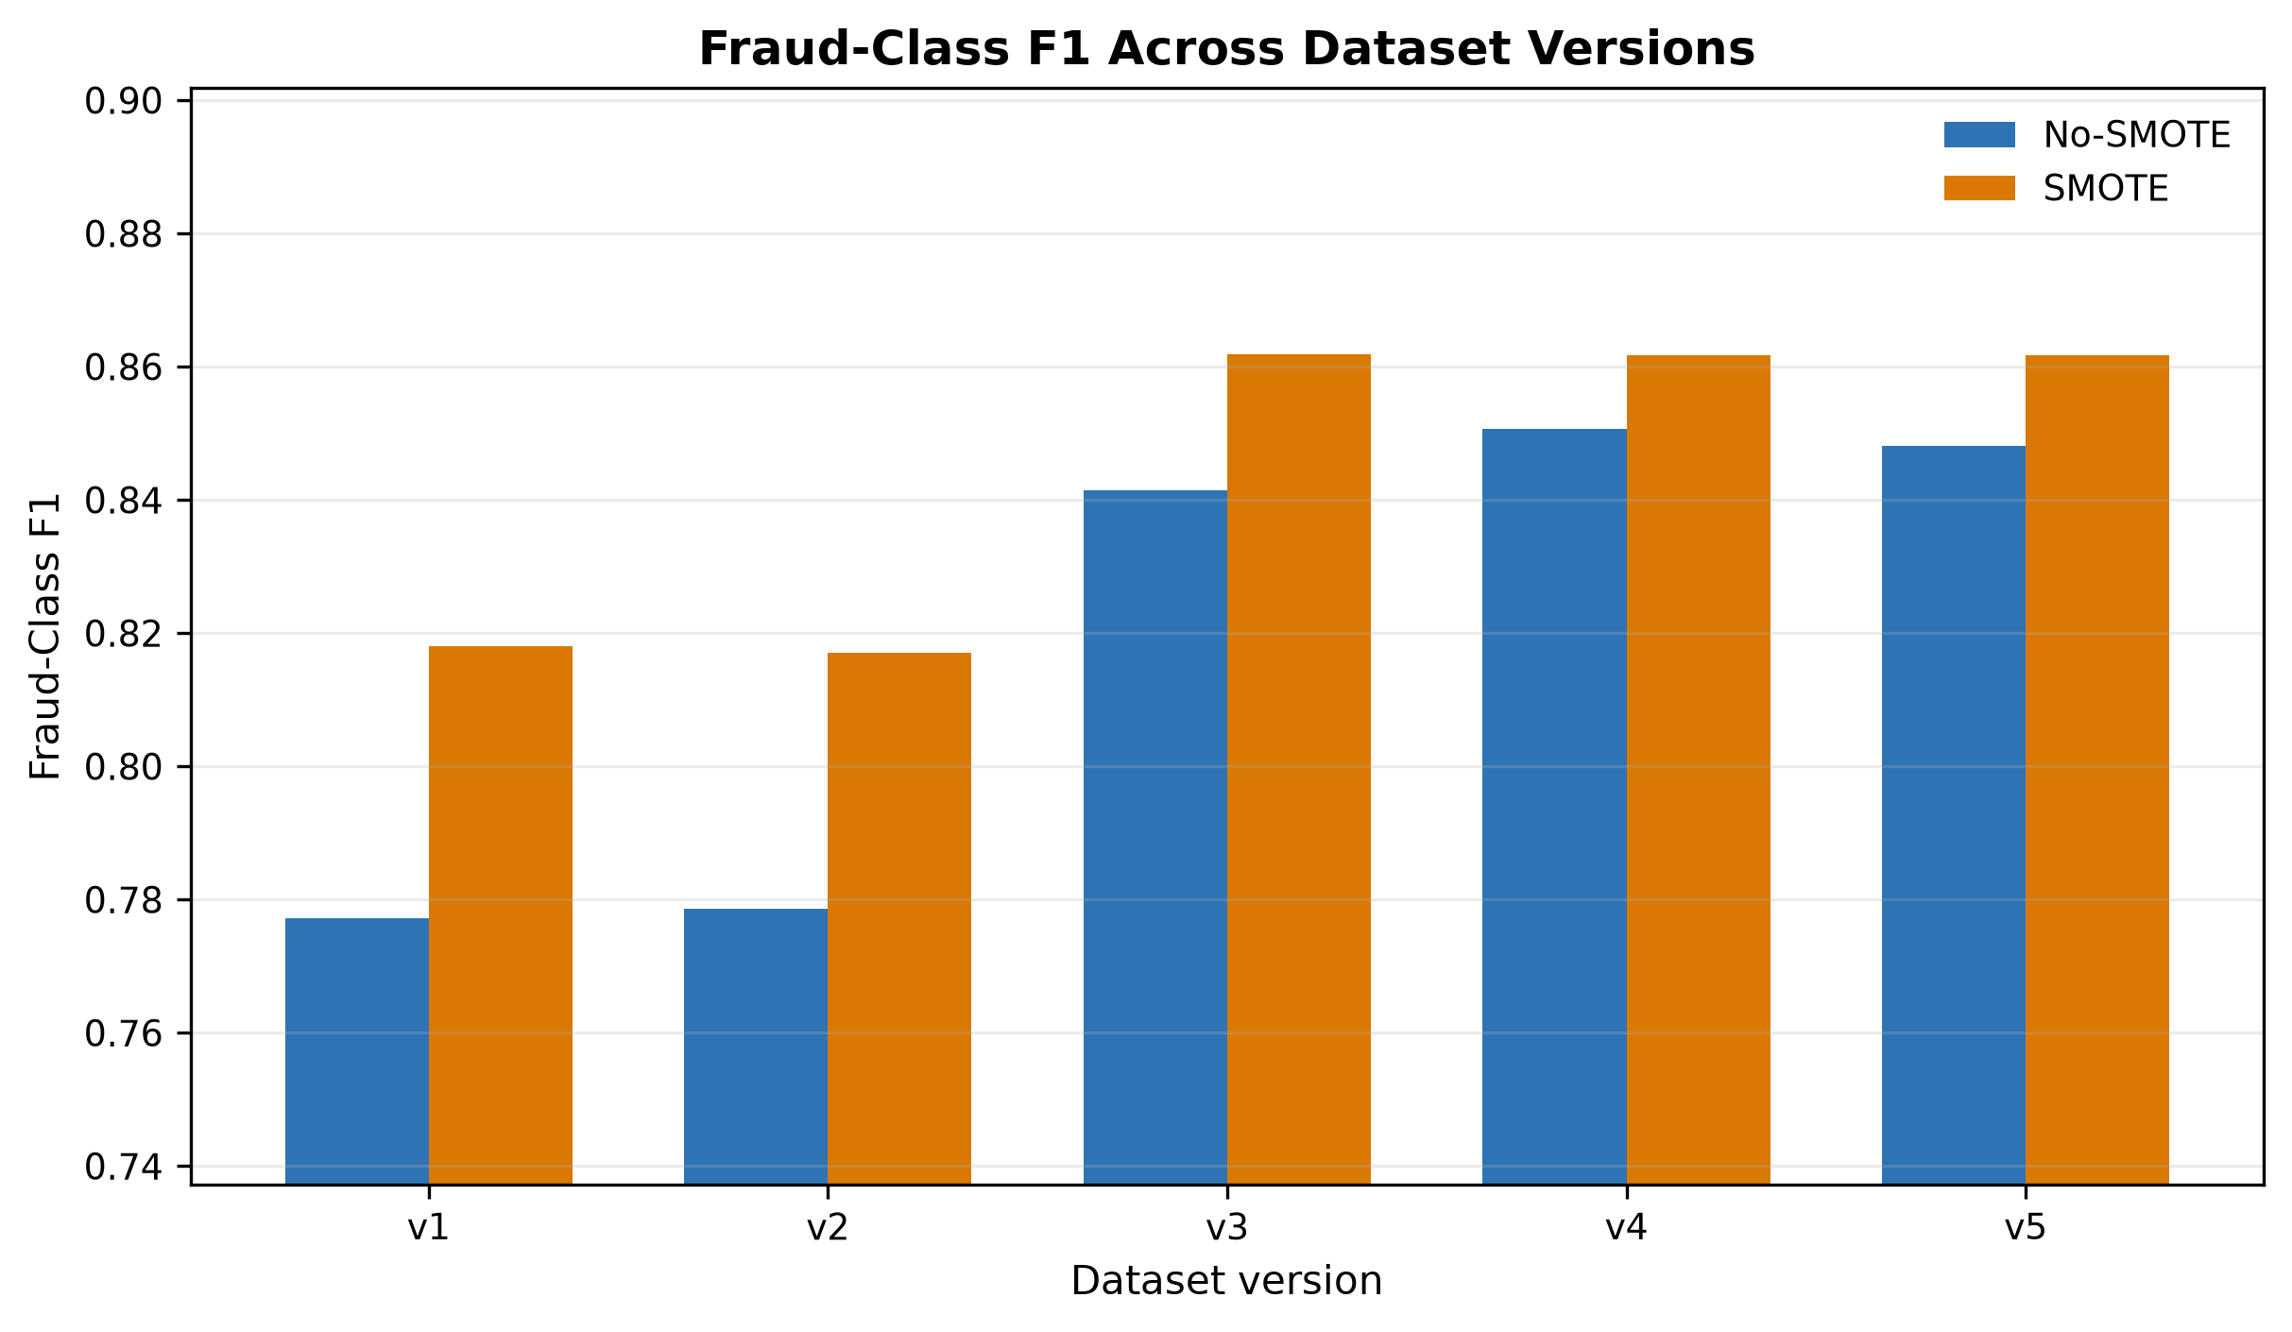
Figure 4.2: Fraud-class F1 comparison between No-SMOTE and SMOTE results.
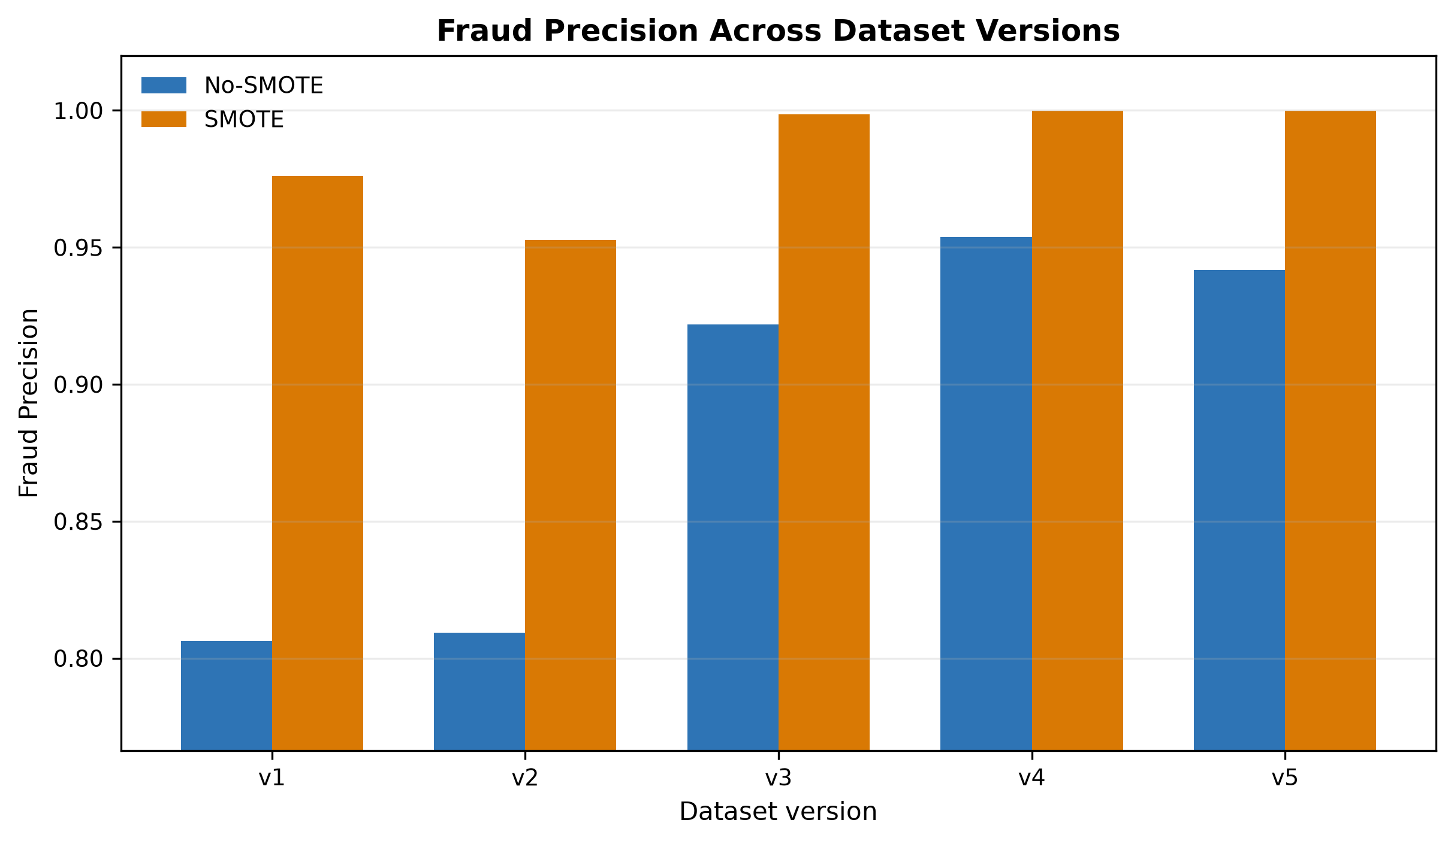
Figure 4.3: Fraud precision comparison between No-SMOTE and SMOTE results.
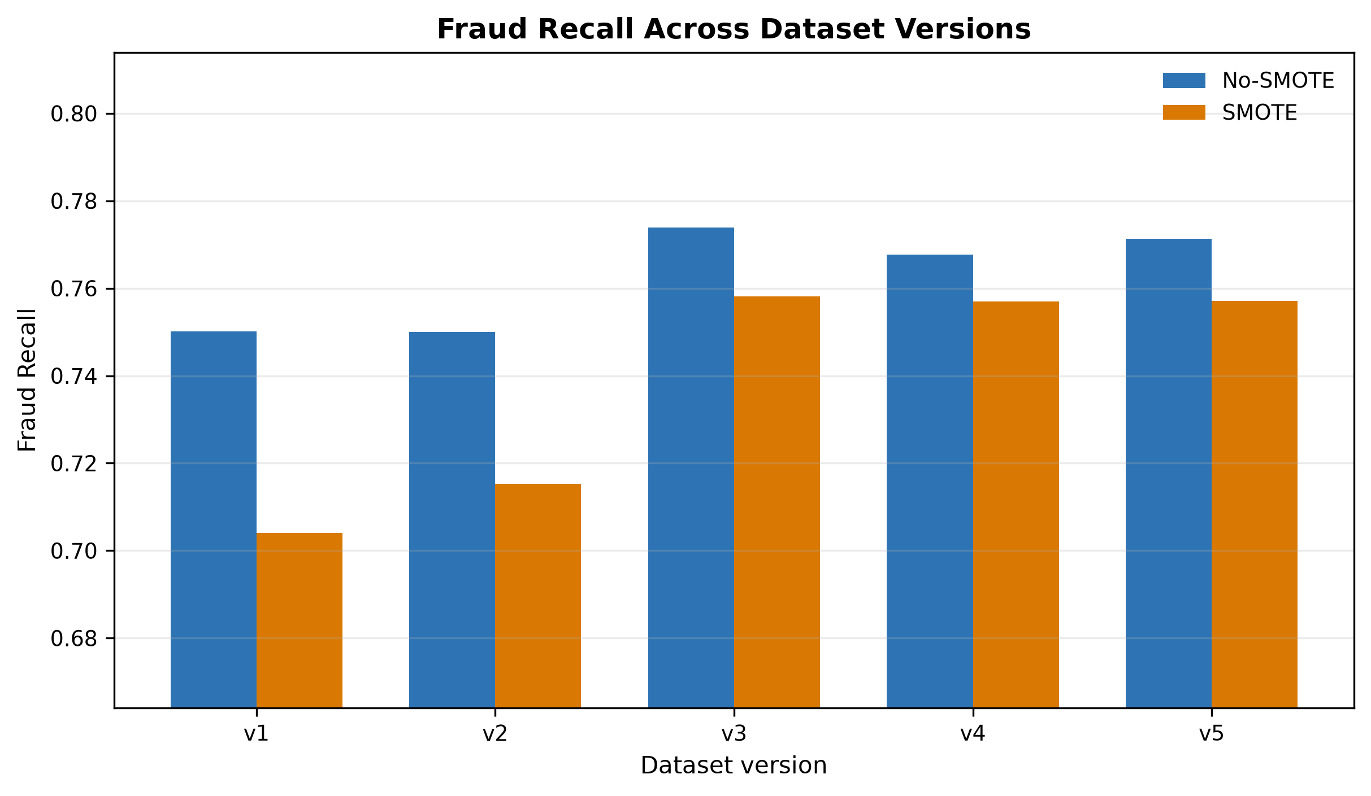
Figure 4.4: Fraud recall comparison between No-SMOTE and SMOTE results.
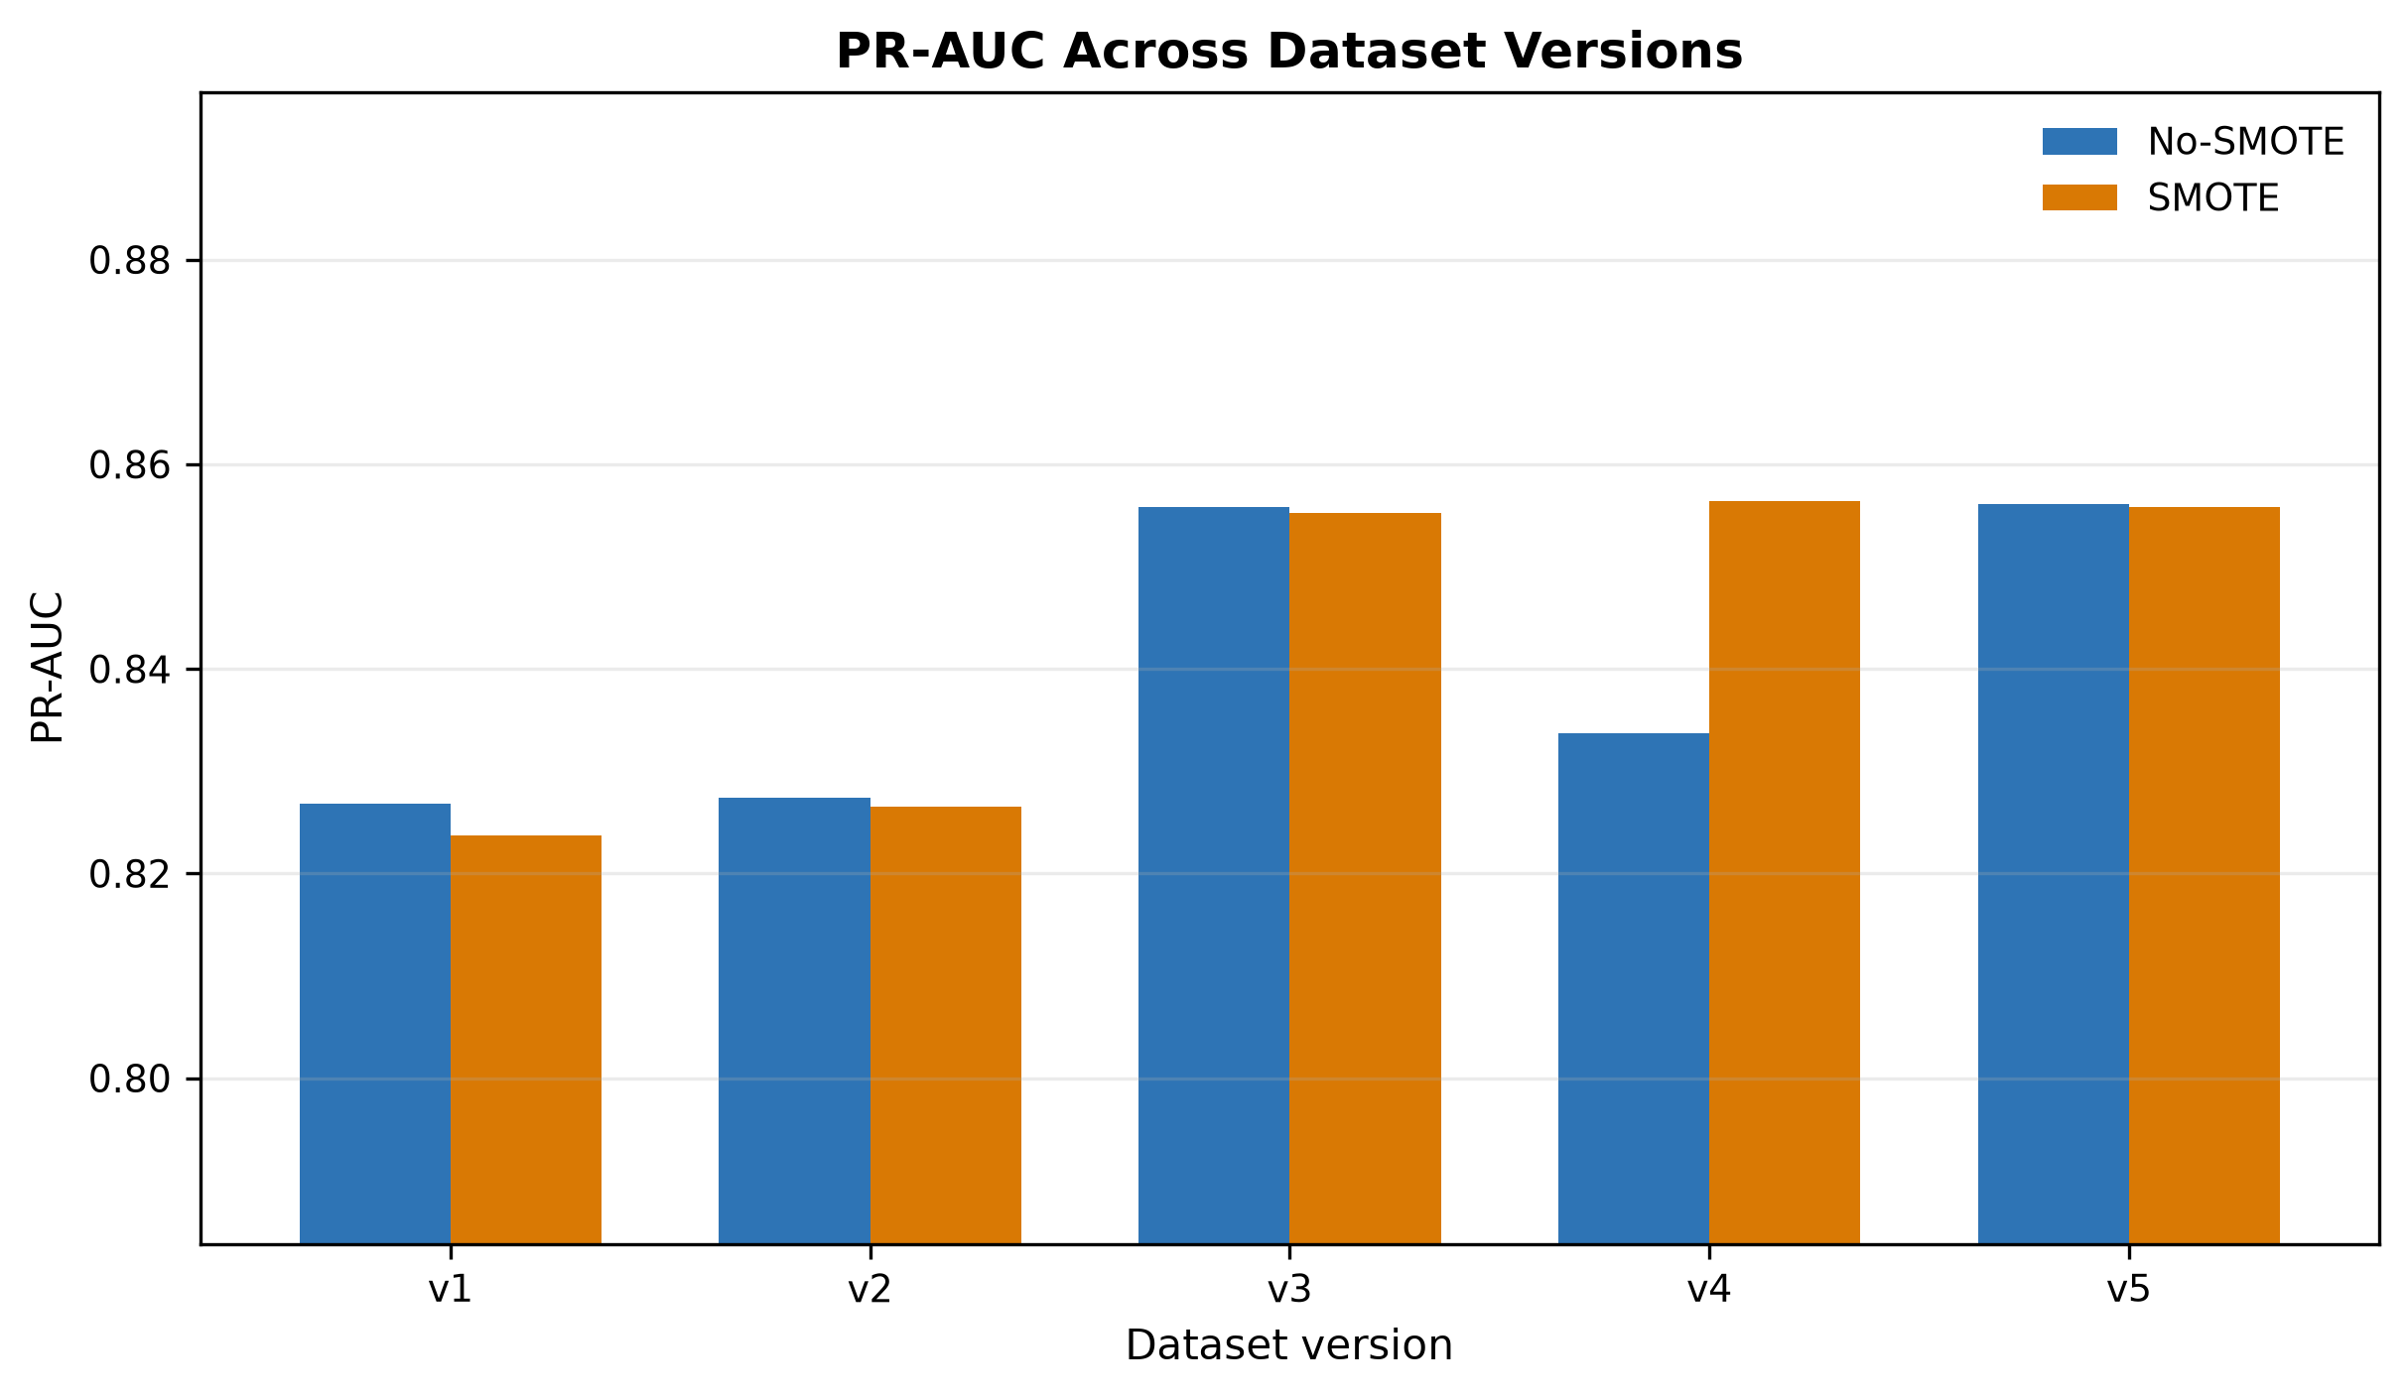
Figure 4.5: PR-AUC comparison between No-SMOTE and SMOTE results.

4.8 Impact of Progressive Feature Engineering
The largest performance gain occurred from v2 to v3, when merchant and card proxy risk indicators were introduced. The strongest v3-v5 results were practically close, so small differences should not be overstated without repeated-seed or uncertainty analysis.

4.9 Threshold Optimization Results
The threshold-tuned results show that the strongest No-SMOTE and SMOTE settings were nearly tied. For example, v5 No-SMOTE Random Forest achieved F1 0.862030, while the strongest SMOTE-tuned alternatives were within a very small margin. Differences below 0.001 should therefore be treated as practically small in the absence of confidence intervals.
Table 4.3 presents the threshold-tuned results. Threshold tuning largely removed the practical advantage of SMOTE, with the strongest tuned F1 values differing by less than 0.001.

Table 4.3: Threshold-Tuned Results
Version | No-SMOTE Model | No-SMOTE Threshold | No-SMOTE F1 | SMOTE Model | SMOTE Threshold | SMOTE F1
v1 | RandomForest | 0.80 | 0.819141 | CatBoost | 0.44 | 0.818983
v2 | XGBoost | 0.83 | 0.818759 | XGBoost | 0.43 | 0.818828
v3 | XGBoost | 0.82 | 0.861660 | XGBoost | 0.51 | 0.861611
v4 | DecisionTree | 0.76 | 0.861826 | XGBoost | 0.47 | 0.861443
v5 | RandomForest | 0.80 | 0.862030 | XGBoost | 0.45 | 0.861520

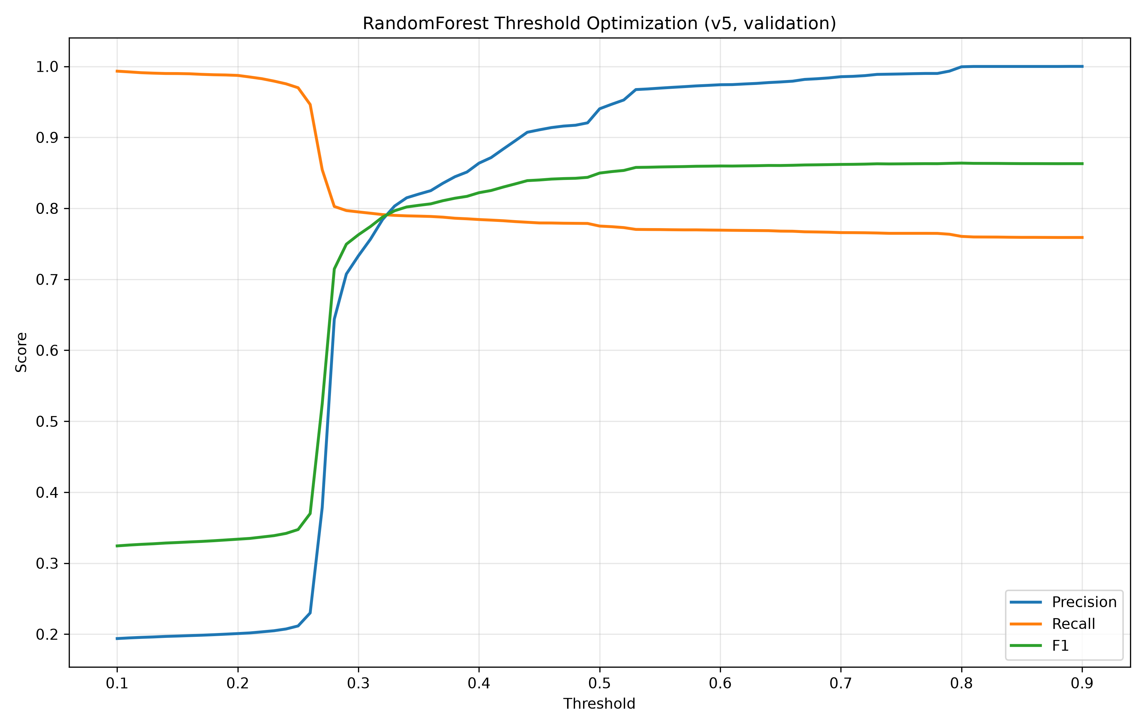
Figure 4.6: Threshold optimization curve for the v5 No-SMOTE Random Forest model.

4.10 Best Model Analysis
At threshold 0.80, the selected v5 No-SMOTE Random Forest produced 87,489 true negatives, 8 false positives, 3,025 false negatives, and 9,475 true positives on the test split. This operating point was highly precise but still missed a meaningful number of fraudulent transactions, so it should not be described as detecting every fraudulent transaction.
The best threshold-tuned operating point was v5 No-SMOTE Random Forest at threshold 0.80, with precision 0.999156, recall 0.758000, and fraud-class F1 of 0.862030. This value was only marginally higher than other strong tuned results.
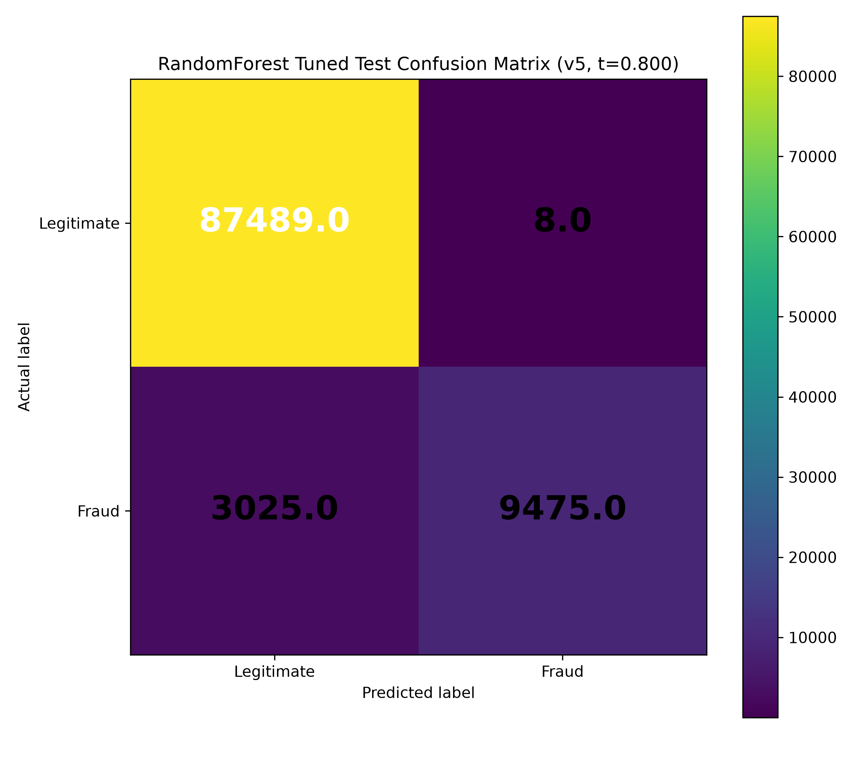
Figure 4.7: Tuned test confusion matrix for the v5 No-SMOTE Random Forest model at threshold 0.80.

4.11 Feature Importance Analysis
The feature-importance result is useful for interpretation but has limitations. Random Forest impurity-based importance can favour continuous or high-cardinality variables and does not prove causality. A stronger future study should compare impurity importance with permutation importance or SHAP-style explanations.
The Random Forest feature-importance output suggested that amount-category interaction and merchant-related indicators were influential in the selected v5 No-SMOTE model. These importance values are model-specific and should not be interpreted as causal effects.
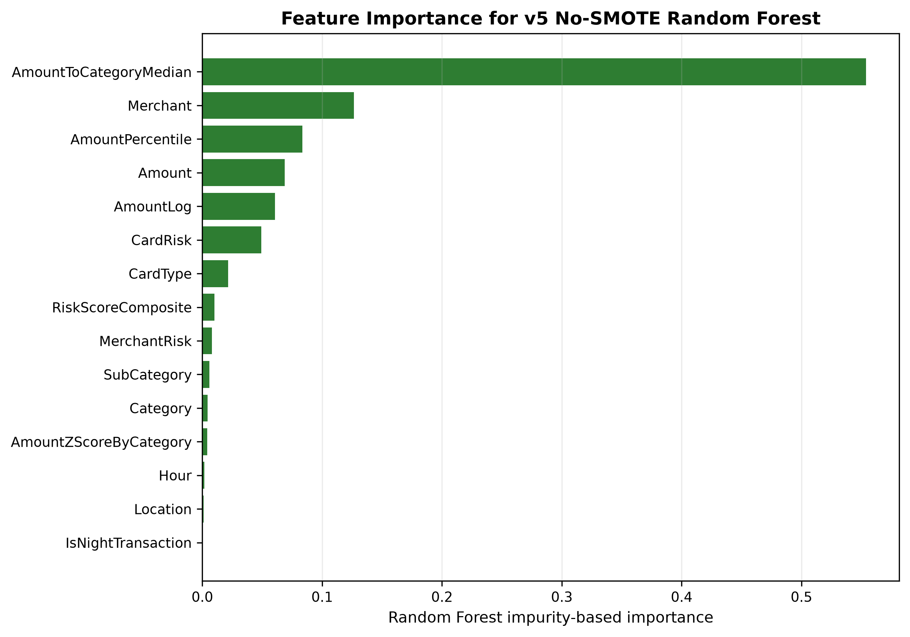
Figure 4.8: Feature importance for the selected v5 No-SMOTE Random Forest model.

4.12 Discussion of Findings
The findings are consistent with prior work showing that feature engineering and tree-based ensembles can improve fraud classification [5], [18]-[22]. They are also consistent with imbalanced-learning literature showing that resampling effects depend on the evaluation threshold and target metric [9]-[14].
The most important methodological implication is that feature enrichment, resampling, and threshold selection should be evaluated together. Reporting only one of these factors can lead to an incomplete interpretation of fraud-detection performance.
The results show that feature engineering was a major driver of model performance. Tree-based models dominated the strongest results because they can capture nonlinear interactions in heterogeneous tabular data. The SMOTE comparison also showed that resampling conclusions depend on the threshold used for classification.

4.13 Answering the Research Questions
First, progressive feature engineering improved fraud-class performance, especially from v2 to v3. Second, SMOTE improved default-threshold fraud-class F1. Third, threshold optimization made No-SMOTE and SMOTE results practically close. Fourth, Random Forest, CatBoost, and XGBoost dominated the strongest results. Fifth, interpretation is limited by synthetic data, proxy risk indicators, and absence of external validation.

4.14 Summary of Findings

Table 4.4: Key Findings Summary
Finding | Evidence | Interpretation
Progressive feature engineering improves fraud-class performance | v3-v5 outperform v1-v2 in fraud-class F1 | Feature enrichment changes minority-class separability.
SMOTE improves default-threshold fraud-class F1 | SMOTE selected models outperform no-SMOTE selected models in all five versions | The benefit is threshold-dependent.
Threshold tuning removes most practical SMOTE advantage | Best tuned F1 values differ by less than 0.001 across setups | Operating-point selection is central to deployment interpretation.
Tree-based methods dominate | Random Forest, XGBoost, CatBoost, and Decision Tree are selected in final best-model summaries | Nonlinear tabular interactions are important in this dataset.
Logistic Regression underperforms | No final best model is Logistic Regression | Linear baseline is less competitive for the engineered feature space.
Strongest versions are practically close | v3-v5 default and tuned results are close | Do not overstate the small differences among v3-v5.
External validity is limited | No external validation dataset is present | Results apply to the synthetic transaction dataset only.

Overall, the evidence supports a cautious conclusion that a reproducible tabular pipeline with progressive feature engineering can improve fraud-class detection on this synthetic dataset.

CHAPTER FIVE: CONCLUSION AND RECOMMENDATIONS

5.1 Summary of the Study
The study prepared a cleaned synthetic credit card transaction dataset, generated five progressively enriched dataset versions, trained five model families, compared No-SMOTE and SMOTE settings, and evaluated default-threshold and threshold-tuned performance.

5.2 Conclusion
Progressive feature engineering improved fraud-class performance on the synthetic transaction dataset. The strongest default-threshold result was v3 SMOTE Random Forest, while the strongest threshold-tuned operating point was v5 No-SMOTE Random Forest. However, the strongest v3-v5 results were practically close, and the findings should be interpreted within the limitations of the dataset and experimental design.

5.3 Contributions of the Study
1. A cleaned and reproducible master dataset workflow for fraud detection research.
2. A five-version feature engineering design using the same transaction population.
3. A controlled comparison of No-SMOTE and SMOTE training settings.
4. A threshold-tuned evaluation showing the importance of operating-point selection.
5. A transparent discussion of leakage-risk features and external-validity limits.

5.4 Recommendations
Before adapting the work for IEEE publication, the student should run repeated-seed experiments, compute confidence intervals or bootstrap uncertainty estimates, and consider an ablation study that removes MerchantRisk and CardRisk. These additions would directly address the strongest likely reviewer objections.
Future project work should add repeated-seed experiments, confidence intervals, and independent validation data. It should also document the construction and availability of MerchantRisk and CardRisk before considering those indicators for practical use.

5.5 Limitations Revisited
The main limitations remain the synthetic dataset, absence of external validation, possible proxy-feature leakage, static offline split, and lack of statistical uncertainty estimates.

5.6 Suggestions for Future Research
Future research should also compare threshold selection under explicit false-positive and false-negative cost assumptions. In fraud detection, a model with very high precision but moderate recall may be appropriate in one operational context but unsuitable in another.
Future research should evaluate the pipeline on independent transaction datasets, compare additional imbalance strategies, test cost-sensitive thresholds, and apply robust interpretability methods beyond impurity-based feature importance.

REFERENCES
[1] R. J. Bolton and D. J. Hand, "Statistical fraud detection: A review," Statistical Science, vol. 17, no. 3, pp. 235-255, 2002, doi: 10.1214/ss/1042727940.
[2] E. W. T. Ngai, Y. Hu, Y. H. Wong, Y. Chen, and X. Sun, "The application of data mining techniques in financial fraud detection: A classification framework and an academic review of literature," Decision Support Systems, vol. 50, no. 3, pp. 559-569, 2011, doi: 10.1016/j.dss.2010.08.006.
[3] S. Bhattacharyya, S. Jha, K. Tharakunnel, and J. C. Westland, "Data mining for credit card fraud: A comparative study," Decision Support Systems, vol. 50, no. 3, pp. 602-613, 2011, doi: 10.1016/j.dss.2010.08.008.
[4] C. Whitrow, D. J. Hand, P. Juszczak, D. Weston, and N. M. Adams, "Transaction aggregation as a strategy for credit card fraud detection," Data Mining and Knowledge Discovery, vol. 18, no. 1, pp. 30-55, 2009, doi: 10.1007/s10618-008-0116-z.
[5] A. C. Bahnsen, D. Aouada, A. Stojanovic, and B. Ottersten, "Feature engineering strategies for credit card fraud detection," Expert Systems with Applications, vol. 51, pp. 134-142, 2016, doi: 10.1016/j.eswa.2015.12.030.
[6] A. Dal Pozzolo, O. Caelen, R. A. Johnson, and G. Bontempi, "Calibrating probability with undersampling for unbalanced classification," in Proc. IEEE Symposium Series on Computational Intelligence, 2015.
[7] J. Jurgovsky et al., "Sequence classification for credit-card fraud detection," Expert Systems with Applications, vol. 100, pp. 234-245, 2018, doi: 10.1016/j.eswa.2018.01.037.
[8] C. Phua, V. Lee, K. Smith, and R. Gayler, "A comprehensive survey of data mining-based fraud detection research," arXiv:1009.6119, 2010.
[9] N. V. Chawla, K. W. Bowyer, L. O. Hall, and W. P. Kegelmeyer, "SMOTE: Synthetic minority over-sampling technique," Journal of Artificial Intelligence Research, vol. 16, pp. 321-357, 2002, doi: 10.1613/jair.953.
[10] H. He and E. A. Garcia, "Learning from imbalanced data," IEEE Transactions on Knowledge and Data Engineering, vol. 21, no. 9, pp. 1263-1284, 2009, doi: 10.1109/TKDE.2008.239.
[11] N. Japkowicz and S. Stephen, "The class imbalance problem: A systematic study," Intelligent Data Analysis, vol. 6, no. 5, pp. 429-449, 2002.
[12] M. Galar, A. Fernandez, E. Barrenechea, H. Bustince, and F. Herrera, "A review on ensembles for the class imbalance problem: Bagging-, boosting-, and hybrid-based approaches," IEEE Transactions on Systems, Man, and Cybernetics, Part C, vol. 42, no. 4, pp. 463-484, 2012, doi: 10.1109/TSMCC.2011.2161285.
[13] P. Branco, L. Torgo, and R. P. Ribeiro, "A survey of predictive modeling on imbalanced domains," ACM Computing Surveys, vol. 49, no. 2, pp. 1-50, 2016, doi: 10.1145/2907070.
[14] C. Elkan, "The foundations of cost-sensitive learning," in Proc. International Joint Conference on Artificial Intelligence, 2001, pp. 973-978.
[15] J. Davis and M. Goadrich, "The relationship between Precision-Recall and ROC curves," in Proc. International Conference on Machine Learning, 2006, pp. 233-240, doi: 10.1145/1143844.1143874.
[16] T. Saito and M. Rehmsmeier, "The precision-recall plot is more informative than the ROC plot when evaluating binary classifiers on imbalanced datasets," PLOS ONE, vol. 10, no. 3, 2015, doi: 10.1371/journal.pone.0118432.
[17] T. Fawcett, "An introduction to ROC analysis," Pattern Recognition Letters, vol. 27, no. 8, pp. 861-874, 2006, doi: 10.1016/j.patrec.2005.10.010.
[18] L. Breiman, "Random forests," Machine Learning, vol. 45, no. 1, pp. 5-32, 2001, doi: 10.1023/A:1010933404324.
[19] J. R. Quinlan, "Induction of decision trees," Machine Learning, vol. 1, no. 1, pp. 81-106, 1986, doi: 10.1007/BF00116251.
[20] T. Chen and C. Guestrin, "XGBoost: A scalable tree boosting system," in Proc. ACM SIGKDD International Conference on Knowledge Discovery and Data Mining, 2016, pp. 785-794, doi: 10.1145/2939672.2939785.
[21] L. Prokhorenkova, G. Gusev, A. Vorobev, A. V. Dorogush, and A. Gulin, "CatBoost: Unbiased boosting with categorical features," in Advances in Neural Information Processing Systems, 2018.
[22] F. Pedregosa et al., "Scikit-learn: Machine learning in Python," Journal of Machine Learning Research, vol. 12, pp. 2825-2830, 2011.
[23] J. Bergstra and Y. Bengio, "Random search for hyper-parameter optimization," Journal of Machine Learning Research, vol. 13, pp. 281-305, 2012.
[24] R. Kohavi, "A study of cross-validation and bootstrap for accuracy estimation and model selection," in Proc. International Joint Conference on Artificial Intelligence, 1995, pp. 1137-1145.
[25] G. C. Cawley and N. L. C. Talbot, "On over-fitting in model selection and subsequent selection bias in performance evaluation," Journal of Machine Learning Research, vol. 11, pp. 2079-2107, 2010.
[26] S. Varma and R. Simon, "Bias in error estimation when using cross-validation for model selection," BMC Bioinformatics, vol. 7, article 91, 2006, doi: 10.1186/1471-2105-7-91.
[27] S. Kaufman, S. Rosset, C. Perlich, and O. Stitelman, "Leakage in data mining: Formulation, detection, and avoidance," ACM Transactions on Knowledge Discovery from Data, vol. 6, no. 4, pp. 1-21, 2012, doi: 10.1145/2382577.2382579.
[28] S. Kapoor and A. Narayanan, "Leakage and the reproducibility crisis in machine-learning-based science," Patterns, vol. 4, no. 9, 2023, doi: 10.1016/j.patter.2023.100804.
[29] I. Guyon and A. Elisseeff, "An introduction to variable and feature selection," Journal of Machine Learning Research, vol. 3, pp. 1157-1182, 2003.
[30] M. Kuhn and K. Johnson, Applied Predictive Modeling. New York, NY, USA: Springer, 2013.

APPENDICES

Appendix A: Dataset Audit Summary
The final master dataset contained 499,985 unique records after removing exact duplicate rows from the raw merged provenance file. The final datasets had zero missing values, zero exact duplicate rows, and zero duplicate TransactionID values.

Appendix B: Experimental Configuration
The experiment used stratified 60/20/20 splitting, 5-fold cross-validation on the training split, PR-AUC tuning, validation-based model selection, untouched test reporting, and threshold optimization based on validation predictions.

Appendix C: Full Result Summary
The selected No-SMOTE, SMOTE, and threshold-tuned results are summarized in Tables 4.1 through 4.3. The strongest default-threshold result was v3 SMOTE Random Forest, and the strongest tuned operating point was v5 No-SMOTE Random Forest.

Appendix D: Reproducibility Notes
The final datasets, result summaries, figures, and audit reports were generated from the active research-clean repository evidence. Legacy scripts and stale result folders were excluded from the final methodology.

Appendix E: Supervisor Review Notes
This section is reserved for comments, corrections, and guidance from the supervisor during review.

Appendix F: Supervisor Approval Questions and Responses
The questions below represent issues a typical MSc supervisor may raise before allowing final submission. The manuscript answers them in the indicated chapters and sections.
Table F.1: Supervisor Questions and Manuscript Responses
Supervisor Question | Response Included in Manuscript | Primary Location
Why is the work not titled as language-oriented fraud analysis? | The dataset contains structured transaction attributes and no language-processing features; the title and scope now state tabular fraud classification. | Title/Ch. 1
What is the dataset source? | The methodology identifies the dataset as researcher-generated synthetic credit-card transaction data and avoids external deployment claims. | Ch. 3
Why are v1-v5 compared? | The dataset-versioning section explains that all versions share one cleaned master population and differ by progressive feature richness. | Ch. 3
How was duplication handled? | The dataset cleaning section states exact duplicate removal and use of deterministic TransactionID uniqueness checks. | Ch. 3
How is leakage controlled? | The methodology explains excluded columns, training-fold-only encoders, distribution-dependent feature handling, and SMOTE placement. | Ch. 3
Why these five models? | The new model-selection subsection explains baseline, interpretability, ensemble, boosting, and categorical-feature rationales. | Ch. 3
Why use SMOTE? | The SMOTE subsection explains imbalance motivation and why SMOTE is applied only inside the training pipeline. | Ch. 3/4
Why emphasize F1 and PR-AUC? | The evaluation section and literature review explain that minority-class metrics are more informative than accuracy alone. | Ch. 2/3
What is the best result? | Chapter 4 reports the strongest default-threshold and threshold-tuned results without changing metrics. | Ch. 4
Can the results be generalized to banks? | The scope, limitations, and discussion state that external validation is absent and operational deployment is not claimed. | Ch. 1/5
What is the main contribution? | Chapter 5 states the reproducible clean-master workflow, progressive feature design, SMOTE comparison, and threshold-tuned evaluation. | Ch. 5
What remains for publication? | The recommendations identify repeated seeds, confidence intervals, ablation, and external validation as future publication-strengthening work. | Ch. 5

