Power924 firmware upgrade

I have just gone through a firmware upgrade cycle for Power 924 server and thought it would be helpful for system administrators planning to go through the same process. This document is customized for our environment from IBM original readme documents. Links to all documents used are cited at the end. This document is shared for educational purposes only.

|  |  |  |
| --- | --- | --- |
| **SYSTEM** | **SERIAL** | **FIRMWARE** |
| **MODEL** | **NUMBER** | **VERSION** |
| 9009-42A | XXXXXXX | FW910.30(135) |

System model and serial number needed to identify and download firmware from IBM Fix central. Currently it is at FW910.30(135) firmware level. This level was released in April 2019. We typically upgrade system microcode around somewhere in the middle of its lifecycle. IBM recommends this to be up-to-date at all times, however, in practice it very hard to maintain

I spent 90% of my time on research and about 10% on actual upgrade work. This work may even tangentially force you to upgrade code on HMC and peripheral devices on the server.

After plugging in these numbers into IBM fix Central, I could see that FW950.70(119) is the latest code available for this model machine. In this case it will be an upgrade since the release level is changing from FW910 to FW950. This will also be a disruptive upgrade, i.e. system will be rebooted. Application downtime must be planned with end user community.

**1.1 Minimum HMC Code Level**

Since our server is managed by HMC model 7063-CR1(ppc64), the Minimum HMC Code level for this firmware is:  HMC V9R2M950 (PTF MH01870).

Although the Minimum HMC Code level for this firmware is listed above, V9R2, HMC V9R2M951.2 (PTF MH01893) or higher is recommended to avoid an issue that can cause the HMC to lose connections to all servers for a brief time with service events E2FF1409 and E23D040A being reported. This will cause all running server tasks such as server firmware upgrade to fail.

Based on this warning, decision made to upgrade the HMC to the highest patch level available at V9 level. This HMC also manages Power7 system, therefore, we can’t upgrade to V10 HMC code.

Hence, HMC was upgraded to **V9R2 M953**

*ppc64 or ppc64le - describes the Linux code that is compiled to run on Power-based HMC server*

hscroot@hmc2:~> lshmc -V

"version= Version: 9

Release: 2

Service Pack: 953

HMC Build level 2208110025

MH01934 - **HMC V9R2 M953**

","base_version=V9R2

"

hscroot@hmc2:~>

Identify managed system’s firmware level:

On the HMC, select Resources > All Systems > select the intended server > Actions > Updates > View System Information >

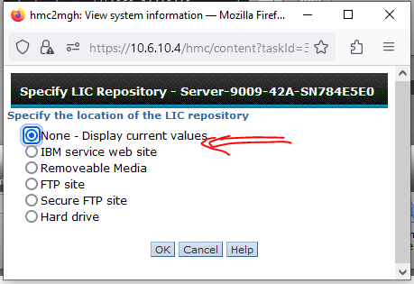

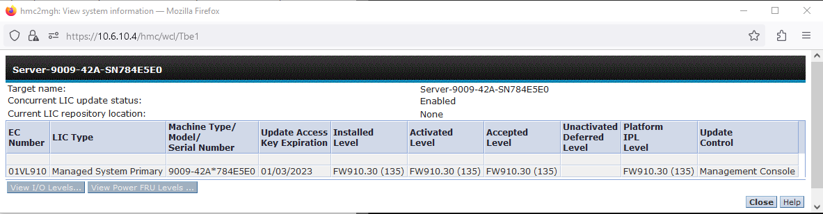

**Boot adapter microcode requirement**

*Update all adapters which are boot adapters, or which may be used as boot adapters in the future, to the latest microcode from IBM Fix Central.  The latest microcode will ensure the adapters support the new Firmware Secure Boot feature of Power Systems. This requirement applies when updating system firmware from a level prior to FW940 to levels FW940 and later.  
The latest adapter microcode levels include signed boot driver code. If a boot-capable PCI adapter is not installed with the latest level of adapter microcode, the partition which owns the adapter will boot, but error logs with SRCs BA5400A5 or BA5400A6 will be posted.  Once the adapter(s) are updated, the error logs will no longer be posted*.

This instruction applies to our case, since we are upgrading from FW910 to FW950. Basically, we have to look into every component that require microcode(firmware). We start that with the command “lsmcode –A”. This shows that we have to, at a minimum, check and compare current microcode level with what is available in Fix Central for components --- NIC, FCS, RAID controllers, disks

In our case NIC, FCS and RAID controllers had to be upgraded. I have individual documents for those. First step in that journey is to identify the model and type of these parts.

# lsmcode -c

The current permanent system firmware image is FW910.30 (VL910_135)

The current temporary system firmware image is FW910.30 (VL910_135)

The system is currently booted from the temporary firmware image.

#

FW910.30 (135)

# lsmcode -A

sys0!system:VL910_135 (t) VL910_135 (p) VL910_135 (t)

sissas0!53495351.19512300

ent0!e4148a1614109304.30090140

ent1!e4148a1614109304.30090140

ent2!e4148a1614109304.30090140

ent3!e4148a1614109304.30090140

fcs0!7710322514101e04.0320080270

fcs1!7710322514101e04.0320080270

fcs2!7710322514101e04.0320080270

fcs3!7710322514101e04.0320080270

pdisk0!HUSMM32.A1800011.42313641

pdisk1!HUSMM32.A1800011.42313641

sissas1!53495351.19512300

#

=================================================

**# lsmcode -d fcs0**

DISPLAY MICROCODE LEVEL 802111

fcs0 PCIe2 8Gb 4-Port FC Adapter (7710322514101e04)

The current microcode level for fcs0

is **0320080270**.

Use Enter to continue.

# lscfg -vpl fcs0

fcs0 U78D2.001.WZS091X-P1-C10-T1 PCIe2 8Gb 4-Port FC Adapter (**7710322514101e04**)

Part Number.................00WT165

EC Level....................N99095

Feature Code/Marketing ID...EN0Y

FRU Number..................00WT107

Customer Card ID Number.....**EN0Y**

Serial Number...............11S00WT165Y250NY82WHX8

Manufacture ID..............RFD1808W66589

Network Address.............21000024FF85BED0

ROS Level and ID............0314080246

Device Specific.(Z0)........00080246

Device Specific.(Z1)........03149095

Device Specific.(Z2)........49535020

Device Specific.(Z3)........00002532

Device Specific.(Z4)........000E0002

Device Specific.(Z5)........0001000A

Device Specific.(Z6)........00010001

Device Specific.(Z7)........00000000

Device Specific.(Z8)........20000024FF85BED0

Device Specific.(Z9)........ISP

Hardware Location Code......U78D2.001.WZS091X-P1-C10-T1

PLATFORM SPECIFIC

Name: fibre-channel

Model: QLE2564

Node: fibre-channel@0

Device Type: fcp

Physical Location: U78D2.001.WZS091X-P1-C10-T1

Part# 7710322514101e04

feature Code# EN0Y

Current code level: 0320080270

New code level: 0325080271

**==================================================**

**# lsmcode -d ent0**

DISPLAY MICROCODE LEVEL 802111

ent0 PCIe2 4-Port Adapter (10GbE SFP+) (e4148a1614109304)

The current microcode level for ent0 is 30090140.

Use Enter to continue.

# lscfg -vpl ent0

ent0 U78D2.001.WZS091X-P1-C9-T1 PCIe2 4-Port Adapter (10GbE SFP+) (e4148a1614109304)

PCIe2 4-Port (10GbE SFP+ & 1GbE RJ45) Adapter:

FRU Number..................00E2715

EC Level....................D77452

Customer Card ID Number.....2CC3

Part Number.................00E2719

Feature Code/Marketing ID...EN0S

Serial Number...............Y1501849K265

Manufacture ID..............000E1E805278

Network Address.............000E1E805278

ROM Level.(alterable).......30090140

Hardware Location Code......U78D2.001.WZS091X-P1-C9-T1

PLATFORM SPECIFIC

Name: ethernet

Node: ethernet@0

Device Type: network

Physical Location: U78D2.001.WZS091X-P1-C9-T1

#

Network card specific attributes:

---------------------------------

Card description: PCIe2 4-Port (10GbE SFP+ & 1GbE RJ45) Adapter

Part# e4148a1614109304

Feature Code/Marketing ID: EN0S

Current microcode level: 30090140

Future microcode level: 30100310

===================================================

**# lsmcode -d sissas0**

DISPLAY MICROCODE LEVEL 802111

sissas0 PCIe3 x8 SAS RAID Internal Adapter 6Gb

The current microcode level for sissas0 is 19512300.

Use Enter to continue.

# lscfg -vpl sissas0

sissas0 U78D2.001.WZS091X-P1-C49-T1 PCIe3 x8 SAS RAID Internal Adapter 6Gb

Hardware Location Code......U78D2.001.WZS091X-P1-C49-T1

PLATFORM SPECIFIC

Name: pci1014,034A

Node: pci1014,034A@0

Physical Location: U78D2.001.WZS091X-P1-C49-T1

PCIe3 x8 Internal SAS Adapter 6Gb :

Part Number.................02DE942

FRU Number..................02DE941

Serial Number...............YL10UE946038

Manufacture ID..............00UE

EC Level....................0

ROM Level.(alterable).......19512300

Customer Card ID Number.....57D7

Product Specific.(Z1).......1

Product Specific.(Z2).......2D35

Hardware Location Code......U78D2.001.WZS091X-P1-C49-T1

#

SAS RAID Adapter specific attributes:

---------------------------------

Card description: PCIe3 x8 SAS RAID Internal Adapter 6Gb

PCIe3 RAID SAS Adapter Quad-port 6Gb x8 (For Tape drive)

Part# 02DE942

02DE932

Customer Card ID: 57D7

57B4

Current microcode(ROM)level: 19512200

19512300

Future microcode(ROM) level: 19512c00

# lsmcode -d pdisk0

DISPLAY MICROCODE LEVEL 802111

pdisk0 Physical SAS 4K Solid State Drive

The current microcode for pdisk0

is HUSMM32.A1800011.42313641.

Use Enter to continue.

# lscfg -vl pdisk*

pdisk0 U78D2.001.WZS091X-P2-D1 Physical SAS 4K Solid State Drive

Manufacturer................IBM

Machine Type and Model......HUSMM3240ASS201

FRU Number..................00LY603

ROS Level and ID............**42313641**

Serial Number...............70V426MX

EC Level....................P02081

Part Number.................00LY597

Device Specific.(Z0)........000006329F001002

Device Specific.(Z1)........BCIP**B16A**

Device Specific.(Z2)........0068

Device Specific.(Z3)........19092

Device Specific.(Z4)........

Device Specific.(Z5)........22

Device Specific.(Z6)........P02081

Hardware Location Code......U78D2.001.WZS091X-P2-D1

pdisk1 U78D2.001.WZS091X-P2-D2 Physical SAS 4K Solid State Drive

Manufacturer................IBM

Machine Type and Model......HUSMM3240ASS201

FRU Number..................00LY603

ROS Level and ID............**42313641**

Serial Number...............70V3SU8X

EC Level....................P02081

Part Number.................00LY597

Device Specific.(Z0)........000006329F001002

Device Specific.(Z1)........BCIP**B16A**

Device Specific.(Z2)........0068

Device Specific.(Z3)........19091

Device Specific.(Z4)........

Device Specific.(Z5)........22

Device Specific.(Z6)........P02081

Hardware Location Code......U78D2.001.WZS091X-P2-D2

Our microcode

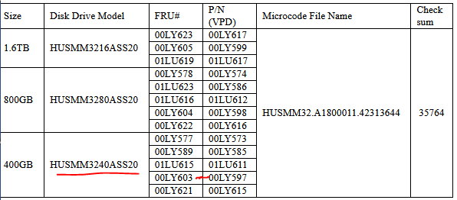

If the data returned in the “Part Number”, “FRU Number”, and “Machine Type and Model” fields match the one listed in section 1.1 AND the "ROS Level and ID...." field of that data is below " **42313641**", this microcode applies.

**Note**: Drive microcode level in “ROS Level and ID …” field is displayed in Hex value of ASCII characters in VPD data. Each alpha-numeric ASCII character converts to a 2-digit hex number. For example in VPD displayed above, 42 Hex= ASCII character "**B**"; 31 Hex= ASCII character "**1**"; 36 Hex=ASCII character "**6**"; 44 Hex=ASCII character "**D**",  microcode level is "**B16D** ". Also note that the microcode level "**B16D**" is displayed in “Z1” field.

Our existing code level B16A which has all necessary fixes. The newly available code B16D has a change that only affects IBM MFG process, it does not have any functional change affecting users.

Therefore, in our case, no need to update the disk micro code.

Disk description: Ultrastar SS300 400/800/1600 GB

Disk drive Model: HUSMM3240ASS20

FRU# 00LY603

Part/VPD# 00LY597

Microcode Level B16D

**All Boot adapters(sissass), FCS and NIC microcodes on HNA2 servers upgraded(24APR2023)**

## Upgrade to newer firmware releases disruptively using the FTP method

Download following firmware files from IBM Fix central. If you are upgrading to 01VL950_119_045 then must download all these *.xml and *.sdd files as well including the main RPM file

[root@centos4js sys0Firmware]# ls -ltr

total 335044

-rw-r--r--. 1 root root 171247093 Apr 12 08:49 01VL950_119_045.rpm

-rw-r--r--. 1 root root 2742 Apr 24 17:32 01VL950_119_045.xml

-rw-r--r--. 1 root root 2688 Apr 24 17:32 01VL950_119_045.pd.sdd

-rw-r--r--. 1 root root 8239 Apr 24 17:33 01VL950_119_045.dd.xml

Downloaded firmware file is located at following location:

Centos4JS 10.12.5.14: /u01/sys0Firmware

[odba@centos4js u01]$ **cksum 01VL950_119_045.rpm**

3791411463 171247093 01VL950_119_045.rpm

[odba@centos4js u01]$ **sum 01VL950_119_045.rpm**

34730 167234

[odba@centos4js u01]$ **md5sum 01VL950_119_045.rpm**

8472614e562ade287f957978922e3b77 01VL950_119_045.rpm

[odba@centos4js u01]$ ls -ltr 01VL950_119_045.rpm

-rw-r--r--. 1 root root 171247093 Apr 12 08:49 01VL950_119_045.rpm

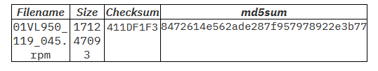

The firmware file is in good condition

# lsmcode -d sys0

Nstalling the new firmware

DISPLAY MICROCODE LEVEL 802811

IBM,9009-42A

The current permanent system firmware image is FW910.30 (VL910_135)

The current temporary system firmware image is FW910.30 (VL910_135)

The system is currently booted from the temporary firmware image.

Use Enter to continue.

[root@centos4js sys0Firmware]# ls -ltr

total 335044

-rw-r--r--. 1 root root 171247093 Apr 12 08:49 01VL950_119_045.rpm

-rw-r--r--. 1 root root 2742 Apr 24 17:32 01VL950_119_045.xml

-rw-r--r--. 1 root root 2688 Apr 24 17:32 01VL950_119_045.pd.sdd

-rw-r--r--. 1 root root 8239 Apr 24 17:33 01VL950_119_045.dd.xml

On the HMC Resources -> All Systems -> select the system being upgraded then

Click on Actions -> updates -> Change licensed Internal code -> To a new release

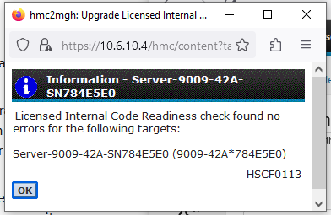

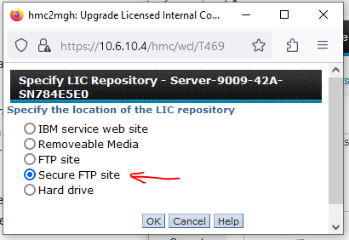

Click OK

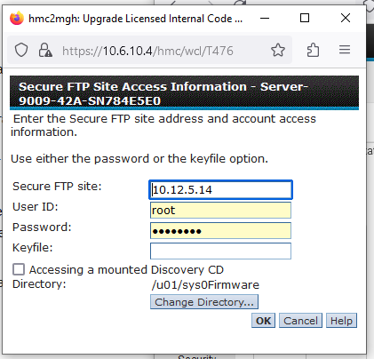

Click OK

This is a disruptive level of upgrade. That means, we have to shut down all applications and databases. After that, all partitions must be shutdown. This upgrade process will reboot(power cycle) the system.

**Downtime step starts here**

At this point, HMC will read all .XML files and the RPM file and will show the following. Check machine model and S/N to make sure intended server is selected for upgrade.

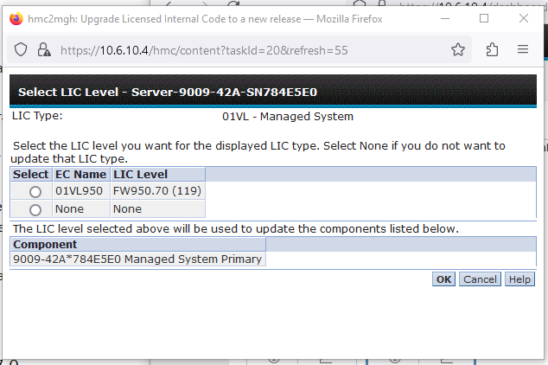

Select the LIC level intended

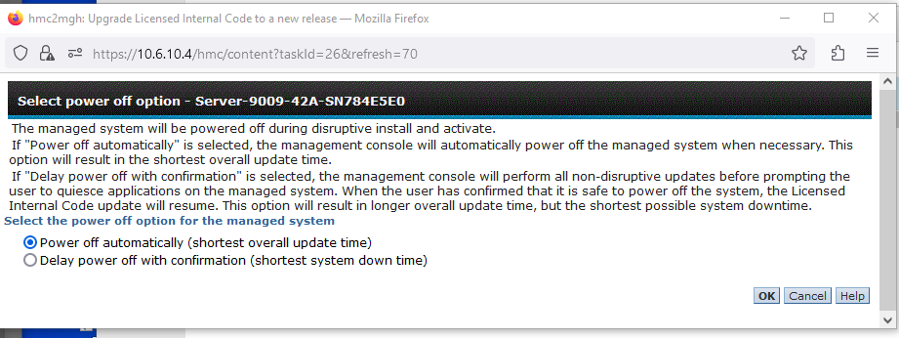

I have selected Power off Auto option

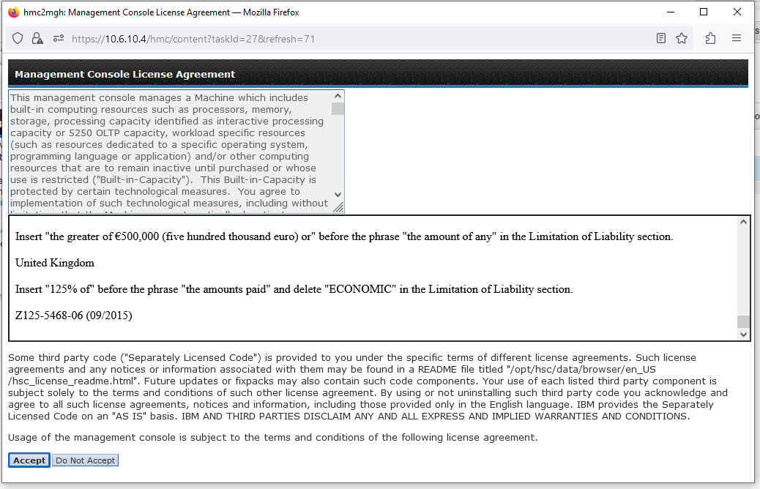

Accept the license agreement

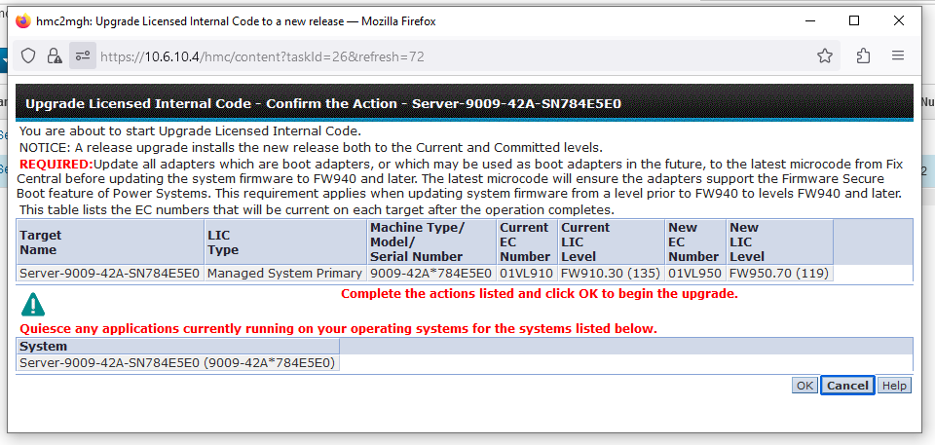

At this point you must have upgraded microcode of all boot adapters(fcs, sissas) and the ent(NIC). You must shutdown all applications, then all LAPRs and VIOS.

Only then Click OK

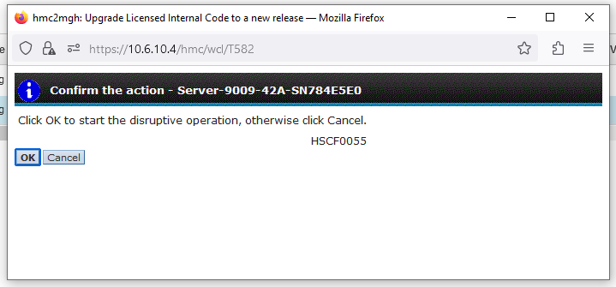

Click OK again

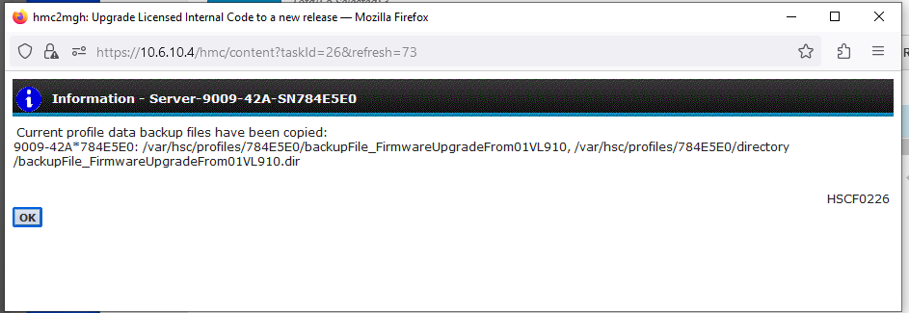

Click OK, the upgrade process will start.

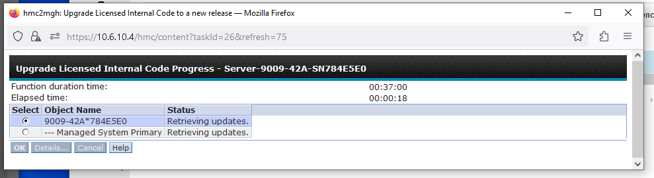

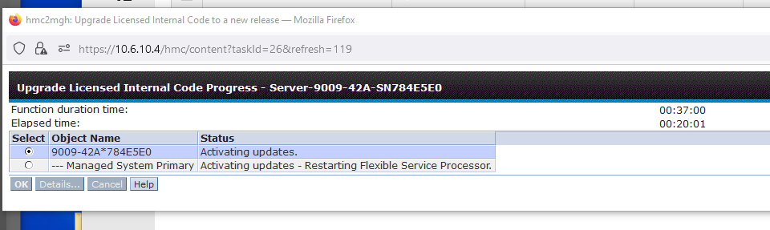

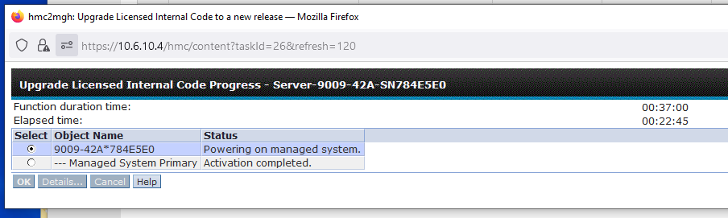

Actual update started at 3:58PM

During powering on process it stayed on c1472000 for long time(approx. 15-20min)

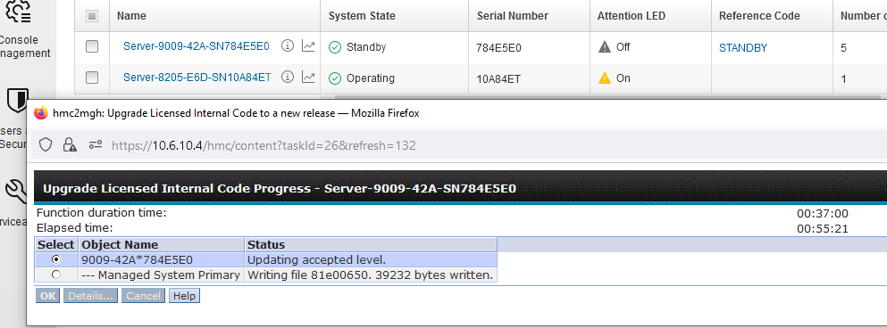

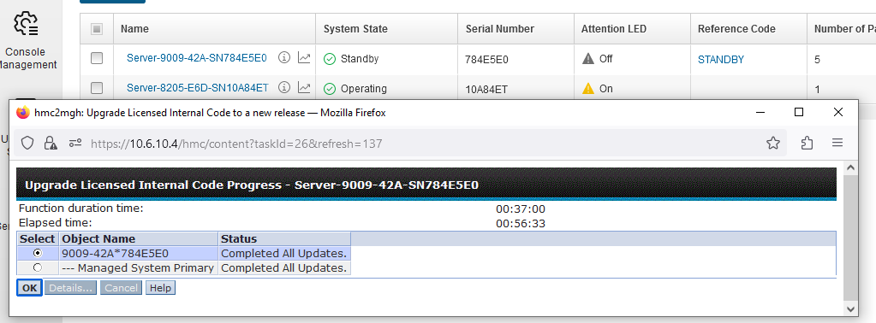

After the update, the system came up in standby mode. Then activate the primary VIO server then secondary VIO server, followed LPARS.

Ref:

<https://www.ibm.com/support/pages/node/6955867>

<https://www.ibm.com/support/knowledgecenter/9009-22A/p9eh6/p9eh6_updates_sys.htm> (installing the firmware using HMC)

[https://www.ibm.com/support/pages/microcode-discovery-service-mds-vios (not](https://www.ibm.com/support/pages/microcode-discovery-service-mds-vios%20%20(not) supported now)

<https://delivery04.dhe.ibm.com/sar/CMA/IOA/08prg/0/EN0Y_EN12_Microcode_Readme_0117202020-fw_0325080271.html> (fcs)

[c](https://www.ibm.com/support/fixcentral/main/selectFixes?parent=ibm~power&product=ibm~power~900942A&release=VL910&platform=All)

<https://ak-delivery04-mul.dhe.ibm.com/sar/CMA/IOA/08blq/3/Shiner-S_EN0S_EN0U_EN0T_EN0V_30100310_readme_V9-AIXandLinux.html> (NIC adapter installation readme)

<https://ak-delivery04-mul.dhe.ibm.com/sar/CMA/IOA/0aax5/0/readme_sissas19512c00.html> (for sissass0 and sissas1 Customer Card ID Number(CCIN: 57D7, 57B4)

<https://ak-delivery04-mul.dhe.ibm.com/sar/CMA/IOA/08fmp/0/SSD3200.html> (For pdisk)