Major Project Report

***on***

**MEDICAL FACILITY ADMINISTRATION WEBSITE**

***In partial fulfillment of requirements for the degree of***

### BACHELOR OF TECHNOLOGY

**IN**

### COMPUTER SCIENCE & ENGINEERING

***Submitted by:***

Aniruddha Trivedi [2010DMTCSE07745]

Siddharth Jain[21100BTCSE09993]

Nakul Mishra [2010DMTCSE07761] Prabal Sharma[2010DMTCSE07766]

***Under the guidance of***

PROF. VIJAY CHAUHAN



#### DEPARTMENT OF COMPUTER SCIENCE & ENGINEERING

**SHRI VAISHNAV INSTITUTE OF INFORMATION TECHNOLOGY SHRI VAISHNAV VIDYAPEETH VISHWAVIDYALAYA, INDORE JAN - JUNE 2023**

**ACKNOWLEDGMENT**

We are grateful to a number of persons for their advice and support during the time of complete our project work. First and foremost, our thanks goes to **Dr. ANAND RAJAWAT,** Professor & Head, Department of computer science and technology and **Prof. Vijay Chauhan** Asst. Professor, the Guide of our project for providing us valuable support and necessary help whenever required and helping us explore new technologies by the help of their technical expertise. His direction, supervision and constructive criticism were indeed the source of inspiration for us.

We would also like to express our sincere gratitude towards our Director-SVIIT,

**Dr. Anand Rajavat** for providing us with valuable support.

We also owe our sincere thanks to all the **faculty members** of Information Technology Department who have always been helpful.

We forward our sincere thanks to all **teaching and non-teaching staff** of CSE department, SVIIT Indore for providing necessary information and their kind co- operation.

We would like to thank our parents and family members, our classmates and our friends for their motivation and their valuable suggestion during the project. Last, but not the least, we thank all those people, who have helped us directly or indirectly in accomplishing this work. It has been a privilege to study at Shri Vaishnav Vidyapeeth Vishwavidyalaya, Indore.

**ABSTRACT:**

The purpose of the project entitled “**Medical Facility Administration Website**” is to integrate the Front Office Management of the Hospital to develop Website, which is user friendly, simple, fast, and cost-effective. It deals with the collection of patient’s information like adding patient details, updating patient information, managing medicines, searching patients, viewing patient diagnosis reports etc. Traditionally it was done manually and in big organizations it was stored in the system but not in integrated or centralized structure. The main function of the system is to manage patient’s details and doctor’s details or retrieve these details when required. It will require username and password for accessing their respective dashboard. The Website will be accessible by admin, doctor, receptionist, and patients but data manipulating or updating patients’ information is done by admin, doctors, and receptionist. This system will reduce the staff work and manual labor. it is an essential tool for modern solution to improve patient interaction.

|  |  |
| --- | --- |
| *4.1 Use Case Model* | *23* |
| *4.2 Conceptual level class diagram* | *24* |
| *4.3 Conceptual level activity diagram* | *25* |
| *4.4 DFD – 0* | *26* |
| *4.5 DFD – 1* | *26* |
| *4.6 DFD – 2* | *27* |
| *4.7 ER Diagram* | *28* |
| *5.1 Detailed Class Diagram* | *29* |
| *5.2 Sequence Diagram for Admin* | *30* |
| *5.3 Sequence Diagram for Patient* | *30* |
| *5.4 Activity Diagram* | *33* |
| *5.5 Component Diagram* | *35* |
| *5.6 Collaboration Diagram Admin* | *31* |
| *5.7 Collaboration Diagram Patient* | *31* |
| *5.8 State Diagram* | *32* |
| *5.9 Object Diagram* | *34* |

*5.10 Deployment Diagram 36*

|  |  |
| --- | --- |
| **TABLE OF CONTENT** |  |
| *Declaration* | **i** |
| *Project Approval Sheet* | **ii** |
| *Certificate* | **iii** |
| *Acknowledgment* | **iv** |
| *Abstract* | **v** |
| *List of Figures* | **vi** |
| CHAPTER 1 – **INTRODUCTION** | **1 - 7** |
| 1.1 Introduction | 1 |
| 1.2 Problem Statement | 2 |
| 1.3 Need for the new System | 3 |
| 1.4 Objective | 4 |
| 1.5 Modules of the system | 5 |
| 1.6 Scope | 6 |
| CHAPTER 2 - **LITERATURE SURVEY** | **8 - 13** |
| 2.1 Existing System | 8 |
| 2.2 Proposed System | 9 |
| 2.3 Feasibility Study | 10 - 13 |
| 2.3.1 Technical Feasibility | 10 |
| 2.3.2 Economical Feasibility | 11 |
| 2.3.3 Operational Feasibility | 12 |
| CHAPTER 3 – **REQUIREMNETS ANALYSIS** | **14 - 19** |
| 3.1 Method used for Requirement analysis | 14 |
| 3.2 Data Requirements | 16 |
| 3.3 Functional Requirements | 17 |
| 3.4 Non-Functional Requirements | 18 |
| 3.5 System Specification | 19 |
| 3.5.1 Hardware specification | 19 |
| 3.5.2 Website Specification | 19 |
| CHAPTER 4 – **DESIGN** | **20 - 27** |
| 4.1 Website Requirements Specification | 20 - 23 |
| 4.1.1 Glossary | 20 |
| 4.1.2 Supplementary Specifications | 21 |
| 4.1.3 Use Case Model | 23 |
| 4.2 Conceptual level class diagram | 24 |
| 4.3 Conceptual level activity diagram | 25 |
| 4.4 Data flow Diagram( Level 0,1,2) | 26 |
| 4.5 Database Design (ER-Diagram) | 28 |

CHAPTER 5 – **SYSTEM MODELING 29 - 36**

|  |  |
| --- | --- |
| 5.1 Detailed Class Diagram | 29 |
| 5.2 Interaction Diagram | 30 - 31 |
| 5.2.1 Sequence Diagram | 30 |
| 5.2.2 Collaboration Diagram | 31 |
| 5.3 State Diagram | 32 |
| 5.4 Activity Diagram | 33 |
| 5.5 Object Diagram | 34 |
| 5.6 Component Diagram | 35 |
| 5.7 Deployment Diagram | 36 |

CHAPTER 6 – **CONCLUSION & FUTURE WORK 37 - 39**

* 1. Limitation of Project 37
  2. Future Enhancement 38

CHAPTER 7 - BIBLIOGRAPHY & REFERENCES 40

* 1. Reference Books 40
  2. Other Documentations & Resources 40

# CHAPTER 1 INTRODUCTION

## Introduction

Medical Facility Administration Website is a cutting-edge solution for healthcare facilities looking to improve their operations and enhance patient care. The system integrates all the key functions of a hospital into a single platform, making it easier to manage and monitor all aspects of hospital operations. MFAW automates manual processes and reduces the risk of errors, allowing healthcare professionals to focus on what they do best – providing high-quality patient care.

MFAW provides real-time access to patient information and medical records, enabling healthcare professionals to access the information quickly and easily they need to make informed decisions. The system also simplifies appointment scheduling, making it easier for patients to book appointments with the right healthcare provider. In addition, MFAW streamlines the billing and financial management process, reducing the administrative burden on hospital staff and freeing up more time for patient care.

MFAW is designed with user-friendliness in mind, with an intuitive interface that makes it easy for hospital staff to navigate and use. The system is also highly secure, ensuring that sensitive patient information is always protected. With its real-time data access, robust security features, and comprehensive functionality, MFAW is the ideal solution for healthcare facilities looking to improve their operations and enhance patient care.

In conclusion, MFAW is a comprehensive solution that can transform the way healthcare facilities operate. By automating manual processes, reducing errors, and simplifying key functions such as patient management and billing, MFAW helps hospitals to run more efficiently and effectively. With its user-friendly interface and secure data storage, MFAW is a valuable tool for hospital administrators and healthcare professionals alike.

## Problem Statement

The problem domain in which we are predominantly focusing on is the old hospital management system that is the complex and inefficient in nature of hospital operations, which can lead to a variety of challenges, including:

* + 1. Incomplete and inaccurate patient information: With manual processes and paper-based systems, it can be difficult to maintain complete and accurate patient records.
    2. Appointment scheduling difficulties: Coordinating patient appointments with multiple healthcare providers can be time-consuming and error prone.
    3. Inefficient billing and financial management: Hospital billing and financial management can be a complex and time-consuming process, with many manual steps that can lead to errors.
    4. Data breaches and data loss happen due to old Website and security systems that are still being used.

By automating manual processes, improving data accuracy, and providing real-time visibility into hospital operations, MFAW helps healthcare facilities to run more efficiently and effectively, while improving the quality of patient care.

The main objectives of an Medical Facility Administration Website are:

1. To increase the efficiency of medical staff by providing them with easy access to patient information and records.
2. To enhance patient safety by reducing the likelihood of medical errors and improving the quality of care.
3. To improve communication between medical staff and support staff by integrating various hospital departments and systems.
4. Efficiently store and manage data of patients.

## Need for the new System

Medical Facility Administration Website is a comprehensive Website solution designed to streamline and automate hospital operations and management. The system helps to manage patient information, medical records, billing, and inventory management. In the current society, MFAW plays a crucial role in ensuring effective hospital management and improved patient outcomes.

One of the primary needs for MFAW is to improve the quality of healthcare services provided by hospitals. The system enables hospitals to manage patient data more efficiently, including medical history, treatment plans, test results, and medication records. With this information readily available, healthcare providers can make more informed decisions and provide better care to patients.

Another need for MFAW is to enhance patient safety and reduce medical errors. The system ensures that patient data is accurate and up to date, which helps healthcare providers make informed decisions. It also provides automated alerts and reminders for medication doses, drug interactions, and other critical patient information, reducing the

risk of errors and improving patient safety.

MFAW also helps to improve hospital efficiency and reduce operational costs. The system streamlines various administrative tasks, such as patient registration, appointment scheduling, and billing, making it easier for hospital staff to manage their workload. It also optimizes inventory management by providing real-time information on stock levels, enabling hospitals to order supplies and medicines as needed, reducing waste, and minimizing costs.

Furthermore, MFAW enables hospitals to provide better patient engagement and satisfaction. The system provides patients with easy access to their medical records, appointment scheduling, and test results, enabling them to take an active role in managing their health. The system also facilitates communication between patients and healthcare providers, improving the quality of care and patient satisfaction.

## Objective

The objective of making an Medical Facility Administration Website in a major project is to design and develop a comprehensive Website solution that can streamline and automate hospital operations and management. The MFAW aims to provide a user-friendly interface for the hospital staff to manage patient data, medical records, billing, and inventory management. The following are the primary objectives of developing an MFAW in a major project:

* + 1. **Improve Hospital Efficiency:** The primary objective of developing an MFAW is to enhance the hospital's overall efficiency by automating and streamlining various administrative tasks. The system will help hospital staff manage their workload more efficiently by reducing manual data entry and paperwork, ensuring that they can focus on providing quality healthcare services.
    2. **Increase Patient Safety and Satisfaction:** Another crucial objective of developing an MFAW is to improve patient safety and satisfaction. The system will help ensure that patient data is accurate and up to date, reducing the risk of medical errors. It will also provide automated alerts and reminders for medication doses, drug interactions, and other critical patient information, reducing the risk of errors and improving patient safety. The system will also provide patients with easy access to their medical records, appointment scheduling, and test results, improving patient engagement and satisfaction.
    3. **Streamline Hospital Management:** The MFAW aims to streamline hospital management by integrating various functions such as patient registration, appointment scheduling, billing, and inventory management into a single system. This integration will reduce data redundancy and improve data accuracy, reducing errors and improving overall hospital management.
    4. **Improve Quality of Healthcare Services:** The MFAW will provide healthcare providers with easy access to patient data, medical history, treatment plans, and medication records. With this information readily available, healthcare providers

can make more informed decisions and provide better care to patients, improving the quality of healthcare services provided by the hospital.

* + 1. **Optimize Inventory Management:** The MFAW will provide real-time information on stock levels, enabling hospitals to order supplies and medicines as needed, reducing waste and minimizing costs. This optimization of inventory

management will reduce the burden on hospital staff and improve overall hospital efficiency.

## Modules of the system

The Medical Facility Administration Website comprises several modules that work together to streamline and automate hospital operations and management. The following are the essential modules of MFAW:

* + 1. **Patient Management Module:** This module manages patient data, including registration, appointments, medical history, treatment plans, and test results. It enables healthcare providers to access and update patient information quickly, ensuring that they can provide quality healthcare services.
    2. **Electronic Medical Records (EMR) Module:** This module stores and manages electronic medical records, including patient information, treatment plans, and medical history. It provides healthcare providers with a comprehensive view of a patient's health, enabling them to make informed decisions.
    3. **Billing Module:** This module manages hospital billing and insurance claims processing. It automates billing processes, generates invoices, and tracks payments.
    4. **Pharmacy Module:** This module manages the pharmacy inventory, including medicines, medical supplies, and equipment. It tracks inventory levels, alerts when stock is low, and enables automated reordering.
    5. **Laboratory Report Module:** This module manages laboratory data, like test

orders, results, and reports. It provides healthcare providers with access to test results, enabling them to make informed decisions.

* + 1. **Human Resources Management Module:** This module manages hospital staff data, including recruitment, payroll, and attendance. It tracks staff performance and enables employee management.
    2. **Finance and Accounting Module:** This module manages financial transactions, including expenses, income, and budgeting. It generates financial reports, including balance sheets and income statements, enabling hospital administrators to make informed decisions.
    3. **Inventory Management Module:** This module manages hospital inventory, including stock levels, item locations, and reordering. It optimizes inventory management, reduces waste, and minimizes costs.
    4. **Doctor's Module:** This module manages doctor's schedules, appointments, patient consultations, and medical prescriptions. It provides healthcare providers with a comprehensive view of patient data, enabling them to make informed decisions.

## Scope

The scope of an Medical Facility Administration Website is vast and encompasses several aspects of hospital operations and management. With the increasing demand for quality healthcare services, the need for efficient hospital management systems has become more critical than ever. The MFAW offers a comprehensive solution to hospitals' management needs and has the potential to transform the healthcare industry. The following are the primary scope of MFAW:

* + 1. **Streamline Hospital Operations:** The MFAW enables hospitals to automate and streamline several administrative tasks, including patient registration, appointment scheduling, billing, and inventory management. This automation can reduce the burden on hospital staff, improve accuracy, and increase efficiency.
    2. **Enhance Patient Care:** The MFAW provides healthcare providers with access to comprehensive patient data, including medical history, treatment plans, and test results. This information enables healthcare providers to make informed decisions, reduce medical errors, and provide quality healthcare services to patients.
    3. **Increase Patient Safety:** The MFAW offers several features that can help enhance patient safety, including medication management, drug interaction alerts, and allergy alerts. These features can help reduce the risk of medication errors, improve patient safety, and enhance the overall quality of healthcare services provided by hospitals.
    4. **Improve Communication:** The MFAW enables better communication between hospital staff, including doctors, nurses, and administrative personnel. The system enables real-time data sharing, reducing the risk of miscommunication, and improving collaboration.
    5. **Optimize Inventory Management:** The MFAW can optimize hospital inventory management, enabling hospitals to track inventory levels, reduce waste, and minimize costs. This optimization can ensure that hospitals have adequate supplies of medicines and equipment, enhancing patient care.
    6. **Increase Operational Efficiency:** The MFAW can increase operational efficiency by automating several administrative tasks, reducing manual data entry and paperwork, and enabling real-time data sharing. This efficiency can lead to cost savings, reduced staffing requirements, and increased productivity.
    7. **Improve Decision-making:** The MFAW provides hospital administrators with access to real-time data, enabling them to make informed decisions. This data can include financial reports, inventory levels, patient data, and operational statistics.

# CHAPTER 2 PROBLEM DOMAIN

## Existing System

In the field of hospital management, the traditional paper-based management system was the most used system. The system involved recording all the patient data, including their medical history and treatment, on paper, which was then stored in the hospital's records department. Every time there was a need to modify or add a record, the staff would have to search through all the previous records to verify their authenticity. This was a time- consuming and inefficient process, often leading to mistakes and errors in the data.

One of the biggest issues with the paper-based management system was its reliance on manual labor. Hospitals required large numbers of staff to manage and maintain these records, which took up a significant amount of time and resources. Furthermore, the storage of paper records required a lot of space, which added to the hospital's overhead costs.

To address these issues, hospitals began to shift towards computer-based management systems. In this system, all patient data is stored in a digital format, making it easier to update and manage. Each record is given a unique value, which allows for quick and efficient searches, reducing the time required to access and verify the data.

The computer-based system is much more reliable and efficient than the paper-based system. The chances of making mistakes in data recording and management are almost zero. This system allows for the efficient management of data, ensuring that patient records are searched and accounted for reliably and accurately. The system's ability to quickly search and access data has greatly improved the efficiency of hospital operations, allowing staff to focus on providing quality healthcare services.

Moreover, computer-based management systems are more cost-effective than the paper- based system. They require less manpower to manage and maintain, reducing staffing

costs, and require less storage space, which lowers the overhead costs of hospitals.

Overall, the computer-based management system has revolutionized hospital management. The system's reliability, efficiency, and cost-effectiveness have made it an essential tool for healthcare providers. This system has made it easier to provide quality healthcare services to patients while improving the overall efficiency of hospital operations. The future of hospital management lies in computer-based management systems, which will continue to evolve and improve as technology advances.

## Proposed System

The Medical Facility Administration Website is designed for any hospital to replace their existing manual, paper-based, and computer-based systems. The new system is intended to manage the complete operations of all the hospital departments in an integrated manner, providing easy access to information from different departments in a single place, without the need for extensive manual merging of records. The MFAW covers a wide range of hospital management functions, including patient information, doctor information, room availability, medicine availability, medical equipment status, staff and operating room schedules, patient invoices, personal information security, sales statistics, and much more.

The MFAW aims to provide these services in an efficient, cost-effective manner, with the objective of reducing the time and resources currently required for such tasks. It also aims to reduce the manpower required to manage the system, enabling hospitals to allocate their resources more effectively. The MFAW provides healthcare providers with easy access to comprehensive patient data, enabling them to make informed decisions and offer better healthcare services.

With the MFAW, patients can easily access information on their bills and test reports without having to visit different departments to obtain different details. This feature improves the patient experience and allows patients to access their medical information easily.

The MFAW also enhances communication and collaboration among hospital staff, enabling real-time data sharing, reducing the risk of miscommunication, and improving collaboration. It helps hospitals comply with various regulations and standards, including HIPAA, ICD-10, and HL7. The MFAW ensures that patient data is secure and private, and helps hospitals avoid penalties for non-compliance.

## Feasibility Study

### Technical Feasibility

When developing a web-based application like the Medical Facility Administration Website, selecting the appropriate front-end technology is crucial. The front-end is the part of the application that the user interacts with directly, and it determines how the application looks and feels. Therefore, it is essential to choose a front-end technology that is intuitive, easy to use, and can support the features of the back end.

One of the most popular back-end technologies for web-based applications is MySQL. MySQL is an open-source relational database management system that is widely used in web development. It is fast, reliable, and scalable, making it an excellent choice for applications that require a high degree of performance and reliability. When selecting a front-end technology for an application like MFAW, it is important to ensure that it supports MySQL.

Based on the features we have selected for MFAW, we have decided to use HTML, CSS, JSP, and JavaScript as the front-end technologies. HTML is the standard markup language used for creating web pages, while CSS is used for styling and formatting. JSP (Java Server Pages) is a technology that allows developers to create dynamic web pages using Java. JavaScript is a scripting language that is used for adding interactivity and functionality to web pages.

Together, these technologies provide a powerful and flexible front-end for MFAW. HTML provides the basic structure of the pages, CSS adds styling and formatting, JSP

allows for dynamic content, and JavaScript adds interactivity and functionality. By using these technologies together, we can create a user-friendly and intuitive interface for MFAW that meets the needs of hospital staff and patients.

we used this computer system as they satisfy following requirements :

* + - 1. A graphical user interface that assists employees that are not from IT background.
      2. Scalability and extensibility.
      3. Flexibility.
      4. Robustness.
      5. Provide excellent reporting features with good printing support.
      6. Platform independent.
      7. Easy to debug and maintain.
      8. Provide Event driven programming facility.
      9. Efficient in data handling.
      10. Implementing features for security is easy.
      11. Efficient data retrieval and maintenance.
      12. Operating System compatible.
      13. Website are Easy to install.
      14. Back-end is Easy to implant with the Front-end.

### Economical Feasibility

The benefits of developing the hospital management Website with a team of three members are numerous. With a smaller team, it is easier to manage the development process, streamline communication, and reduce costs. The team can focus on developing a high-quality product that meets the needs of the hospital while keeping the costs low.

The hospital management Website will be designed to simplify and centralize the administrative tasks of the hospital. With the current system, different departments use different Website and paperwork, which can lead to confusion, errors, and duplication of

efforts. By consolidating all the information into one system, the hospital can reduce the need for paperwork and eliminate the possibility of errors caused by manual data entry.

Furthermore, the Website will not override or harm the old database. It will work on or over the old database, integrating the existing data with the new system seamlessly. This means that the hospital will not have to start from scratch and can continue to use their existing data while benefiting from the new system's advanced features.

The new Website will also be designed with security in mind. The system will incorporate measures to ensure that patient information is kept confidential and secure. The system will adhere to all relevant regulations and standards to protect sensitive patient data.

Another benefit of the new hospital management Website is that it will improve the accuracy and speed of data collection and analysis. This will enable hospital administrators to make more informed decisions and better manage their resources.

In summary, developing hospital management Website with a team of three members has numerous benefits, including reduced costs, streamlined development, and improved quality. The Website will centralize administrative tasks, cut down on paperwork, and work seamlessly with the old database. It will also be designed with security in mind and improve the accuracy and speed of data collection and analysis, providing hospital administrators with the information they need to make informed decisions.

### Operational Feasibility

One of the primary objectives of the Medical Facility Administration Website is to provide an easy-to-use and user-friendly interface for hospital staff and patients. In this regard, the Website we are proposing includes a graphical user interface (GUI) based application and a Java Server Pages (JSP) based website. This dual approach ensures that the system can be accessed through various devices and platforms, including desktops, laptops, tablets, and smartphones.

The GUI based application is designed to be intuitive and user-friendly, with a clear and concise layout that allows users to navigate easily between different features and functionalities. This application will be installed on local hospital computers, allowing hospital staff to access the system quickly and easily. It will provide an easy-to-use interface for managing patient records, appointment scheduling, billing, and other essential tasks.

In addition to the GUI based application, we are also developing a JSP based website for MFAW. This website will be accessible through any web browser, making it easy for patients and their families to access their medical records, schedule appointments, and view test results. The website will also include features like online bill payment and prescription refills, making it convenient for patients to manage their healthcare needs from the comfort of their homes.

To ensure that even those with minimal computer knowledge can operate the system, we have included a help panel in both the GUI based application and the JSP based website. This panel will provide step-by-step instructions for performing various tasks, as well as answers to frequently asked questions. Additionally, our team will provide training sessions to hospital staff to help them become familiar with the system and its features.

# CHAPTER 3

# SOLUTION DOMAIN

## Method used for Requirement analysis.

Based on following questions, we have investigated that the existing systems in hospitals use separate management systems for different department that makes it difficult to merge and inter-relate the complete data records of a patient in a single system as they have different identification number in different departments. Some Question investigated were :

#### Are you aware of the history of the visitors?

In the current management systems the records are stored in a paper-based form which are the records of visitors are disposed of at the end of every 6th month and only the records of surgeries, OPD’s, and test reports of patients are kept intact and in some bigger Hospitals records are managed through database or computer-based which can keep the record of visitors intact for way longer period of time in database but all these management systems are not integrated Hospitals maintain separate management systems for different purposes like operations, patient visit, patient record, doctors record, staff records, medical store record, transaction records, etc.

#### Do you have the facility of storing the records of new visitors without need to access the various record.

Not all the systems have these facilities as for the paper-based management the staff must search through all the records to find the last record of the patient, But the record-based management systems have no need to access the previous records as all the record have a unique number/alpha-numeric value that link each previous records with the new one and update the previous records as per defined rules. But the records

of different department management cannot be linked to the record with that of the other for the same person.

#### How tedious is to add a new visitor and make the desired changes in the desired record.

It is very tedious to add or modify a visitors and patient record as in the paper-based system if the record has to be changed then all the previous records must be changed which will take a lot of time and this method results in changes of a lot more mistakes in adding and updating a person’s record, Whereas in computer based management system since the records are linked then any updating in records are done efficiently and faster than paper-based system and to add a new record system auto generate a unique identification number for it no need to check if that number is taken or not as in paper-based system is done But in computer-based systems the records has to be updated in each and every different department.

#### Do you have enough staff to handle the project?

Computer-based system management require technical staff and the need for staff is reduced so every department management system needs at least a team of 3-4 staff members for management. On the other hand, paper-based system management do not require any technical staff, but it requires large staff team of at least 15-20 members for each department which and these staff members requirement are hard to achieve for small hospitals.

#### Does the existing system need automation to enhance integration, information sharing and transparency.

Yes, through automation to enhance the proper management of records of different departments in a single place so that the information of every record of visitor can be easily accessible to them easily and nothing will remain un-searched or un-accounted.

#### What is the mechanism of report generation?

For paper-based management system all the records of tests reports, medical history, surgeries history, ventilator/observation stay record, etc. are searched, collected, analyzed, and then summarized in a single record and accounted all-together for final report comprising of bills, insurance policies, test analytic data, next check-up date, doctor details, etc. In computer-based management system the procedure is almost same as in paper-based system, but the only improvement is that the time taken for searching and analyztion of record is reduced very much.

## Data Requirements

The data requirements for an Medical Facility Administration Website will depend on the specific needs of the healthcare organization and the goals of the system. However, some common data requirements for an MFAW may include:

* + 1. **Patient data**: This includes personal information, medical history, current health conditions, and any tested allergies or adverse reactions to medications. It should also include demographic data, such as age, gender, and ethnicity.
    2. **Clinical data**: This includes data related to patient diagnosis, treatment reports, medications, lab results, imaging studies, and other clinical documentation.
    3. **Financial data**: This includes data related to patient billing, payment processing, and revenue management. It should also include financial reporting and analytics to track revenue and expenses.
    4. **Inventory data**: This includes data related to medical supplies, equipment, and medications. It should include information about stock levels, ordering, and usage.
    5. **Operational data**: This includes data related to the day-to-day operations of the hospital, such as staffing, scheduling, and resource allocation.
    6. **Quality data**: This includes data related to patient outcomes, quality of care, and patient satisfaction. It should include data from patient surveys, clinical audits,

and other quality metrics.

* + 1. **Security data**: This includes data related to user access and security incidents. It should include data about system logins, access attempts, and security breaches.
    2. **Analytics data**: This includes data that can be used to generate insights and identify trends in patient care, resource utilization, and operational efficiency. It should include data from all areas of the MFAW, such as patient data, financial data, and quality data.

## Functional Requirements

Integrated Central and Hospital Management System (MFAW) is a Website system designed to manage the daily operations of clinics and hospitals. Some of the functional requirements of MFAW may include:

* + 1. **Patient Management**: This includes the ability to create and maintain patient records, schedule appointments, and manage patient demographics, medical history, and other relevant information.
    2. **Appointment Management**: This feature enables the scheduling of appointments and the management of patient wait times and treatment times. It should also include the ability to cancel or reschedule appointments if necessary.
    3. **Electronic Health Records**: MFAW should have a feature that enables the electronic storage, retrieval, and management of patient health records. This includes clinical notes, lab results, imaging studies, and medication records.
    4. **Billing and Payment Management**: This feature should enable the management of patient billing, insurance claims, and payment processing. It should also provide financial reporting and analytics to track revenue and expenses.
    5. **Inventory Management**: MFAW should have a feature that enables the management of medical supplies, equipment, and medications. This includes tracking inventory levels, ordering supplies, and managing stock levels.
    6. **Reporting and Analytics**: MFAW should provide detailed reporting and analytics capabilities to help healthcare providers track patient outcomes, measure performance, and make informed decisions.
    7. **Security and Privacy**: MFAW should have robust security features that protect patient data and ensure compliance with relevant privacy regulations.

## Non-Functional Requirements

Some of the non-functional requirements of MFAW may include:

* + 1. **Performance**: MFAW should be designed to provide optimal performance in terms of speed, responsiveness, and reliability. It should be able to handle many users and data with ease and ensure fast response times.
    2. **Scalability**: The system should be designed to handle future growth and expansion without affecting its performance. It should be easy to scale up or down based on the needs of the healthcare organization.
    3. **Security**: MFAW should provide a high level of security to protect patient data from unauthorized access, hacking, and other security threats. It should be designed to meet relevant security standards and regulations.
    4. **Usability**: The Website should be easy to use and navigate, with a user-friendly interface that enables healthcare providers to access patient information quickly and easily. It should also be customizable to suit the specific needs of the healthcare organization.
    5. **Reliability**: MFAW should be designed to be highly reliable and available, with minimal downtime or system failures. It should also have backup and disaster recovery mechanisms in place to ensure that data is not lost in case of a system failure.
    6. **Interoperability**: The system should be able to integrate with other healthcare systems and tools, such as Electronic Health Records (EHRs), medical devices,

and lab systems, to enable seamless data exchange and communication.

* + 1. **Compliance**: The system should be designed to comply with relevant regulations and standards, such as HIPAA, GDPR, and other data privacy laws.

The specific non-functional requirements will vary depending on the healthcare organization's needs and the patient population it serves.

## System Specification

* + 1. **Hardware specification Processor:** Intel Core i5 or higher **RAM:** 4GB or higher

**Storage:** 256GB SSD or higher

**Network Interface Card (NIC):** Gigabit Ethernet

**Display**: 12-inch monitor or larger

**Input devices:** Keyboard, mouse and scanner

### Website Specification

**Web Technology:** HTML, CSS, Bootstrap, JavaScript, JSP

**Operating System:** Windows 7/8 or higher **Development Environment:** NetBeans IDE **Tools:** Xampp

**Database:** MySQL

**Server:** Apache Tomcat 6.0

# CHAPTER 4

**SYSTEM DOMAIN**

## Website Requirements Specification

### Glossary

Here are some terms and definitions that are commonly used in the context of an integrated central hospital management system:

* + - 1. **Electronic Health Record (EHR):** A digital record of a patient's medical history, including their diagnoses, treatments, test results, and other medical information.
      2. **Patient Management System:** A system that manages the registration, admission, discharge, and transfer of patients within a hospital.
      3. **Medical Billing System:** A system that manages the billing and invoicing for medical services provided by a hospital to patients and third-party payers.
      4. **Electronic Prescribing:** A system that allows healthcare providers to electronically generate and transmit prescriptions to pharmacies.
      5. **Laboratory Information System (LIS):** A system that manages laboratory test orders, results, and workflows.
      6. **Radiology Information System (RIS):** A system that manages radiology orders, results, and workflows.
      7. **Inventory Management System:** A system that manages the inventory of medical supplies, medications, and other healthcare-related products.
      8. **Appointment Scheduling System:** A system that manages the scheduling of patient appointments with healthcare providers.
      9. **Healthcare Analytics:** The use of data analysis and business intelligence tools to

extract insights from healthcare data to improve decision-making and patient outcomes.

* + - 1. **Employee / Staff Management System:** Register new employee basic information about employee and their professional details.
      2. **Doctors Management System:** View currently available doctor’s department- wise, Create the duty plan of doctor and edit or update the duty plan, Details of doctor.

### Supplementary Specifications

**SCALABILITY:**

* Central System: Multiple facilities can be hooked up to a central administrative control center, all able to operate together at the same time and able to share information with each other at the same time.
* Multi-facility: Special multi facility features allow more efficient data integration and processing.
* Accommodation: Hospital Management Website System can accommodate any size facility with any number of users.

**SECURITY:**

* Patient Identification: The system needs the patient to recognize herself or himself using the phone.
* Login ID: Any users who make use of the system need to hold a Login ID and password.
* Modifications: Any modifications like insert, delete, update, etc. for the database can be synchronized quickly and executed only by the ward administrator.
* Front Desk Staff Rights: The staff at the front desk can view any data in the Hospital Management system, and add new patients record to the HMS but they don't have any rights to alter any data in it.
* Administrator rights: The administrator can view as well as alter any information in the Hospital Management System.

**PERFORMANCE:**

* Response Time: The system provides acknowledgment in just one second once the 'patient's information is checked.
* Capacity: The system needs to support at least 1000 people at once.
* User-Interface: The user interface acknowledges within five seconds.
* Conformity: The system needs to ensure that the guidelines of the Microsoft accessibilities are followed.

**MAINTAINABILITY:**

* Back-Up: The system offers efficiency for data backup.
* Errors: The system will track every mistake as well as keep a log of it.

**RELIABILITY:**

* Availability: The system is available all the time.
  + 1. **Use Case Model**

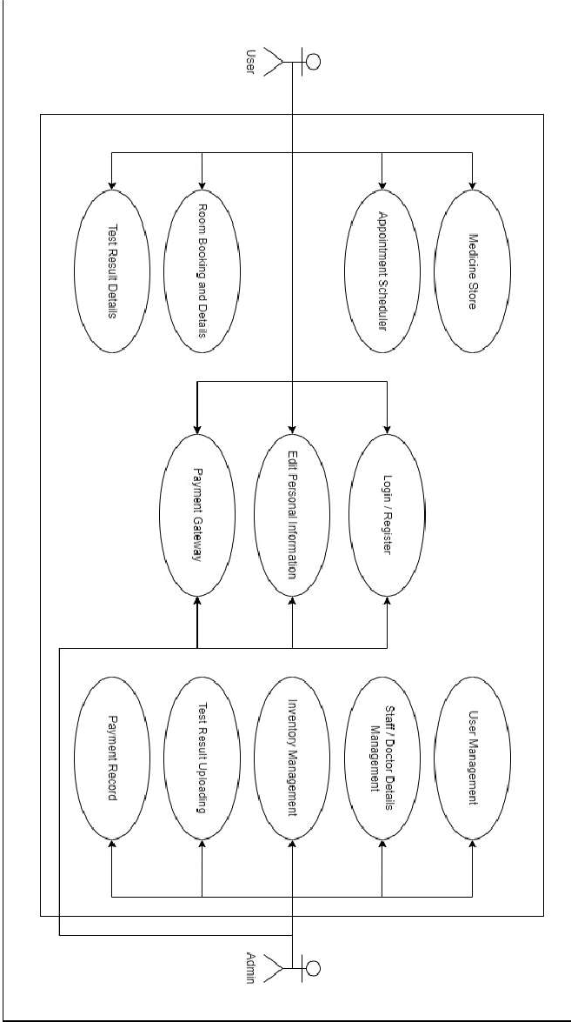

## Conceptual level class diagram

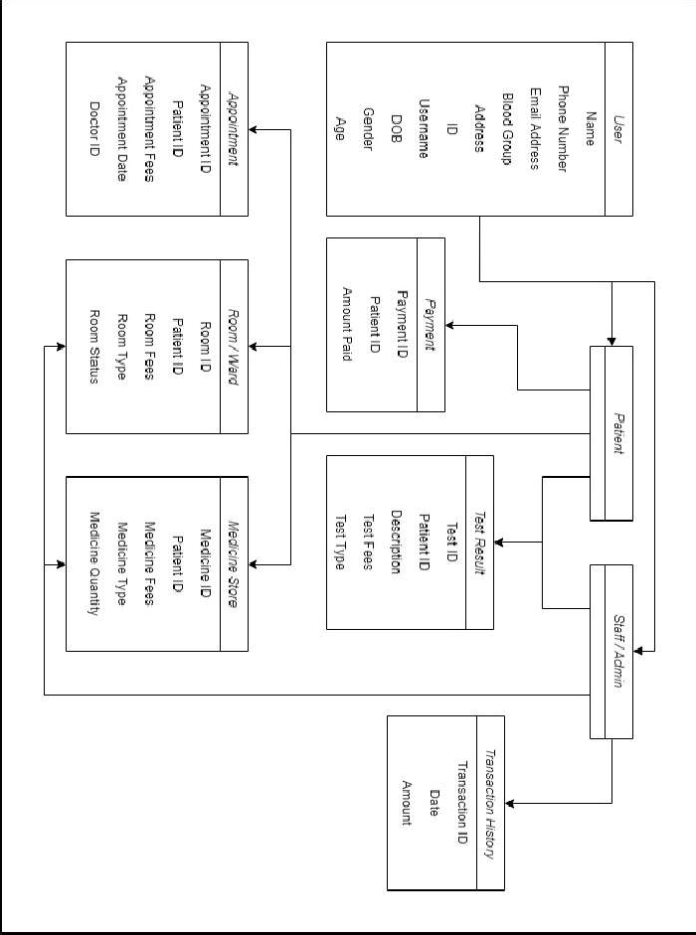

* 1. **Conceptual level activity diagram**

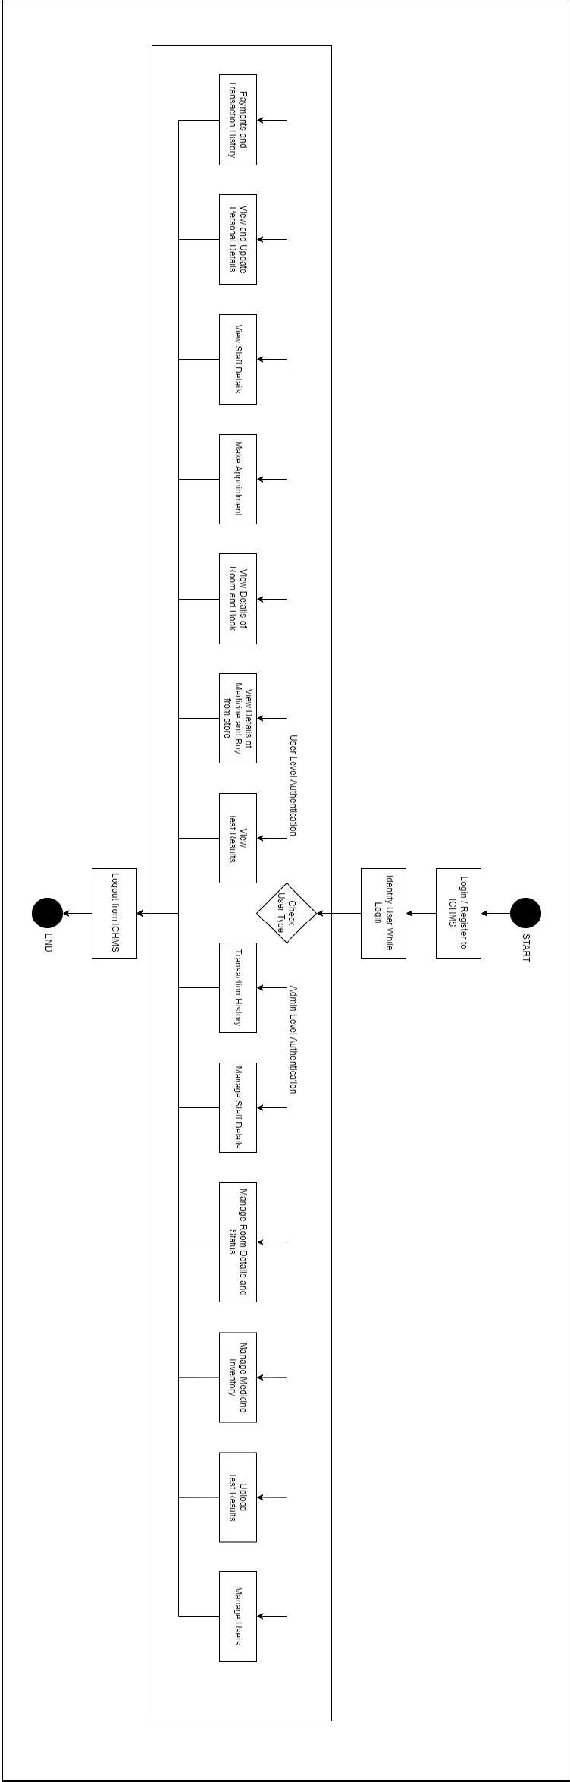

## Data flow Diagram( Level 0,1,2)

#### DFD Level - 0

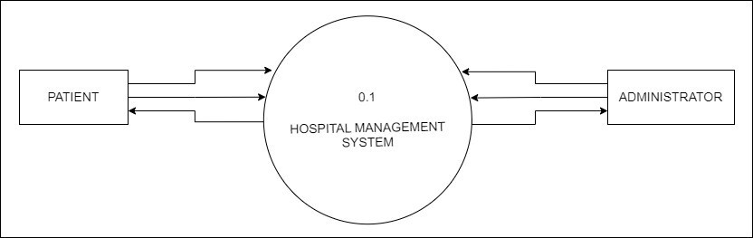

fig 4.4

#### DFD Level - 1

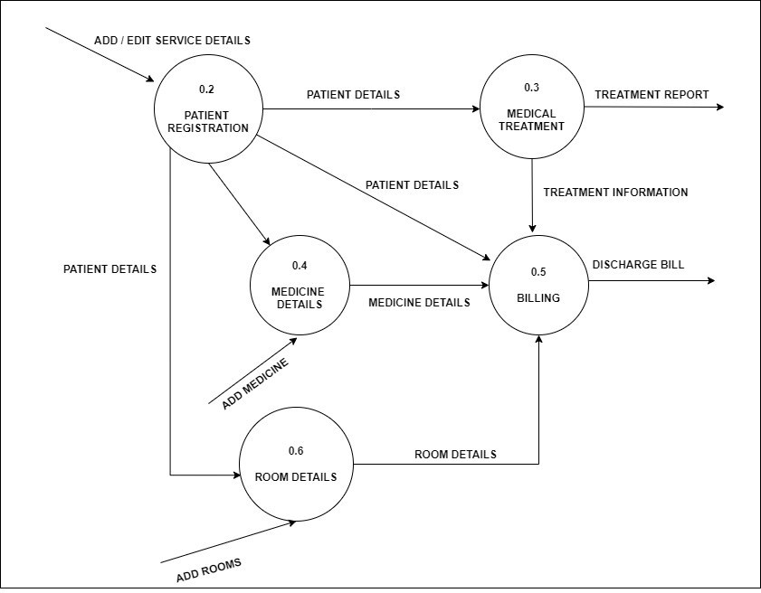

**DFD Level - 2**

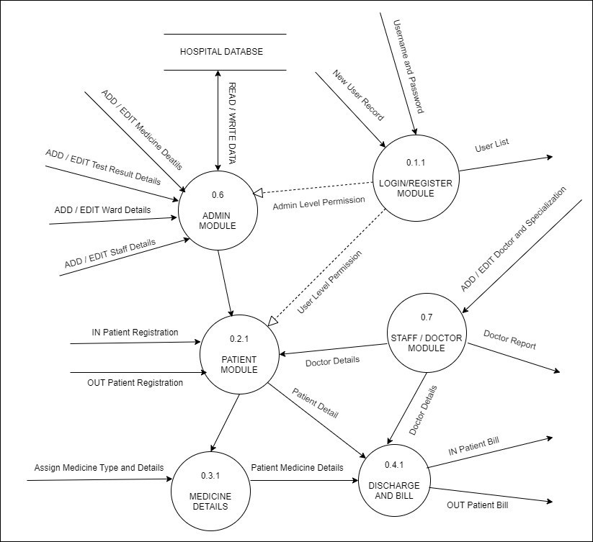

fig 4.6

## Database Design (ER-Diagram)

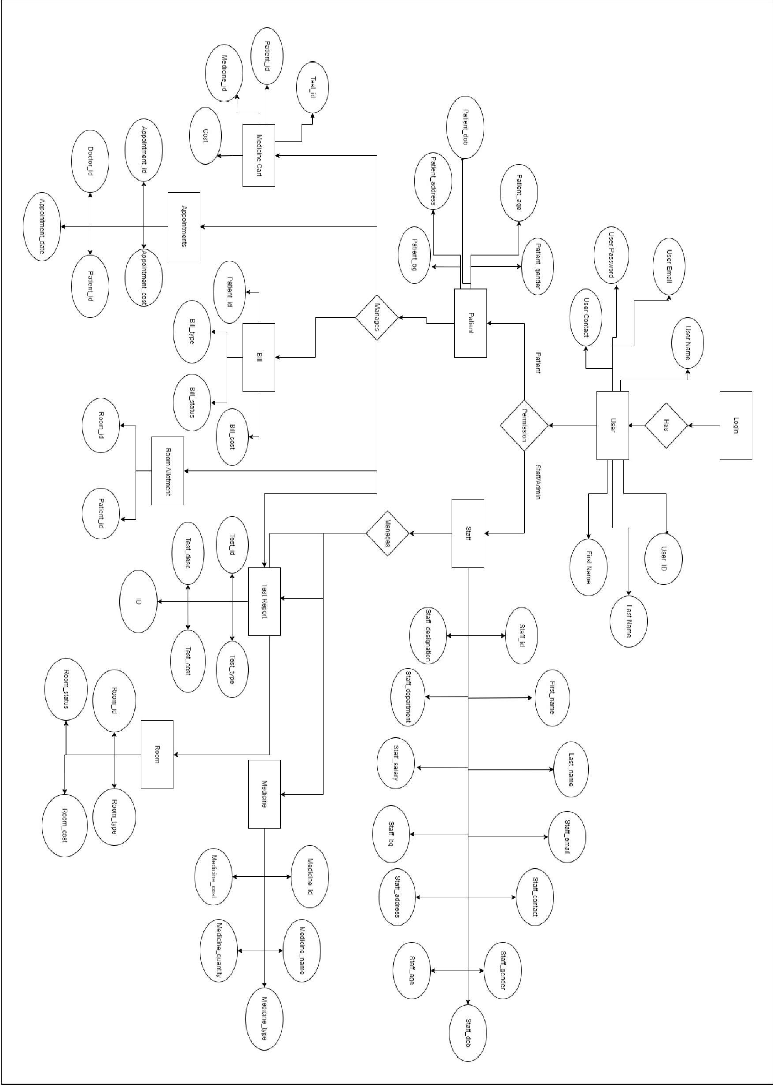

fig 4.7

# CHAPTER 5

# APPLICATION DOMAIN

## Detailed Class Diagram

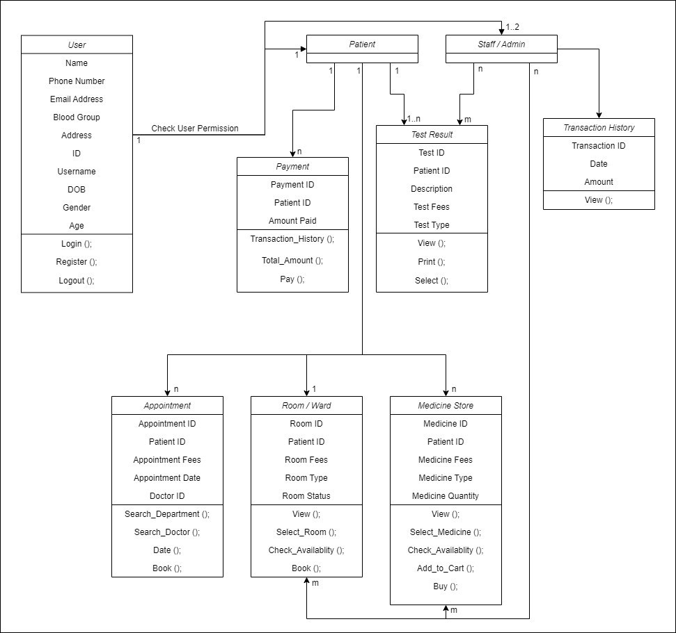

fig 5.1

## Interaction Diagram

### Sequence Diagram

#### For Admin

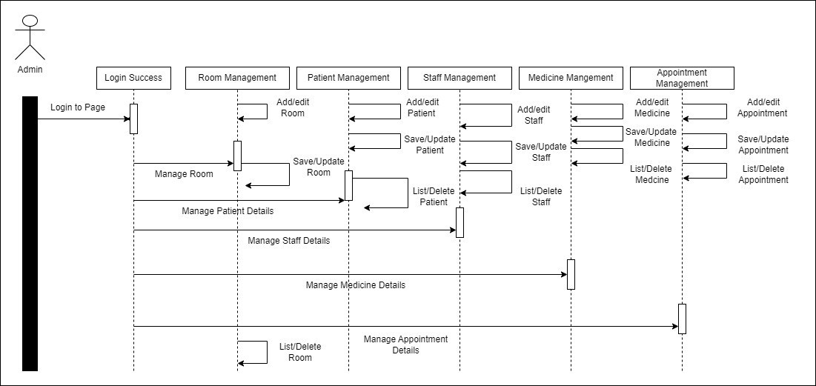

fig 5.2

#### For Patient

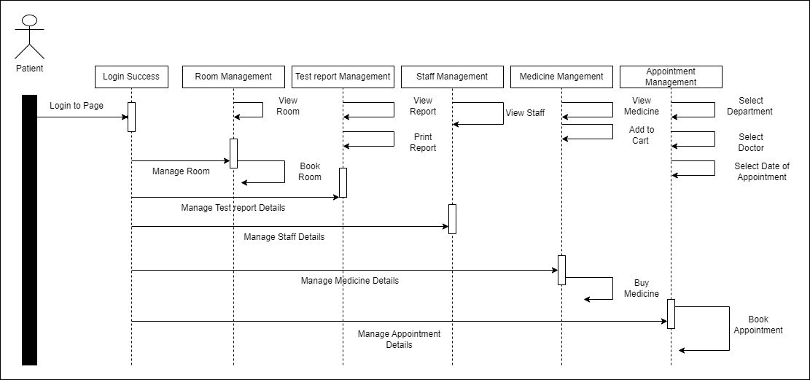

fig 5.3

### Collaboration Diagram

#### For Admin

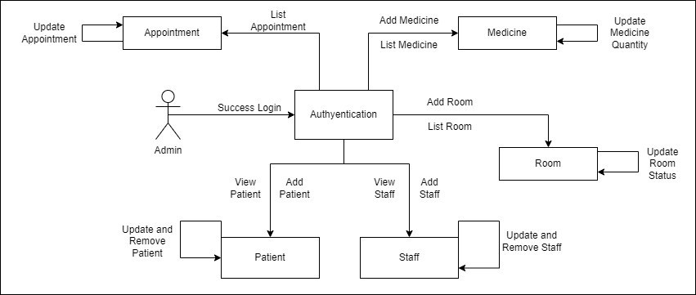

fig 5.6

#### For Patient

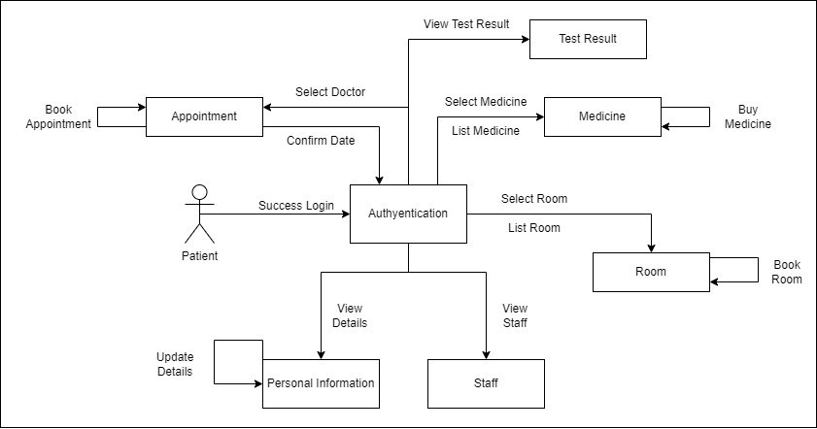

fig 5.7

## State Diagram

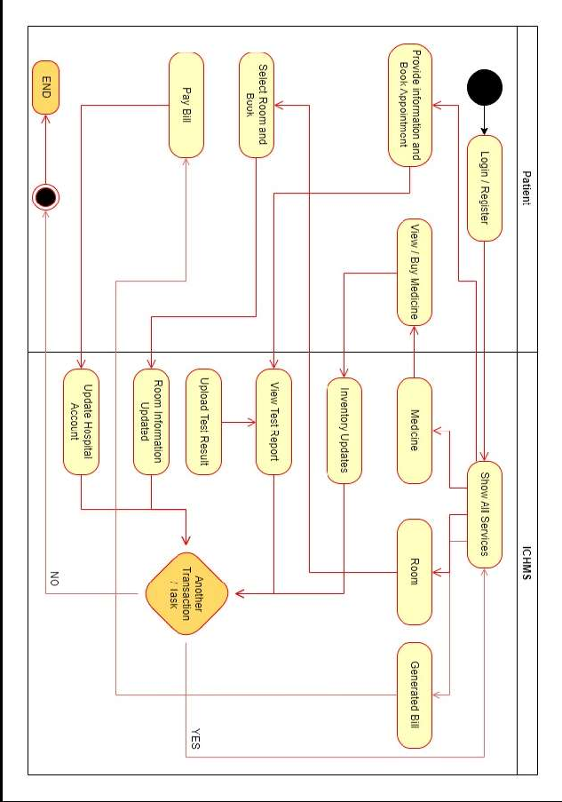

fig 5.8

## Activity Diagram

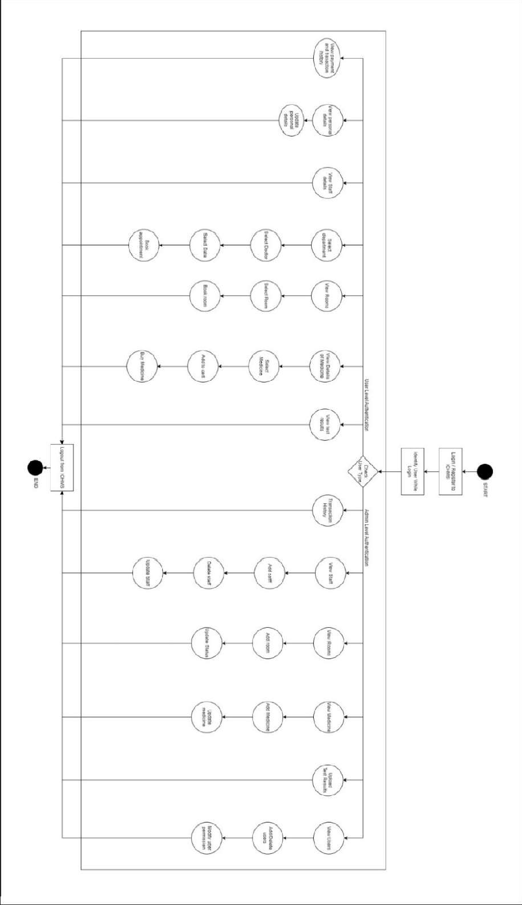

fig 5.4

## Object Diagram

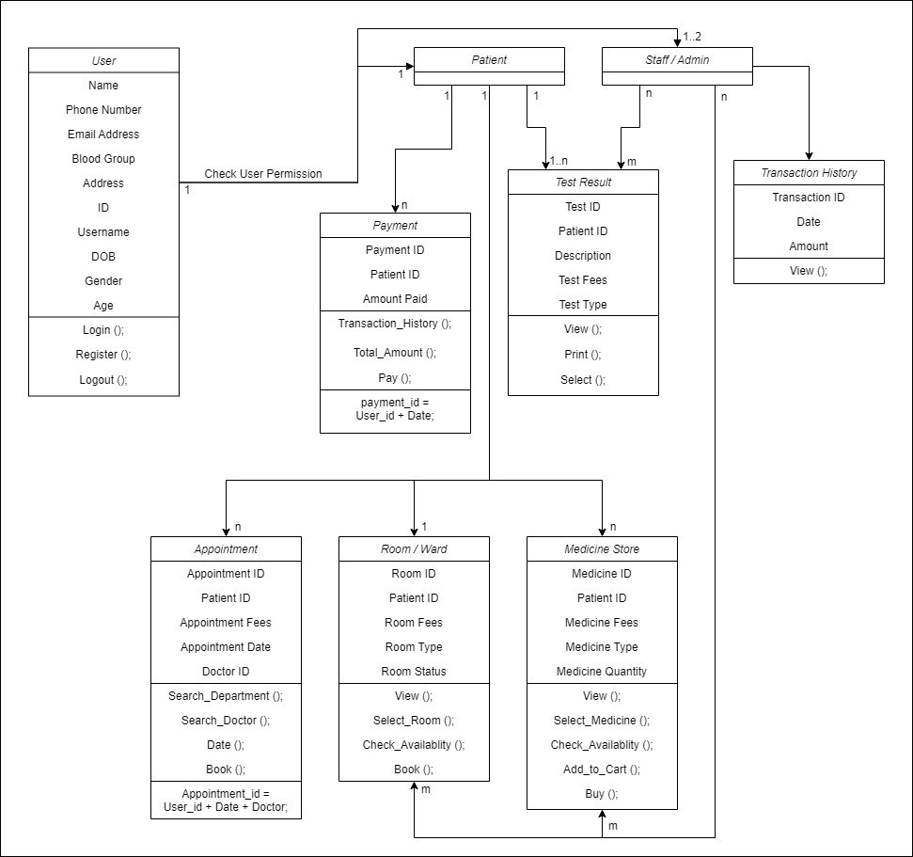

fig 5.9

## Component Diagram

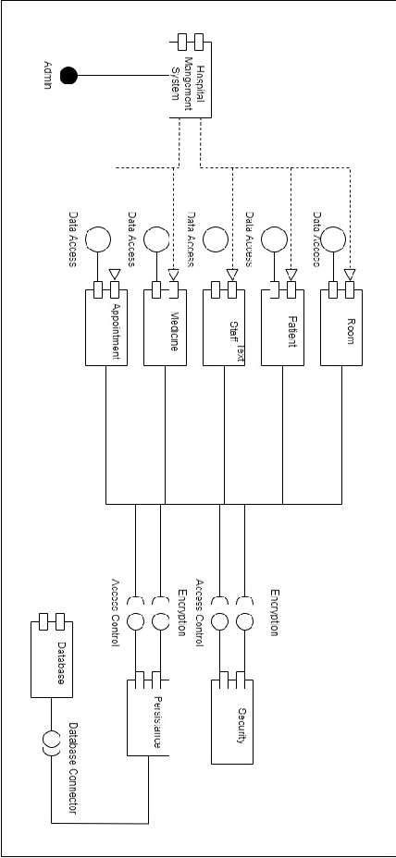

fig 5.5

## Deployment Diagram

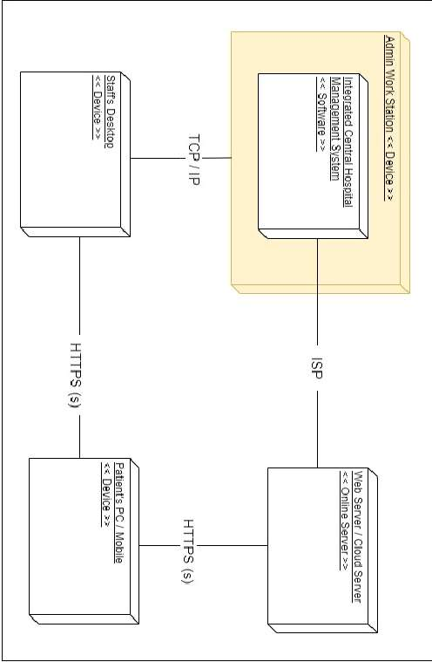

fig 5.10

# CHAPTER 6

# EXPECTED OUTCOME

## Limitation of Project

is a healthcare management system that helps healthcare organizations manage various aspects of their operations, such as patient registration, appointment scheduling, billing, inventory management, and more. While MFAW offers several benefits, there are also some limitations to consider, including:

* + 1. **Cost:** Implementing and maintaining an MFAW can be expensive, especially for smaller healthcare organizations with limited resources.
    2. **Complexity:** MFAW is a complex system that requires extensive training for staff members to use effectively. This can be time-consuming and may require additional staffing resources.
    3. **Technical Issues:** Like any computer system, MFAW can experience technical problems, such as crashes or connectivity issues, which can disrupt operations and cause delays.
    4. **Data Security:** MFAW stores sensitive patient data, making it a potential target for cyberattacks. Healthcare organizations need to invest in robust cybersecurity measures to ensure that patient data is protected.
    5. **User Acceptance:** Not all healthcare professionals may be comfortable with using MFAW, especially older staff members who may prefer paper-based systems. This can lead to resistance and reluctance to adopt the system.
    6. **Customization:** While MFAW offers various features and functions, it may not meet the specific needs of all healthcare organizations. Customization can be expensive and time-consuming, and may require technical expertise that some

organizations may not have.

Overall, while MFAW can offer several benefits to healthcare organizations, it is important to consider its limitations and carefully evaluate whether it is the right solution for a particular organization's needs.

## Future Enhancement

MFAWis a complex Website application that can be enhanced in many ways to improve its functionality, usability, and performance. Here are some possible future enhancements:

* + 1. **Mobile App:** Develop a mobile application for the system that can be used by doctors, nurses, and other medical staff to access patient records, schedule appointments, and communicate with each other. The app could also provide patients with access to their medical records and allow them to book appointments and communicate with their healthcare providers.
    2. **Machine Learning:** Use machine learning algorithms to analyze patient data and identify patterns that can help doctors diagnose and treat medical conditions more effectively. For example, the system could use machine learning to analyze patient symptoms and suggest possible diagnoses based on similar cases in the past.
    3. **Electronic Prescriptions:** Implement an electronic prescription system that allows doctors to prescribe medication directly through the system. This would eliminate the need for handwritten prescriptions and reduce the risk of errors.
    4. **Integration with Wearable Devices:** Integrate the system with wearable devices such as smartwatches and fitness trackers to collect real-time data on patients' health and monitor their progress. This would allow doctors to provide more personalized care and adjust treatment plans as needed.
    5. **Telemedicine:** Incorporate telemedicine capabilities into the system so that

doctors can consult with patients remotely. This would improve access to care for patients in remote areas and reduce in-person visits, especially during a pandemic.

* + 1. **Data Analytics:** Develop robust data analytics capabilities to help hospital administrators make informed decisions about staffing, resource allocation, and patient care. The system could provide real-time dashboards and reports that show key performance indicators and help identify areas for improvement.
    2. **Chat Bot:** Develop a Chat Bot integration that allows patients to interact with their queries. This would improve patient engagement and satisfaction, and reduce administrative burden on staff.
    3. **Smart Scheduling:** Use artificial intelligence to optimize scheduling of appointments, procedures, and resources, considering factors such as patient preferences, staff availability, and equipment availability. This would reduce waiting times and improve efficiency.

# CHAPTER 7 REFERENCES

## Reference Books

* + 1. "Healthcare Information Management Systems: A Practical Guide" *by Marion J. Ball, Charlotte A. Weaver, and Joan Kiel*
    2. "Hospital Information Systems: Design and Development Characteristics" *by T. Norris and R. E. Anderson*
    3. "Cyber security for Hospitals and Healthcare Facilities: A Guide to Detection and Prevention" *by Luis Ayala*
    4. "Handbook of Research on Healthcare Administration and Management" *edited by Sonal Singh and Pradeep Kumar*
    5. "Healthcare Information Technology: Examining the Foundations, Developments, and Future of Healthcare IT" *by Scott Thie and Jonathan R. Slotkin*

## Other Documentations & Resource

* + 1. *https://*[*www.nextgen.com/solutions/hospital-management*](http://www.nextgen.com/solutions/hospital-management)
    2. *https://*[*www.cerner.com/solutions/hospitals-health-systems/integrated-hospital-*](http://www.cerner.com/solutions/hospitals-health-systems/integrated-hospital-) *management*
    3. *https://*[*www.healthit.gov/topic/privacy-security/hispc*](http://www.healthit.gov/topic/privacy-security/hispc)
    4. *https://*[*www.himss.org/resources/cybersecurity-hub*](http://www.himss.org/resources/cybersecurity-hub)
    5. *https://*[*www.hhs.gov/hipaa/for-professionals/security/index.html*](http://www.hhs.gov/hipaa/for-professionals/security/index.html)
    6. *https://letsencrypt.org/*