


Functional Safety Concept Lane Assistance
Document Version: [1.0]



Document history

Date | Version | Editor | Description
2019-04-18 | 1.0 | Justin Simerly | First submission.

Table of Contents
Document history 2
Table of Contents 2
Purpose of the Functional Safety Concept 2
Inputs to the Functional Safety Concept 2
Safety goals from the Hazard Analysis and Risk Assessment 2
Preliminary Architecture 3
Description of architecture elements 4
Functional Safety Concept 4
Functional Safety Analysis 5
Functional Safety Requirements 6
Refinement of the System Architecture 7
Allocation of Functional Safety Requirements to Architecture Elements 8
Warning and Degradation Concept 9

Purpose of the Functional Safety Concept

The functional safety concept looks at the general functionality of the item, identifying new requirements and allocating these requirements to system diagrams.

Inputs to the Functional Safety Concept

Safety goals from the Hazard Analysis and Risk Assessment

ID | Safety Goal
Safety_Goal_01 | The oscillating steering torque from the lane departure warning function shall be limited.
Safety_Goal_02 | The lane keeping assistance function shall be time limited and the additional steering torque shall end after a given timer interval so that the driver can not misuse the system for autonomous driving.

Preliminary Architecture

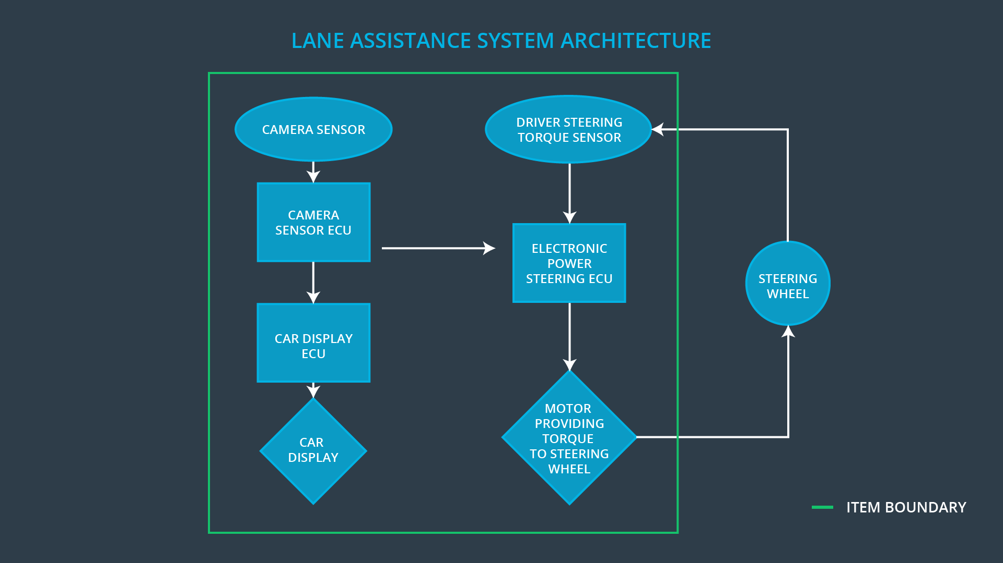

Description of architecture elements

Element | Description
Camera Sensor | Provides the camera input.
Camera Sensor ECU | Derives lanes from the camera sensor and requests the desired steering wheel torque.
Car Display | Controls the output of the car dashboard.
Car Display ECU | Outputs a warning light when the Lane Departure Warning function is activated.
Driver Steering Torque Sensor | Measures the torque applied to the steering wheel.
Electronic Power Steering ECU | Calculates the resulting torque to apply to the steering wheel based on the desired and current torque.
Motor | Turns the steering wheel.

Functional Safety Concept
The functional safety concept consists of:
- Functional safety analysis
- Functional safety requirements
- Functional safety architecture
- Warning and degradation concept

Functional Safety Analysis

Malfunction ID | Main Function of the Item Related to Safety Goal Violations | Guidewords (NO, WRONG, EARLY, LATE, MORE, LESS) | Resulting Malfunction
Malfunction_01 | Lane Departure Warning (LDW) function shall apply an oscillating steering torque to provide the driver a haptic feedback | MORE | The lane departure warning function applies an oscillating torque with very high torque amplitude (above limit).
Malfunction_02 | Lane Departure Warning (LDW) function shall apply an oscillating steering torque to provide the driver a haptic feedback | MORE | The lane departure warning function applies an oscillating torque with very high torque frequency (above limit).
Malfunction_03 | Lane Keeping Assistance (LKA) function shall apply the steering torque when active in order to stay in ego lane | NO | The lane keeping assistance function is not limited in time duration which leads to misuse as an autonomous driving function.

Functional Safety Requirements

Lane Departure Warning (LDW) Requirements:

ID | Functional Safety Requirement | ASIL | Fault Tolerant Time Interval | Safe State
Functional  Safety  Requirement  01-01 | The electronic power steering ECU shall ensure that the lane departure warning oscillating torque amplitude is below Max_Torque_Amplitude. | C | 50 mS | The torque request from the lane keeping assistance will be set to 0.
Functional  Safety  Requirement  01-02 | The electronic power steering ECU shall ensure that the lane departure warning oscillating torque frequency is below Max_Torque_Frequency. | C | 50 mS | The torque request from the lane keeping assistance will be set to 0.

Lane Departure Warning (LDW) Verification and Validation Acceptance Criteria:

ID | Validation Acceptance  Criteria and Method | Verification Acceptance  Criteria and Method
Functional  Safety  Requirement  01-01 | Test how drivers react to the chosen Max_Torque_Amplitude. | A software test that sets the torque amplitude above Max_Torque_Amplitude and ensures the lane assistance output is set to 0 within the fault tolerant time interval.
Functional  Safety  Requirement  01-02 | Test how drivers react to the chosen Max_Torque_Frequency. | A software test that sets the torque frequency above Max_Torque_Frequency and ensures the lane assistance output is set to 0 within the fault tolerant time interval.

Lane Keeping Assistance (LKA) Requirements:

ID | Functional Safety Requirement | ASIL | Fault Tolerant Time Interval | Safe State
Functional  Safety  Requirement  02-01 | The electronic power steering ECU shall ensure that the lane keeping assistance torque is applied for only Max_Duration. | B | 500 ms | The torque request from the lane keeping assistance will be set to 0.

Lane Keeping Assistance (LKA) Verification and Validation Acceptance Criteria:

ID | Validation Acceptance  Criteria and Method | Verification Acceptance  Criteria and Method
Functional  Safety  Requirement  02-01 | Test that the Max_Duration did dissuade drivers from taking their hands off the wheel. | Verify the system turns off if the lane keeping assistance exceeds Max_Duration.

Refinement of the System Architecture

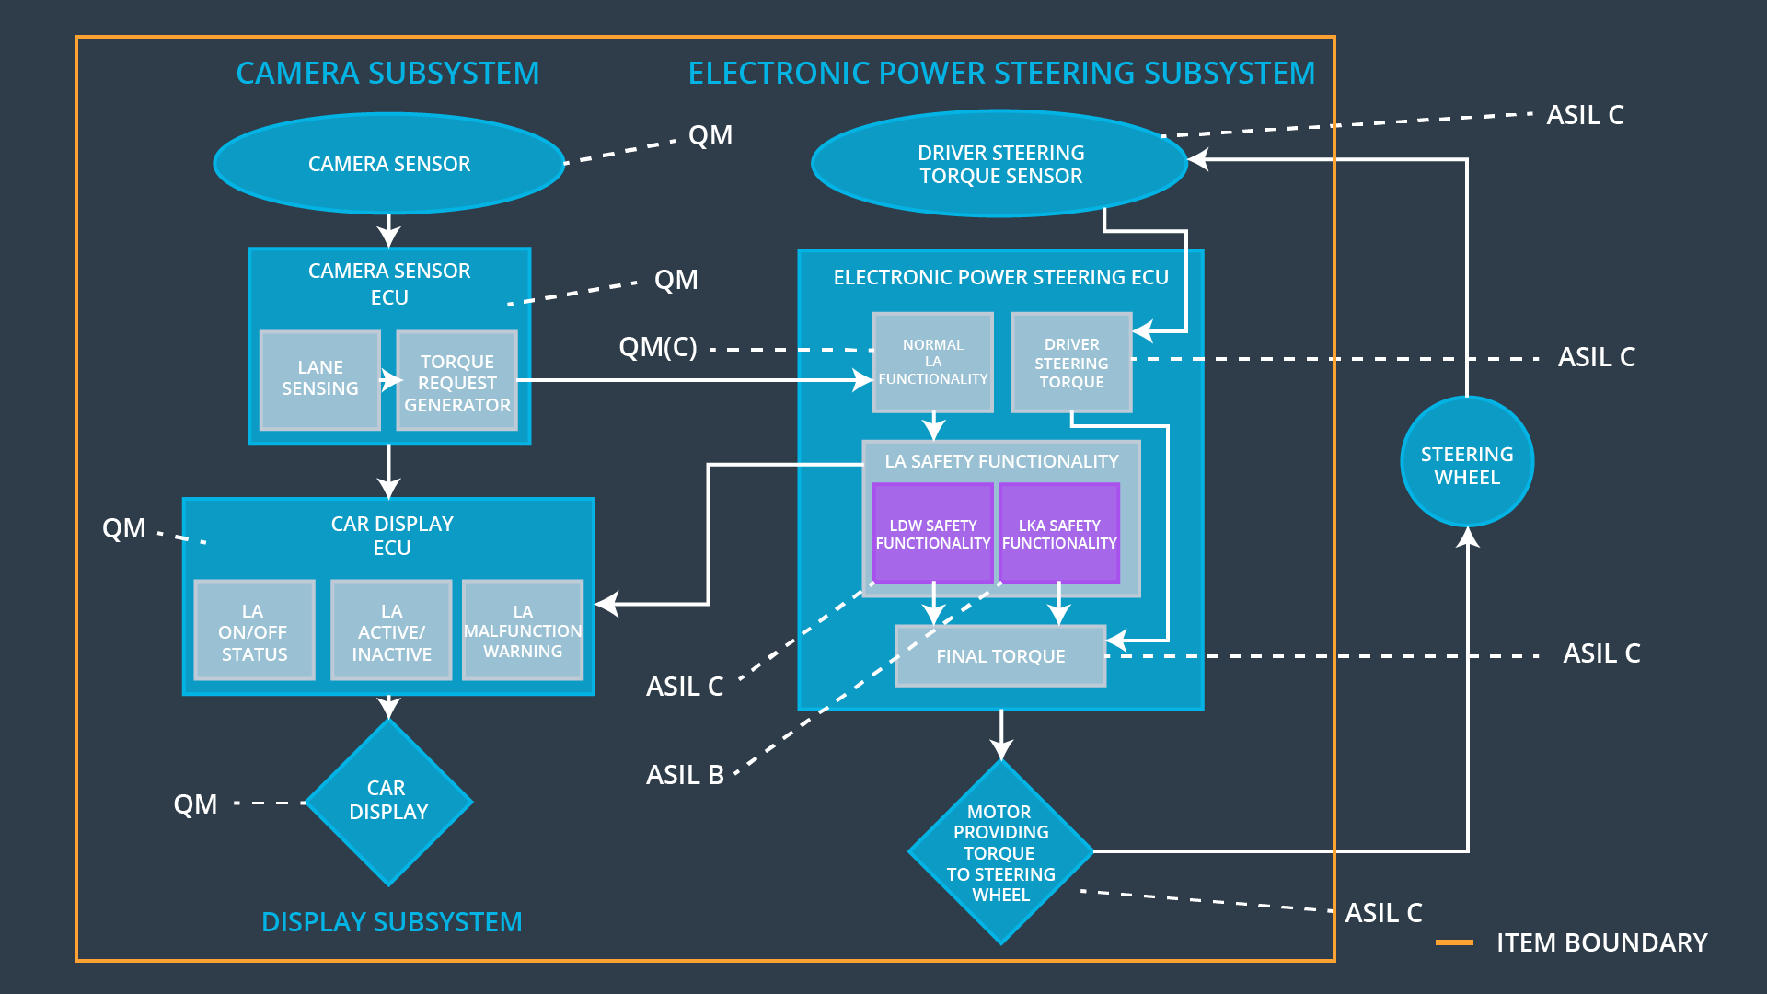

Allocation of Functional Safety Requirements to Architecture Elements

ID | Functional Safety Requirement | Electronic Power Steering ECU | Camera ECU | Car Display ECU
Functional  Safety  Requirement  01-01 | The electronic power steering ECU shall ensure that the lane departure warning oscillating torque amplitude is below Max_Torque_Amplitude. | X
Functional  Safety  Requirement  01-02 | The electronic power steering ECU shall ensure that the lane departure warning oscillating torque frequency is below Max_Torque_Frequency. | X
Functional  Safety  Requirement  02-01 | The electronic power steering ECU shall ensure that the lane keeping assistance torque is applied for only Max_Duration. | X

Warning and Degradation Concept

ID | Degradation Mode | Trigger for Degradation Mode | Safe State invoked? | Driver Warning
WDC-01 | Turn off the Lane Departure Warning functionality. | The lane departure warning function applies an oscillating torque with very high torque amplitude (above limit). | yes | Car Display shows a Lane Assist Malfunction Warning.
WDC-02 | Turn off the Lane Keeping Assistance functionality. | The lane keeping assistance function is not limited in time duration which leads to misuse as an autonomous driving function. | yes | Car Display shows a Lane Assist Malfunction Warning.

