


Technical Safety Concept Lane Assistance
Document Version: 1.0



Document history

Date | Version | Editor | Description
2019-04-19 | 1.0 | Justin Simerly | First submission.

Table of Contents

Document history 2
Table of Contents 2
Purpose of the Technical Safety Concept 2
Inputs to the Technical Safety Concept 3
Functional Safety Requirements 3
Refined System Architecture from Functional Safety Concept 3
Functional overview of architecture elements 4
Technical Safety Concept 5
Technical Safety Requirements 5
Refinement of the System Architecture 11
Allocation of Technical Safety Requirements to Architecture Elements 11
Warning and Degradation Concept 12

Purpose of the Technical Safety Concept

The technical safety concept turns functionality safety requirements into technical safety requirements and allocates technical safety requirements to the system architecture.

Inputs to the Technical Safety Concept

Functional Safety Requirements

ID | Functional Safety Requirement | ASIL | Fault Tolerant Time Interval | Safe State
Functional  Safety  Requirement  01-01 | The electronic power steering ECU shall ensure that the lane departure warning oscillating torque amplitude is below Max_Torque_Amplitude. | C | 50 ms | The torque request from the lane keeping assistance item will be set to 0.
Functional  Safety  Requirement  01-02 | The electronic power steering ECU shall ensure that the lane departure warning oscillating torque frequency is below Max_Torque_Frequency. | C | 50 ms | The torque request from the lane keeping assistance item will be set to 0.
Functional  Safety  Requirement  02-01 | The electronic power steering ECU shall ensure that the lane keeping assistance torque is applied for only Max_Duration. | B | 500 ms | The torque request from the lane keeping assistance item will be set to 0.

Refined System Architecture from Functional Safety Concept

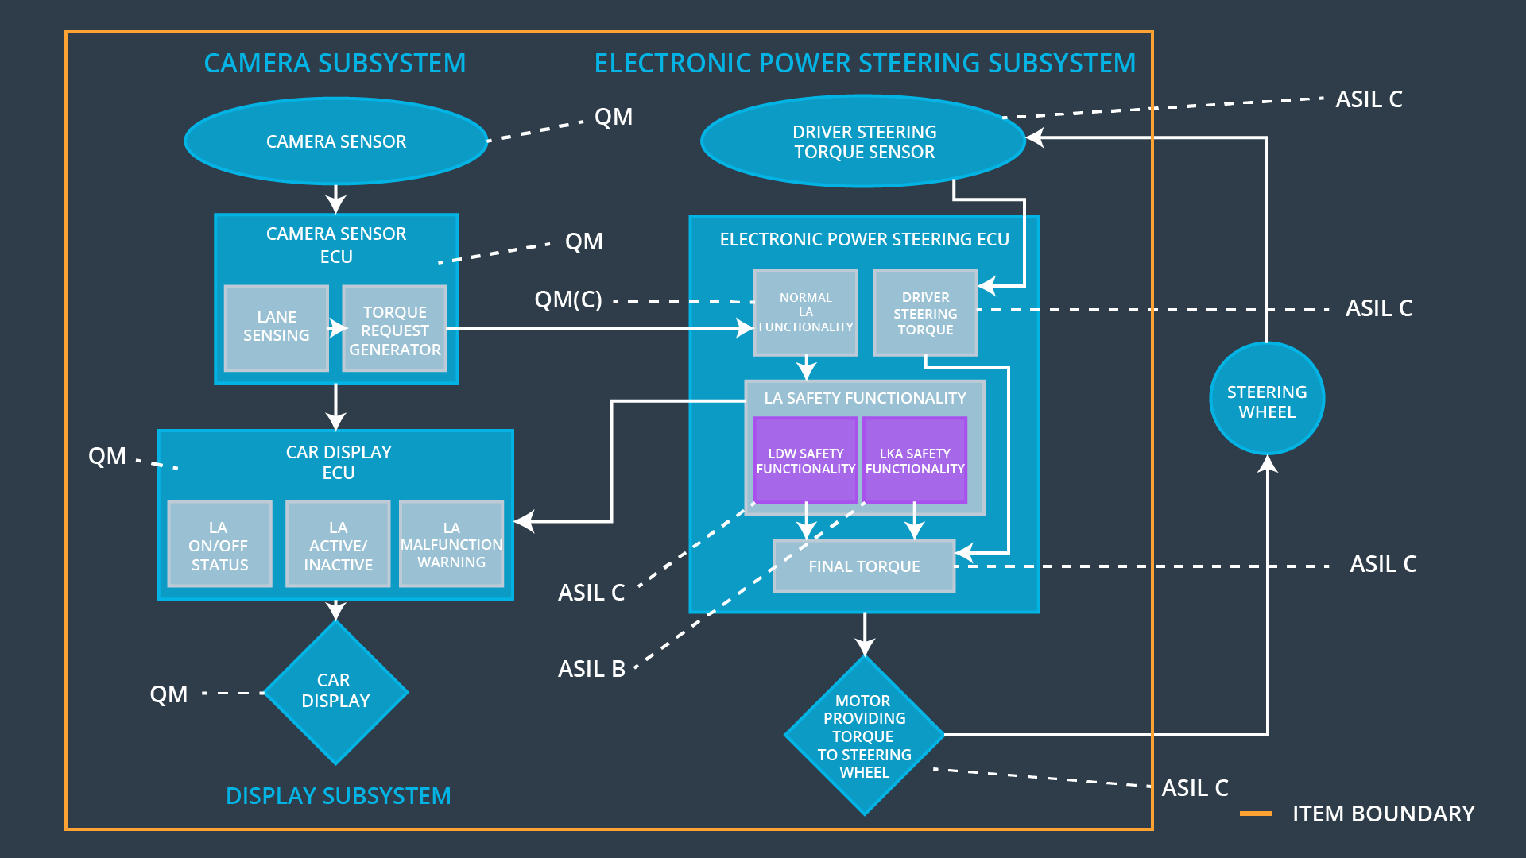

Functional overview of architecture elements

Element | Description
Camera Sensor | Provides the camera input.
Camera Sensor ECU - Lane Sensing | Derives lanes from the camera sensor.
Camera Sensor ECU - Torque request generator | Requests the desired steering wheel torque.
Car Display | Controls the output of the car dashboard.
Car Display ECU - Lane Assistance On/Off Status | Stores the status of the Lane Assistant.
Car Display ECU - Lane Assistant Active/Inactive | Stores the activation status of the Lane Assistant.
Car Display ECU - Lane Assistance malfunction warning | Stores if the Lane Assistant has detected a malfunction.
Driver Steering Torque Sensor | Measures the torque applied to the steering wheel.
Electronic Power Steering (EPS) ECU - Driver Steering Torque | Receives the torque measured from the Driver Steering Torque Sensor.
EPS ECU - Normal Lane Assistance Functionality | Processes the requested steering wheel torque.
EPS ECU - Lane Departure Warning Safety Functionality | Requests the final steering wheel torque while ensuring the safety of the Lane Departure Warning function.
EPS ECU - Lane Keeping Assistant Safety Functionality | Requests the final steering wheel torque while ensuring the safety of the Lane Keeping Assistant function.
EPS ECU - Final Torque | Receives the final steering wheel torque.
Motor | Applies the Final Torque to the steering wheel.

Technical Safety Concept

Technical Safety Requirements
Lane Departure Warning (LDW) Requirements:

Functional Safety Requirement 01-01 with its associated system elements
(derived in the functional safety concept)
ID | Functional Safety Requirement | Electronic Power Steering ECU | Camera ECU | Car Display ECU
Functional  Safety  Requirement  01-01 | The lane keeping item shall ensure that the lane departure oscillating torque amplitude is below Max_Torque_Amplitude | X

Technical Safety Requirements related to Functional Safety Requirement 01-01 are:
ID | Technical Safety Requirement | ASIL | Fault Tolerant Time Interval | Architecture Allocation | Safe State
Technical  Safety  Requirement  01 | The LDW safety component shall ensure that the amplitude of the ‘LDW_Torque_Request’ sent to the ‘Final electronic power steering Torque’ component is below ‘Max_Torque_Amplitude’. | C | 50 ms | LDW Safety | ‘LDW_Torque_Request’ Amplitude shall be set to zero.
Technical  Safety  Requirement  02 | The validity and integrity of the data transmission for `LDW_Torque_Request` signal shall be ensured. | C | 50 ms | Data Transmission Integrity Check | ‘LDW_Torque_Request’ Amplitude shall be set to zero.
Technical  Safety  Requirement  03 | As soon as a failure is detected by the LDW function, it shall deactivate the LDW feature and the `LDW_Torque_Request` shall be set to zero. | C | 50 ms | LDW Safety | ‘LDW_Torque_Request’ Amplitude shall be set to zero.
Technical  Safety  Requirement  04 | As soon as the LDW function deactivates the LDW feature, the ‘LDW Safety’ software block shall send a signal to the car display ECU to turn on a warning light. | C | 50 ms | LDW Safety | ‘LDW_Torque_Request’ Amplitude shall be set to zero.
Technical  Safety  Requirement  05 | Memory test shall be coonducted at start up of the EPS ECU to check for any faults in memory. | A | Ignition cycle | Safety Startup | ‘LDW_Torque_Request’ Amplitude shall be set to zero.

Functional Safety Requirement 01-2 with its associated system elements
(derived in the functional safety concept)
ID | Functional Safety Requirement | Electronic Power Steering ECU | Camera ECU | Car Display ECU
Functional  Safety  Requirement  01-02 | The lane keeping item shall ensure that the lane departure oscillating torque frequency is below Max_Torque_Frequency | X

Technical Safety Requirements related to Functional Safety Requirement 01-02 are:
ID | Technical Safety Requirement | ASIL | Fault Tolerant Time Interval | Architecture Allocation | Safe State
Technical  Safety  Requirement  01 | The LDW safety component shall ensure that the frequency of the ‘LDW_Torque_Request’ sent to the ‘Final electronic power steering Torque’ component is below ‘Max_Torque_Frequency’. | C | 50 ms | LDW Safety | ‘LDW_Torque_Request’ Frequency shall be set to zero.
Technical  Safety  Requirement  02 | The validity and integrity of the data transmission for `LDW_Torque_Request` signal shall be ensured. | C | 50 ms | Data Transmission Integrity Check | ‘LDW_Torque_Request’ Frequency shall be set to zero.
Technical  Safety  Requirement  03 | As soon as a failure is detected by the LDW function, it shall deactivate the LDW feature and the `LDW_Torque_Request` shall be set to zero. | C | 50 ms | LDW Safety | ‘LDW_Torque_Request’ Frequency shall be set to zero.
Technical  Safety  Requirement  04 | As soon as the LDW function deactivates the LDW feature, the ‘LDW Safety’ software block shall send a signal to the car display ECU to turn on a warning light. | C | 50 ms | LDW Safety | ‘LDW_Torque_Request’ Frequency shall be set to zero.
Technical  Safety  Requirement  05 | Memory test shall be coonducted at start up of the EPS ECU to check for any faults in memory. | A | Ignition cycle | Safety Startup | ‘LDW_Torque_Request’ Frequency shall be set to zero.

Lane Keeping Assistance (LKA) Requirements:

Functional Safety Requirement 02-1 with its associated system elements
(derived in the functional safety concept)

ID | Functional Safety Requirement | Electronic Power Steering ECU | Camera ECU | Car Display ECU
Functional  Safety  Requirement  02-01 | The lane keeping item shall ensure that the lane keeping assistance torque is applied for only Max_Duration | X

Technical Safety Requirements related to Functional Safety Requirement 02-01 are:
ID | Technical Safety Requirement | ASIL | Fault Tolerant Time Interval | Allocation to Architecture | Safe State
Technical  Safety  Requirement  01 | The LKA safety component shall ensure that the ‘LKA_Torque_Request’ is sent to the ‘Final electronic power steering Torque’ component for only Max_Duration. | B | 500 ms | LKA Safety | ‘LKA_Torque_Request’ shall be set to zero.
Technical  Safety  Requirement  02 | The validity and integrity of the data transmission for `LKA_Torque_Request` signal shall be ensured. | B | 500 ms | Data Transmission Integrity Check | ‘LKA_Torque_Request’ shall be set to zero.
Technical  Safety  Requirement  03 | As soon as a failure is detected by the LKA function, it shall deactivate the LKA feature and the `LKA_Torque_Request` shall be set to zero. | B | 500 ms | LKA Safety | ‘LKA_Torque_Request’ shall be set to zero.
Technical  Safety  Requirement  04 | As soon as the LKA function deactivates the LKA feature, the ‘LKA Safety’ software block shall send a signal to the car display ECU to turn on a warning light. | B | 500 ms | LKA Safety | ‘LKA_Torque_Request’ shall be set to zero.
Technical  Safety  Requirement  05 | Memory test shall be coonducted at start up of the EPS ECU to check for any faults in memory. | A | Ignition cycle | Safety Startup | ‘LKA_Torque_Request’ shall be set to zero.

Refinement of the System Architecture
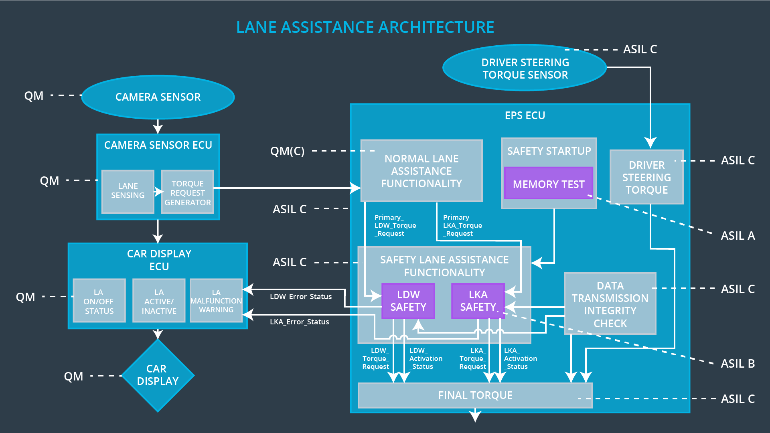

Allocation of Technical Safety Requirements to Architecture Elements

For the Lane Assistance item, all technical safety requirements are allocated to the Electronic Power Steering ECU.

Warning and Degradation Concept

ID | Degradation Mode | Trigger for Degradation Mode | Safe State invoked? | Driver Warning
WDC-01 | Turn off the Lane Departure Warning functionality. | The lane departure warning function applies an oscillating torque with very high torque amplitude (above limit). | yes | Car Display shows a Lane Assist Malfunction Warning.
WDC-02 | Turn off the Lane Keeping Assistance functionality. | The lane keeping assistance function is not limited in time duration which leads to misuse as an autonomous driving function. | yes | Car Display shows a Lane Assist Malfunction Warning.

