6/27 comparison between MPCC and big-M formulations of tank filling problem
Using IPOPT for NLP; using bonmin (branch and bound with IPOPT) for big-M
 | MPCC [solve time, num iter] | Big-M [solve time, num iter]
3 tanks, nfe=10 | 0.0289s, 21 iter | 2.1104 s, 1136 iter – 57 nodes
3 tanks, nfe = 20 | 0.0422 s, 25 iter | 4.5004 s, 15 iter – 0 nodes
3 tanks, nfe = 40 | 0.0696 s, 31 iter | 14.4410 s, 21 iter – 0 nodes
3 tanks, nfe = 100 | 0.3353 s, 72 iter | 87.6999 s, 26 iter – 0 nodes
4 tanks, nfe = 20 | 0.0596 s, 32 iter | 8.1890 s, 15 iter – 0 nodes
5 tanks, nfe = 20 | 0.0585 s, 27 iter | 18.5321 s, 3572 iter – 171 nodes
6 tanks, nfe = 20 | 0.1333 s, 58 iter | 27.4776 s, 4185 iter – 201 nodes
10 tanks, nfe = 20 | 0.1690 s, 46 iter | 471.3916 s, 146547 iter, 3967 nodes

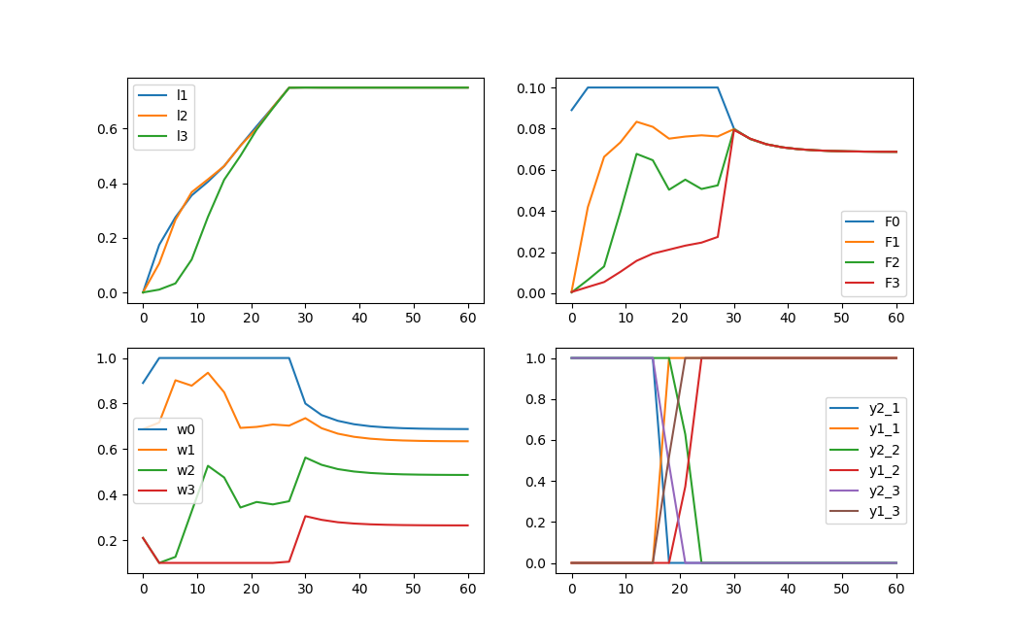

20 FE, MPCC
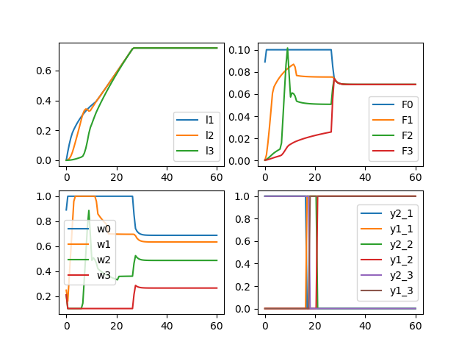

100 FE, MPCC

Penalty terms need to be tweaked to ensure the objective is actually minimized (in this case, that the setpoint is tracked – it is certainly always feasible, so need to make sure IPOPT finds one of the multiple solutions), and also that the complementarity conditions are enforced.
Example: for 5 tanks, with the tracking part multiplied by 10, we get bad results:
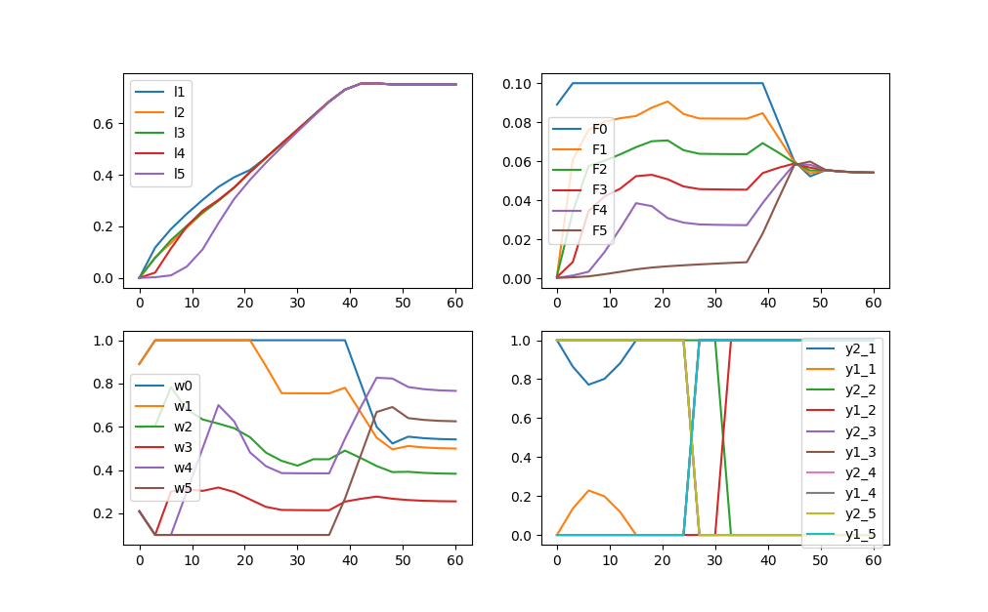

with no multipliers (in this case) it works well:
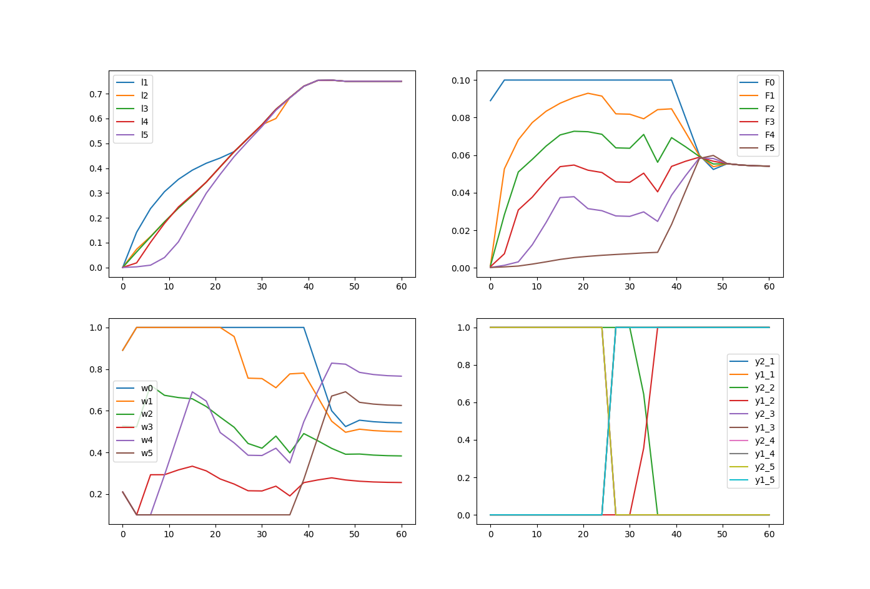

BigM – 5 tanks, 20 cp – M1 = 0.6, M2 = 0.4
solved using bonmin branch and bound with IPOPT
integrated error = 13.646
solution time = 18.5022
Cbc0004I Integer solution of 13.646041 found after 2891 iterations and 171 nodes (16.06 seconds)
Cbc0001I Search completed - best objective 13.64604080046229, took 2891 iterations and 171 nodes (16.06 seconds)
Cbc0032I Strong branching done 206 times (7209 iterations), fathomed 0 nodes and fixed 34 variables
Cbc0035I Maximum depth 85, 0 variables fixed on reduced cost
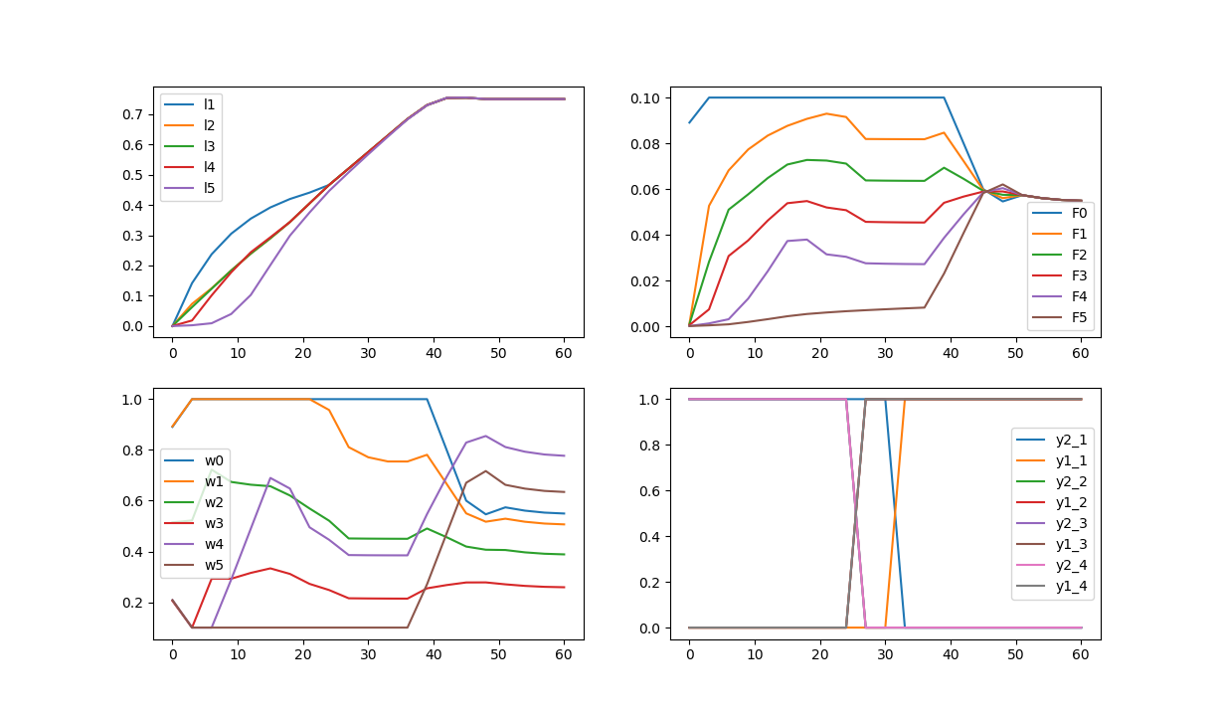

MPCC – 5 tanks, 20 cp – penalty term = 100
solved using IPOPT
integrated squared error: 13.863 – suboptimal local solution
solution time: 0.1446 s

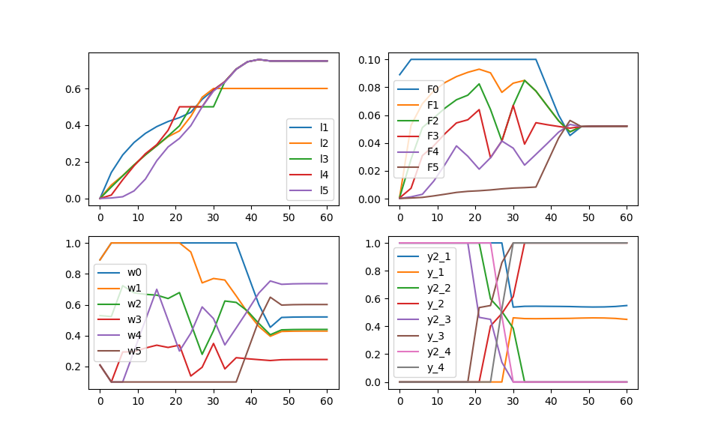

MPCC with branching – 5 tanks, 20 cp – penalty term = 100
solved using branching and bound with complementarity terms in NLP subproblem
integrated squared error: 13.662
solution time: 1.81 s
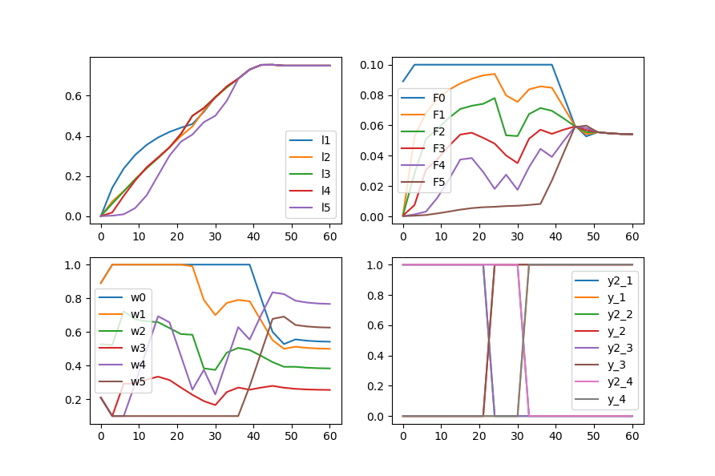

MPCC – 5 tanks, 20 cp – penalty term =1 (good value)
integrated squared error: 13.646
solution time = 0.0495 s
Since solution is integer, branching routine will also return this right away
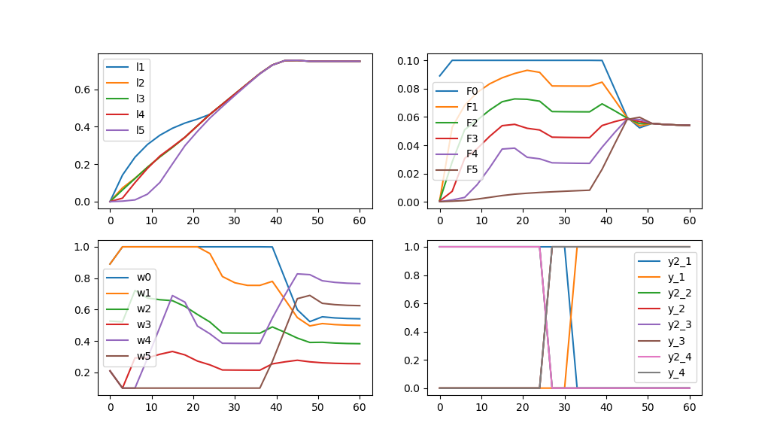

MPCC – 5 tanks, 20 cp – penalty term =0.1 (slightly low value)
integrated squared error: 13.613 (DYNAMICS VIOLATED)
solution time = 0.050 s
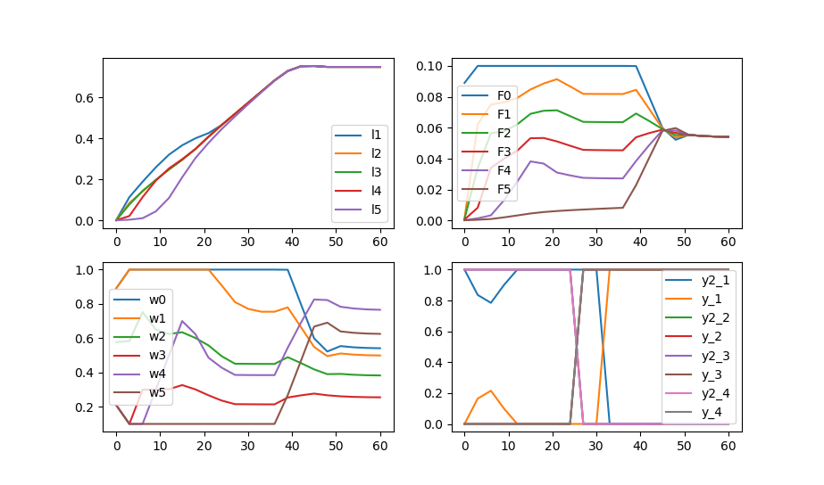

MPCC with branching – 5 tanks, 20 cp – penalty term = 0.1 (slightly low value)
solved using branching and bound with complementarity terms in NLP subproblem
integrated squared error: 13.646
solution time: 0.99 s
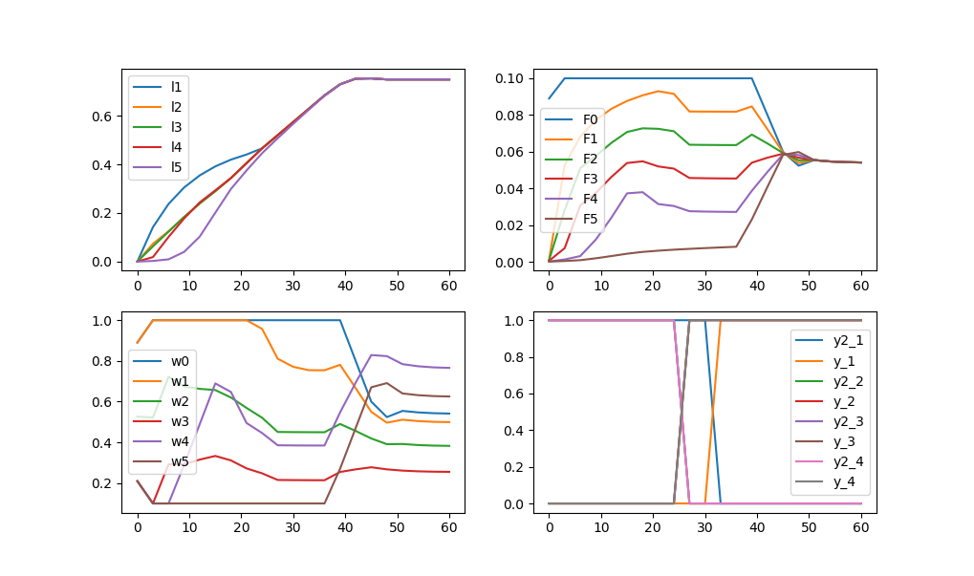

MPCC – 5 tanks, 20 cp – penalty term =0.01 (very low value)
integrated squared error: 13.595 (DYNAMICS VIOLATED)
solution time = 0.0521 s
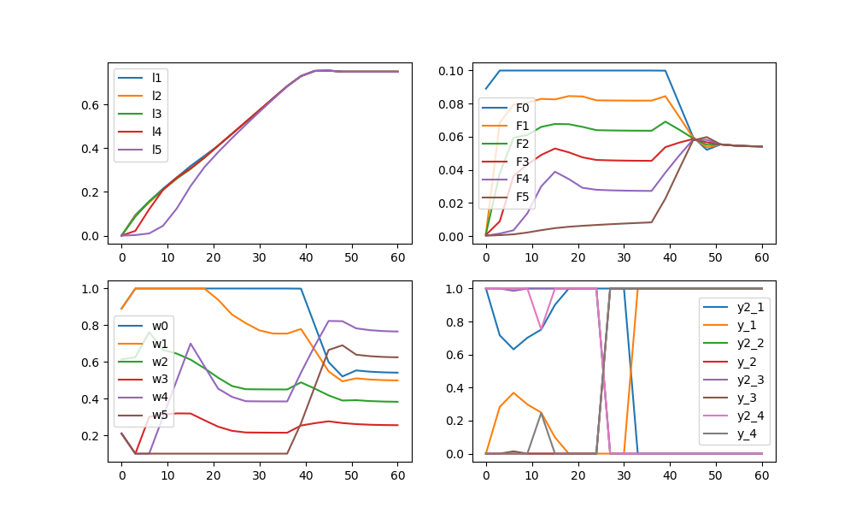

MPCC with branching – 5 tanks, 20 cp – penalty term = 0.01 (very low value)
solved using branching and bound with complementarity terms in NLP subproblem
integrated squared error: 13.602 (DYNAMICS VIOLATED)
solution time: 3.32 s
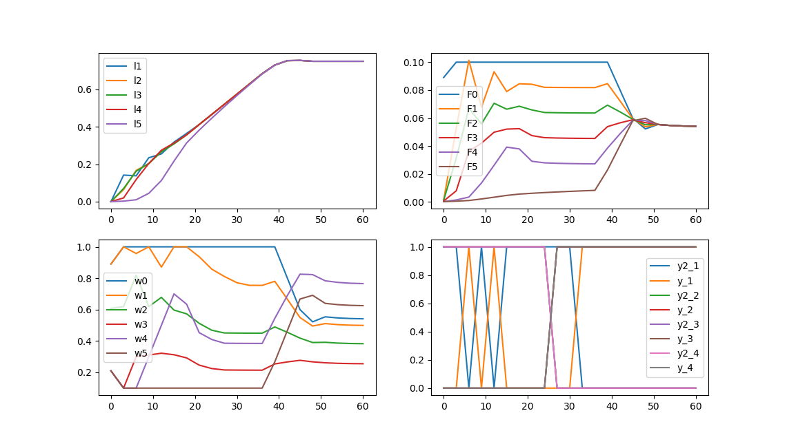

Below a certain threshold, the branching routine can't help – in the pure NLP dynamics will be violated which manifests through a convex combination of the two modes that allows more fluid to flow out of Tank 1 early by exploiting a non-physical negative driving force ( L(i) – (L(i+1) – H(i+1) ) where the level in tank i+1 is still below its inlet height.
The branching does not really resolve this problem – it forces y to be zero, but doesn't actually enforce the complementarity conditions – y values that take 1 can still be paired with nonnegative slack terms since the contribution to the objective function is sufficiently small.
Heuristics…
Fixing a binary could also require adding the associated complementarity constraint? This may work well.
* Tried doing this – only really works if you go further and enforce CS conditions to the left/right as appropriate – problem specific (and maybe not even appropriate for this problem) since there's no reason modes can't switch back and forth – that's the whole point (otherwise, switching time would be the only binary)

Need tight tolerance and reasonably tight integer check
Problem: using 1e-9 integer tolerance for the penalty = 100 case, we can a very very similar solution to the accepted/big M solution. BUT this actually causes an issue with the penalty = 1 case (which works well and terminates in one iteration using 1e-8 or higher tolerance). Now it takes 92 iterations and ~7 seconds to reach the optimum. Also, I think bonmin is using a higher integer tolerance since it converges to the first solution.
So, probably we can't get the solution from penalty=100 to match by changing integer tolerance. I think we just use 1e-6 and accept that the algorithm isn't global and so it's not guaranteed to match the solutions exactly.
I also think we might need to give up on the very low penalty issue or include some heuristic for increasing the penalty there.

Global solution
Big M formulation didn't solve in 12 hours:

Well-scaled penalty formulation, didn't converge in 12 hours but gap very small
Model saved in baron_soln.txt, log files also saved
Solution = 13.6407 : IPOPT solution is within 0.04% (w profiles not exactly the same but the problem is clearly very degenerate)
