# Lab 4 – Responsive App

In this lab, you will be using;

* Bootstrap
* Media Queries
* Angular
* AJAX/JSONP

Create fully responsive web app using a streaming API like the weather api we used in the Weather app in lab 2.

For example: Check out

<https://www.instagram.com/developer/endpoints/>

Grid Layouts using Bootstrap.

Processing data back from the AJAX call to the API using Angular

The app should be responsive and use media queries in order to see the appropriate grid layout in Bootstrap (Note this is not normally necessary in real life as Bootstrap is inherently responsive)

for the purposes of this lab, however use a media query to set the grids to md or other based on desktop or mobile) - extensive media querying is not necessary

Viewing in the desktop/smartphone can be emulated by resizing the browser window and by setting an emulation in chrome dev tools.

Some responsive output examples below – including one for the twitter API

You will be graded on the following;

Objective 1 - API : 10

Objective 1 – Bootstrap : 10

Objective 2 – Angular : 10

Creativity/Coding style : 10

Doc/README.md : 10

Example Implementation:

Desktop mode

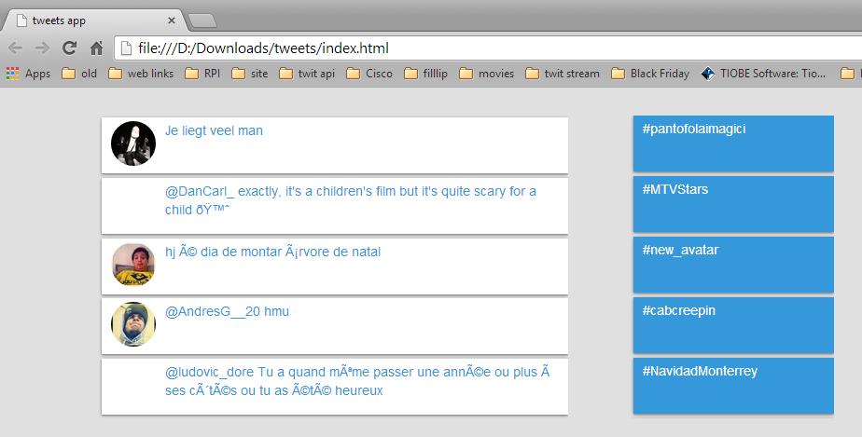

Mobile mode

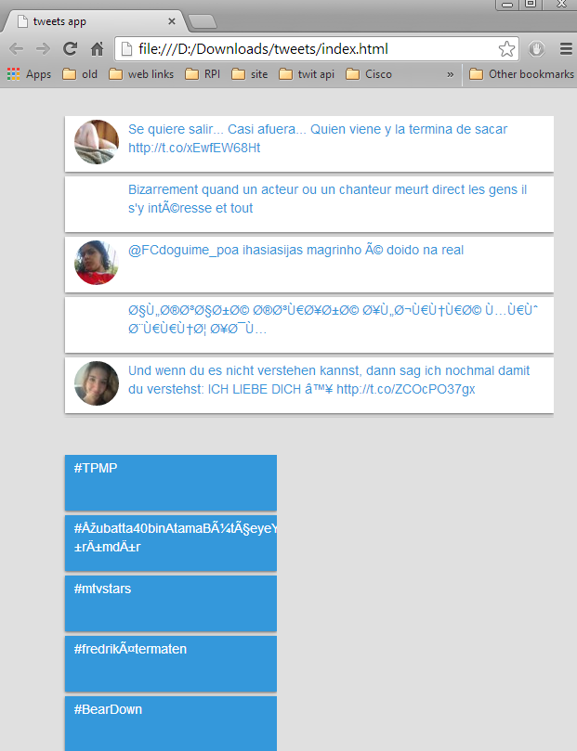

Example for responsive design:

Open <http://www.behance.net/> and resize the browser window manually to see different layouts for desktop, tablet and smartphone

Desktop

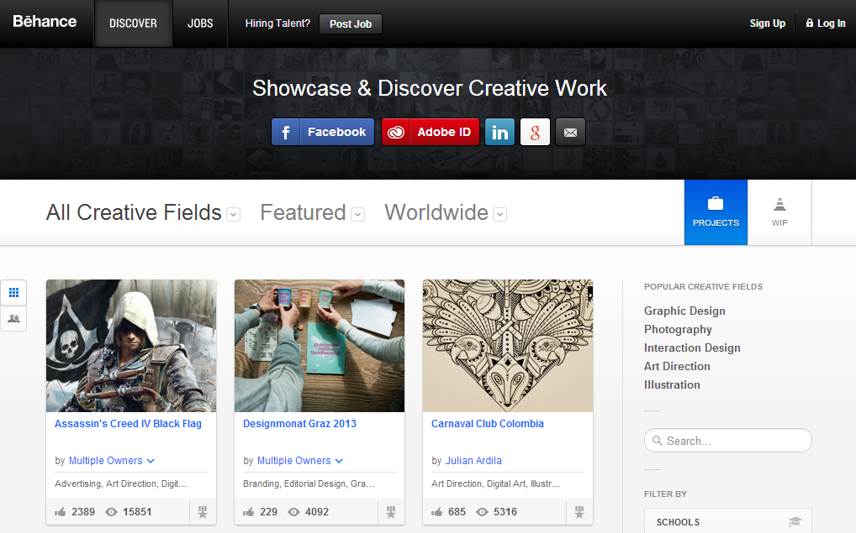

Tablet

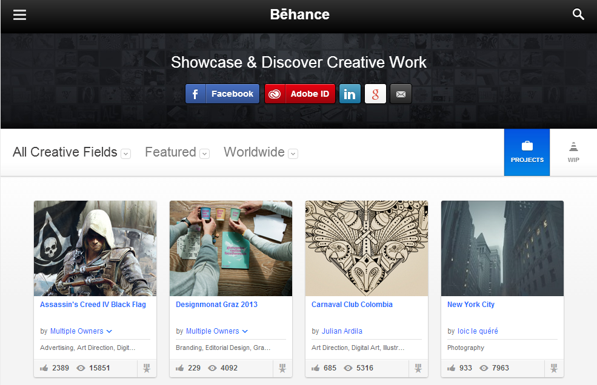

Smartphone

