**Lab 9: Lists + Lab 10: Multidimensional Lists**

**Question1:**

Write a program that reads some integers between 1 and 100 and counts the occurrences of each. Here is a sample run of the program:

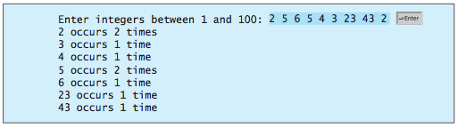

Note that if a number occurs more than one time, the plural word “times” is used in the output.

**Question 2:**

Write a program that reads in numbers separated by a space in one line and displays distinct numbers (i.e., if a number appears multiple times, it is displayed only once). (Hint: Read all the numbers and store them in **list1**. Create a new list **list2**. Add a number in **list1** to **list2**. If the number is already in the list, ignore it.) Here is the sample run of the program:



**Question3:**

Write a function that returns the sum of all the elements in a specified column in a matrix using the following header:

**def** sumColumn(m, columnIndex):

Write a test program that reads a 3 * 4 matrix and displays the sum of each col- umn. Here is a sample run:

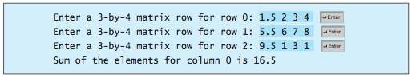

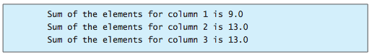

**Question 4:**

Write a function that sums all the numbers of the major diagonal in an *n* * *n* matrix of integers using the following header:

**def** sumMajorDiagonal(m):

The major diagonal is the diagonal that runs from the top left corner to the bottom right corner in the square matrix.

Write a test program that reads a 4 * 4 matrix and displays the sum of all its elements on the major diagonal. Here is a sample run:

