Introduction

The PathPlanner LabVIEW library provides utility functions to read, create, and follow PathPlanner paths.
The library source code, package build specifications, and test package can be found here https://github.com/jsimpso81/PathPlannerLabVIEW

Function Menus

A PathPlanner function pallete contains the PathPlanner functions and type definitions. This pallete can be accessed from the WPI Robotics Library Third Party pallete.

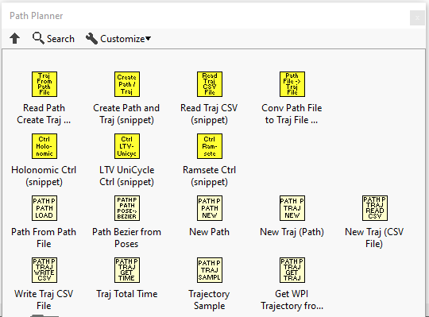

Function Help

Each VI includes help that can be accessed using the standard LabVIEW help toggle (Ctrl H).

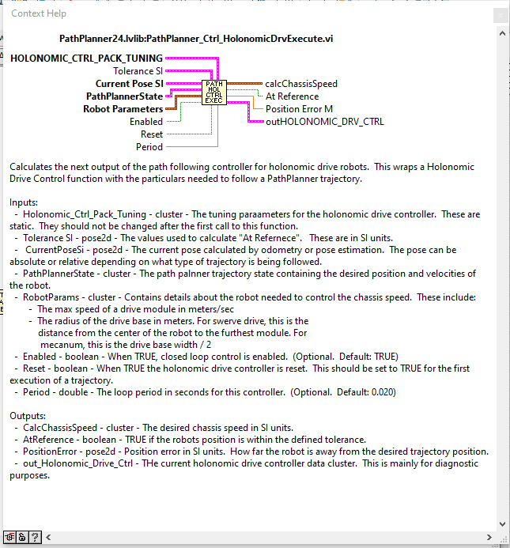

Function Examples

Many of the functions have examples that can be found under the LabVIEW "Find examples..." function. (Help -> Find Examples...). The function examples are easiest to find when "Directory Structure" is selected.
